Print ID Craft
Comprehensive User Manual

Multi-School ID Card Management & Print Portal

Version 1.0 • April 2026

Table of Contents
1. Introduction & Overview
2. System Architecture & User Roles
3. Landing Page
4. Login System
4.1 Teacher Login
4.2 Manufacturer (Admin) Login
5. Manufacturer Dashboard
5.1 Dashboard Overview & Statistics
5.2 Recent Schools Table
6. Schools Management
6.1 Schools List & Cards
6.2 Adding a New School
6.3 Search, Filter & Pagination
6.4 Deleting a School
7. School Detail Page
7.1 Overview Tab & Teacher Credentials
7.2 School Logo Upload
7.3 Classes Tab — Form Links & Sharing
7.4 Students Tab — Management & Actions
7.5 Template Tab — JPG Template Mapper
7.6 Generate Tab — Batch Generation
7.7 Batches Tab — Downloads
7.8 Export Tab — CSV & Excel
7.9 Bulk Import & Bulk Photo Upload
8. Teacher Dashboard
8.1 Overview Tab & Stats
8.2 Class Form Links & Sharing
8.3 Class Breakdown & Export
8.4 Students Tab — Review & Actions
8.5 Sub-Teachers Management
8.6 ID Template Preview
9. Student Submission Form
9.1 Step 1: Fill Details
9.2 Step 2: Photo Upload & Verification
9.3 Step 3: Review & Submit
9.4 Success Screen
10. Photo Verification Engine
11. ID Card Preview & Watermark System
12. Data Export (CSV & Excel)
13. Security Features
14. Troubleshooting & FAQ

1. Introduction & Overview
Print ID Craft is a comprehensive, web-based platform designed for managing student ID cards across multiple schools. It provides a complete end-to-end solution from student data collection to ID card printing, with built-in role-based access control, photo verification, and batch processing.

Key Features
- Multi-School Management — Manage unlimited schools from a single manufacturer dashboard
- Role-Based Access — Three distinct roles: Manufacturer, Main Teacher, Sub-Teacher
- Smart Form Links — Unique per-class submission URLs for students/parents
- Photo Verification Engine — Automated quality checks for passport-size photos
- JPG Template Mapping — Upload ID card images and visually map data fields
- Dual-Side Support — Front and back ID card template support
- Batch Generation — Print-ready PDF batches with all approved student cards
- Data Export — CSV and Excel export with class/status filters
- Bulk Import — Import student data from CSV/Excel with validation preview
- Bulk Photo Upload — Folder upload with automatic name-matching to students
- Sub-Teacher System — Class-specific teacher accounts with restricted visibility
- Watermarked Previews — Mandatory watermarks on all card previews

2. System Architecture & User Roles
Print ID Craft uses Next.js, Prisma ORM, PostgreSQL (Supabase), and Supabase Storage. The application supports three distinct user roles:

Role | Access Level | Key Permissions | Login URL
Manufacturer (Admin) | Full System | Create schools, manage templates, view all data, generate batches, bulk download cards | /login?mode=admin
Main Teacher | School-wide | View all classes, approve/flag students, add sub-teachers, add classes, export data, map templates | /login
Sub-Teacher (Class) | Single Class | View assigned class only, approve/flag own students, add comments | /login

💡 Workflow: Manufacturer creates school → Assigns Main Teacher → Main Teacher adds classes & sub-teachers → Form links shared with students → Students submit data & photos → Teachers review & approve → Manufacturer generates print batches → Cards printed & delivered.

3. Landing Page
The landing page introduces Print ID Craft with animated sections and a modern design.

3.1 Hero Section
Features the "We build powerful ID Card systems" tagline, CTA buttons (Explore Solution, School Login), and information cards highlighting platform differentiators on the right side.
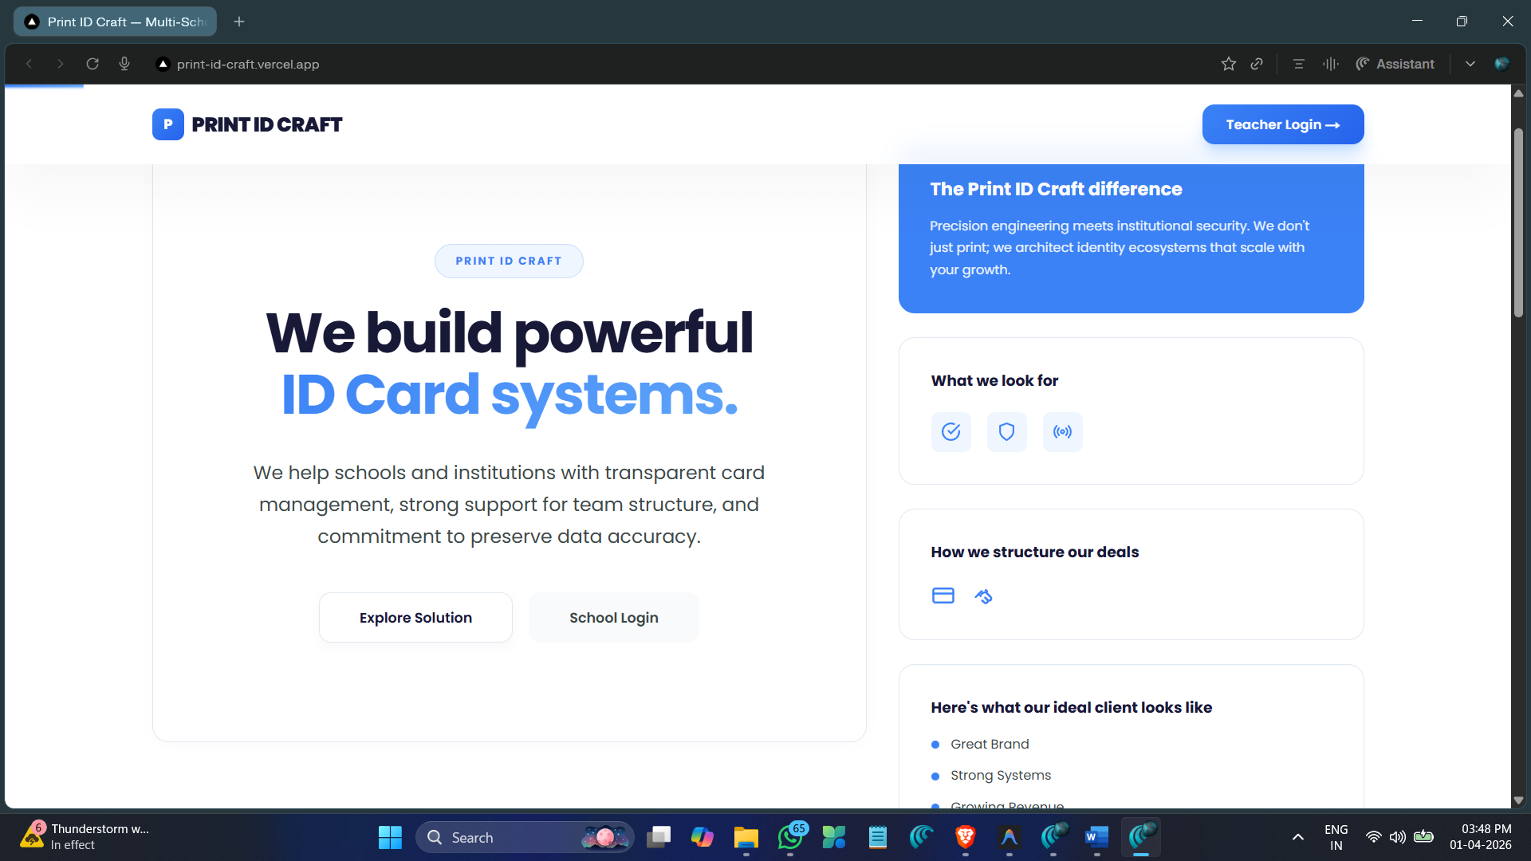

3.2 Statistics Bar
Animated statistics bar with: 50+ Schools Managed, 25,000+ Cards Printed, 99.9% Match Accuracy. Numbers animate from zero as user scrolls into view.
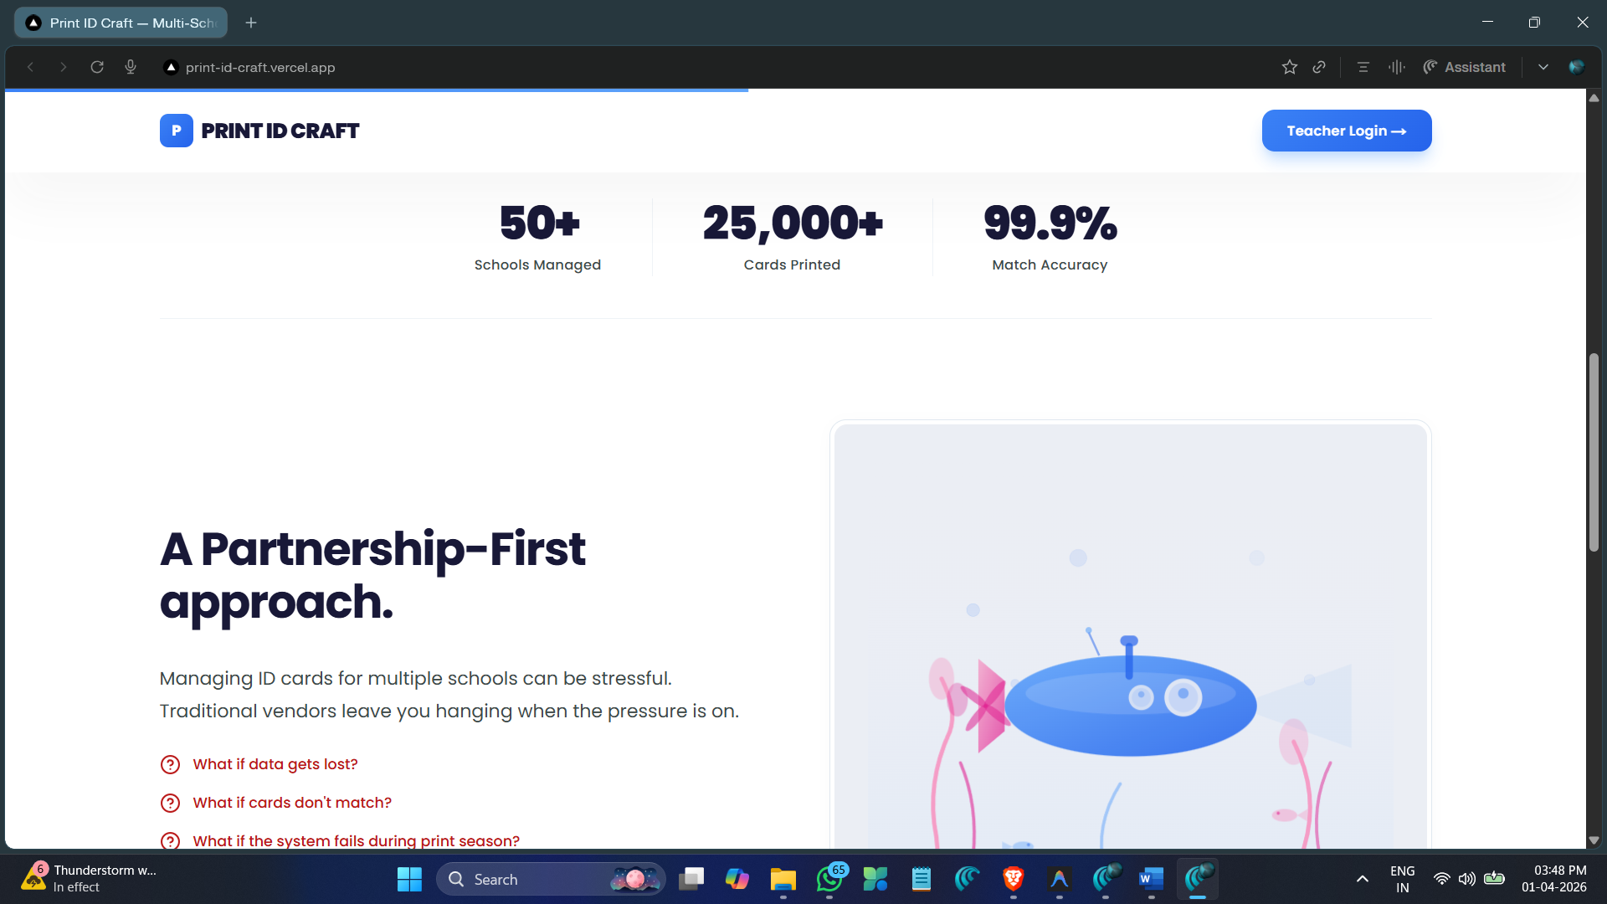

3.3 Partnership Section
Addresses common concerns about ID card management with a "Partnership-First Approach" message. Includes an animated submarine SVG illustration.

3.4 Footer & CTA
Dark-themed footer with "Get Started" CTA button, links to Privacy Policy, Terms of Service, and Support.

4. Login System
Separate login portals for Teachers and Manufacturers using NextAuth.js with bcrypt password hashing.

4.1 Teacher Login
Located at /login. Split-screen layout with animated ID card mock-up on the left, login form on the right. Photo guidelines reminder displayed below the form.
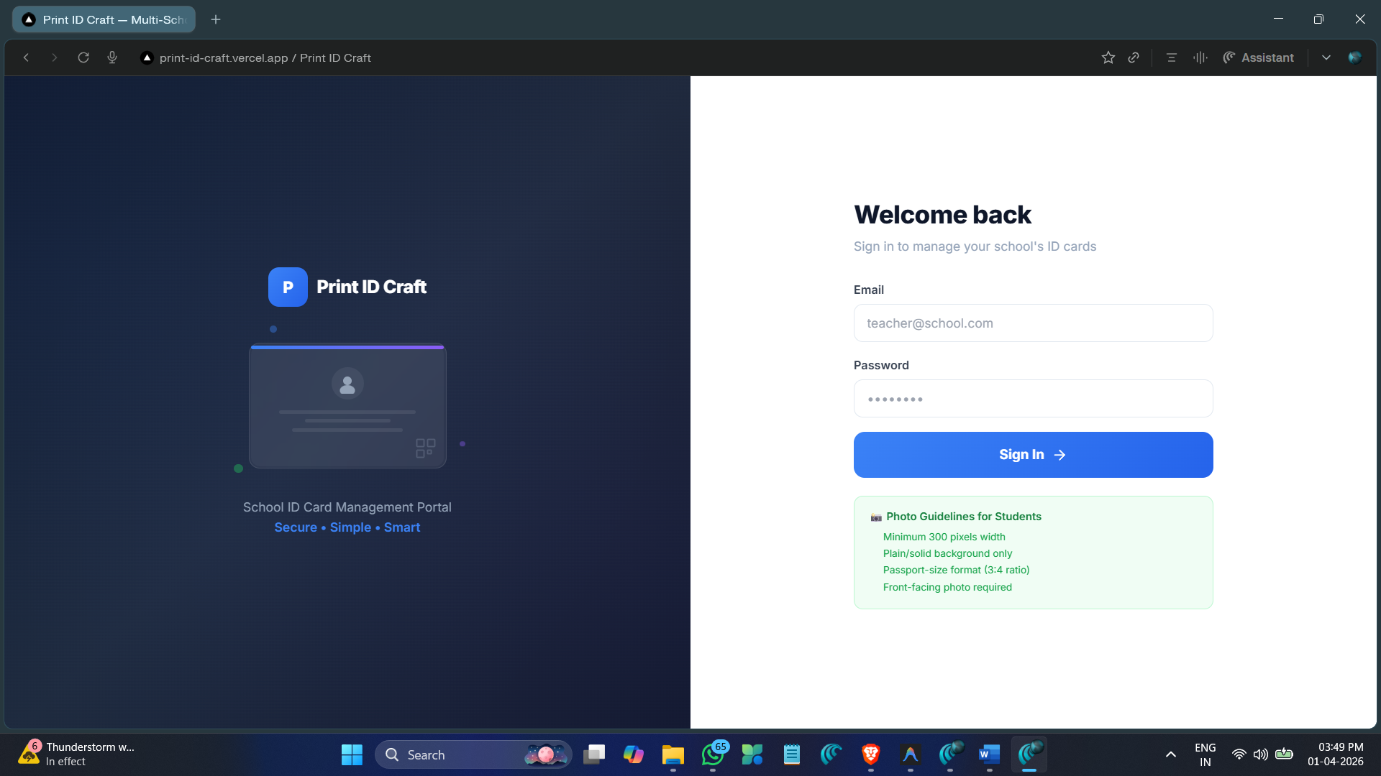

- Email and password authentication
- Photo guidelines reminder for student submissions
- Animated ID card illustration with floating dots
- Responsive design for mobile devices
- Toast notifications for success/error feedback

4.2 Manufacturer (Admin) Login
Located at /login?mode=admin. Distinct "Manufacturer Login" header with "Manage schools, templates & printing" subtitle and factory icon. (https://print-id-craft.vercel.app/login?mode=admin )
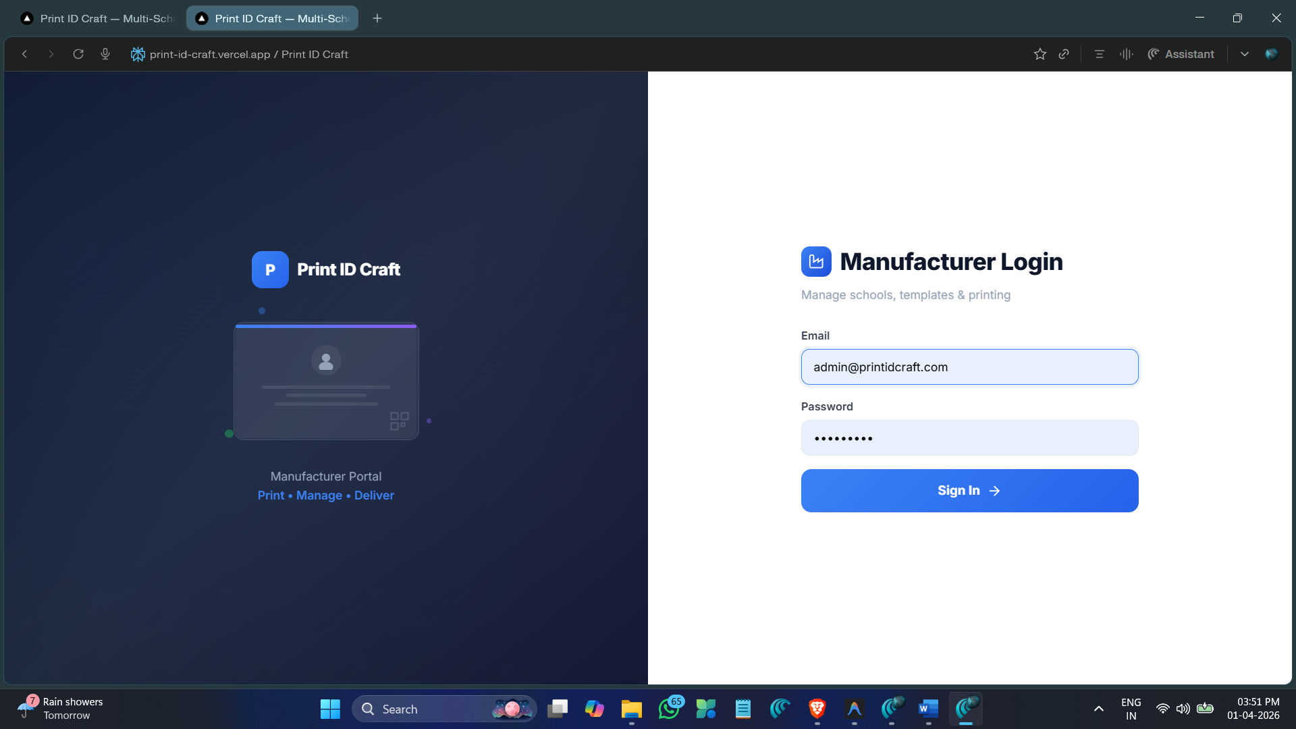

Login Steps:
Step 1: Navigate to the login page (/login for teachers, /login?mode=admin for manufacturer)
Step 2: Enter your registered email address
Step 3: Enter your password
Step 4: Click "Sign In" — you will be redirected to the appropriate dashboard
💡 Default Credentials: Main teacher accounts use default password: Teacher@123. The manufacturer should share these credentials with the school administrator.

5. Manufacturer Dashboard
The central command center for managing all schools, templates, and printing operations. Includes a left sidebar with navigation.

5.1 Dashboard Overview & Statistics
Four animated statistics cards:
- Total Schools (Blue) — Number of registered schools
- Total Students (Purple) — Total student submissions across all schools
- Print Batches (Amber) — Total generated print batches
- This Month (Green) — Student submissions for the current month
📸 Figure 5.1: Manufacturer Dashboard with Stats Cards
[Paste screenshot here]

5.2 Recent Schools Table
Displays 5 most recently added schools with columns: School name & email, Student count, Classes count, Template status (Ready/Not Set), and Manage button. On mobile, transforms to stacked cards.
📸 Figure 5.2: Recent Schools Table
[Paste screenshot here]

Sidebar Navigation
- Dashboard — Overview with stats and recent schools
- Schools — Complete school list with management
- User Profile — Logged-in user name with sign-out

6. Schools Management

6.1 Schools List & Cards
Schools displayed as gradient-banner cards showing: school initial, name, contact, student/class counts, template status badge, Manage and Delete buttons. Summary stats at top.
📸 Figure 6.1: Schools List with Cards
[Paste screenshot here]

6.2 Adding a New School
Click "+ Add School" to open the modal:
Step 1: Fill School Name (required) and Contact Email (required)
Step 2: Optionally add Address and upload School Logo
Step 3: Add class names (e.g., "1st A", "2nd B") — press Enter or click + Add
Step 4: Click "Create School" — auto-generates main teacher account and class form links
📸 Figure 6.2: Add School Modal
[Paste screenshot here]

6.3 Search, Filter & Pagination
Debounced search bar (400ms) for name, email, or address. Clear button resets filter. Pagination for 50+ schools per page.

6.4 Deleting a School
Click red trash icon → type "DELETE" to confirm. Permanently removes school and ALL associated data.
⚠️ Warning: Deleting a school is irreversible. All student data, photos, classes, templates, and batches will be permanently lost.

7. School Detail Page
7 tabs: Overview, Classes, Students, Template, Generate, Batches, Export. Breadcrumb navigation: Dashboard › Schools › School Name.

7.1 Overview Tab & Teacher Credentials
Shows 4 stat cards (Classes, Students, Batches, Template Status). Below, the Main Teacher Login section displays:
- Login URL with Copy button
- Email address with Copy button
- Default password: Teacher@123
- Reset Password button (restores default)
- Quick Auto-Generate option if no teacher exists
- Manual email entry option
📸 Figure 7.1: School Overview with Teacher Credentials
[Paste screenshot here]

7.2 School Logo Upload
Upload/replace school logo (JPEG, PNG, WebP). Drag-and-drop supported. Logo appears on student ID cards.
📸 Figure 7.2: School Logo Upload Section
[Paste screenshot here]

7.3 Classes Tab — Form Links & Sharing
Complete class management:
- Add New Class — name + optional expiry date
- Unique Form Link per class — students use this to submit details
- Copy Link — one-click clipboard copy
- Share via WhatsApp — pre-formatted message with school/class info
- Share via Email — pre-filled subject and body
- Toggle Active/Inactive — enable/disable submissions
- Set Expiry Date — auto-deactivate after date
- Delete Class — requires "DELETE" confirmation
📸 Figure 7.3: Classes Tab with Form Links
[Paste screenshot here]

7.4 Students Tab — Management & Actions
Student table with filters (Status, Class, Search) and columns: Photo, Serial, Name, Class, Status, Flag Note, Teacher Comment, Actions.
Available actions per student:
- View (👁) — Full detail modal with photo, form data, ID card preview
- Approve — Mark approved for printing
- Flag (🚩) — Flag with custom reason note
- Unflag — Remove flag, return to submitted
- Edit — Modify form fields in modal
- Delete — Remove student record
📸 Figure 7.4: Students Tab with Table
[Paste screenshot here]

7.5 Template Tab — JPG Template Mapper
Upload an actual ID card template image and visually map data field positions:
Step 1: Upload front-side template image (JPG/PNG)
Step 2: Optionally upload back-side template
Step 3: Click on template to add field mapping zones
Step 4: For each zone: select data field (Full Name, Class, Photo, Serial, etc.)
Step 5: Adjust font size, color, alignment, position
Step 6: Preview with sample data; Save configuration
📸 Figure 7.5: JPG Template Mapper
[Paste screenshot here]

7.6 Generate Tab — Batch Generation
Preview cards with actual student data, then generate print-ready batches:
Step 1: Review card preview with real student photos and data
Step 2: Click "Generate Batch" to start processing
Step 3: Progress indicator shows status; auto-polls for completion
Step 4: Completed batch appears in Batches tab for download
💡 Note: Only SUBMITTED or APPROVED students are included. Flagged students are excluded. High-quality downloads restricted to Manufacturer role.

📸 Figure 7.6: Generate Tab with Preview
[Paste screenshot here]

7.7 Batches Tab — Downloads
Lists all generated batches with: creation date, student count, status (Processing/Ready), download options (Front PDF, Back PDF, Manifest CSV).
📸 Figure 7.7: Batches Tab
[Paste screenshot here]

7.8 Export Tab — CSV & Excel
Download student data filtered by class and status. CSV (.csv) and Excel (.xlsx) formats. Includes: Serial Number, Name, Class, all form fields, Photo URL, Status, Comments, Date.
📸 Figure 7.8: Export Tab
[Paste screenshot here]

7.9 Bulk Import & Bulk Photo Upload
Bulk Student Import:
Step 1: Click "📥 Import" → select class → upload CSV/Excel
Step 2: Review validation preview (matched columns, errors, warnings)
Step 3: Confirm to import data into system
Bulk Photo Upload:
Step 1: Click "📷 Bulk Photos" → select folder with student photos
Step 2: Auto-matches by filename (serial number or student name)
Step 3: Review results; manually assign unmatched photos
📸 Figure 7.9: Bulk Import / Photo Upload
[Paste screenshot here]

8. Teacher Dashboard
Central hub for school administrators and class teachers. Tabs: Overview, Students, Sub-Teachers (main only), ID Template (main only).

8.1 Overview Tab & Stats
Displays school name, teacher role badge (Main Teacher / Class Teacher), and stat cards:
- Total Submissions — all student entries
- Approved — approved for printing (green)
- Pending Review — awaiting teacher review (amber)
- Flagged — marked for issues (red)
- Approval Progress bar with percentage
📸 Figure 8.1: Teacher Dashboard Overview
[Paste screenshot here]

8.2 Class Form Links & Sharing
Each class shows a unique submission URL with: 📋 Copy button, 💬 WhatsApp share (pre-formatted message), student count, assigned teacher name. Main teachers can add new classes via "+ Add Class" form.
📸 Figure 8.2: Class Form Links Section
[Paste screenshot here]

8.3 Class Breakdown & Export
Table with columns: Class, Teacher, Students, Approved, Flagged. Export buttons for CSV and Excel formats.
📸 Figure 8.3: Class Breakdown Table
[Paste screenshot here]

8.4 Students Tab — Review & Actions
Filters: Class dropdown (main teachers only), Status dropdown. Student table columns: Photo, Serial, Name, Class, Status, Comment, Actions.
Action buttons per student:
- 👁 View — Detailed modal with photo, form data, ID card preview
- ✓ Approve — Mark approved for printing
- ✕ Disapprove — Mark as flagged/disapproved
- 🚩 Flag — Flag with custom reason note
- Unflag — Remove flag
- ✏️ Edit — Modify all form fields
- 💬 Comment — Add teacher comment (visible to manufacturer)
📸 Figure 8.4: Teacher Students Tab
[Paste screenshot here]

8.5 Sub-Teachers Management
Available only to Main Teachers. Add class-specific teacher accounts:
Step 1: Click "+ Add Teacher"
Step 2: Fill: Name, Email, Password (min 6 chars), Assign to Class
Step 3: Success banner shows credentials (Name, Email, Password, Login URL)
Step 4: Copy & share — password shown ONLY once
Sub-teacher list table: Name (with avatar), Email, Assigned Class, Added date, Remove button. Sub-teachers can only see their assigned class.
📸 Figure 8.5: Sub-Teachers Management
[Paste screenshot here]

⚠️ Security: Passwords are bcrypt-hashed and shown only at creation. If forgotten, delete and recreate the sub-teacher account.

8.6 ID Template Preview
Main teachers can view and configure the school's ID card template using the JPG Template Mapper. All previews include mandatory watermarks.
📸 Figure 8.6: Teacher Template Preview
[Paste screenshot here]

9. Student Submission Form
Students/parents use a unique class URL (/submit/{token}) to submit ID card data. 3-step wizard: Details → Photo → Review.

9.1 Step 1: Fill Details
Displays school name, class, step indicator (1-2-3). Form fields include: Full Name, Father's Name, DOB, Blood Group, Address, etc. Required fields marked with *.
📸 Figure 9.1: Student Form — Details Step
[Paste screenshot here]

9.2 Step 2: Photo Upload & Verification
Photo requirements box lists: 300px minimum, plain background, face visible, 3:4 ratio. Includes sample photo reference. Photo Verifier checks quality before accepting. React Image Crop for passport-size cropping.
📸 Figure 9.2: Student Form — Photo Upload & Crop
[Paste screenshot here]

9.3 Step 3: Review & Submit
Side-by-side: Card Preview (with watermark) and Details Check panel. Shows student photo thumbnail, all entered fields, class, and confirmation note. Progress bar during upload (0-100%).
📸 Figure 9.3: Student Form — Review Screen
[Paste screenshot here]

9.4 Success Screen
Green checkmark, unique Serial Number (students should save this), watermarked ID Card Preview, "Powered by Print ID Craft" branding.
📸 Figure 9.4: Submission Success Screen
[Paste screenshot here]

10. Photo Verification Engine
Built-in automated photo validation:
- 🔍 Minimum Resolution — 300×300 pixels for print quality
- 🔍 File Format — JPEG, PNG, WebP only
- 🔍 File Size — Maximum 5MB
- 🔍 Aspect Ratio — Cropped to 3:4 (passport standard)
- 🔍 Background Check — Verifies plain/solid background
- 🔍 Face Detection — Ensures face is visible and centered
💡 Photo Tips: Use natural lighting, plain white/light wall, face camera directly, avoid filters or editing.

📸 Figure 10: Photo Verification in Action
[Paste screenshot here]

11. ID Card Preview & Watermark System
Two preview types: JPG Card Preview (template image with data overlay) and Canvas-Based Preview (drag-and-drop layout).
Watermark system:
- Diagonal watermark on ALL preview screens (student, teacher, manufacturer)
- Removed only in high-quality batch downloads (Manufacturer role only)
- Cannot be disabled by teachers or students
- Covers entire card surface to prevent screenshot reproduction
📸 Figure 11: ID Card Preview with Watermark
[Paste screenshot here]

12. Data Export (CSV & Excel)
Both manufacturer and teacher dashboards support export. Includes: Serial Number, Name, Class, all form fields, Photo URL, Status, Flag Note, Teacher Comment, Date.
Feature | CSV | Excel
Format | .csv | .xlsx formatted
Filters | Class, Status | Class, Status

13. Security Features
- 🔒 Authentication — NextAuth.js with JWT sessions (24h expiry), bcrypt passwords
- 🔒 Role-Based Access — Middleware enforces role-based routing
- 🔒 Sub-Teacher Isolation — Class teachers see only their assigned class
- 🔒 Watermarked Previews — Mandatory on all card previews
- 🔒 Batch Download Restriction — High-quality downloads restricted to Manufacturer
- 🔒 Form Link Control — Deactivation and expiry date support
- 🔒 Delete Confirmation — Requires typing "DELETE" for destructive operations
- 🔒 Input Validation — Client and server-side validation
- 🔒 Photo Validation — Format, size, resolution, and content quality checks
- 🔒 Force Logout — API endpoint to force sign-out user sessions

14. Troubleshooting & FAQ
Q: I forgot my teacher login password.
A: Contact the manufacturer. They can reset from School Detail → Overview → "Reset Pw" button. Default: Teacher@123.

Q: A student submitted incorrect information.
A: Students tab → Edit (✏️) button to modify form fields. Or flag the student and add a comment.

Q: The form link isn't working.
A: Check if class link is active (Classes tab → Toggle). Check expiry date. Generate new link if needed.

Q: Photos are being rejected.
A: Ensure: 300×300px minimum, JPEG/PNG/WebP, under 5MB, plain background, front-facing.

Q: How do I generate print-ready cards?
A: School → Generate tab → Review preview → Click "Generate Batch". Download from Batches tab.

Q: Can sub-teachers see all students?
A: No. Sub-teachers only see their assigned class. Only Main Teacher has school-wide access.

Q: How to share form links with parents?
A: Teacher Dashboard → Overview → Class Form Links → Copy or WhatsApp share button.

Q: Can I import from spreadsheet?
A: Yes. Students tab → "📥 Import" → upload CSV/Excel → validate → confirm import.

Q: Why are previews watermarked?
A: Watermarks prevent unauthorized reproduction. Removed only in Manufacturer batch downloads.

Q: How to upload photos in bulk?
A: Students tab → "📷 Bulk Photos" → select folder → auto-matches by filename → manually assign unmatched.

Thank You
For support or feature requests, contact the Print ID Craft team.

© 2026 Print ID Craft. All rights reserved.

