SLE-3: Architectural Design (Full C4 Model)
Course: 02AML204 – Introduction to Artificial Intelligence
SY B.Tech. CSE (AI & ML) | SEM-VI
PRN: 25UAM077 Name: Darshan Jivandhar Chougule
Division: B
GitHub / Portfolio: IAI-SLE-AI-Agent and IAI-SLE-2-profiling

1. System Title & Short Description
Performance Comparison of BFS and DFS on a 20×20 Grid is a Python-based search system that finds a path from a fixed start position to a fixed goal position. The system implements Breadth-First Search (BFS) and Depth-First Search (DFS) on the same grid. It records path length and nodes expanded for correctness, then profiles execution time using repeated runs. The system is designed to show both the working and empirical performance of two uninformed search algorithms.

2. Context Diagram (Level 1)
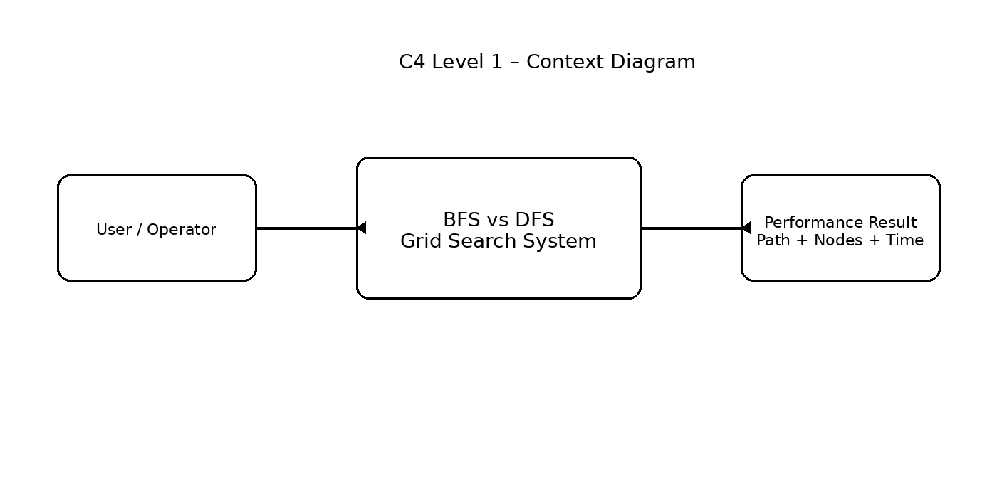
The user runs the grid-search program and selects the BFS-vs-DFS profiling operation. The system processes the fixed grid and returns search results including path length, nodes expanded, and average execution time. The SLE-2 repository defines the problem as a 20×20 grid with start (0,0) and goal (19,19).

3. Container Diagram (Level 2)
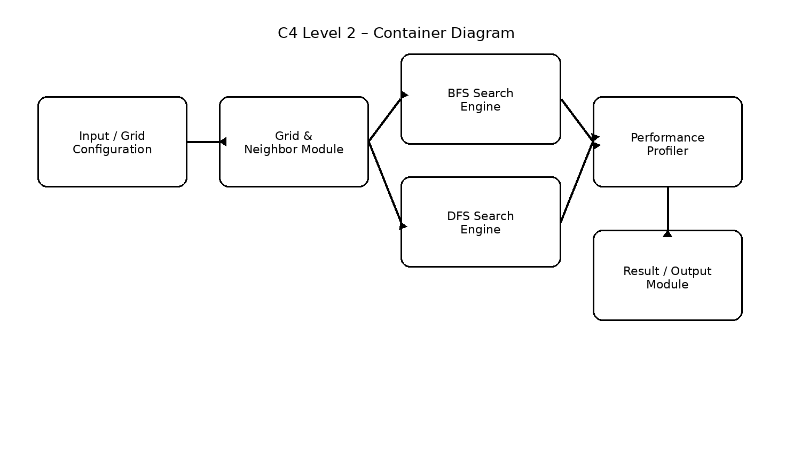
Container | Responsibility
Input / Grid Configuration | Stores grid dimensions, start/goal positions, and blocked/free cells.
Grid & Neighbor Module | Checks valid adjacent cells using boundary and free-cell conditions.
BFS Search Engine | Uses a FIFO queue, visited set, and parent map to search level by level.
DFS Search Engine | Uses a LIFO stack, visited set, and parent map to search depth-first.
Performance Profiler | Runs correctness checks and repeated timing experiments using timeit and statistics.
Result / Output Module | Displays path length, nodes expanded, execution time, and final comparison.

4. Component Diagram (Level 3)
The Search Engine is the most important container, so its internal components are shown below. The same logical structure is used by BFS and DFS, while the frontier data structure differs: BFS uses a queue and DFS uses a stack.
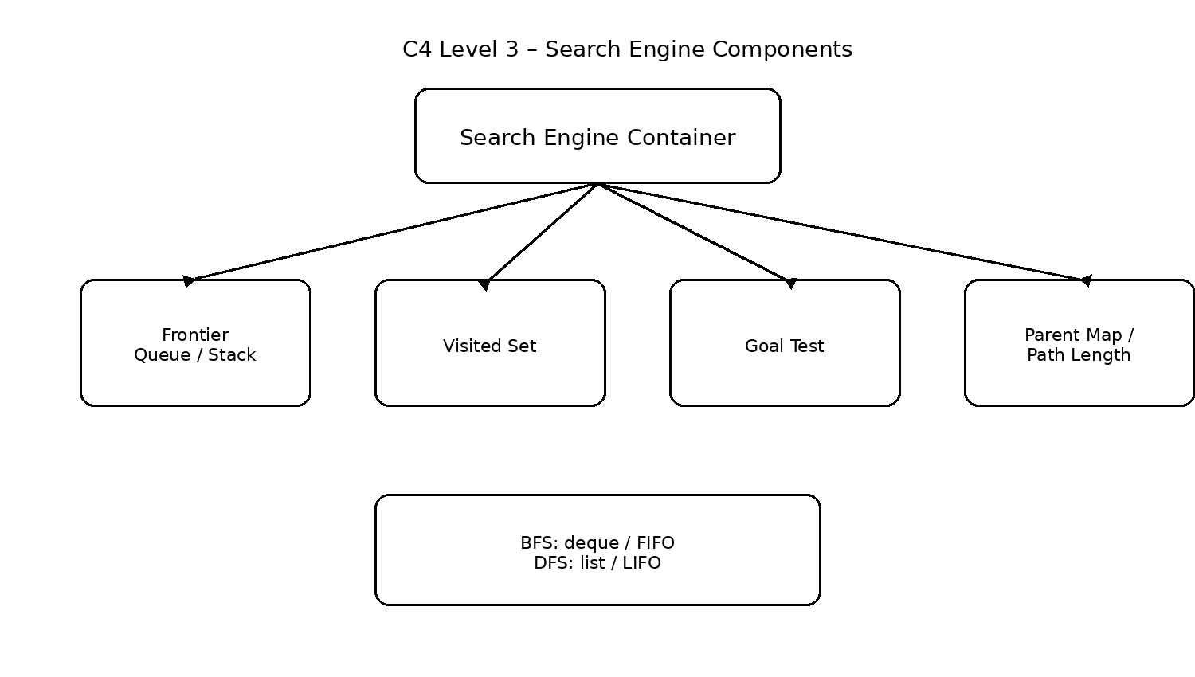
Frontier controls which node is processed next. The visited set prevents repeated processing. The goal test checks whether the current node is the target, and the parent map stores the predecessor of each discovered node so that the path length can be reconstructed.

5. Code Level Overview (Level 4)
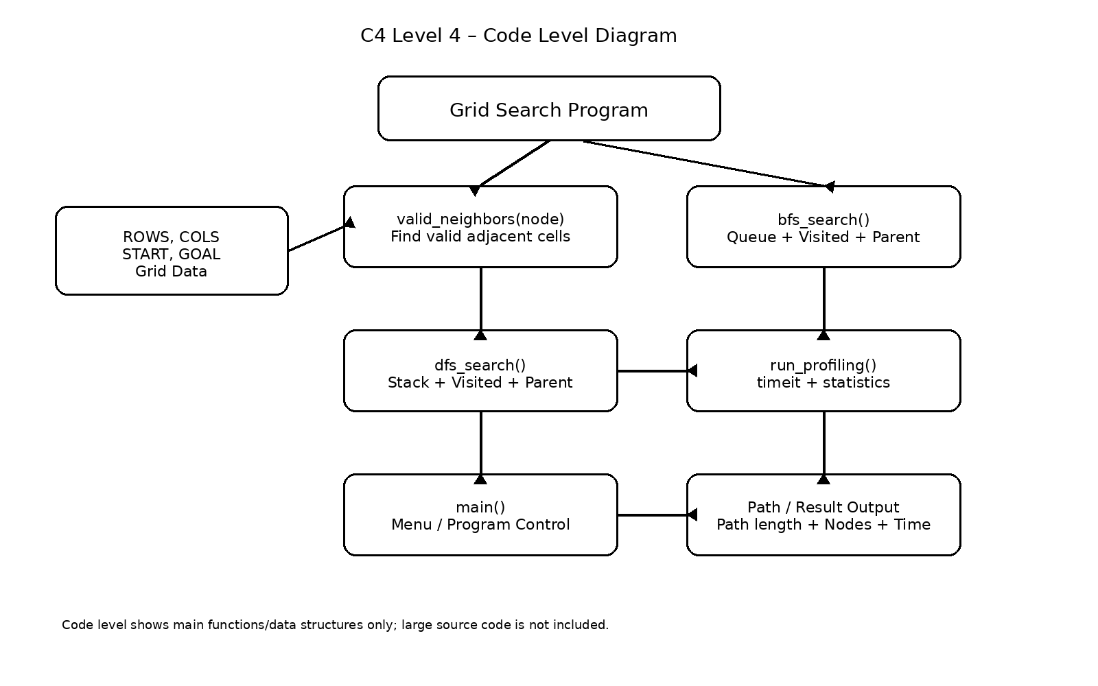
ROWS, COLS : Define the 20×20 grid dimensions.
START, GOAL : Define the starting and target coordinates.
valid_neighbors(node) : Generates valid free neighboring cells.
bfs_search() : Performs BFS using deque, visited and parent structures.
dfs_search() : Performs DFS using a stack, visited and parent structures.
run_profiling() : Runs correctness checks and 5 × 5000 timing experiments.
main() : Provides the menu and starts the selected profiling operation.

6. Design Decisions
The SLE-3 architecture continues the SLE-2 BFS-vs-DFS grid-search system so that the architecture directly matches the profiled implementation. BFS and DFS are kept as separate search containers because their frontier structures differ. A shared neighbor-validation approach keeps grid movement consistent, while the profiler isolates performance measurement from search logic.

7. AI Contribution Note
AI tools used (if any): ChatGPT / AI assistance for understanding the C4 model, organizing the architecture, and preparing concise documentation.
What AI helped with: Mapping the existing SLE-2 code into Context, Container, Component, and Code levels and improving the explanation of design decisions.
What I did myself: I provided and worked with my GitHub SLE-1/SLE-2 work, checked the implementation, and will verify the diagrams and explanations before submission.

8. Conclusion
This SLE-3 converts the BFS-vs-DFS search implementation into a complete C4 architecture. The four levels show the system from the user-facing context down to its main functions. The design makes the relationship between grid handling, search algorithms, and performance profiling clear. It also shows how the SLE-2 empirical analysis can be connected to a structured software architecture.

