### CHAPTER-5

**IMPLEMENTATION**

* **5.1 Form Layouts :**

**Login Page :**

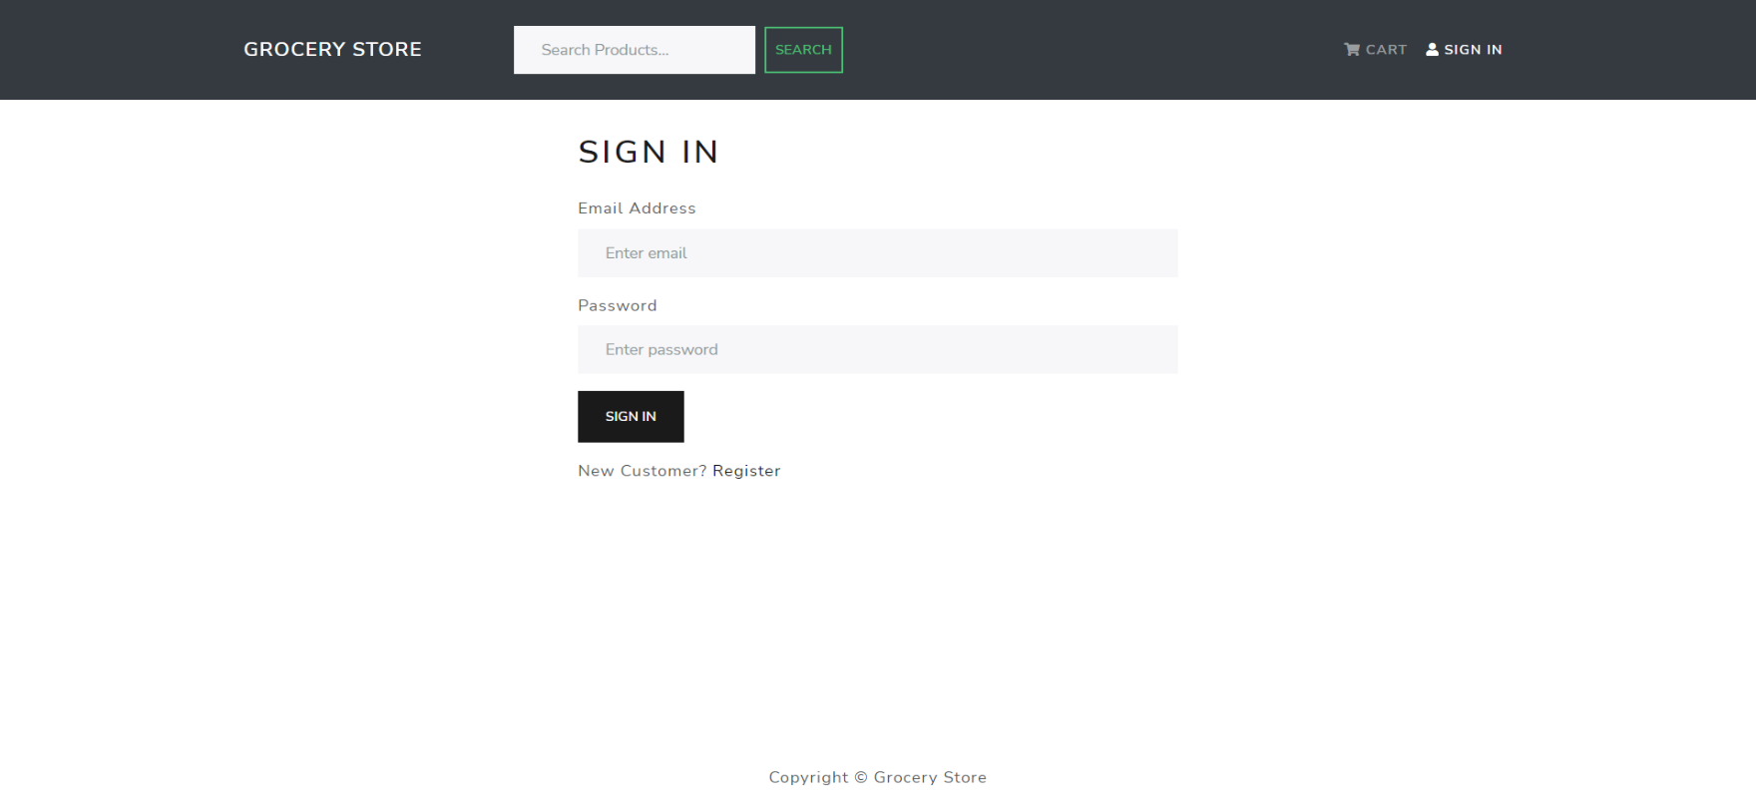

**Sign Up Page :**

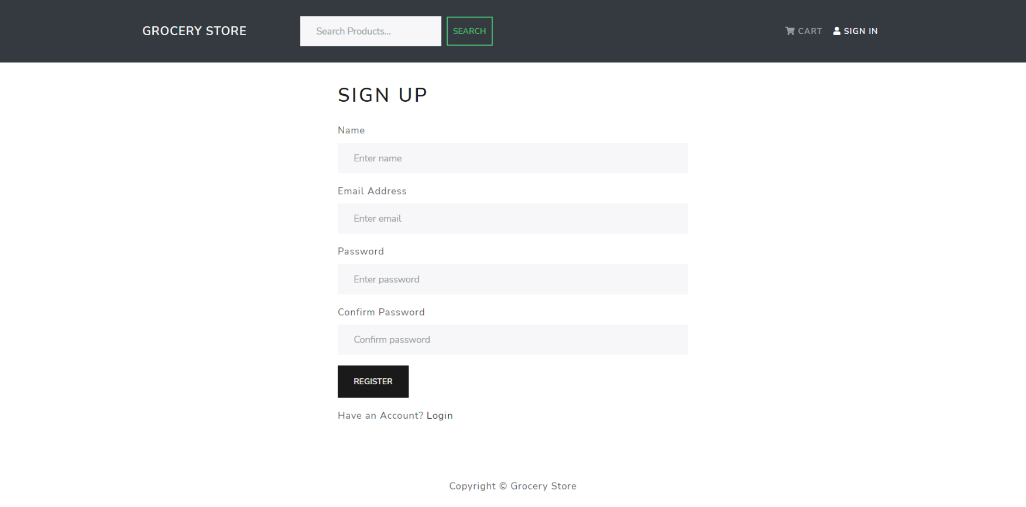

* **5.2 Page Layouts :**

**Home page :**

**Home page :**

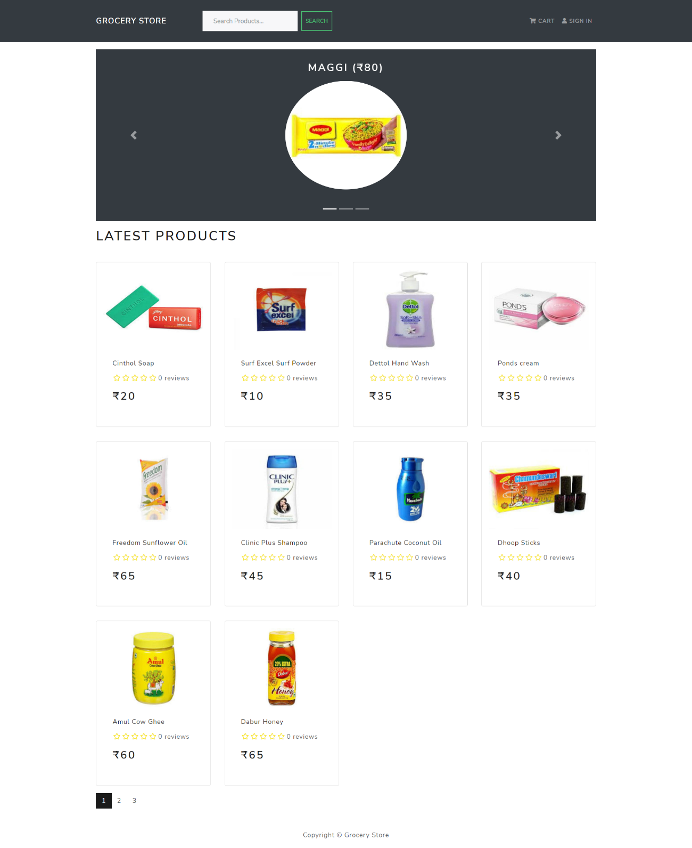

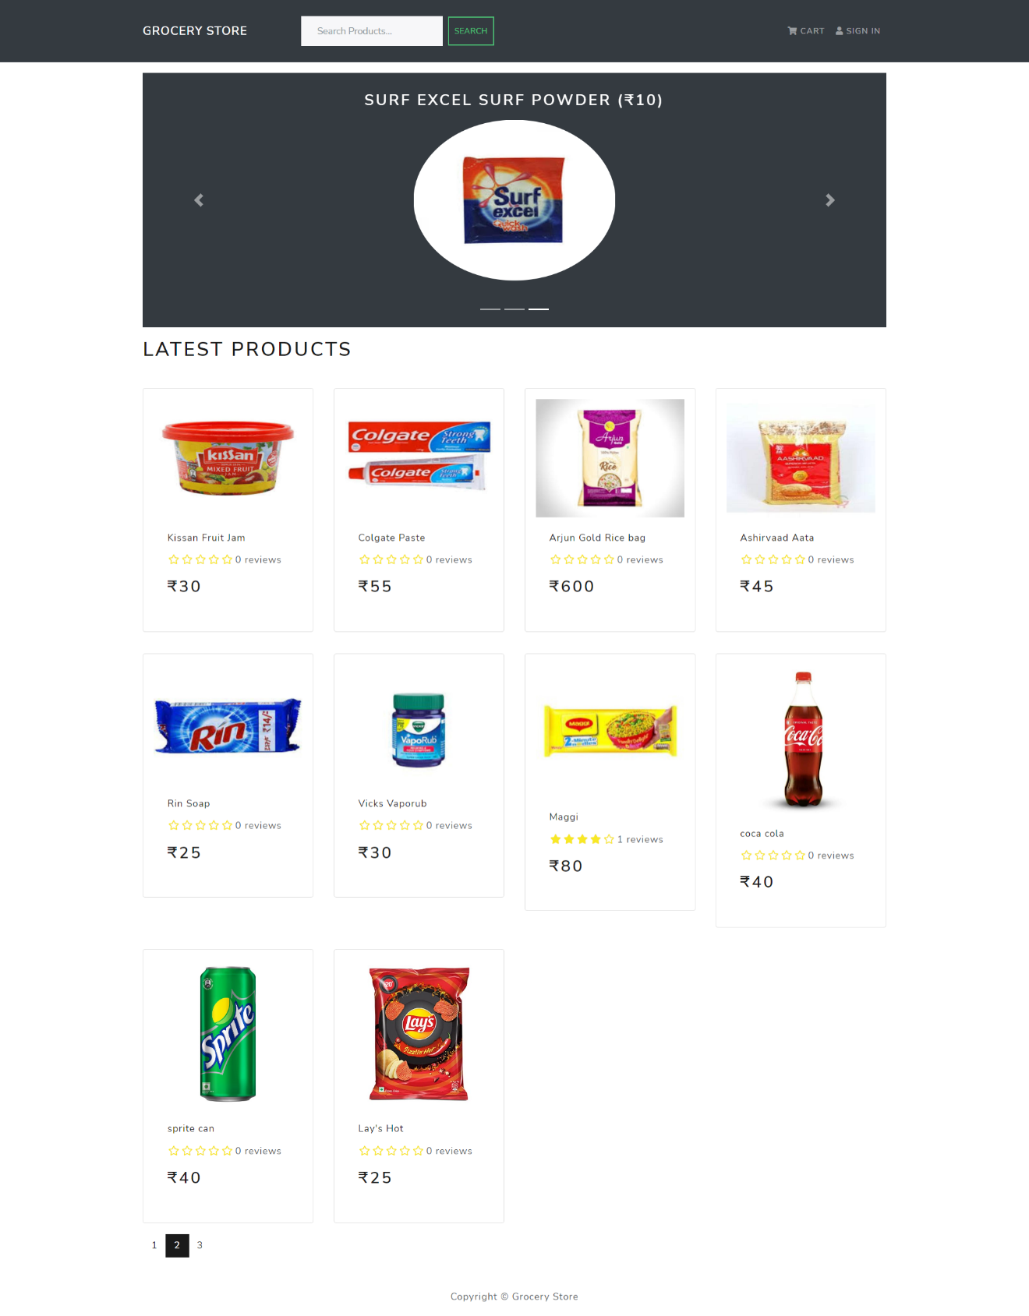

**Cart page :**

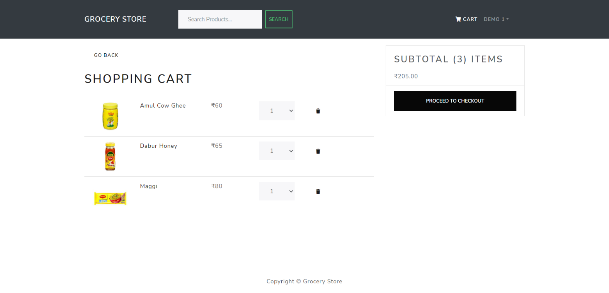

**Shipping page :**

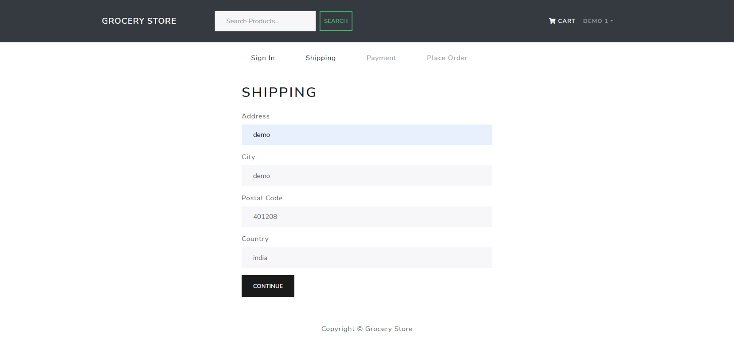

**Payment Method page :**

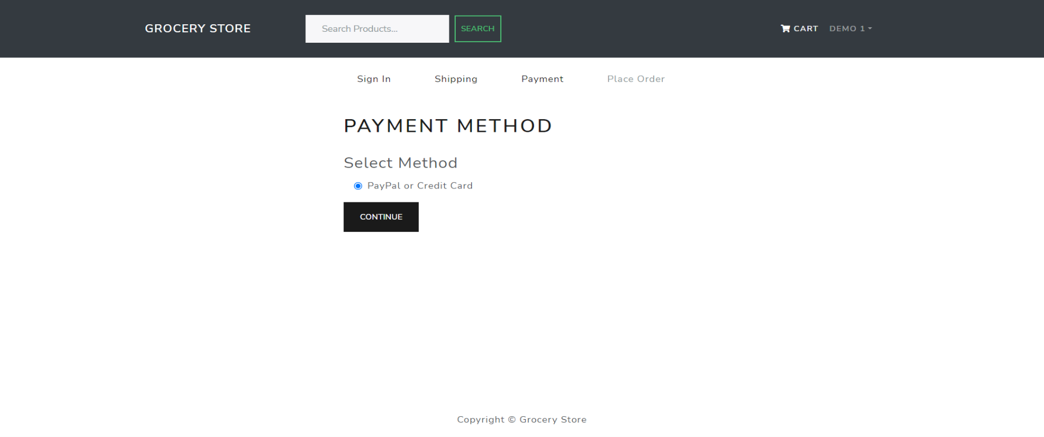

**Place Oder page :**

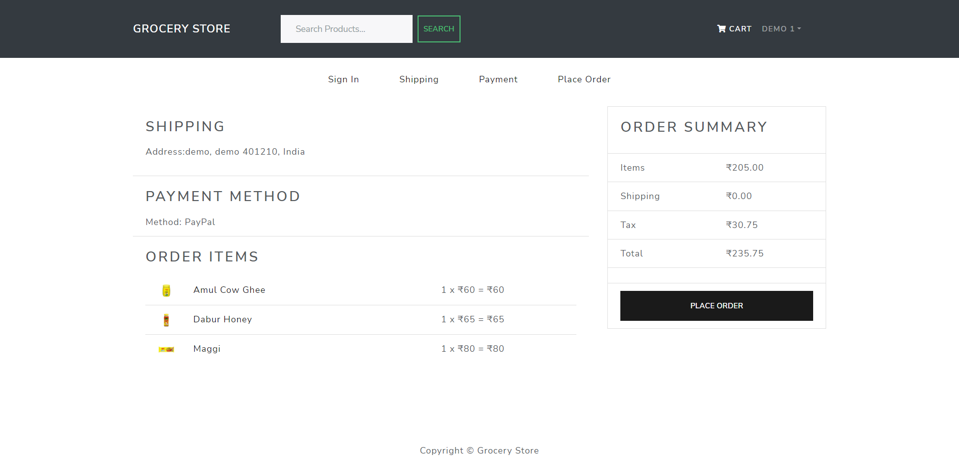

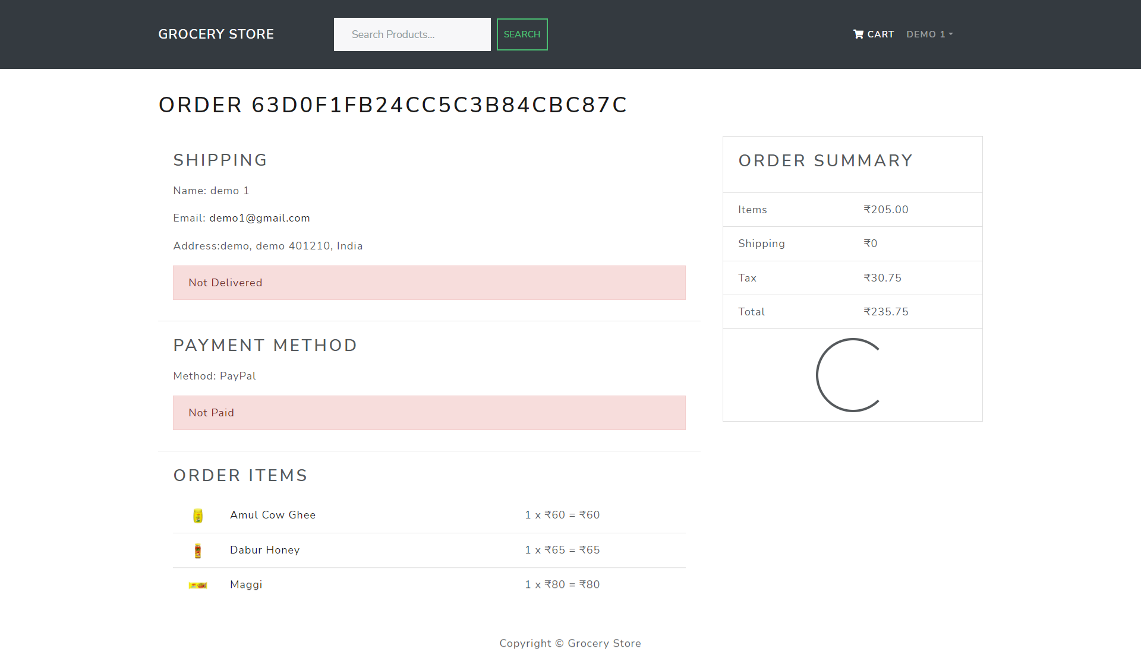

* **5.3 Report Layouts:**

**User Orders Reports:**

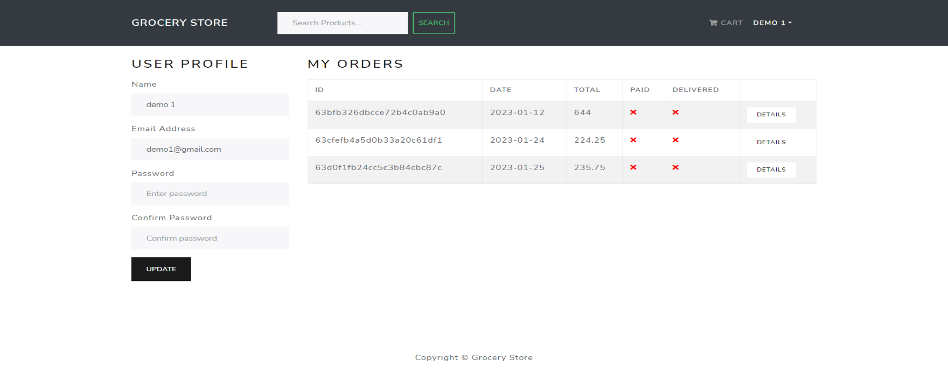

**Admin Orders Reports:**

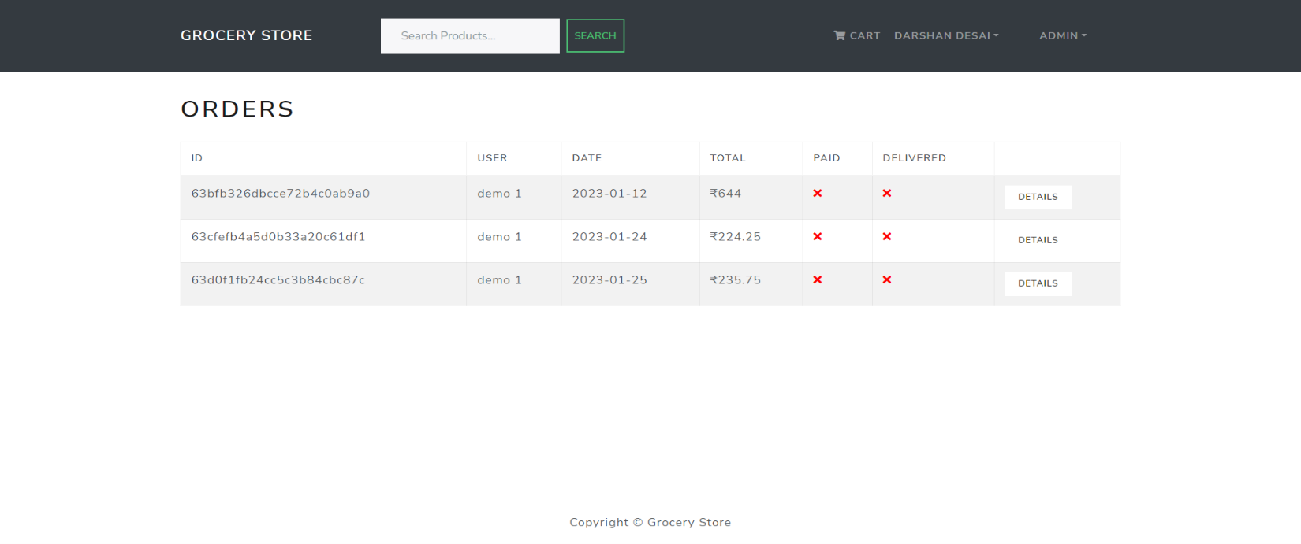

* **5.4 Coding Conventions [Business Logic]:**

Ecommerce online grocery store would include several different components, including the business logic, which handles the core functionality of the store, as well as the user interface, database, and server-side code.

In terms of coding conventions for the business logic, it is important to follow a consistent set of guidelines and best practices for writing code. This can include:

1. Naming conventions for variables, functions, and classes, using clear and descriptive names that accurately reflect their purpose.
2. Indentation and spacing that is consistent and easy to read.
3. Use of comments and documentation throughout the code to explain the purpose and functionality of different sections.
4. Use of appropriate data structures and algorithms to improve performance and scalability.
5. Proper error handling and logging to facilitate debugging and troubleshooting.
6. Validation of user input and handling of edge cases to ensure data integrity and security.

Other components of the full solution for an ecommerce online grocery store would include:

1. A user interface that allows customers to browse and purchase products, manage their account, and view order history and status.
2. A database to store customer information, product information, and order details.
3. Server-side code to handle customer requests, process orders, and interact with the database.

It is also important to consider additional features such as payment gateway integration, inventory management, and shipping calculation.

Overall, following coding conventions in the business logic of an ecommerce online grocery store can help to ensure that the store functions smoothly, efficiently, and securely.