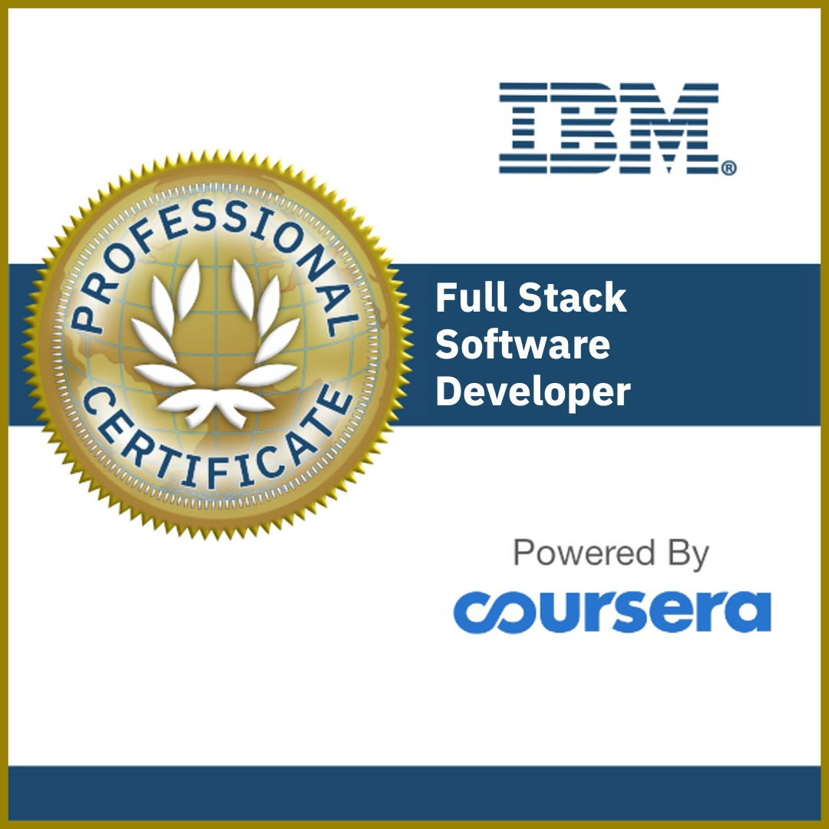

Full Stack Software Developer Professional Certificate

ISSUED TO

DARSHAN JAIN

Issued on: 19 OCT 2022

Issued by: Coursera | Authorized by: IBM Verify: <https://www.credly.com/go/wfZEl8JH>



Oct 18, 2022

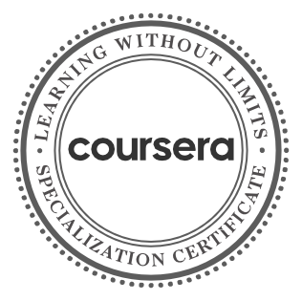

**Front-End Web UI**

**Frameworks and Tools: Bootstrap 4**

**Front-End Web**

**Development with React**

**Server-side Development with NodeJS, Express and MongoDB**

**3 Courses**

#### Darshan Jain

has successfully completed the online, non-credit Specialization

# Full-Stack Web Development with React

In this specialization you learnt to (1) Design a full-ﬂedged Web client application using Bootstrap 4 and React, (2) Design a hybrid mobile application using React Native, and (3) Develop server-side support for the web application using Node.js, ExpressJS together with database support using MongoDB.

The online specialization named in this certiﬁcate may draw on material from courses taught on-campus, but the included courses are not equivalent to on-campus courses. Participation in this online specialization does not constitute enrollment at this university. This certiﬁcate does not confer a University grade, course credit or degree, and it does not verify the identity of the learner.

Jogesh K. Muppala, Associate Professor of Computer Science and Engineering

Verify this certiﬁcate at: [https://coursera.org/verify/specializat ion/6M6Z4PPZJ9L6](https://coursera.org/verify/specialization/6M6Z4PPZJ9L6)

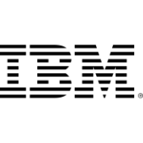

Oct 19, 2022

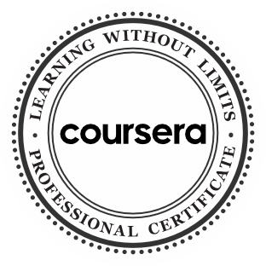

**Introduction to Cloud Computing**

**Introduction to Web Development with HTML, CSS, JavaScript**

**Getting Started with Git and GitHub**

**Developing Cloud Native Applications**

**Developing Cloud Apps with Node.js and React**

**Introduction to Containers w/ Docker, Kubernetes & OpenShift**

**Python for Data Science, AI & Development**

**Python Project for AI & Application Development**

**Developing Applications with SQL, Databases, and Django**

**Application Development using Microservices and Serverless**

**Full Stack Cloud Development Capstone Project**

**Full Stack Software Developer Assessment**

**12 Courses**

#### Darshan Jain

has successfully completed the online, non-credit Professional Certiﬁcate

# IBM Full Stack Software Developer

The earner of this Professional Certiﬁcate has completed 10 courses on various Application Development and Cloud technologies and is now equipped with the skills and know how to undertake challenges of Developing Cloud Native Applications. The Certiﬁcate earner has hands-on working knowledge with HTML, CSS, JavaScript, GitHub, Node.js, React, Cloud Native practices, DevOps, CI/CD, Containers, Docker, Kubernetes, OpenShift, Python programming, Databases, SQL, NoSQL, Django ORM, Bootstrap, Application Security, Microservices, Serverless computing, and more. The learner has also deployed several applications on cloud, completed a capstone project, and delivered a Software as a Service (SaaS) solution using Cloud Native methodologies.

The online specialization named in this certiﬁcate may draw on material from courses taught on-campus, but the included courses are not equivalent to on-campus courses. Participation in this online specialization does not constitute enrollment at this university. This certiﬁcate does not confer a University grade, course credit or degree, and it does not verify the identity of the learner.

Rav Ahuja

AI & Data Science Program Director IBM Skills Network

Verify this certiﬁcate at: [https://coursera.org/verify/profession al-cert/H4DS6WNQ7P2Z](https://coursera.org/verify/professional-cert/H4DS6WNQ7P2Z)

### Certificate of Completion

Congratulations, Darshan Jain

**React.js Essential Training (2020)**

##### Course completed on Oct 18, 2022 at 10:52AM UTC • 1 hour 49 min

###### By continuing to learn, you have expanded your perspective, sharpened your skills, and made yourself even more in demand.

Head of Content Strategy, Learning

###### LinkedIn Learning 1000 W Maude Ave Sunnyvale, CA 94085

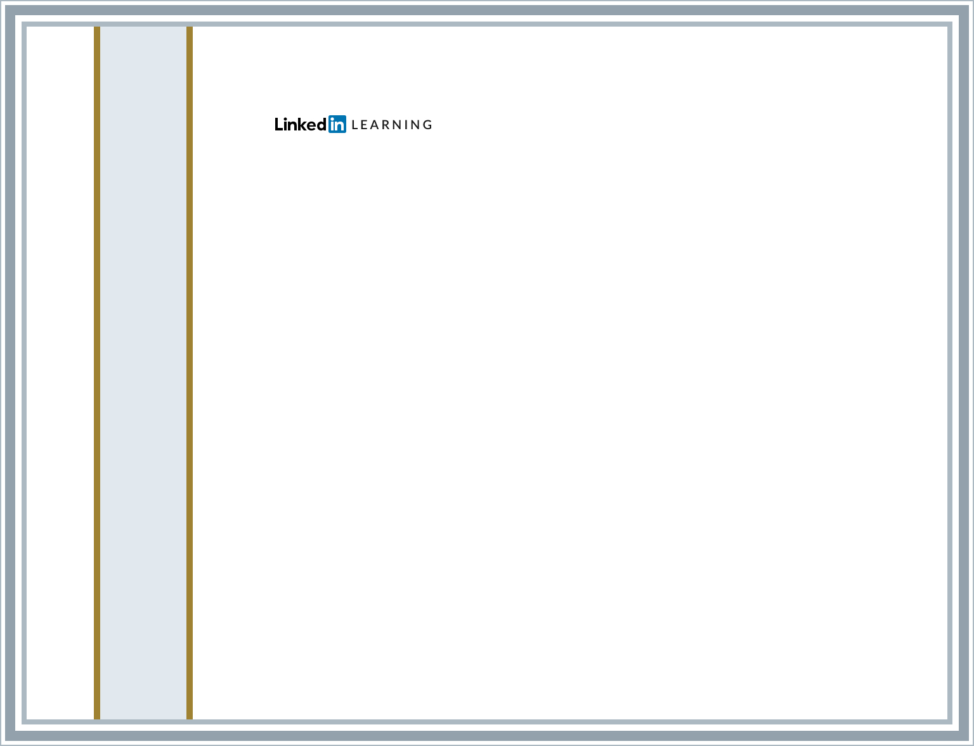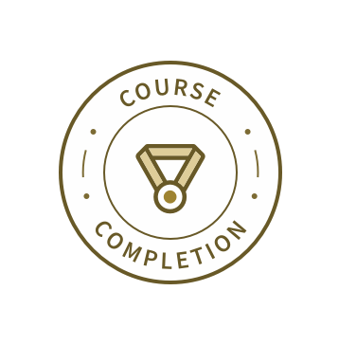

Certificate ID: ARfZf-Q9izw-hzqwFBIvadRenAPS

Certificate of Completion

Congratulations, Darshan Jain

## React.js: Building an Interface

##### Course completed on Oct 18, 2022 at 11:04AM UTC • 1 hour 40 min

###### By continuing to learn, you have expanded your perspective, sharpened your skills, and made yourself even more in demand.

Head of Content Strategy, Learning

###### LinkedIn Learning 1000 W Maude Ave Sunnyvale, CA 94085



Certificate ID: AcC5cwe4RkxkZcQ2r8hXzdDP3Yv-

Certificate of Completion

Congratulations, Darshan Jain

## React: Creating and Hosting a Full-Stack Site (2019)

##### Course completed on Oct 18, 2022 at 11:10AM UTC • 2 hours 39 min

###### By continuing to learn, you have expanded your perspective, sharpened your skills, and made yourself even more in demand.

Head of Content Strategy, Learning

###### LinkedIn Learning 1000 W Maude Ave Sunnyvale, CA 94085



Certificate ID: AZZ5wpe_fT4FN2hxZNW56C-cIfak

Certificate of Completion

Congratulations, Darshan Jain

## React: Ecosystems

##### Course completed on Oct 18, 2022 at 11:12AM UTC • 12 min

###### By continuing to learn, you have expanded your perspective, sharpened your skills, and made yourself even more in demand.

Head of Content Strategy, Learning

###### LinkedIn Learning 1000 W Maude Ave Sunnyvale, CA 94085



Certificate ID: AfbUG1UU79oH5C0xWjxLGPUsdZu1

