Leave Management Can be like this
It can have Three section :
- Leave Apply – Apply, Pending, History
- Leave Balance
- Holiday Calander
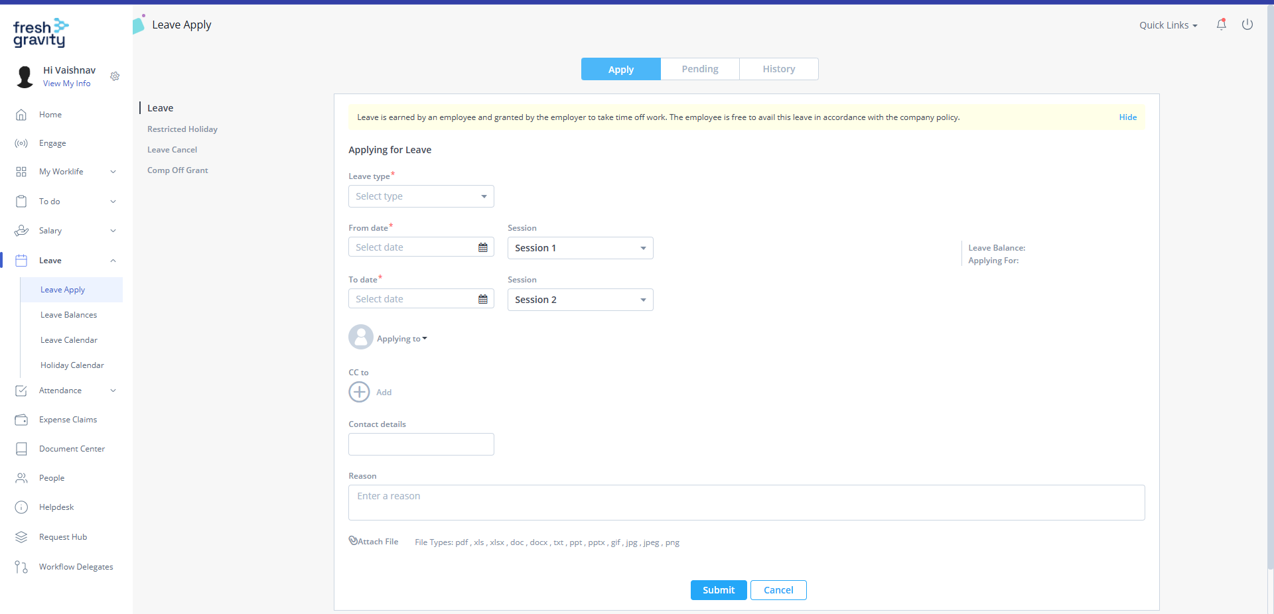
Leave Apply - Apply

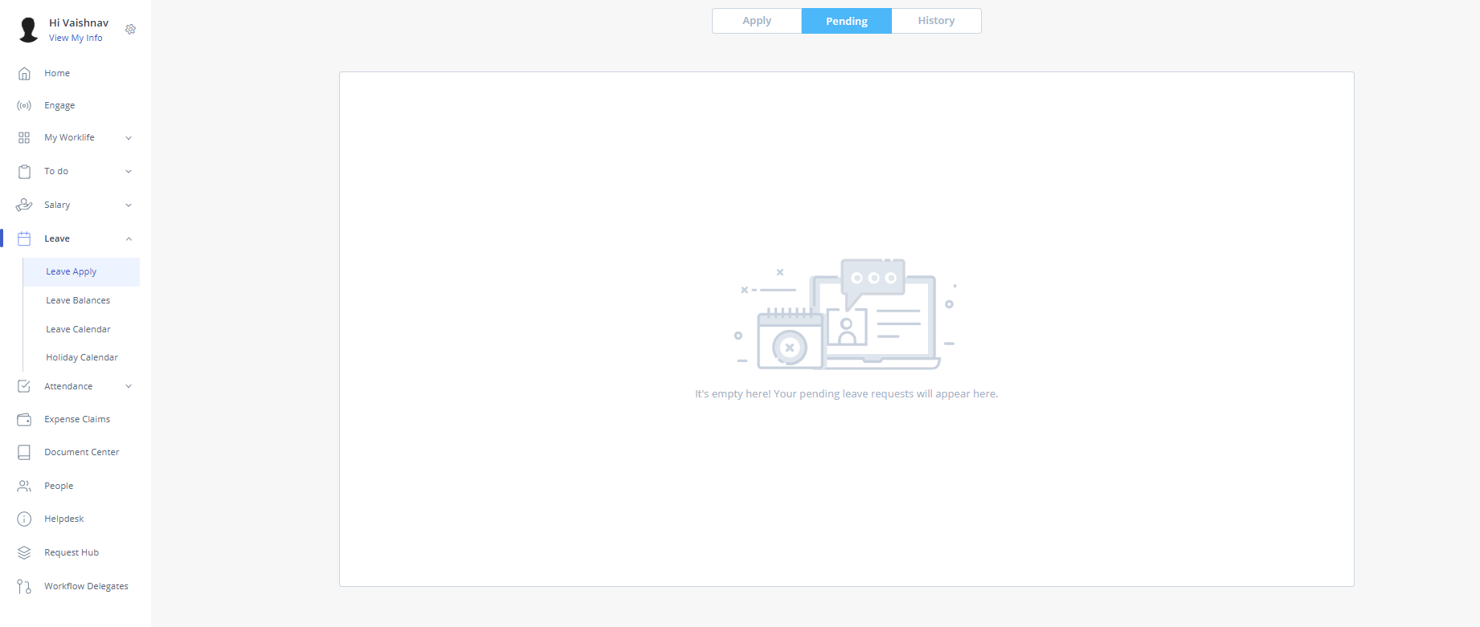
Leave Apply - Pending

Leave Apply - History
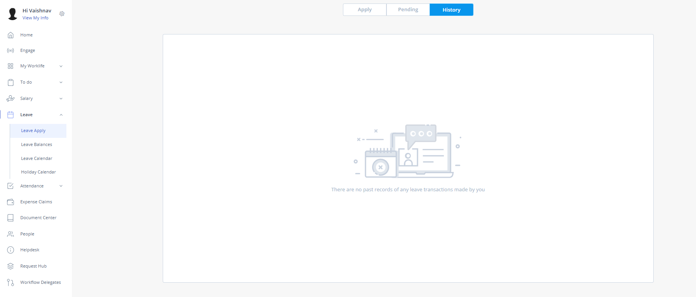

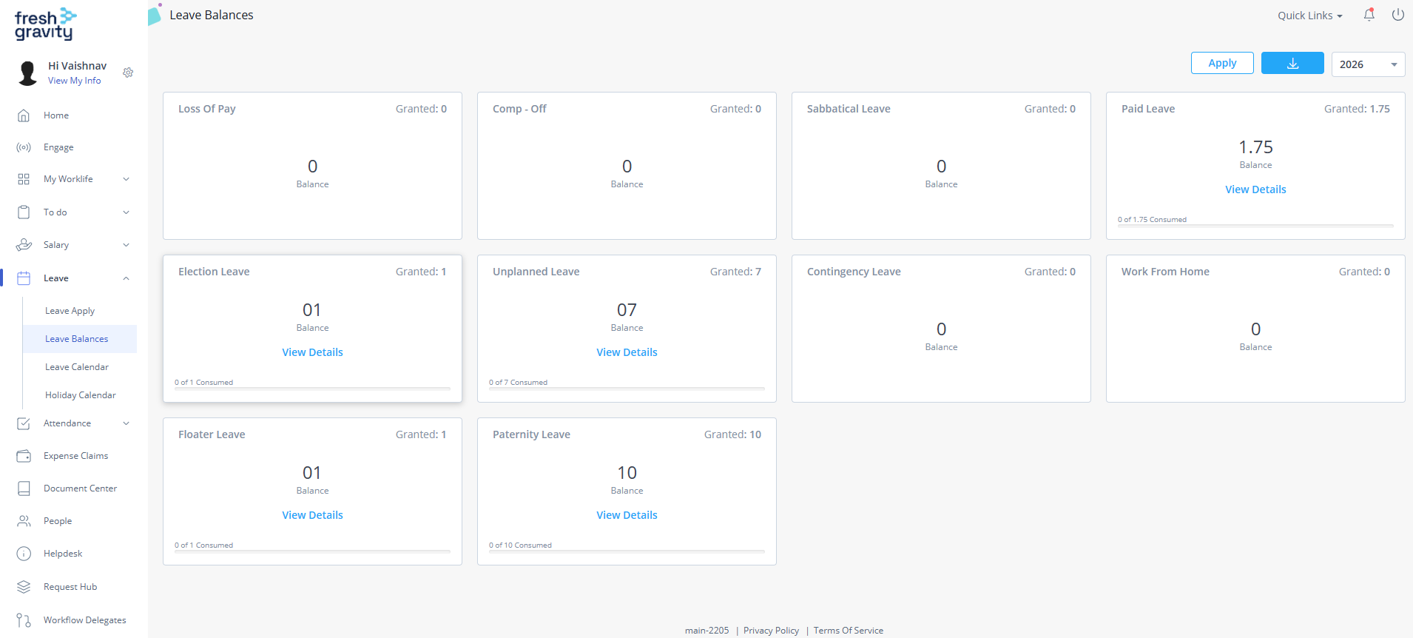
Leave Balance

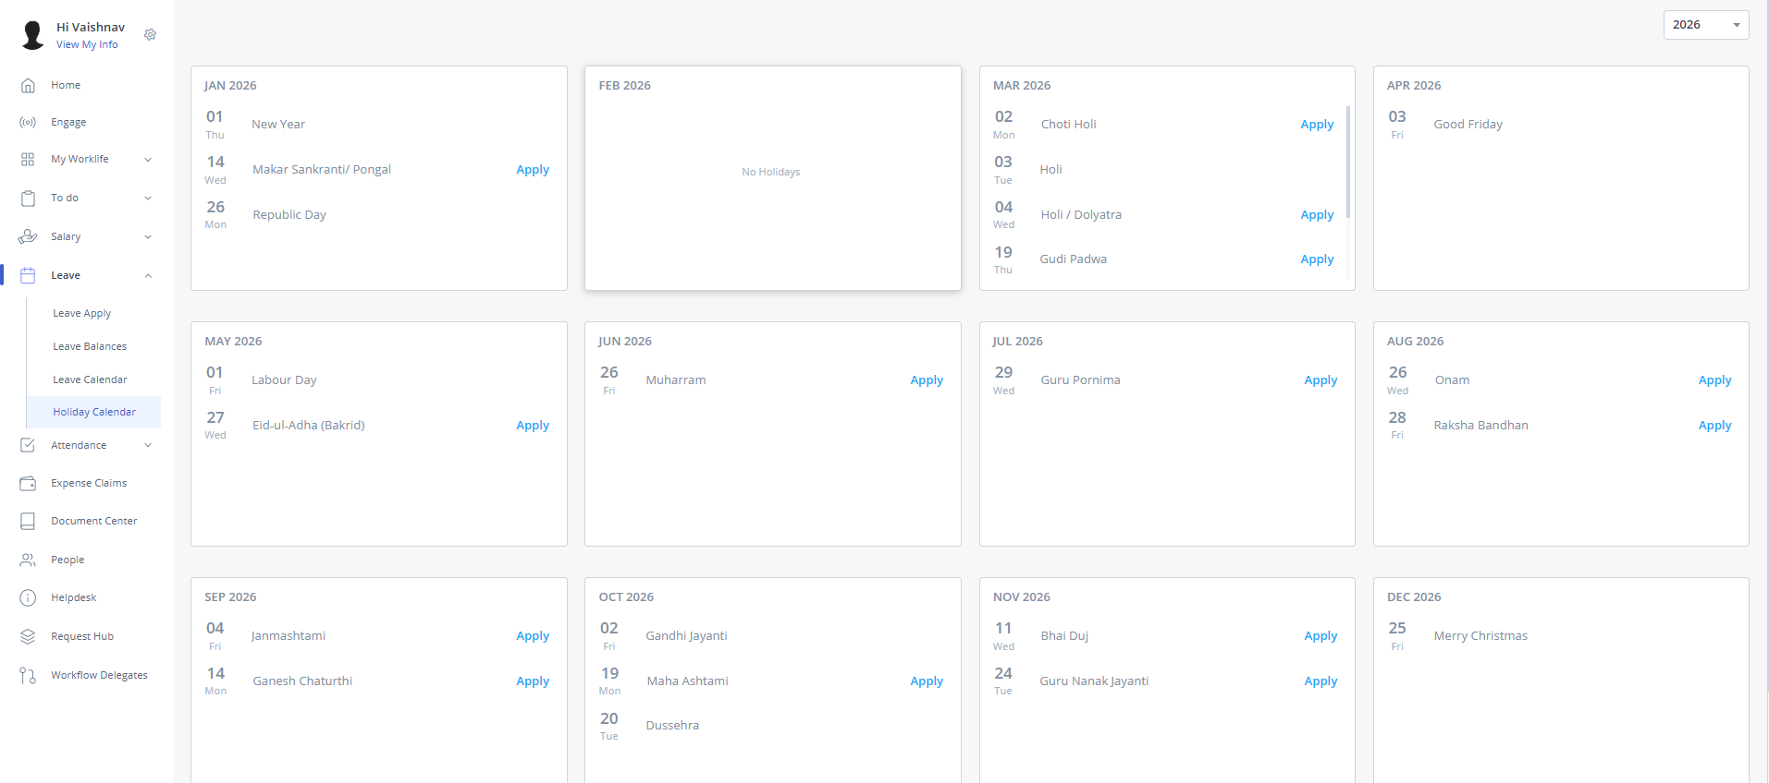
Holiday Calenda

Attendance Info

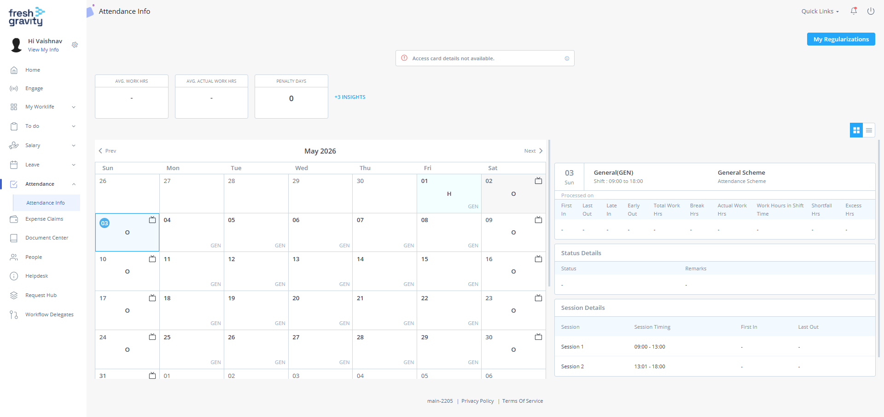
11:40:27 AM 11:40:32 A
The Attendance section should show First In, Last Out, Late In, Early Out, Total Work, Extra Hours, etc. You can refer to the image.
The Attendance section should also include a Regularization section. If an employee fails to register their attendance for the day, they can apply for regularization so the day is not marked as leave.
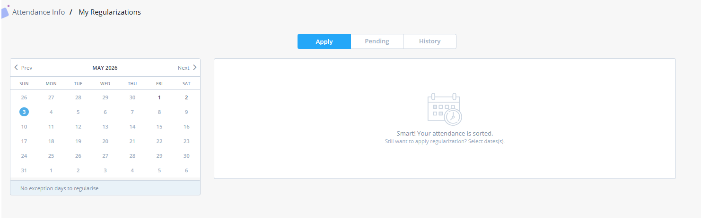

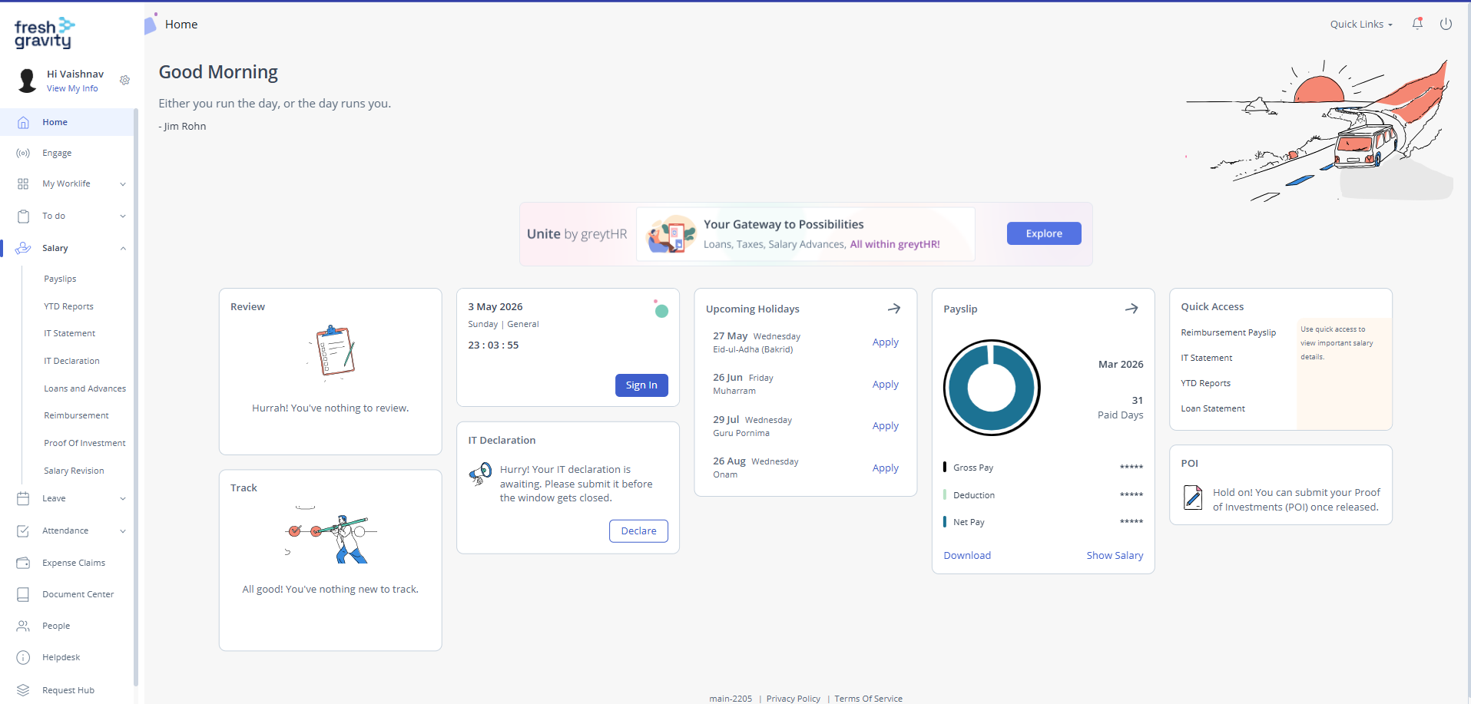
Home Page

Salary
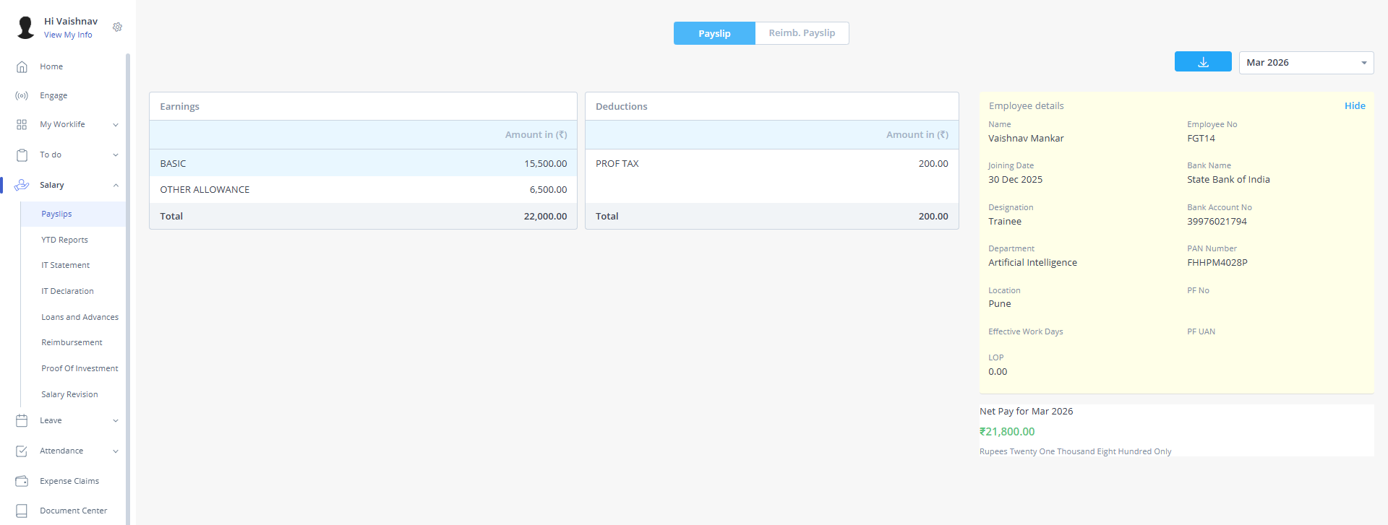
Pay slips

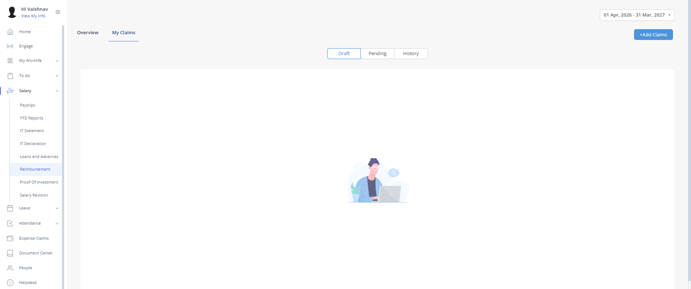
Reimbursement

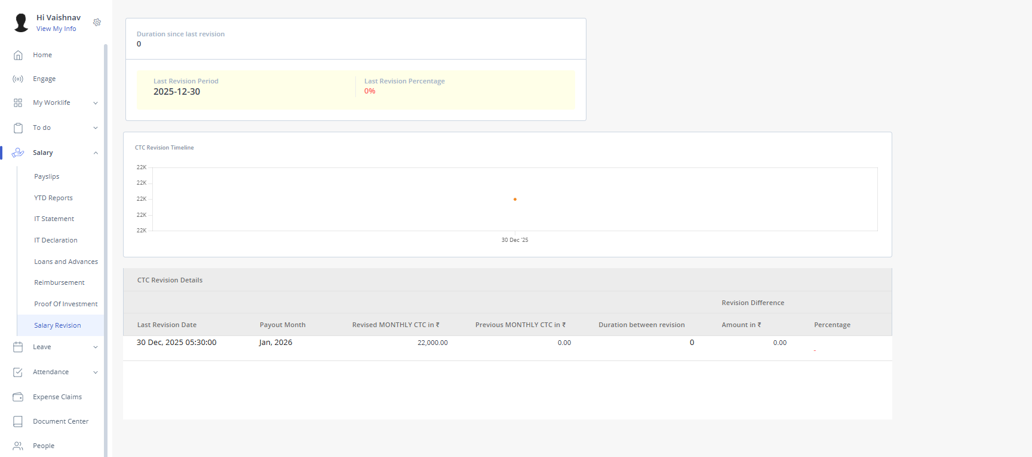
Salary Revision

Helpdesk
