FSD .NET Capstone Project Healthcare

Submitted by: Darshan A

GitHub Source Code Link:

<https://github.com/DarshanKambali/FSDCapStone.git>

Technologies used:

1. Database management: SQLServer

2. Back-end API: ASP.NET Web API

3. Front-end development: React, HTML/CSS, Bootstrap.

5. DevOps and Docker Images: Git, GitHub, Docker

1. **Create React project:**

**Project name**: react-healthcareclient-project

**Packages installed**:

npm install react-router-dom

npm install axios

**Starting the project**: npm start

* 1. **Home Page:**

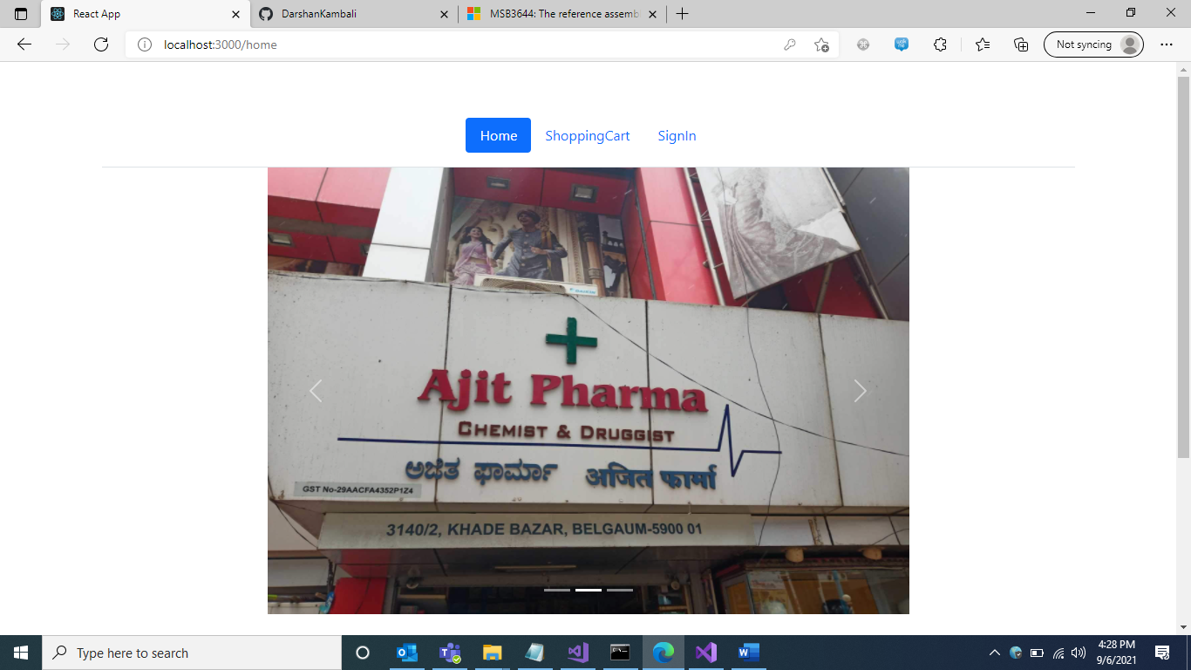

1. **Shopping Cart:**
2. **Empty Cart**

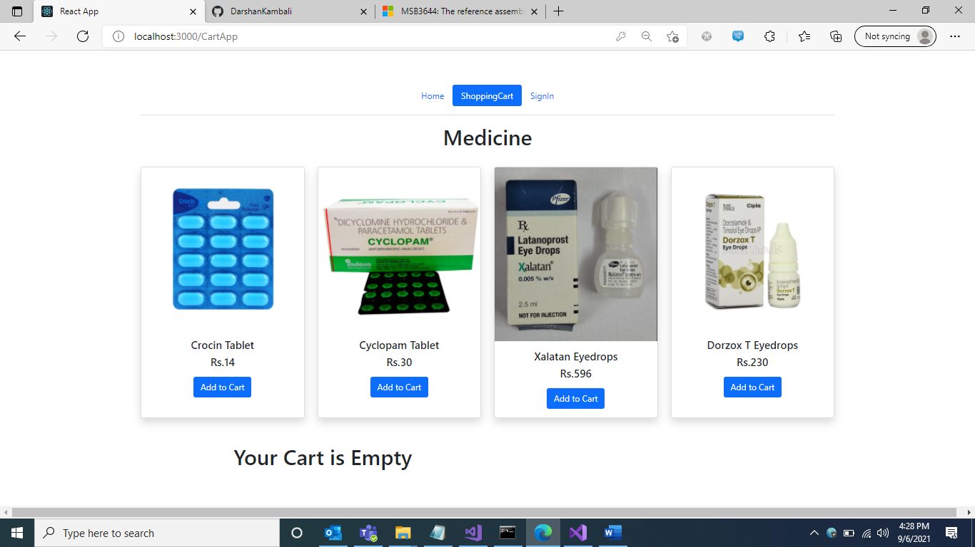

1. **Add to Cart**

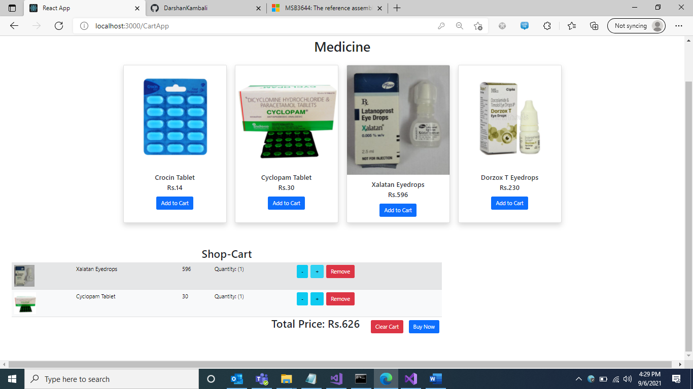

1. **User Registration & Sign In:**
2. **Sign in Page**

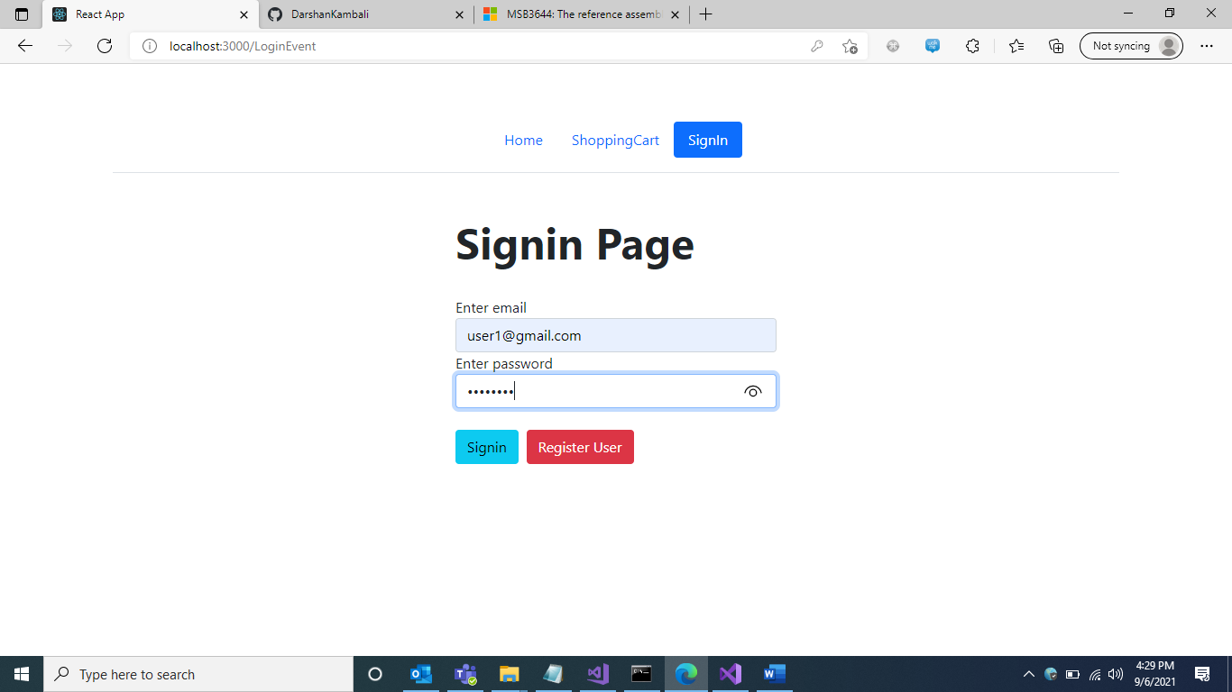

1. **Registration Page**

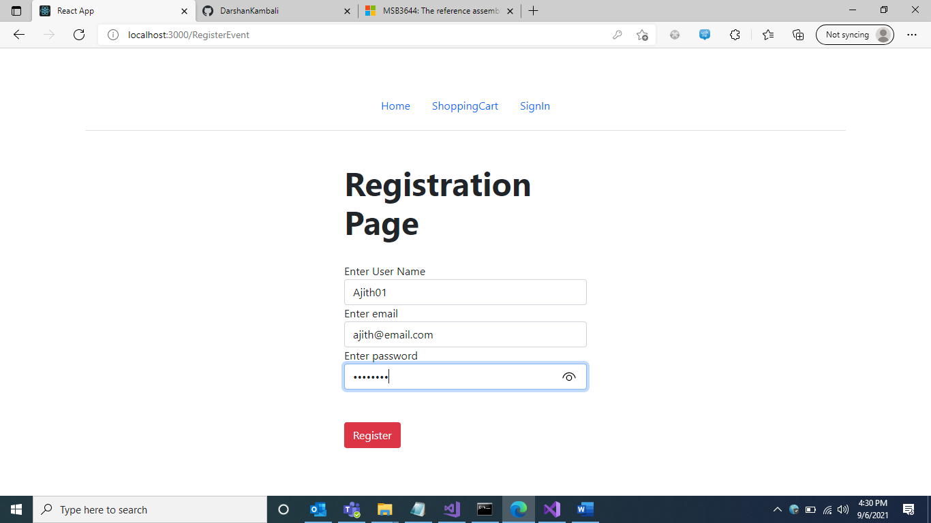

**Admin List:**

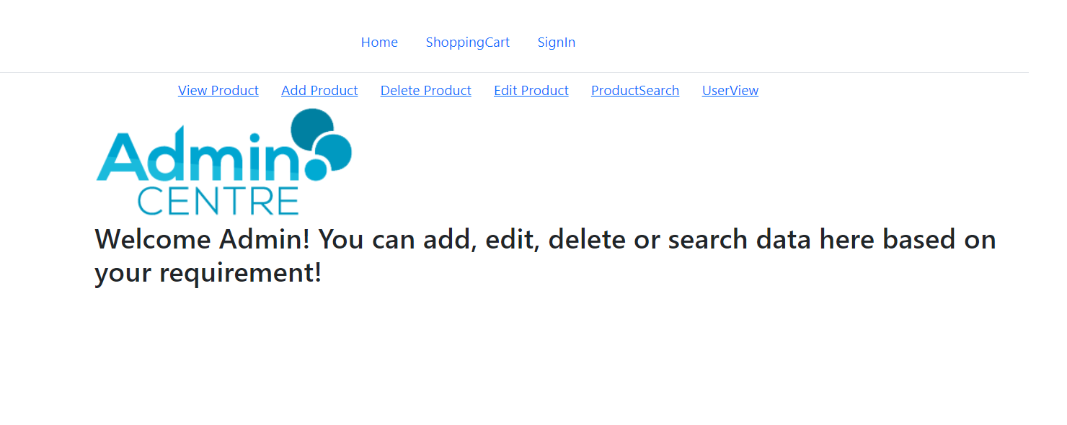

**Admin Functionalities: Admin performs CRUD operation like: Add, Update, View and Delete Medicine**

1. **View Product page**

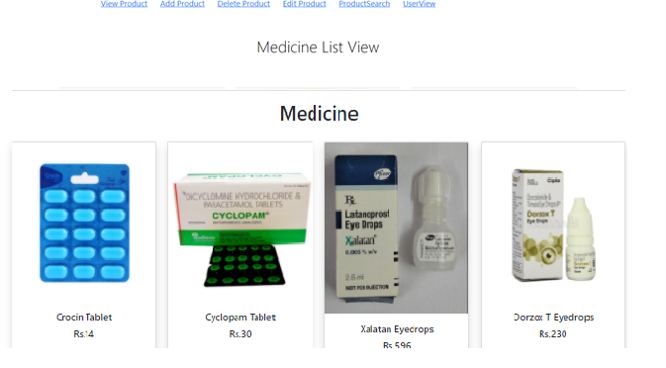

1. **Add Medicine**

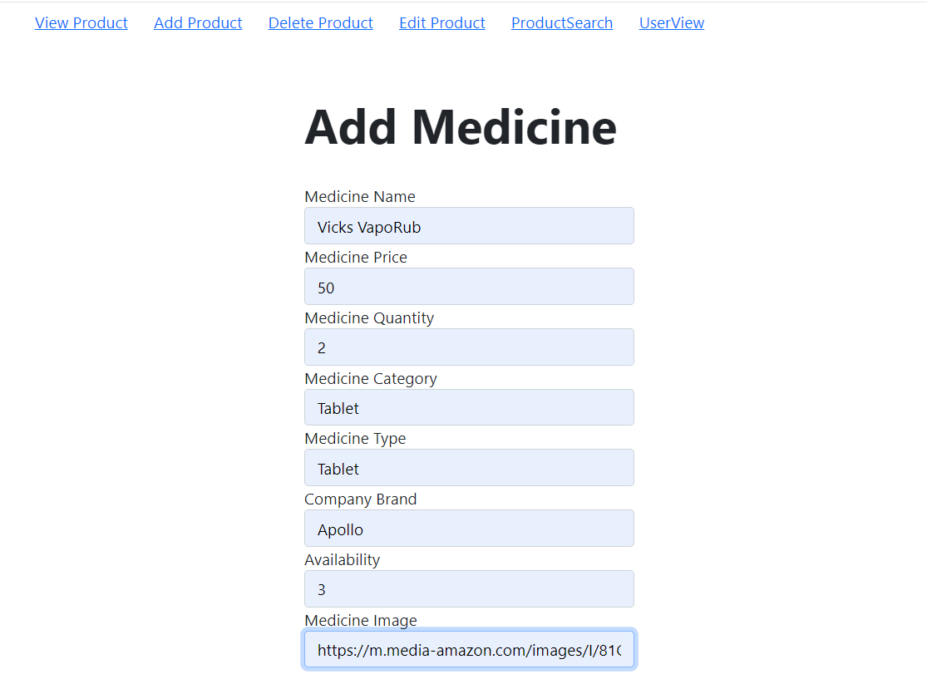

1. **Delete Medicine**

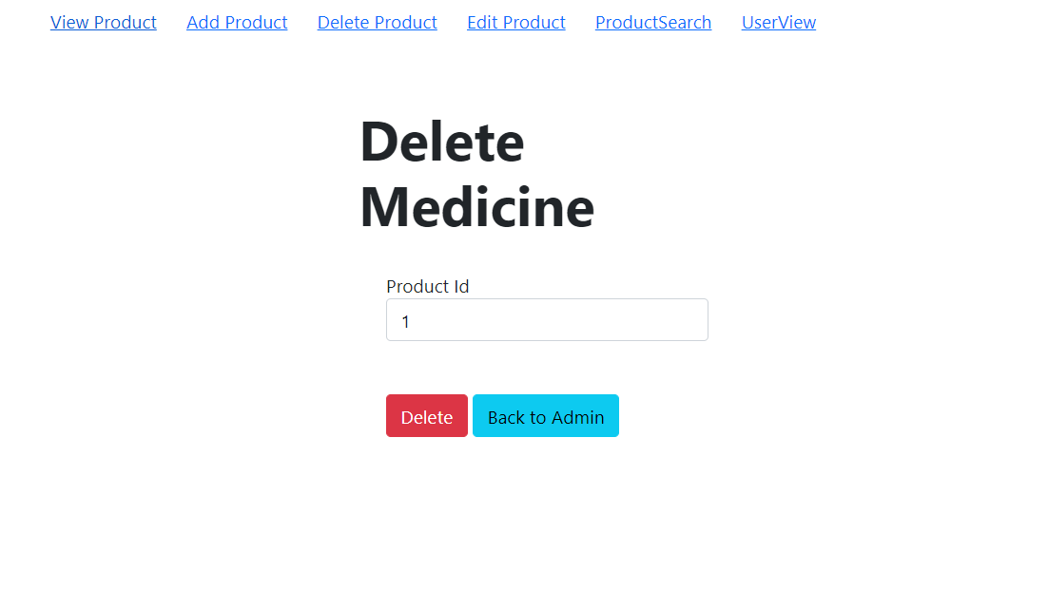

1. **Edit Product**

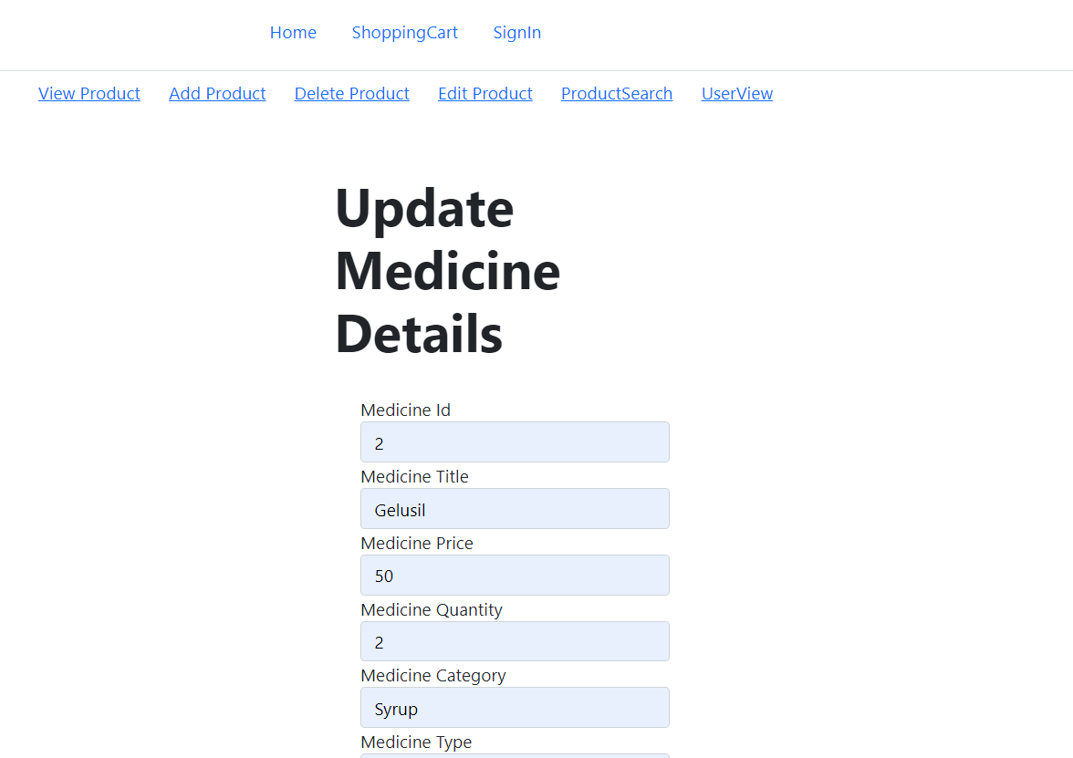

1. **Search Product**

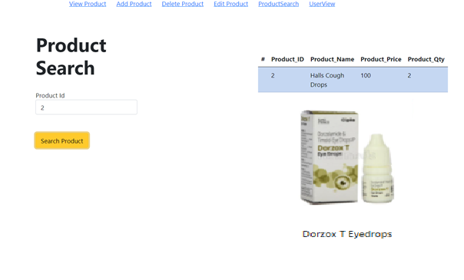

1. **User Details Page**

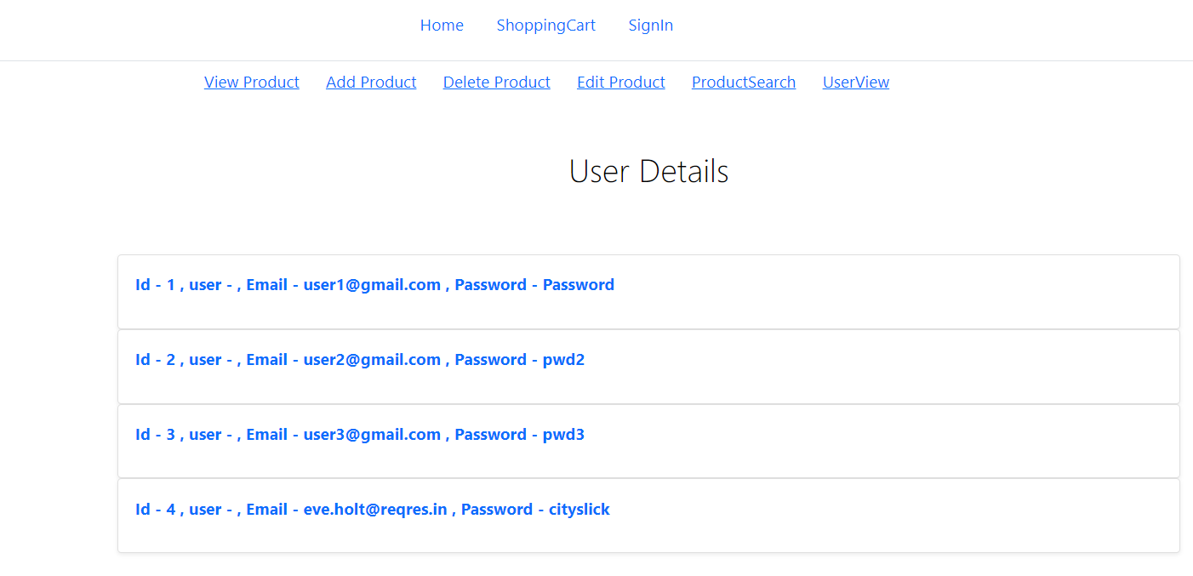

**Part 2: ASP.NET API functionality: using ASP.NET core Web API**

1. **Install Entity Framework:**

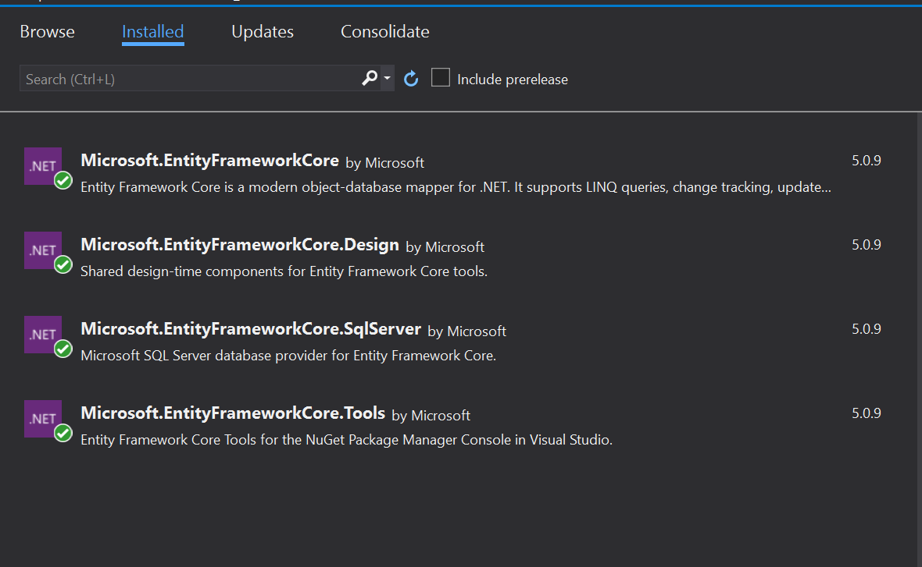

1. **SQL Server Tables:**

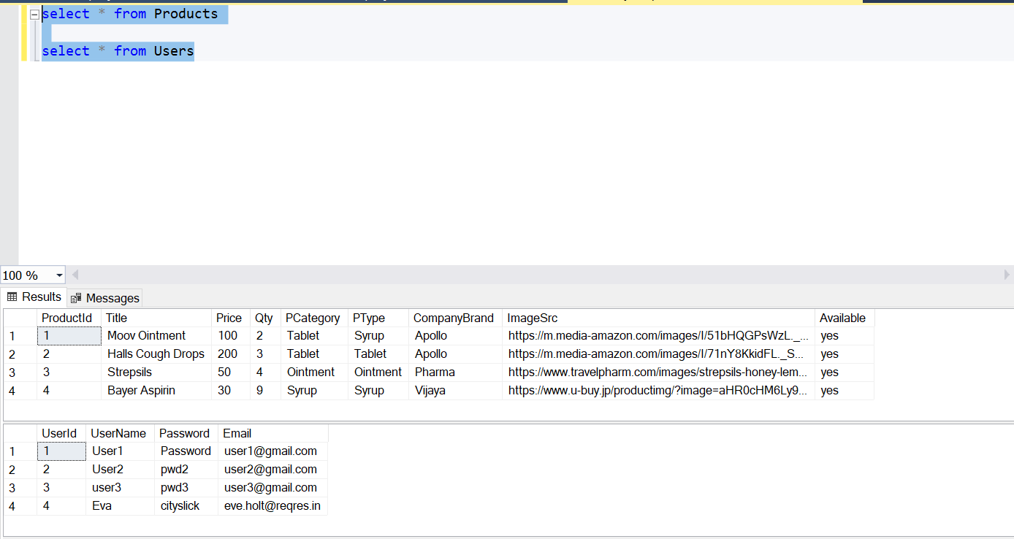

1. **Model and Controller Files, including ApplicationDBContext.cs:**

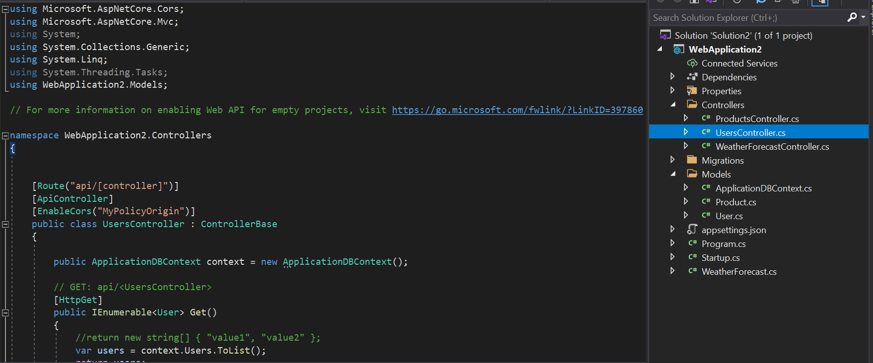

1. **Migration:**

add-migration InitialCreate

update-database -verbose

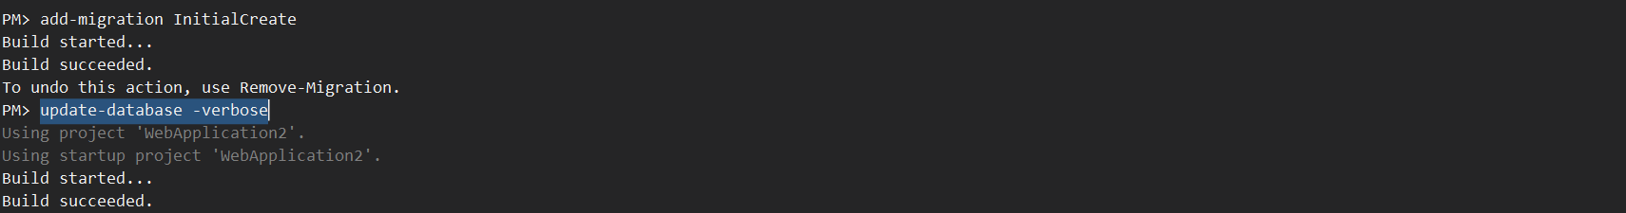

1. **ASP.NET Users API:**

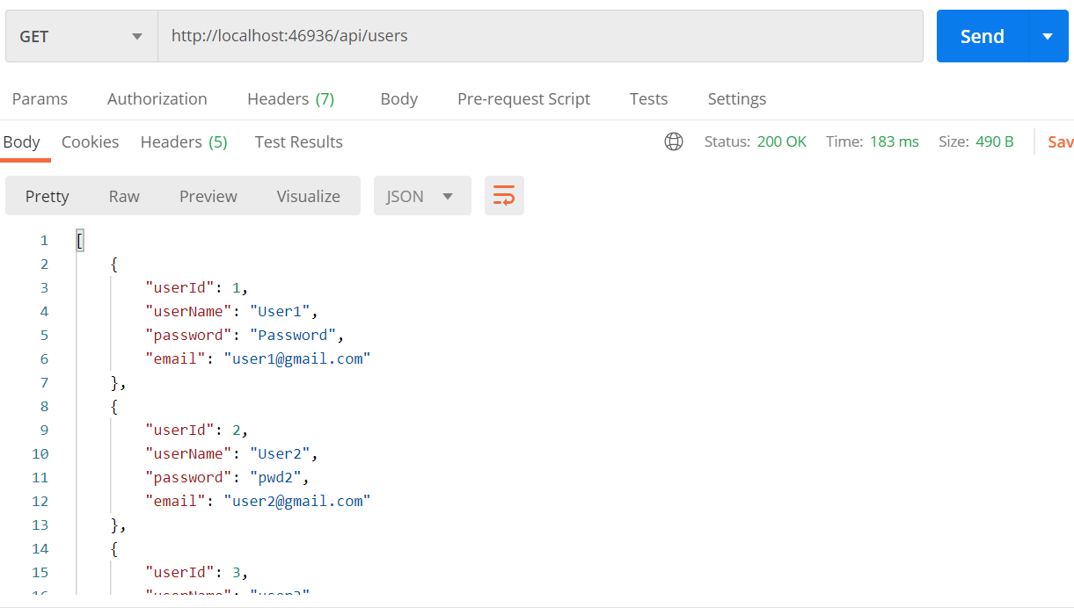

1. **ASP.NET Products API:**

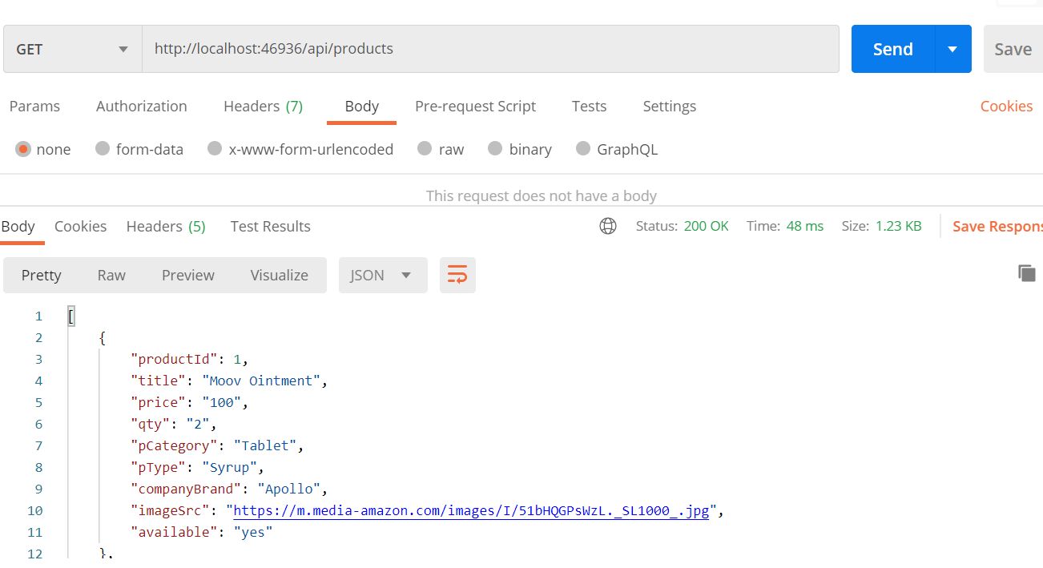

**Docker:**

1. React app – react-client project
2. Create docker file inside react-app:

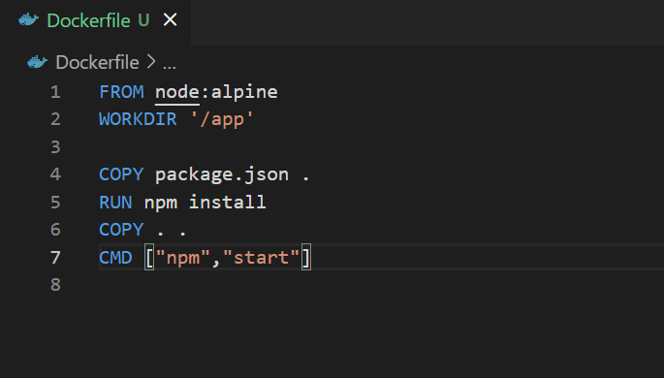

1. Build docker image:

**docker build . -t healthcare-capstone-project**

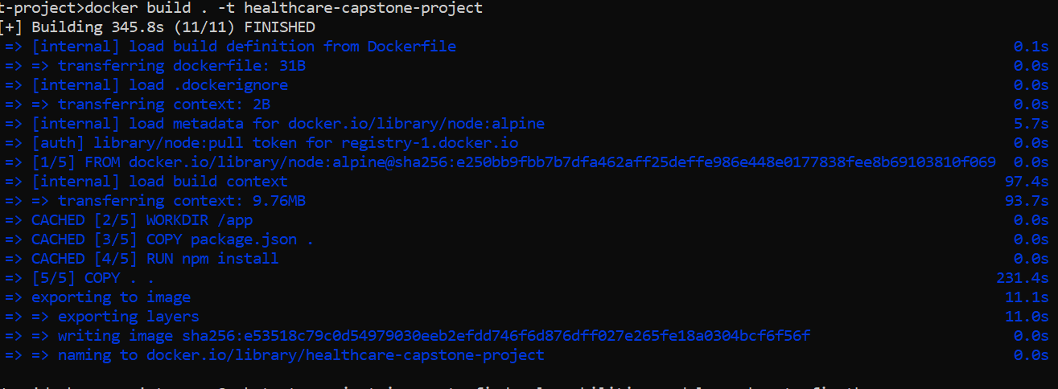

1. List docker images

**docker images**



1. **Run docker images created on local machine:**

docker run -it -p 3000:3000 healthcare-capstone-project

project runs locally on localhost:3000

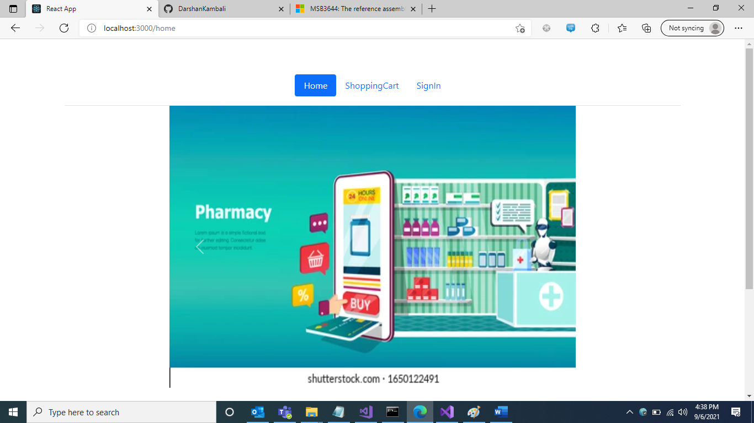

Run the dockerized project:

