1. **Create Table Name : Student and Exam**

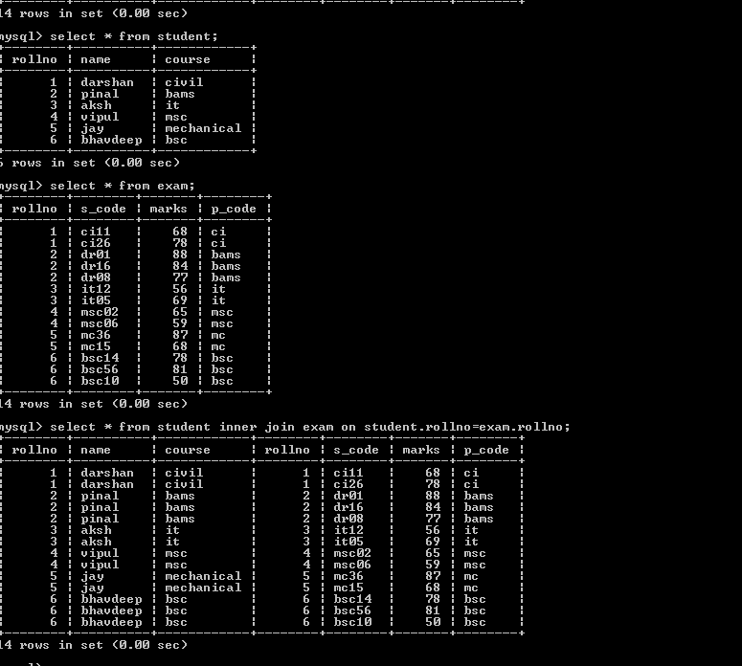

1. **Create table given below: Employee and IncentiveTable**

Get FIRST_NAME, Joining Date, and Salary from employee table.

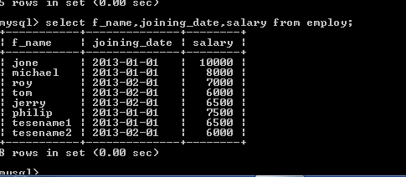

Get all employee details from the employee table order by First_Name Ascending and Salary descending?

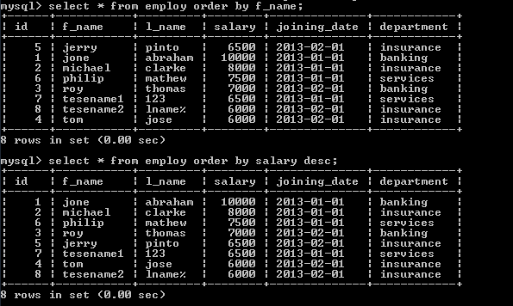

Get employee details from employee table whose first name contains ‘J’

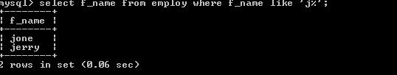

Get department wise maximum salary from employee table order by salary ascending?

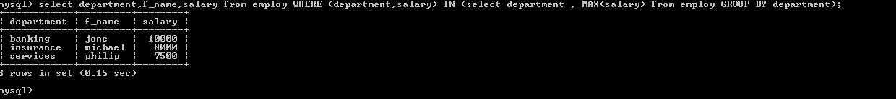

Select first_name, incentive amount from employee and incentives table forthose employees who have incentives and incentive amount greater than 3000

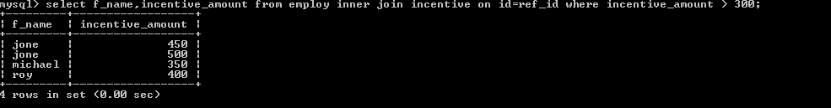

1. **Create table given below: Salesperson and Customer**

Names and cities of all salespeople in London with commission above 0.12

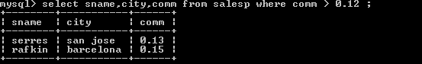

All salespeople either in Barcelona or in London

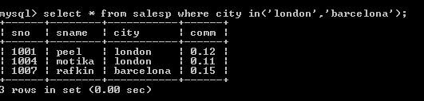

All salespeople with commission between 0.10 and 0.12. (Boundary valuesshould be excluded).

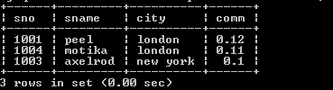

All customers excluding those with rating <= 100 unless they are located inRome

1. **L**
2. **L**
3. **L**
4. **L**
5. **L**
6. **L**
7. **L**
8. **L**
9. **L**
10. **L**
11. **L**
12. **L**
13. **L**
14. M
15. M
16. M
17. M