Consumables Floor Map
How to use it • GXO Sherburn
The floor map is an Excel file (Consumables_Map.xlsx) that shows every pallet space in the consumables area. It shows what's in each space, what's free, and what's running low.
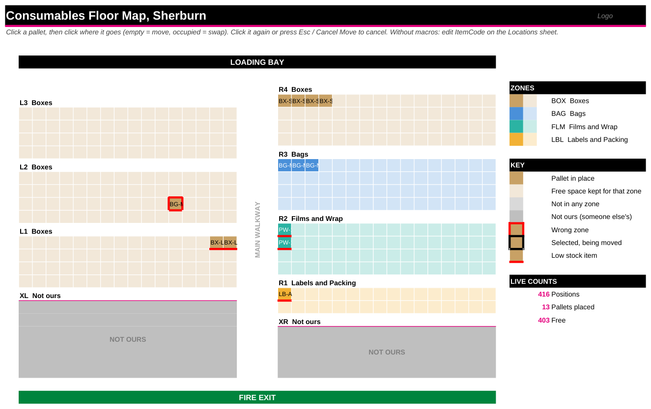
Example map with a few test pallets. The loading bay is at the top, the fire exit at the bottom, and the main walkway runs up the middle.

The sheets (tabs at the bottom)
Sheet | What it's for
Map | The floor plan. Look here first.
Dashboard | Totals for each item, space used in each zone, the low-stock list and the next free space.
Items | Your list of products. You fill this in.
Locations | One row for every pallet space. This is where the map gets its information.
Config | Aisle sizes, zones, colours and settings.
MoveLog | Every move, with the time and who did it. Written automatically.

What the map shows
You see | It means
Solid colour | A pallet is there. Hover over it to see the details.
Stripes | A free space, kept for that zone.
Grey “NOT OURS” | Someone else's space. Don't use it.
Thick red border | The pallet is in the wrong zone.
Red line along the bottom | That item is low on stock.
Thick black border | The pallet you've picked up to move.

Zone | Colour and what goes there | Zone | Colour and what goes there
BOX | Brown: all box types | FLM | Teal: pallet wrap, films, bubble wrap
BAG | Blue: packing bags | LBL | Amber: labels, void fill, tape, other packing

Reading a location code: L2-05-C means aisle L2, 5 pallets in from the walkway, row C. Row letters go A, B, C, D from the top of each aisle on the map.

1. First-time setup (do once)

Check the aisles
- Open the Config sheet.
- In the Aisles table, check each aisle. PalletsAcross is how many pallets wide it is, and PalletsDeep is how many deep. Zone is what goes there.
- Active is Yes for your aisles, Blocked for someone else's space, and No to hide one.
The starting sizes come from your floor sketch. R1 (the narrow aisle) is 1 across. Please check that R2–R4 are 4 × 16. Also check which zone each aisle is for. After changing any sizes, press Rebuild Layout on the Map (needs macros, see section 3).

Add your items
- Open the Items sheet.
- Type over the two rows marked EXAMPLE, then keep adding items in the row under the table. The table grows by itself.
- Fill in ItemCode (short, like BX-S), Description, Zone, UnitsPerPallet and OnHandUnits.
- Leave ReorderPallets blank to use the normal low-stock level (2 pallets), or type a number for that item.
- Don't type in the grey columns on the right. They work themselves out.

2. Everyday use: no macros needed
This always works, even if your PC blocks macros.

Put a pallet away
- Open the Locations sheet.
- Find the space, for example R3-01-B.
- Click its ItemCode cell and pick the item from the dropdown. The list only shows items for that zone.
- Optional: type the number of units in UnitsOnPallet if it's not a full pallet.

Take a pallet out
- Find its space on Locations and delete the ItemCode (and UnitsOnPallet).

Move a pallet
- Delete it from the old space and pick it in the new space.
The Map and Dashboard update straight away. When stock is used, update OnHandUnits on the Items sheet.

3. Click-to-move: turning on the macros (once)
If your PC allows macros, you can move pallets by clicking the map. You'll need the file FloorMap_VBA.txt.
- In Excel, click File → Save As. Choose Excel Macro-Enabled Workbook (.xlsm) and save. Use this .xlsm file from now on.
- Press Alt + F11 to open the code window.
- Click Insert → Module. Open FloorMap_VBA.txt in Notepad, copy everything between PART 1 START and PART 1 END, and paste it in.
- On the left, double-click the sheet marked (Map) and paste PART 2.
- Double-click the sheet marked (Locations) and paste PART 3.
- Optional: double-click ThisWorkbook and paste PART 4, so the file opens on the map.
- Click Debug → Compile VBAProject. If nothing pops up, it's fine.
- Close the code window. Press Alt + F8, choose SetupButtons and click Run. Five pink buttons appear on the Map.
- Press Ctrl + S to save. Next time you open it, click Enable Content if you see a yellow bar.
If Excel says macros are blocked, close the file. Right-click it in File Explorer, choose Properties, tick Unblock, then click OK. If IT blocks macros completely, just use section 2. Everything else still works.

4. Everyday use with the buttons
To do this | Do this
Move a pallet | Click the pallet (it gets a black border), then click an empty square.
Swap two pallets | Click one pallet, then click the other.
Cancel a move | Click the same pallet again, press Esc, or press Cancel Move.
Put a delivery away | Press Find Space. Type the item code, then the number of units. It works out how many pallets and picks free spaces in the right zone, nearest the loading bay. Click Yes to put them in.
Zone full? | Find Space offers spaces in other zones, marked OUT OF ZONE. It's your choice.
Colours look wrong | Press Refresh.
Changed aisle sizes on Config | Press Rebuild Layout. Pallets stay where they are. Any that no longer fit are listed and saved in MoveLog.
Map too big or small | Press Fit to Screen.

- If you move a pallet into the wrong zone, Excel asks you to confirm. You can say Yes if you need to.
- Every move is recorded on MoveLog with the time and your login name.

5. Something not right?
Problem | Fix
Clicking the map does nothing | Macros are off or not set up. Use the Locations sheet (section 2), or set up the macros (section 3).
“Compile error” | A part went in the wrong place, or a banner line was copied. Paste each part again.
Item not in the dropdown | Check the item's Zone on the Items sheet matches the aisle's zone.
A pallet vanished after Rebuild Layout | Look at the bottom of MoveLog for “removed by Rebuild Layout”.
Item shows LOW but you have stock | Check that the pallets are placed on Locations, and check ReorderPallets on Items.

