HADOOP MAPREDUCE

PROBLEM:

Create data set in excel as .csv file and it should contan the following fields at least 20 sample dataset in it:

Name | USN | Subject1 | Subject2 | Subject3 | Pass/Fail
Akul | 1NT16IS021 | 56 | 64 | 74 | YES

Use the Hadoop mapreduce programming framework to comeupwith a program which will take the data from this .csv file and compute the following

1. Total number of students who have scored more than 60 in suject 1
2. Total number of students who have passed in all subjects

Java Program:

package com.marks.la2;
import java.io.IOException;
import java.util.*;
import org.apache.hadoop.fs.Path;
import org.apache.hadoop.io.*;
import org.apache.hadoop.mapred.*;
public class StudentMarks {
//MAPPER CLASS
public static class Map extends MapReduceBase implements
Mapper<LongWritable,Text,Text,IntWritable>{
private final static IntWritable one=new IntWritable(1);
public void map(LongWritable key,Text value,OutputCollector<Text,IntWritable>
output,Reporter reporter)throws IOException{
String myString=value.toString();
String[] userCount=myString.split(",");
//1. Total number of students who have scored more than 60 in Subject 1
if(Integer.parseInt(userCount[3])>60)
{
output.collect(new Text("score>60"),one);
}
// 2. Total number of students who have passed in all the subjects
if(userCount[5].equals("YES"))
{
output.collect(new Text("PASSED"),one);
}
}
}
//REDUCER CLASS
public static class Reduce extends MapReduceBase implements
Reducer<Text,IntWritable,Text,IntWritable>{
public void reduce(Text key,Iterator<IntWritable>
values,OutputCollector<Text,IntWritable> output,Reporter reporter)throws IOException{

int finaluserCount=0;
Text myKey=key;
while(values.hasNext())
{
IntWritable value =values.next();
finaluserCount += value.get();
}

output.collect(myKey, new IntWritable(finaluserCount));
}
}
//DRIVER CONFIGURATION
public static void main(String[] args)throws Exception{
JobConf conf = new JobConf(StudentMarks.class);
conf.setJobName("student_marks");
conf.setOutputKeyClass(Text. class);
conf.setOutputValueClass(IntWritable.class);
conf.setMapperClass(Map.class);
conf.setCombinerClass(Reduce.class);
conf.setReducerClass(Reduce.class);
conf.setInputFormat(TextInputFormat.class);
conf.setOutputFormat(TextOutputFormat.class);
FileInputFormat.setInputPaths(conf, new Path(args[0]));
FileOutputFormat.setOutputPath(conf,new Path(args[1]));
JobClient.runJob(conf);
}
}

Screenshots of Excel Sheet:

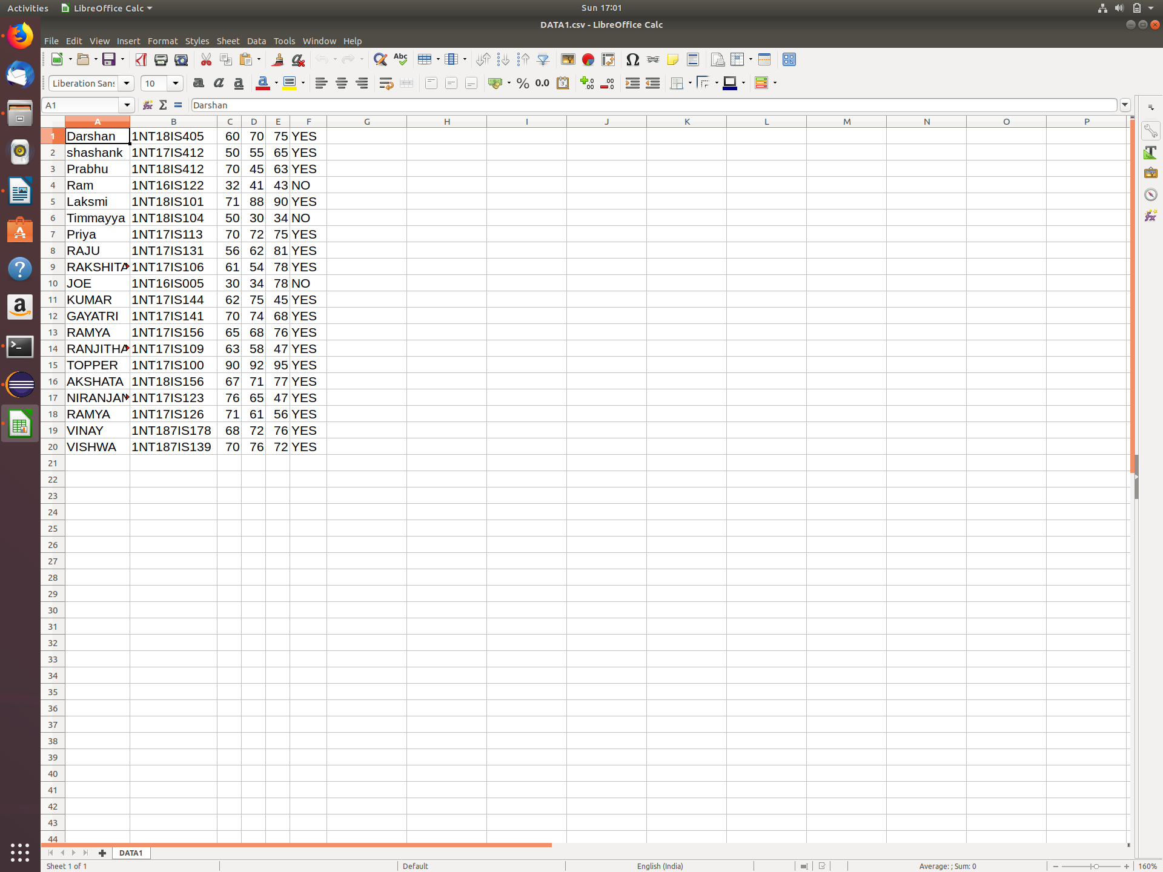

Output Screenshot:

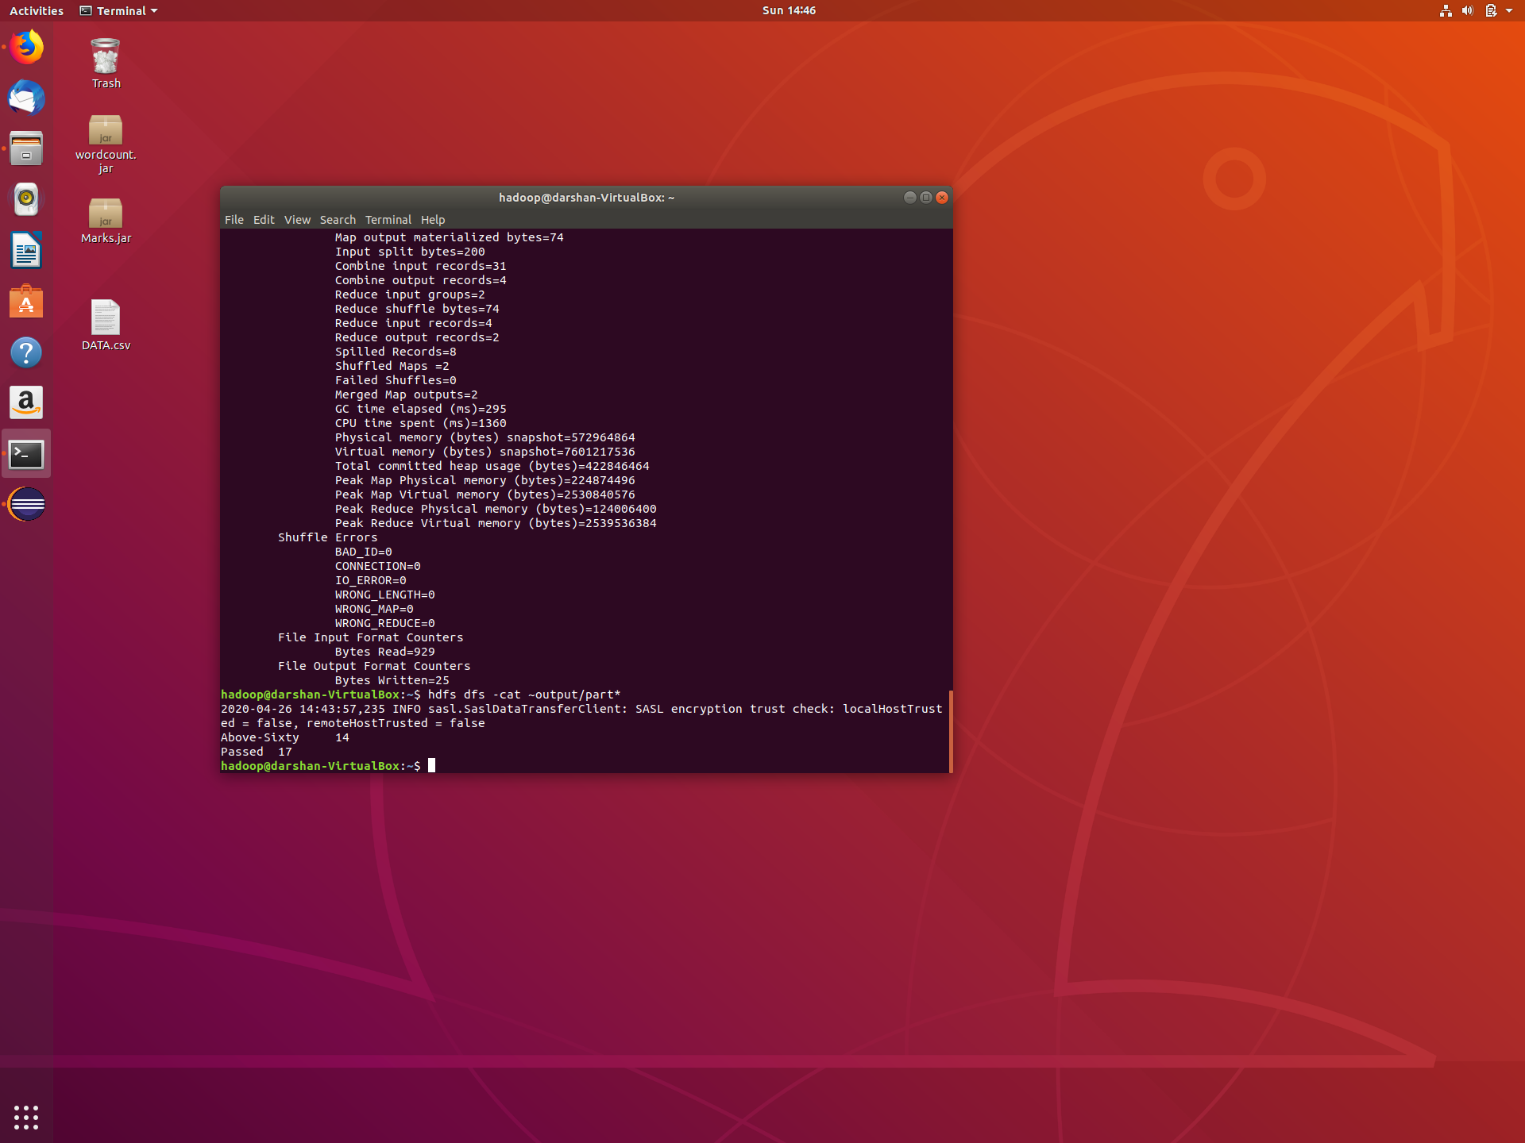

Commands:

Start hdfs service:

First we have to go to sbin folder Then enter the command
start-all.sh
Wait for 10 seconds to start all deamons

Check the availability of all the nodes

Jps is a command to check all the deamons are started or not

Create Input directory
hdfs dfs -mkdir [PATH_WITH_NAME]
Example:
hdfs dfs -mkdir ~/input

Move dataset to Input directory
hdfs dfs -put [DATSET_PATH[INPUT_DIRECTORY_ON_HDFS]
Example:
hdfs dfs -put /Users/rajeshhegde/Desktop/data.csv /input

Run The MapReduce program with created JAR file:
hadoop jar [JAR_PATH] [INPUT_DIRECTORY_ON_HDFS] [OUTPUT_DIRECTORY_ON_HDFS]
Example:
hadoop jar/Users/rajeshhegde/Desktop/StudentsMarks.jar /input /output

Output:
hdfs dfs -cat /[OUTPUT_DIRECTORY_ON_HDFS]/part*
Example:
dfs dfs -cat /output/part*

