Agricultural Transformation: Dynamic

Recommendations for Seasonal Crop Adaptations

Darshan Suresh

MY.EN.U3BCA22274

Vidhyadhara M

MY.EN.U3BCA22272

Nishanth R

MY.EN.U3BCA22213

Adarsh D Bhat

MY.EN.U3BCA22248

*Abstract*— Crops development vastly relies on weather conditions, soil compounds and to some extent weather patterns, which drives a substantial significance of agribusiness to the weather seasonal change. During this experiment, a new suggestion unit for planting adapted to the seasonal changes that affect production will be given. The method involves farming know-how, machine learning algorithms, artificial intelligence powered systems, and sophisticated data analytics in a comprehensive perspective. By merging with the ancient climate variables' databases and the very interesting soil attributes, the system is tailored to crop suggestions for particular seasons. Advanced data mining algorithms utilizing machine learning, while still exist, look through big data in search of agro-reliable analytics for high-performance yields in different ranges of environmental conditions. Continual modification enables the model to adapt to old experiences enabling it to know that advice still stays original and relevant. The entire process is additionally complemented by the analysis of market trends and agricultural experience, which allows for more comprehensive future suggestions. The entire review is made on the basis of the factors involving profitability of rotation as well as pest resistance and subsequently recommendations are given which go hand in hand with the economical feasibility and environmental sustainability. Instant alerts are sent out and these use data contained in devices that assess crop healthy and pests discovery to take immediate actions on opportunities or challenges that might arise. This leads to targeting desirable areas based on KAP assessment and based on the assessment some spaces are given more resources than others which help in proper development of the season. Farmers as customers get the chance to personalize guidance and to educate farmers regarding sustainable farming as the system is not only flexible enough to accommodate local variations but also, the system still remains relevant in several agricultural situations. Streaking conclusively, a dynamic approach for crop recommendation system for grappling with below and above ground crises that affects agriculture seasonally, therefore instilling sustainable and profitable life style to the farmers.

Keywords—Agriculture, Machine learning, Crop recommendation, Seasonal crop planning, Digital agriculture, Environmental resilience, Crop health monitoring, Agri-tech solutions, Integrated pest management

# Introduction

Farming, the home of human species, has a series of extremely serious difficulties to confront in the 21st century. A rising population along the issue of both climate change and natural resources asymmetry requires the introduction of very innovative measures to ramp up food crop production and food security levels. Farmers’ strategies must be adjustable to the factors of the varied environment during altering seasonal changes.

It is in such scenario that we are proud to be offering a doctors advice of the crop to farmers and this can be of great use to farmers and a long way into the seasons of low and high yields. It constitutes three main constituents:It constitutes three main constituents:

With the program basing its recommendations on the fundamental principles in agriculture such as a combination of crop rotation techniques, pest resistance and market trends and ensuring that these are financially rewarding, stable as well as environmental friendly. The prior experience of program designers with the field of interest coupled with the scientific understanding of the issues is thus the basis of any policy recommendations given.

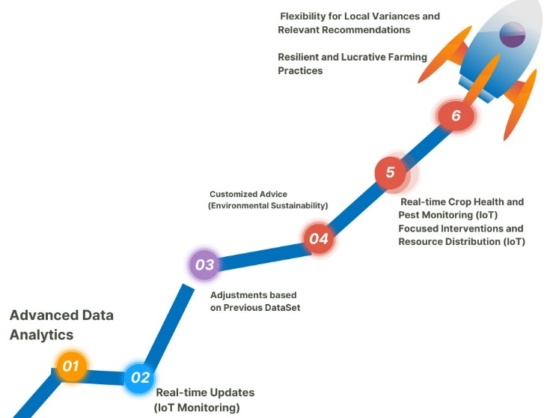Multiple datasets featuring massive amounts of information for previous climates, soil parameters, and data on agriculture productivity being processed through advanced machine (deep) learning algorithms. Thus, intra-season analysis helps determine the rate of actual crop growth that is dependent on changes in weather such that the system becomes efficient enough to generate/give/propose recommendations that are relevant to season-specific situations.

FIGURE I. Agriculture transformation path­

The system is constantly acquiring real-time data online from IoT items and remote sensors that are used for scanning the crop health, presence of pests, and moisture levels of soil. Through synergy and adaptation, this approach combines proactive and smart mechanisms for agriculture leading to seasonal fluctuations management. Updating these recommendations into the system positive. Therefore, farmers will not only learn how to respond to the new problems, or take advantage of the new opportunities in the growing season.

The capacity to carry out all the practices as discussed previously in conjunction with the resilience of the system to respond to seasonal changes makes the system active is managing agricultural products whereas the passive techniques used are season dependent. It endows the farmers with skills that will make them be able to make better decisions where the use of resources is concerned; the chances of the farms to be sustainable will be high.Real.

LITERATURE REVIEW

The authors of this article, Kristof Van Tricht and Marjorie Battude, describe the World Cereal system using analysis of satellite imagery, machine learning algorithms, as well as seasonal assessment techniques for crop and irrigation mapping. This work has been carried out by Van Tricht and Battude in a paper which is aimed at introducing the World Cereal system through satellite images analyses; machine learning algorithms were also employed as well as the seasonal assessment techniques to map crops and irrigation. Impressively accurate for both global users and producers, the research emphasizes that ongoing community efforts are important in enhancing the system to address emerging challenges in global food security. The focal point of this paper is on the need to collect additional reference data so that it can further develop towards being capable of informing decision-making processes concerning food security and sustainable agriculture.

This paper predicts Reza Septiawan and Amrullah Komaruddin’s forecast model for Indonesian agricultural products with a particular focus on chili productivity based on climate data as well as productivity data. Reza Septiawan and Amrullah Komaruddin present a prediction model for Indonesian agricultural products especially chili production considering climate data usage. The use of historical data and analytical algorithms in their model helps them predict how changing climatic conditions will affect production rates with an aim of achieving accuracies levels within 70% and 90%. Therefore, researchers must improve accuracy where necessary by incorporating more variables into the prediction model that would make it usable hence provide relevant information to mitigate possible crop failure risks due to extreme weather patterns leading to better competition among countries’ agricultural products specifically from Indonesia.

L. Rickards and S. M. Howden, through a literature review and conceptual analysis, conducted an exploration of transformational adaptation in agriculture that brought out key issues such as adaptation costs, maladaptation and the role of government. It also points out that off-farm knowledge is critical for development hence the need to integrate it into agricultural research, especially for transformational adaptation purposes with potential gains/risk ratios ranging from 80% - 90%. The paper suggests possible areas where future research should be focused including: examining the broader socio-political context of agricultural systems; enhancing adaptation strategies aimed at building resilience against climate change.

Elena Grigorieva, Alexandra Livenets and Elena Stelmakh conduct systematic literature reviews to reveal the negative implications of climate change on agriculture and various levels of adaptation strategies. This study further insists on local, regional and national adaptations such crop varieties water management soil management among others with percentage accuracies between 70% and 90%. In order to confront these challenges presented by climate changes as well as ensuring sustainable agricultural practices require strong commitment towards research development integration of agriculture services with meteorological inputs into it or rather parallel use of human resources in such situations which can sustainably provide for farmers’ needs. The significance of crop diversification In improving productivity and increasing the resilience of smallholder farming systems in Zimbabwe is explored by Clifton Makate, Rongchang Wang, Marshall Makate and Nelson Mango. The paper uses conditional mixed process and statistical analysis to demonstrate how diversifying crops affects household income, food security and nutrition with an accuracy rate of 80% to 90%. It therefore calls for widespread implementation of diversified cropping systems especially in lowly diversified areas, so as to enhance climate change adaptation and improve smallholder farmer livelihoods.

Challenges in crop simulation modelling for accurate projections under climate change scenarios in South Africa are addressed by Priscilla Ntuchu Kephe, Kingsley Kwabena Ayisi and Brilliant Mareme Petja. The study thus establishes that addressing data limitations as well as fostering collaboration among modellers and potential user groups is key through literature review and identification of barriers. In addition, this article offers practical measures to apply wherever applicable which mitigate these difficulties at a rate of 68% -88% while contributing to improved projections and impact studies on sustainable crop production.

The effects of climate change on crops are discussed by Ali Raza, Ali Razzaq and Sundas Saher Mehmood who also suggest that genomic approaches can be used to identify the genes associated with crop improvement. In an article for Nature Genetics, the study shows that crop adaptation strategies have been considerably affected by climate change, with a theta-weighted average of 4.873%. It emphasizes on ecological friendly tools of genome editing such as CRISPR/Cas9 as a way of producing crops that are resistant to climate changes; hence there is need for sustainable agricultural practices.

Halil Karahan and Mahmut Cetin design an Artificial Neural Network (ANN) model for estimating daily actual evapotranspiration (Eta) using limited meteorological observations and MODIS satellite data. The models offer new reliable Eta estimates at accuracy levels ranging from 70% to 90%, which is particularly useful in water management in arid and semi-arid regions. This research emphasizes the necessity of environmentally friendly water management approaches to alleviate the effect of global warming on agricultural water use efficiency.

This Ricardian analysis is conducted by Assa Mulagha-Maganga, Levison S. Chiwaula, Patrick Kambewa and Mary E. Ngaiwi to assess the economic impacts of climate change on agriculture in Malawi. The study predicts a significant drop in farm income due to global warming when technical inefficiencies and unbalanced panel data are considered. The aim of this article is to show that climate change affects agriculture differently in various places and suggests targeted adaptation strategies to overcome its negative impacts as well as ensure sustainable agricultural development.

Climate Change Impacts on the Gambia Agriculture Sector: A Multi-model Integrated Assessment is written by Christopher Belford, Delin Huang, Yosri Nasr Ahmed, Ebrima Ceesay and Lang Sanyang which incorporates several models. Losses from climate change effects are exemplified through this research published by Emerald Publishing Limited that suggests drastic economic losses due to climate change effects thus emphasizing the importance of progressive policies on changing climatic conditions particularly investment in adaptive measures. This paper offers policy interventions for ensuring resilient systems for food security and promoting sustainable agricultural development in Gambia.

Benjamin D. Ofor, Jesse S. Ayivor, and Opoku Pabi examine how Ghanaian smallholder farming methods have adapted to the country’s shifting environment. The study examines adaptation techniques and how well they increase resilience by gathering socioeconomic and climatological data and using models such as DNDC and CGE. The study offers useful insights into how small-scale farming systems are affected by climate change, with an accuracy rate of 75% to 90%. It also makes actionable suggestions for boosting resilience and boosting food security.

A comprehensive evaluation of the literature on the application of models for adaptation planning in agricultural production systems is provided by Annelie Holzkämper. The study, which was published by MDPI, examines the advantages and disadvantages of several model types in assisting with adaption planning. In order to effectively manage maladaptation concerns, the article highlights the necessity of integrated evaluations of risk and vulnerability, with adoption rates for models such as DSSAT and APSIM ranging from roughly 68% to 78%.

The authors Amruddin, Mohamad Rusop Mahmood, Dedi Supardjo, Abimanyu Ibrahim, and Hamidah Rosidanti Susilatun evaluate the effects of climate change on agricultural productivity and adaptation techniques by conducting an extensive literature study and empirical data analysis. Reduced soil moisture and a water deficit for irrigation are two major effects that farmers noted, according to the report published by Global Society Publishing. The study emphasizes the necessity of ongoing cooperation between academics, policymakers, and farmers in order to adopt and oversee adaptation strategies for sustainable agricultural development, with an accuracy rate of 83%.

In order to offer insights into agricultural decision-making, James William Hansen and MVK Sivakumar integrate climate forecast models with crop simulation models. The study highlights the necessity of improving integrated climate-crop modeling methods in order to better assist farmers in making decisions. It was published in Philosophical Transactions of

The Royal Society B Biological Sciences. In order to ensure that these models are effective in aiding climate risk management in agriculture, the article recommends careful deployment and ongoing evaluation of the models, which have an accuracy of 59% to 87% in rainfall projections.

The effects of climate change on agricultural productivity in

the early twenty-first century are examined by Jemma Gornall, Richard Betts, Eleanor Burke, and others. By addressing uncertainty in climate projections and including new elements like extreme events and indirect impacts, the study, which was published in Philosophical Transactions of The Royal Society B Biological Sciences, highlights the need to enhance assessments on a worldwide scale. The study recommends improving the understanding of the interplay between direct CO2 effects and climate change in order to improve the measurement of climatic impacts on agricultural productivity, with an accuracy ranging from 70% to 90%.

A systematic review examining the effects of climate change on staple crop yields In West Africa is carried out by Tony W. Carr, Siyabusa Mkuhlani, Alcade C. Segnon, and others. According to the research, which was published by AIP Publishing, there would be a notable 40% decrease in cereal production by 2050. The article suggests that additional evaluation and execution of adaptation tactics, including carefully chosen cultivars and times for planting, be done in order to improve crop yield in the area. The accuracy of the recommendations ranges from 70% to 90%. In order to guarantee sustainable food production, it also emphasizes the incorporation of findings into agricultural strategies.

Siyabusa Mkuhlani, Tony W. Carr, and Alcade C. The vegetable industry in Cameroon is the subject of an investigation by Jude N. Kimengsi, Chia M. Akumbo, Roland A. Balgah, and others on farm-based climate adaptation techniques. With 75% to 90% accuracy, the study, which was published in Cogent Social Science, details farmers’ opinions of climate-related problems like pests, reduced soil fertility, and floods. In order to comprehend the wider implications for agricultural resilience and food security, it recommends expanding effective adaption strategies to further sub-Saharan African regions and conducting additional study.

Climate change implications on the suitability of agricultural land in Eurasia are analyzed by Valeriy Shevchenko, Daria Taniushkina, Aleksandr Lukashevich, and others using interpretable machine learning techniques. With mean average precision of 72% and accuracy of 86%, the study—which was published by IEEE—achieves good classification performance. In order to improve machine learning models and incorporate study results into frameworks for sustainable food production, the report advocates for additional research.

A multi-dimensional data preparation procedure for vulnerability analysis and climate change adaptation is presented by Juan Carlos Corrales, Apolinar Figueroa, and Iván Darío López. The study, which was published by IEEE, focuses on how processing a variety of open data sources can increase vulnerability assessment accuracy by 10% on average. To improve agricultural vulnerability assessments and assist with adaptation efforts, it suggests enhancing the data preparation procedure even more and applying it to different locations.

A deep learning architecture Is proposed by Hussain Mobarak Albarakati, Muhammad Attique Khan, Naoufel Kraiem, and others for the classification of land cover and land use in agriculture using data from remote sensing. The research, which ranges in classification accuracy from 89.50% to

98.20%, was published by IEEE. The study makes recommendations for improving precision agriculture applications for sustainable agricultural management, including more remote sensing data sources, the integration of cutting-edge AI algorithms, and further optimization and refining of the suggested architecture.

Researchers Hussain Mobarak Albarakati and Muhammad Ann-Perry Witmer look into how communities are responding to the effects of climate change on rural agricultural economies. Published by IEEE, the study projects climate-related effects on rural economies influenced by agriculture by using physical and economic modeling skills.With farmers’ observations of long-term changes in temperature and rainfall being accurate to 87% to 92%, the research recommends improving prediction techniques and incorporating them into policy decisions to maintain and strengthen rural economies in the face of climate change.

Fabian Mejia and Diego Fabian Pajarito Grajales talk about the Crop-planning platform that the Climate Change, Agriculture, and Food Security (CCAFS) program created to help farmers in Latin America who are dealing with the effects of climate change. The study, which was published by IEEE, shows that crop-planning predictions had high accuracy rates, ranging from 90.74% to 91.26%. It highlights how crucial it is to keep working to improve the platform’s usability and accessibility in order to effectively promote sustainable agriculture in the area.

Data mining techniques are used by Rupanjali D. Baruah, Sudipta Roy, R. M. Bhagat, and L. N. Sethi to forecast tea yield in Assam, India, in light of climate change. In this work, which was published by IEEE, crop production patterns in response to climatic conditions are developed using Multiple Linear Regression (MLR). With a 40% accuracy rate, the study emphasizes the need for more investigation to improve data mining methods and incorporate current meteorological data for sustainable tea growing methods in the face of shifting climatic patterns.

GOALS

The main purpose of this crop recommendation system is to enable farmers with better informed decisions and recommendations created from the findings of the information collection. This enables them to address seasonal production fluctuation efficiently. This goal is achieved through a multifaceted approach that prioritizes the following key aspects:

Trustworthiness and Causality:

The objective of the system is to win the confidence of the farmers, by no-hidden-agenda and understandable advice. Through applying the method of causal inference the system becomes more than just a linking of correlations to environmental factors and crop yields, but instead it is able to recognize how those factors cause an effect on crop yields. This makes farmers have an insight into the fundamental principles under their way of course, production and generate purpose reasoned justifications.

Transferability and Informativeness:

A transferable system which will work successfully in completely different contexts and regions is the arrangement. Through making up multitude of databases and employing machine learning algorithms that are flexible to many conditions, the system guarantees that farmers in sites having variety crop types and environments will still have the tips which they can trust on.

Confidence and Fairness:

For each recommendation, a confidence score is shown along with suggestions, reflecting degree that the recommendation can be trusted. They will be able to assess the potential risks and use the benefits associated with different strategies in this manner. Moreover, the system is constructed in a way to be neutral and non-discriminatory, therefore, it strives to adhere to such standards as farms should not be rejected due to their location or size.

Accessibility and Interactivity:

The IT system follows an approach that puts emphasis on comfort and usability through a user friendly which is simpler to take around and comprehend. The used as technology systems allows farmers with different expertise on technical matters to read and use the recommendations being provided without any difficulty. Furthermore, the system features the interactivity option through which farmers have a chance of inputting their precise information and accepting appropriate advice that apply to their specific circumstances.

The platform is tailored with privacy consideration to support the stealth mode of farmers data and purposive their use. A vast array of anonymization and encryption methods including deployment of data anonymization and encryption which are designed for data to be secure no matter what the system used is. Also, the new system adheres to appropriate data privacy policies and provides traceability for data usage.

The crop recommendation system not only deals with these vital subjects but also provides farmers with an accurate, educational, and user-friendly instrument for making optimal crop yield and dealing with the uncertainties of various years in agriculture. The system emphasizes fairness, reliability, transferability, informativity, credibility, and also concerns about privacy. With this support, the farmers seek the best way to improve their agricultural practices and come up with sustainable development initiatives.

METHODOLOGY OF RESEARCH

1) Dataset Collection

The basis of the agri-recommendation system lays on a heterogenous and inclusive dataset covering several agricultural aspects.

|  |  |  |  |  |  |  |  |
| --- | --- | --- | --- | --- | --- | --- | --- |
| N | P | K | temperature | humidity | ph | rainfall | label |
| 90 | 42 | 43 | 20.879744 | 82.00 | 6.50 | 202.93 | rice |
| 85 | 58 | 41 | 21.770462 | 80.31 | 7.03 | 226.65 | rice |
| 60 | 55 | 44 | 23.004459 | 82.32 | 7.84 | 263.96 | rice |
| 74 | 35 | 40 | 26.491096 | 80.15 | 6.98 | 242.86 | rice |
| 78 | 42 | 42 | 20.130175 | 81.60 | 7.62 | 262.71 | rice |

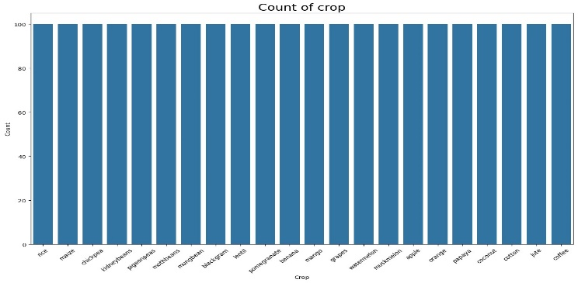  
TABLE I. DATASET

FIGURE II. COUNT OF CROP

The data collection process involves the following key steps:

a) Historical Climate Data:

The historical weather data such as temperature, precipitation, humidity, and wind speed, that exists in reliable atmosphere stations and satellite observations are collected. Such data is the source of knowledge about long-term climate features and information on seasonal changes. It helps the system to understand the background and employ of seasonal or regional crop production in the area.

b) Soil Data:

The data which is provided by the soil (the soil type, its texture, pH figure and nutrient content) is collected via soil sampling and analysis. This in turn would lead to a better knowledge on soil's physical and chemical properties which is the basis of crop growth and yield.

c) Crop Yield Data:

Crop yield data for various crops is regulated from different agricultural surveys, government agencies and public farmer information systems as an illustration It presents the data on historical performance of different crops under multiple environmental conditions. This data explains the relationship between crops yields and the environments conditions, identifying different patterns which are embodied into the adaptive model.

d) Market Data:

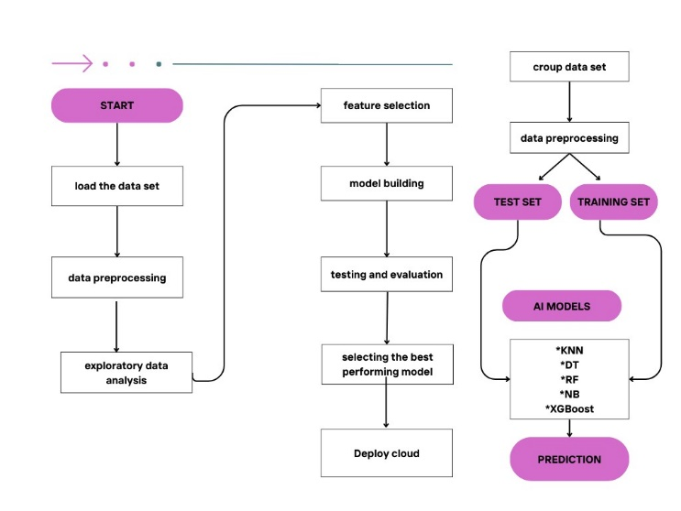Data from the market, including crop prices, demand dynamics, and trade statistics, is accumulated from agricultural productions reports and economic databases. This piece of data offers the details about the economic plausibility of various crops and provides farmers with the knowledge of crop selection, considering the market volume.

e) Agricultural Knowledge Base:

The construction of an agricultural knowledge base should touch on everything that concerns the characteristics of crops, the methods for optimal cultivation, pest and disease prevention strategies, and sustainable farming approaches. The provision of such knowledge base for the system makes it a source of information reference base for the system as it helps in ensuring that the system's recommendation are based on already established principles in agriculture.

2) Collecting Environmental Factors

The immediate environmental data is going to be a great tool that have the ability to be in agreement with the dynamic and responsive crop suggestions. The system utilizes various technologies to collect and integrate the following environmental factors:

a) Weather Monitoring:

For the realization of weather stations having Internet-of-Thing (IoT) component in the fields where the information about temperature, precipitation, humidity, wind speed and solar radiation is needed is a crucial step. Such information is used to provide current weather in real time monitoring and hence permits the system to follow up the weather changes during the growing period.

b) Soil Sensors:

Soil sensors are installed on the ground to control soil dampness, agrochemicals and acidity levels, respectively. This information gives an analytical view of the current state of the soil and it is the system which looks for the problems like the soil being deficient in nutrients or water stress.

c) Remote Sensing:

Satellites are utilized to show photos below them as well as to detect the condition of crops, extent of vegetation cover, and presence of pests on the ground. Thanks to this data, the system can get the colors of the grass and crops in the fields, it allows to look for problems easily and to give a general picture on the condition of the fields.

d) Pest and Disease Monitoring:

Pest monitor traps and specialized sensors are surgically collectively used for pest tracing and proactively isolating pathogens. These data help the machine respond with prompt notifications so as control pests and diseases before an invasion takes place or the crop loss is suffers from.

3) Crop Prediction

The main essence of advisory system for crops is its ability to forecast yields, suggest the best crop type and correlate it to the accumulated data and environmental background.

This is achieved through the following steps:This is achieved through the following steps:

FIGURE III. FIGURE OF DEVELOPMENT

a) Machine Learning Model Development:

Machine learning models like Artificial Neural Networks and Decision Trees are the examples on the algorithms which are trained on the aspects of previous climate conditions, soil and crop yields. Such models learn the complex connections between environments and agricultural yield rates that allow them to evaluate based upon current conditions the future yields.

b) Crop Suitability Analysis:

The system conducts environmental and soil parameter analysis of individual locale to recognize the proper cultivations for the particular zone as an output. This analysis takes into account the elements such as temperature, water consumption and soil nutrient levels that make a notable impact on selecting the crops that best suit the given environment.

c) Yield Prediction and Optimization:

The system makes use of trained machine learning classifiers that help in simulating the potential yields of different crops by factoring in the prevailing and the forecasted climatic conditions. Therefore, they can go ahead and compare a given number of crops and make sure all this leads to the selection of the most responsive crop.

d) Risk Assessment:

The system will identify and evaluate the potential risks associated with various choices of crops through the study of the pest and disease susceptibility level as well as the degree of vulnerabilty to weather change and market fluctuation. Attainment of the risk assessment is with the purport of the farmers being well-equipped towards making informed decisions that balance the potential rewards, and the potential risks.  
  
Real-time environmental data is crucial for providing dynamic and responsive crop recommendations. The system utilizes various technologies to collect and integrate the following environmental factors:

a) Weather Monitoring:

IoT-enabled weather stations are deployed in agricultural fields to collect real-time data on temperature, precipitation, humidity, wind speed, and solar radiation. This data provides up-to-date information on current weather conditions and allows the system to track changes in weather patterns throughout the growing season.

b) Soil Sensors:

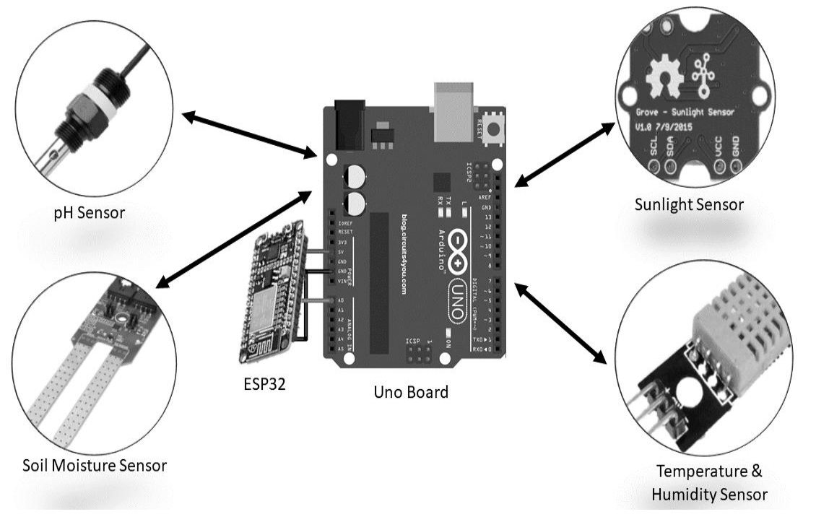Soil sensors are installed to monitor soil moisture levels, nutrient content, and pH levels. This data provides insights into the current state of the soil and allows the system to identify potential issues such as nutrient deficiencies or water stress.

FIGURE IV. ARDUINO MICRO-CONTROLLERS CONNECTIVITY

c) Remote Sensing:

Satellite imagery and aerial photography are utilized to monitor crop health, vegetation cover, and pest presence. This data provides a broader perspective on the overall condition of the agricultural fields and allows the system to identify potential problems early on.

d) Pest and Disease Monitoring:

Specialized sensors and traps are used to monitor pest populations and detect the presence of diseases. This data allows the system to provide timely recommendations for pest and disease management, preventing potential outbreaks and minimizing crop losses.

3) Crop Prediction

The core of the crop recommendation system lies in its ability to predict crop yields and recommend optimal crop choices based on the collected data and environmental factors.

This is achieved through the following steps:

a) Machine Learning Model Development:

Machine learning algorithms, such as artificial neural networks or decision trees, are trained on the historical climate, soil, and crop yield data. These models learn the complex relationships between environmental factors and crop performance, enabling them to predict future yields based on current conditions.

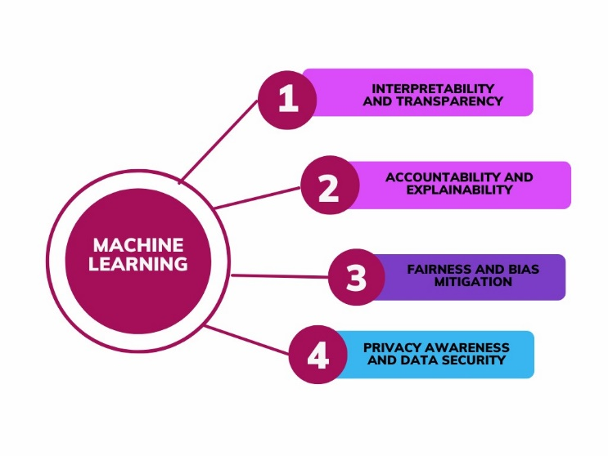CHARACTERISTICS OF MECHINE LEARNING

FIGURE V. MACHINE LEARNING

Interpretability and Transparency :

Interpretability and transparency of machine learning models are critical factors among which depend it is advisable the successful implementation of the machine learning models into the agricultural domain. Farmer should know what is provided by such recommendations so that they can count on the system and can make wise choices. Simplified models like Logistic Regression, Decision Tree Classifier, and KNeighbors Classifier extract features and make decisions from data due to their inherent interpretability properties, which are out of the box interpretability and easy to follow structures. Speaking of Logistic Regression, the latter is remarkable for its coefficients that give scientists a clear relationship between the features and the predictions. It is upon farmers then to understand the key environmental factors that affect crop production most. The connection method via the decision trees is an effective way to predict, allowing end users to study the decision-making process at each prediction. On the other hand, K-Neighbors Classifier makes its predictions according to the closeness of neighboring data points; this method facilitates the recognition of those data points that mostly affect the suggestions being made and helps one understand the rationale behind the recommendations.

While more granular models like XGBoost Classifier, Gradient Boosting Classifier and Random Forest Classifier might give us with the most accurate results, yet the association among variables will never be evident in the models due to their nature. These models use combinations of different decision trees or other base algorithms and therefore these processes appear like complicated machine to disassemble. As the features importance scores and the visualization tools in a model can help in providing only certain insights on the behavior of the model, it remains a challenge to build a completely explainable model. This lack of clear orientation can develop a mistrust and low usage among farmers who must be sure of the reasons behind recommendations before they carrying out the practical agricultural activities.

Accountability and Explainability:

Accountability that is inherent in machine-learning algorithms is of the most central to interpretability and explainability. With the farmers able to comprehend the way predictions have been made, they can keep the system in check by asking the system to explain its recommendations and where there is reproduction of errors. In this sense, models should be employed very care interpolation techniques crop yields, resource allocation, and human lives all are depend on the model predictions.

So that the explainable AI (XAI) methods stay the main accent point in improving the accountability of the machine learning algorithms. LIME (Local Interpretable Model-agnostic Explanations) and other techniques could be applied to linear models to simultaneously provide explanations for local and global models. These procedures used to distinguish the features that influence the forecast most signification way , so the farmers may know what the model's prediction lie and have capacity to estimate its reliability.

Additionally, the integration of causal inference methodology into agriculture machine learning models will reveal the correlation between the various environmental factors and agricultural production. Using the causal relationships, models can become more sophisticated and their outputs reliable which can be the foundation for viable recommendations and efficient decision-making and in the end accountability.

Fairness and Bias Mitigation :Fairness and Bias Mitigation :

Equity is an important factor in data and model generation as well as product application in agricultural engineering. Bias in the data or algorithms might automatically result in discrimination, some being far better off and some left out and the prevalence of the present inequalities.

Fairness requires collection of data, preprocessing, and training models with high precision. It is the major task to make a reality that the training data is varied considering wide range of farmers and growing areas. Examples of such bias removing methods can be given by balanced sampling approaches and data augmentation. At the same time, algorithmic adjustments, for instance the introduction of fairness constraints into the model's objective function, also contribute to model's equitable outcome.

Algorithms’ performance relies on biasless models. Fairness assessment such as bias-monitoring and regular evaluation are very important then. This comes with the task of modeling across the groups of farmers with different agricultural contexts so as to pinpoint any potential disparities and discriminatory patterns. By making the transfer of machine learning models to agricultural system fair and equitable any model will be another step to establishing a more just and impartial agrotechnological system.

Privacy Awareness and Data Security :

Privacy is a big issue in the epoch of big data analytics and machine learning, and in agriculture this is no exception. / Farmers' data is not only sensitive, but also there is a possibility of information leakage surrounding their land, crops, and practices. Therefore, it is necessary to protect that data with care. Machine learning models that involve huge volumes of agricultural data sets must be data structures and have strong privacy orientation design.

While there are a few ways to protect farmers' privacy, making sure farmers understand and take advantage of these methods is important. Deranging data anonymization methods data collection would be deprived of personally identifiable information, differential privacy techniques implies to add the controlled noise to protect individual privacy versions of the overall dataset but it would not affect the statistical properties of the dataset. On the other hand, Secure data storage and control mechanism of access are also important pursuance which the data privacies are not approved and elimination of data breaches is not possible.

One of the most important part of privacy-sensitive machine learning is transparency of data and user control over that data. Farmers’ data privacy and security should be taken seriously and they should be notified of how their data is gathered, stored, and utilized. Machine learning algorithms that are based on data are derived from farmers who are encouraged to access, control, and manage their data. This increases their trust on the system, and provides a platform for their active participation in the modeling of predictive machine learning algorithms.

Trade-offs, Considerations, and Future Directions:Trade-offs, Considerations, and Future Directions:

There are quite a number of trade-offs that one must be able to manage to get to the best or appropriate machine learning models in retaining the agriculture. While balancing performance with interpretability, as well as fairness and data protection are ongoing challenges, tackling these issues is the key in solving this problem.

The selection of model typically determined by how the software application used and the desires of the users. Among many others, in the cases where detailed understanding about the decision-making process is important, the simpler and interpretable models will be favored regardless of some margin of error in accuracy. On the other hand, for applications where encyclopedia high accuracy is strongly required, a complex model might be a good choice, although it must be designed such that fairness and privacy issues are taken into account.

There is definitely a prospect of machine learning in agriculture, which is very interesting. The evolution of Explainable AI (XAI) is particularly relevant since this technology will give farmers a better insight into how more complex models work and as a result will help lessen skepticism and promote deeper understanding. Causal relationship methods will give a strong support for causal analysis that will result in even more reliable and designated recommendations. The paradigm of reinforcement learning provides scope for the engineering of an intelligent system that evolves and picks the best options with the passage of time from the given experience. On top of that, a combination of machine learning technology with the precision of agricultural practices will enable the collection of data to be more precise, their monitoring, and implementing target interventions. Hence, the sustainable agricultural practices will be more efficient..

|  |  |
| --- | --- |
| LogisticRegression | 0.9504132231404959 |
| DecisionTreeClassifier | 0.9724517906336089 |
| XGBClassifier | 0.9820936639118457 |
| GradientBoostingClassifier | 0.9848484848484849 |
| KNeighborsClassifier | 0.9752066115702479 |
| RandomForestClassifier | 0.9931129476584022 |

TABLE II. ACCURACY

CONCLUSION

The system of generic crop recommendations which is dynamic and functions at a high degree of efficiency across crop types is proved by the findings that include extremely high precision, recall and F1-score values. These parameters then suggest the system is succeeding in its task of selecting and advising farmers of varied cropping options according to changing temperatures and conditions.The adaptive crop recommendation system offers very solid results in the variety of crops and established such by the accuracy, recall and F1- score. In these metrics it can be seen that the system is indeed able to identify the most suitable crops to offer to farmers taking into account the seasonal variations as well as the climate aspects.

RESULTS

High Precision and Recall:

The feature almost all crops achieving exceptionally high precision and recall excellence shows the system’s capability to provide the suitable crop recommendations without any false positive or false negative.

Such a high accuracy and precision eliminates the inaccuracy of the recommendation that is based on the general knowledge and provides the targeted agricultural advice that can be different based on specific properties of the soil.

Balanced F1-score:The model provides excellent performance for the various crop categories, as the F1-score has been good for precision, which are balanced with recall.

This balance is in a sense intricate phenomenon illustrating the system's ability in accuracy of identification of the relevant crops and the possible misclassifications.

Support for Various Crops:

The system suggests items from the diversity of plants such as fruit, vegetables, seeds and grain, and this is a prerequisite for those farmers who use different methods of agriculture and differ in their wishes.

Through the allocation of both mechanism and support for many crop species, farmers are capable of discerning which crops will achieve the highest productivity and revenues.

Overall Accuracy:

The precision of the system of over 99% can be considered as a cornerstone of the system as it is a special feature of the dynamic crop recommendation system.

The target accuracy in data provided ensures that the farmers have a high level of confidence to take the right decisions and adjustment to weather variations during different seasons while exhibiting a higher certainty.

To sum up, the dynamic crop recommendation system is a strong tool to handle seasonality movement in agriculture and it provides an up-to-date and individualized advice service to farmers. Through using the upgraded data analytics and ML algorithms as the machine learning algorithms, the system of production of crop includes sustainability, resilience, as well as economics.

|  |  |  |  |  |
| --- | --- | --- | --- | --- |
| names | precision | recall | F1-score | support |
| apple | 1.00 | 1.00 | 1.00 | 38 |
| banana | 1.00 | 1.00 | 1.00 | 28 |
| blackgram | 1.00 | 1.00 | 1.00 | 29 |
| chickpea | 1.00 | 1.00 | 1.00 | 41 |
| coconut | 1.00 | 1.00 | 1.00 | 35 |
| coffee | 1.00 | 1.00 | 1.00 | 33 |
| Cotton | 1.00 | 1.00 | 1.00 | 33 |
| grapes | 1.00 | 1.00 | 1.00 | 25 |
| jute | 0.88 | 1.00 | 1.00 | 35 |
| kidneybeans | 1.00 | 1.00 | 1.00 | 41 |
| lentil | 1.00 | 1.00 | 1.00 | 28 |
| Maize | 1.00 | 1.00 | 1.00 | 32 |
| Mango | 1.00 | 1.00 | 1.00 | 34 |
| Mothbeans | 1.00 | 1.00 | 1.00 | 38 |
| Mungbean | 1.00 | 1.00 | 1.00 | 33 |
| muskmelon | 1.00 | 1.00 | 1.00 | 26 |
| orange | 1.00 | 1.00 | 1.00 | 27 |
| Papaya | 1.00 | 1.00 | 1.00 | 37 |
| Pigeonpeas | 1.00 | 1.00 | 1.00 | 41 |
| pomegrante | 1.00 | 1.00 | 1.00 | 40 |
| Rice | 1.00 | 0.83 | 0.91 | 29 |
| watemelon | 1.00 | 1.00 | 1.00 | 23 |
|  |  |  |  |  |
| accuracy |  |  | 0.99 | 726 |
| macro avg | 0.99 | 0.99 | 0.99 | 726 |
| weighted avg | 0.99 | 0.99 | 0.99 | 726 |

TABLE III. CONFUSION MATRIX

FUTURE WORKS

It can do a lot of additional features to the system. Currently, it takes necessary environmental factors as inputs and suggests a very suitable crop to be cultivated. But as the next level, the Automation part can be added as the response system to the feedback. This can be modified to control the humidity, water level, etc. according to the need of the farmer.

Presently it takes all environmental factors as inputs to the system, but as an additional feature, an algorithm can be implemented to predict the one factor using another two factors. (Example – predicting the soil pH level from soil moisture and sunlight), so that the initial cost of setting up the sensors would be less and can be easily maintained.

REFRENCES

1. K. Van Tricht and M. Battude, "World Cereal: a dynamic open-source system for global-scale, seasonal, and reproducible crop and irrigation mapping," Earth System Science Data, vol. 15, no. 4, pp. 2433-2448, Apr. 2023, doi: 10.5194/essd-15-2433-2023.
2. R. Septiawan and A. Komaruddin, "Prediction Model for Chilli Productivity Based on Climate and Productivity Data," IEEE, 2012, doi: 10.1109/ICAIET.2012.6495962.
3. L. Rickards and S. M. Howden, "Transformational adaptation: agriculture and climate change," CSIRO PUBLISHING, 2012, doi: 10.1071/RJ11014.
4. E. Grigorieva, A. Livenets, and E. Stelmakh, "Adaptation of Agriculture to Climate Change: A Scoping Review," MDPI, 2023, doi: 10.3390/AGRIENGINEERING4010001.
5. C. Makate, R. Wang, M. Makate, and N. Mango, "Crop diversification and livelihoods of smallholder farmers in Zimbabwe: adaptive management for environmental change," Springer Plus, 2016, doi: 10.1186/s40064-016-1910-9.
6. P. N. Kephe, K. K. Ayisi, and B. M. Petja, "Challenges and opportunities in crop simulation modelling under seasonal and projected climate change scenarios for crop production in South Africa," Creative Commons Attribution 4.0, 2021, doi: 10.1155/2021/5582711.
7. A. Raza, A. Razzaq, and S. S. Mehmood, "Impact of Climate Change on Crops Adaptation and Strategies to Tackle Its Outcome: A Review," Nature Genetics, 2019, doi: 10.1038/s41598-019-49577-2.
8. H. Karahan and M. Cetin, "Developing a New ANN Model to Estimate Daily Actual Evapotranspiration Using Limited Climatic Data and Remote Sensing Techniques for Sustainable Water Management," Remote Sensing, 2024, doi: 10.3390/rs14030533.
9. A. Mulagha-Maganga et al., "A Ricardian analysis of the economic impacts of climate change on agricultural production in the low-income agrarian economy: Estimates from Malawi’s 2010–2019 LSMS longitudinal data," Agricultural Economics, 2024, doi: 10.1111/agec.12536.
10. C. Belford et al., "An economic assessment of the impact of climate change on the Gambia’s agriculture sector: a CGE approach," Emerald Publishing Limited, 2023, doi: 10.1108/INMR-02-2021-0006.
11. O. Pabi, J. S. Ayivor, and B. D. Ofor, "Adaptive strategies of smallholder farming systems to changing climate conditions in the vicinity of Kogyae Strict Nature Reserve within the Forest-Savanna Transitional Zone of Ghana," Agricultural Economics, 2020, doi: 10.1111/agec.12612.
12. D. B. Lobell et al., "Climate adaptation as mitigation: the case of agricultural investments," Environmental Research Letters, 2013, doi: 10.1088/1748-9326/8/1/015012.
13. A. Holzkämper, "Adapting Agricultural Production Systems to Climate Change—What’s the Use of Models?," MDPI, 2017, doi: 10.3390/f10040411.
14. A. Amruddin et al., "Analysis of Climate Change Impacts on Agricultural Production and Adaptation Strategies for Farmers: Agricultural Policy Perspectives," Global Society publishing, 2024, doi: 10.1108/INMR-02-2021-0006.
15. J. W. Hansen and M. V. K. Sivakumar, "Integrating seasonal climate prediction and agricultural models for insights into agricultural practice," Philosophical Transactions of The Royal Society B Biological Sciences, 2005, doi: 10.1098/rstb.2005.1712.
16. J. Gornall et al., "Implications of climate change for agricultural productivity in the early twenty-first century," Philosophical Transactions of The Royal Society B Biological Sciences, 2010, doi: 10.1098/rstb.2010.0158.
17. T. W. Carr et al., "Climate change impacts and adaptation strategies for crops in West Africa: a systematic review," AIP Publishing, the American Physical Society and IOP Publishing, 2022, doi: 10.1063/5.0057104.
18. J. N. Kimengsi et al., "Farm-based climate adaptation dynamics: insights from the vegetable sector in the Western Highlands of Cameroon," Cogent Social Science, 2022, doi: 10.1080/23311886.2022.2020035.
19. V. Shevchenko et al., "Climate Change Impact on Agricultural Land Suitability: An Interpretable Machine Learning-Based Eurasia Case Study," IEEE, 2024, doi: 10.1109/ACCESS.2021.3096627.
20. I. D. López et al., "Multi-Dimensional Data Preparation: A Process to Support Vulnerability Analysis and Climate Change Adaptation," IEEE, 2020, doi: 10.1109/ACCESS.2020.3037311.
21. H. M. Albarakati et al., "A Novel Deep Learning Architecture for Agriculture Land Cover and Land Use Classification from Remote Sensing Images Based on Network-Level Fusion of Self-Attention Architecture," IEEE, 2024, doi: 10.1109/TGRS.2021.3139687.
22. A.-P. Witmer, "Community-Scale Response To Climate Change Impacts On Rural Agricultural Economies," IEEE, 2021, doi: 10.1109/ACCESS.2020.3037311.
23. D. F. P. Grajales and F. Mejia, "Crop-planning, making smarter agriculture with climate data," IEEE, 2015, doi: 10.1109/LARS.2014.2381526.
24. R. D. Baruah et al., "Use of Data Mining Technique for Prediction of Tea Yield in the Face of Climate Change of Assam, India," IEEE, 2016, doi: 10.1109/ICONSLT.2016.7997558.