



**Cisco HyperFlex Sizer Getting Started Guide**

**First Published:** 2018-05-07

**Last Modified:** 2020-09-05

**Americas Headquarters**

Cisco Systems, Inc. 170 West Tasman Drive San Jose, CA 95134-1706 USA

[http://www.cisco.com](http://www.cisco.com/) Tel: 408 526-4000

800 553-NETS (6387)

Fax: 408 527-0883

THE SPECIFICATIONS AND INFORMATION REGARDING THE PRODUCTS IN THIS MANUAL ARE SUBJECT TO CHANGE WITHOUT NOTICE. ALL STATEMENTS, INFORMATION, AND RECOMMENDATIONS IN THIS MANUAL ARE BELIEVED TO BE ACCURATE BUT ARE PRESENTED WITHOUT WARRANTY OF ANY KIND, EXPRESS OR IMPLIED. USERS MUST TAKE FULL RESPONSIBILITY FOR THEIR APPLICATION OF ANY PRODUCTS.

THE SOFTWARE LICENSE AND LIMITED WARRANTY FOR THE ACCOMPANYING PRODUCT ARE SET FORTH IN THE INFORMATION PACKET THAT SHIPPED WITH THE PRODUCT AND ARE INCORPORATED HEREIN BY THIS REFERENCE. IF YOU ARE UNABLE TO LOCATE THE SOFTWARE LICENSE OR LIMITED WARRANTY, CONTACT YOUR CISCO REPRESENTATIVE FOR A COPY.

The Cisco implementation of TCP header compression is an adaptation of a program developed by the University of California, Berkeley (UCB) as part of UCB's public domain version of the UNIX operating system. All rights reserved. Copyright © 1981, Regents of the University of California.

NOTWITHSTANDING ANY OTHER WARRANTY HEREIN, ALL DOCUMENT FILES AND SOFTWARE OF THESE SUPPLIERS ARE PROVIDED “AS IS" WITH ALL FAULTS. CISCO AND THE ABOVE-NAMED SUPPLIERS DISCLAIM ALL WARRANTIES, EXPRESSED OR IMPLIED, INCLUDING, WITHOUT LIMITATION, THOSE OF MERCHANTABILITY, FITNESS FOR A PARTICULAR PURPOSE AND NONINFRINGEMENT OR ARISING FROM A COURSE OF DEALING, USAGE, OR TRADE PRACTICE.

IN NO EVENT SHALL CISCO OR ITS SUPPLIERS BE LIABLE FOR ANY INDIRECT, SPECIAL, CONSEQUENTIAL, OR INCIDENTAL DAMAGES, INCLUDING, WITHOUT LIMITATION, LOST PROFITS OR LOSS OR DAMAGE TO DATA ARISING OUT OF THE USE OR INABILITY TO USE THIS MANUAL, EVEN IF CISCO OR ITS SUPPLIERS HAVE BEEN ADVISED OF THE POSSIBILITY OF SUCH DAMAGES.

Any Internet Protocol (IP) addresses and phone numbers used in this document are not intended to be actual addresses and phone numbers. Any examples, command display output, network topology diagrams, and other figures included in the document are shown for illustrative purposes only. Any use of actual IP addresses or phone numbers in illustrative content is unintentional and coincidental.

Cisco and the Cisco logo are trademarks or registered trademarks of Cisco and/or its affiliates in the U.S. and other countries. To view a list of Cisco trademarks, go to this URL: [https://www.cisco.com/go/trademarks.](https://www.cisco.com/go/trademarks) Third-party trademarks mentioned are the property of their respective owners. The use of the word partner does not imply a partnership relationship between Cisco and any other company. (1721R)

© 2020 Cisco Systems, Inc. All rights reserved.

### C O N T E N T S

**C H A P T E R 1**

#### Overview 5

Introduction **5**

Installation Prerequisites **6**

Access HyperFlex Sizer **6**

Quick Start Guide **7**

HyperFlex Sizer Home Page **8**

**C H A P T E R 2**

#### Scenarios 9

Add a Scenario **9**

Scenario Page **10**

Scenarios Page with Workloads **11**

Scenario Tasks **13**

Fixed Configuration Tab (Reverse Sizing) **15**

**C H A P T E R 3**

#### Workloads 19

Workloads Pane **19**

VDI Workloads **20**

* Virtual Desktop Infrastructure (VDI)
* Epic Hyperspace
* VDI Infrastructure VMs
* RDSH Workload

Database Workloads **32**

* Microsoft SQL database
* Oracle
* Splunk Workload
* Bulk Database Input

Other Workloads **44**

* General Server Virtualized Environment (VSI)
* Microsoft Exchange Server
* HX Edge (ROBO)
* Compute and Capacity Sizer (RAW)
* File Upload on HX
* Veeam Availability Solution on HX
* Kubernetes Container
* Artificial Intelligence/Machine Learning

**C H A P T E R 4**

**Configure Microsoft Exchange 2013 Server Role Requirements Calculator** **66**

Configure the Microsoft Exchange 2013 Server Role Requirements Calculator

Troubleshooting

**C H A P T E R 5**

**Appendix 70**

**C H A P T E R 1**



# Overview

## Introduction

* Introduction
* Installation Prerequisites
* Access HyperFlex Sizer
* Quick Start Guide
* HyperFlex Sizer Home Page

Cisco HyperFlex Sizer is a web-based application that helps in sizing different workloads and matching them with appropriate Cisco Hyperflex Systems.

The HyperFlex Sizer supports the following workloads categorized as:

* **VDI**
  + Virtual Desktop Infrastructure (VDI)
  + RDSH Workload
  + Epic Hyperspace
  + VDI Infrastructure VMs
* **Database**
  + Microsoft SQL database
  + Oracle
  + Splunk Workload
  + Bulk Database Input
* **Others**
  + General Server Virtualized Environment (VSI)
  + Microsoft Exchange Server
  + HX Edge (ROBO)
  + Compute and Capacity Sizer (RAW)
  + File Upload on HX
  + Artificial Intelligence/Machine Learning
  + Kubernetes Container
  + Veeam Availability Solution on HX

## Installation Prerequisites

#### Supported Browsers

|  |  |
| --- | --- |
| **Browser** | **Version** |
| Chrome | 65 or higher |
| Firefox | 59 or higher |

## Access HyperFlex Sizer

HyperFlex Sizer is hosted on the Cisco Cloud Application Environment (CAE) infrastructure. You can access the HyperFlex Sizer using the following link:

[https://hyperflexsizer.cloudapps.cisco.com](https://hyperflexsizer.cloudapps.cisco.com/ui/index.html)

Enter your Cisco user credentials.

|  |  |
| --- | --- |
| Username | Cisco user ID |
| Password | Cisco password |

Click **Log In**.



**Note:** All the features are available only for Cisco employees and certified partners. The access level of your login credentials restricts access to certain features.

For guest accounts, features such as Download Sizing Report and Download BOM are restricted.

## Quick Start Guide

**STEP 1:** **STEP 2:**

|  |
| --- |
| This is the first page you see when you log in to HyperFlex Sizer. The home page displays a list of all the scenarios previously created by you, if any. |

|  |
| --- |
| On the HyperFlex Sizer home page, click the Create Scenario button. Enter valid Scenario name and click Ok. |

**STEP 3: STEP 4:**

|  |
| --- |
| In the Scenario page, add a Workload using the + Add Workload button on the workloads pane. |

|  |
| --- |
| In the Workload Panel, select the desired workload type, proceed by clicking Next to configure workload parameters, and then Save to complete the Sizing workflow. |

**STEP 5:**

|  |
| --- |
| The Scenario page loads the Sizing Result in Lowest Cost / All Flash /All NVMe tabular format.  You can view all details of the workload input, aggregate summary, Node results on right panel and utilization of resources for the chosen option. You can download the sizing report or BOM via the Action button on the top right. Click on Customize button to customize Cluster settings or Node settings. |

**Note**: In Case of any Issues, click on the Send Feedback to ask for help.

## HyperFlex Sizer Home Page

The HyperFlex Sizer home page displays a list of all the scenarios previously created by you, if any.

This is the first page you see when you log in to HyperFlex Sizer.

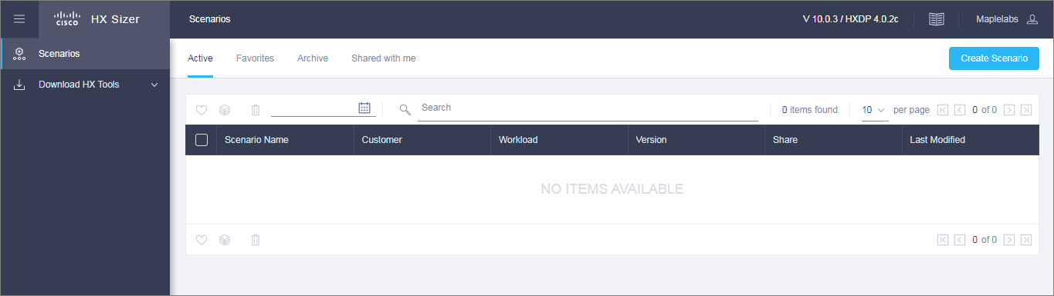

|  |  |
| --- | --- |
| **UI Element** | **Description** |
| **Create Scenario** button | If there are no scenarios, you can click the **Create Scenario** button to create a new scenario. |
| **Active** tab | Displays a list of all scenarios previously created by you, if any. |
| **Favorites** tab | Displays a list of all the favorite scenarios, if any. |
| **Archive** tab | Displays a list of all the archive scenarios, if any. |
| **Shared with me** tab | Displays a list of all the shared scenarios by other users, if any. |
| **Download HX Tools** Dropdown | Provides links to download the OVA files for HX Bench and HX Profiler. |
| **Getting Started** button | Provides training materials for HxSizer, HxBench, and HxProfiler. |
| **What's New** button | Provides information on what's new in the various HyperFlex Sizer releases. |
| **User Preferences** option | Click the User Preferences option under User menu to change theme preference. |
| **Send Feedback** option | Click the Send Feedback option under User menu to send feedback and/or queries, if any. |

# Scenarios

* + Add a Scenario
  + Scenario Page
  + Scenarios Page with Workloads
  + Scenario Tasks
  + Fixed Configuration Tab (Reverse Sizing)

## Add a Scenario

The following steps describe how to add a Scenario:

**Step 1** In the HyperFlex Sizer home page, click the **Create Scenario** button.

The Create Scenario window appears, shown as follows:

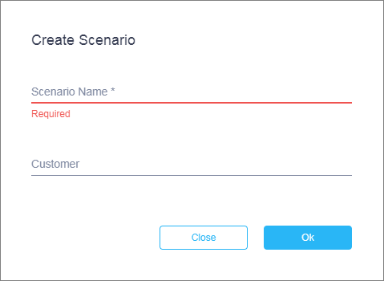

To Create Scenario, enter a valid Scenario name and click Ok.

**Step 2** In the **Add Scenario** window, complete the following fields:

|  |  |
| --- | --- |
| **Field Name** | **Description** |
| **Scenario Name** | Enter a name for the sizing Scenario. Use the following guidelines to create the name:   * The Scenario name must begin with an alphabetic character. * Use alphanumeric characters only. An underscore, hyphen, or plus symbol can be used as a separator. * Special characters are not allowed. * The Scenario name must be unique. |
| **Customer** | (Optional) |

**Step 3** Click **Save**.

You are now redirected to the Scenario details page.

## Scenario Page

The HyperFlex Sizer Scenario details page displays a list of all the Workloads created by you, if any.

You can size different workloads on the Scenario details page by using the various options provided on the HyperFlex Sizer web application. You can choose between Lowest Cost, All- Flash and All NVMe sizing options to view the recommended sizing configurations that you can use in your HyperFlex cluster.

The Lowest cost option considers both Hybrid and All-Flash HX nodes for sizing and provides the optimal solution that can satisfy the given set of workloads.

The All-Flash option includes only All-Flash HX nodes to provide the optimal All-Flash solution that can satisfy the given set of workloads.

The All NVMe option includes only All NVMe HX nodes to provide the optimal All NVMe solution that can satisfy the given set of workloads.



**Note** Cisco recommends using the **All-Flash** option for all performance sensitive workloads as All-Flash configurations provide better performance consistency.

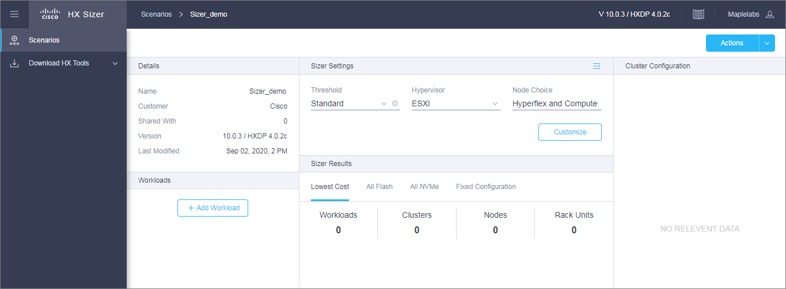

## Scenarios Page with Workloads

The HyperFlex Sizer Scenario details page displays a list of all the Workloads created by you, if any.

Let’s look at the sizing results page.

Click the Add Workload button under Workloads.

On the Workload Type page, select any workload (in ex: VDI workload being selected). Proceed by Next, then Save.

The fields described in this section are displayed under the **Lowest_Cost** tab, **All-Flash** tab and **All NVMe** tab, shown as follows:

The Lowest cost option considers both Hybrid and All-Flash HX nodes for sizing and provides the optimal solution that can satisfy the given set of workloads. Whereas the All-Flash option includes only All-Flash HX nodes to provide the optimal All-Flash solution that can satisfy the given set of workloads. The All NVMe option includes only All NVMe HX nodes to provide the optimal All NVMe solution that can satisfy the given set of workloads.

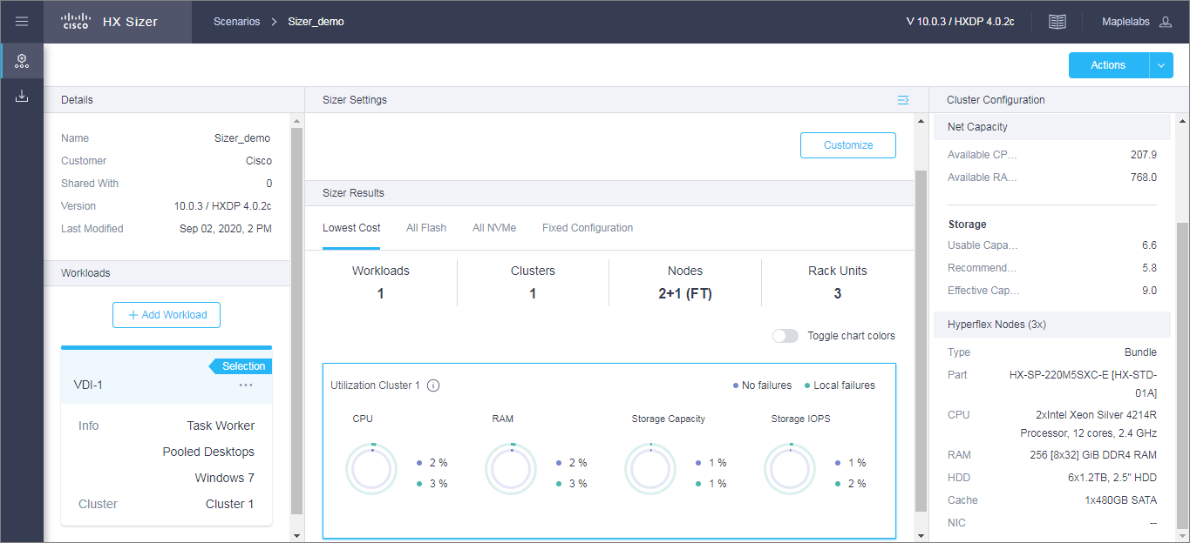

#### Scenario Details Page

|  |  |
| --- | --- |
| **UI Element** | **Description** |
| **Threshold** dropdown | Set the sizing threshold to one of the following:   * **Standard**—Default * **Conservative** * **Aggressive** * **No Hypervisor Reservation**   The threshold setting controls the target utilization of clusters being sized. |
| **Hypervisor** dropdown | Choose the type of Hypervisor for which you want to do sizing:   * **ESXi**—Default * **Hyper-V** |
| **Node Choice** dropdown | Choose the type of node for which you want to calculate sizing:   * **HyperFlex & Compute**—Default * **HyperFlex Only** |
| **Summary** details | Displays the Aggregate recommended number of Clusters, Nodes, and Rack Units for a given number of workloads. |
| **Toggle Chart Colors** button | User can toggle colors for Utilization charts. |
| **Utilization** Chart | Displays the expected hardware resource utilization, namely CPU, RAM, Storage Capacity, and Storage IOPS for a workload.  There are three different components in utilization:   * **With no failures**—For workloads that have replication enabled, the resource utilization includes the replication overhead. * **With local failures**—The number of failures matches the sizing parameter used for specifying the *Performance Headroom* parameter. For workloads that have replication enabled, resource utilization includes the replication overhead. * **Unused / Free**—Applicable only if the workload has replication enabled. Shows the resource utilization when the DR partner cluster has failed and workloads running on the cluster have moved over. |
| **Cluster Configuration** Panel | You can view the Node Results for the individual cluster based on the selection. The following results are displayed:   * **Cluster Configuration Settings**—Specific settings for the HX cluster, for instance, the Replication Factor that is set * **Hyperflex Nodes (Count**—Number of nodes)   **Type**—Type of node  **Part** —Node used in the HX cluster  **Descriptions** —Properties of the node |

#### Download Button

You can download the sizing reports from the HX Sizer in two formats:

#### Download Sizing Report

You can view all details of the sizing input, proposed sizing configurations, workload summary, aggregate workload requirements, and utilization of resources for the chosen option. Click the Download button in the top-right corner of the Scenario page (shown as follows), then click Download Sizing Report.

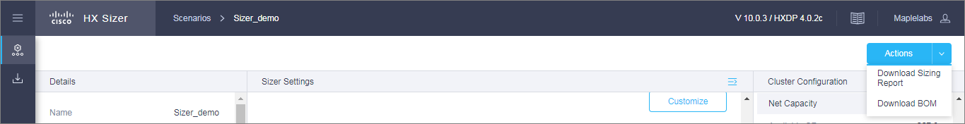

#### Download BOM for Lowest_Cost, All-Flash, All NVMe and Fixed Configuration

A detailed Bill of Materials (BOM) is available separately for the Lowest Cost, All-Flash, All NVMe and Fixed configuration options as an Excel spreadsheet. This Excel sheet can be directly loaded to your Cisco Commerce Workspace (CCW).

**Fixed Configuration**

In the Fixed Configuration tab (also referred to as "Reverse Sizing"), the workflow starts with a fixed HX configuration and helps validate whether a given set of workloads will run on it or not.

See “Fixed Configuration tab (Reverse Sizing)” for more information.

## Scenario Tasks

To view the existing Scenarios, navigate to the **Active** tab in Hyperflex Sizer homepage. You can perform the following tasks with existing Scenarios.

#### Clone a Scenario

Click the *Clone* icon of an existing Scenario to create a copy of the Scenario and complete the following fields.

|  |  |
| --- | --- |
| **Field Name** | **Description** |
| **Scenario Name** | Enter a name for the sizing Scenario. Use the following guidelines to create the name:   * The Scenario name must begin with an alphabetic character. * Use alphanumeric characters only. An underscore, hyphen, or plus symbol can be used as a separator. * Special characters are not allowed. * The Scenario name must be unique. |
| **Customer** | (Optional) |

#### Edit a Scenario

Click the *Edit* icon of an existing Scenario to edit the **Scenario name**, **Customer**.

#### Share a Scenario

To share a Scenario with an existing user or a new user, follow these steps:

1. Click the *Share* icon of an existing Scenario to share the Scenario.
2. Add the valid Cisco email ID with whom you are intended to share scenario.
3. You can set the following access privileges to users:

A Scenario always shared with read and write access.

* + Write access—Users have privileges to modify the Scenario, add new workloads, and modify existing workloads.

If username is not available in the database or unable to retrieve from LDAP server, check for the provided email ID and try again.

1. Click **Save**.

You can find the list of Scenarios shared with you under the **Shared with me** tab. You can find details about the owner of the Scenario and the users with whom the Scenario is shared on the **Shared Scenarios** page.

#### Delete a Scenario

Click the *Delete* icon of an existing Scenario to delete the Scenario.

#### Archive a Scenario

Click the *Archive* icon of an existing Scenario to archive the Scenario. The archived scenarios are shown in Archive tab.

#### Favorite a Scenario

Click the *Favorite* icon of an existing Scenario to favorite the Scenario. The favorite scenarios are shown in Favorite tab.

## Fixed Configuration Tab (Reverse Sizing)

Fixed Sizing (also referred to as "Reverse Sizing") is a workflow that starts with a fixed configuration and helps validate whether a given set of Workloads will run on it or not.

In the Scenario page, click the **Fixed Configuration** tab. The tab appears, shown as follows:

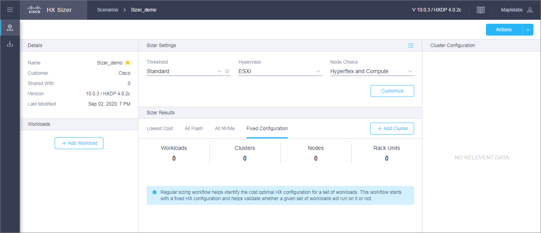

In the Fixed Scenario/Sizing the workflow starts with a fixed HX configuration and helps validate whether a given set of workloads will run on it or this can also be used to find out the specific details of a given configuration.

## Configure Cluster in Fixed Configuration

The steps to add Fixed Configuration cluster details as shown below.

**Step 1** In the FixedConfiguration tab, click on Add Cluster to configure the HyperFlex node and the Compute node

(shown as follows).

Make your selections, then click Apply. The Scenario page reloads.

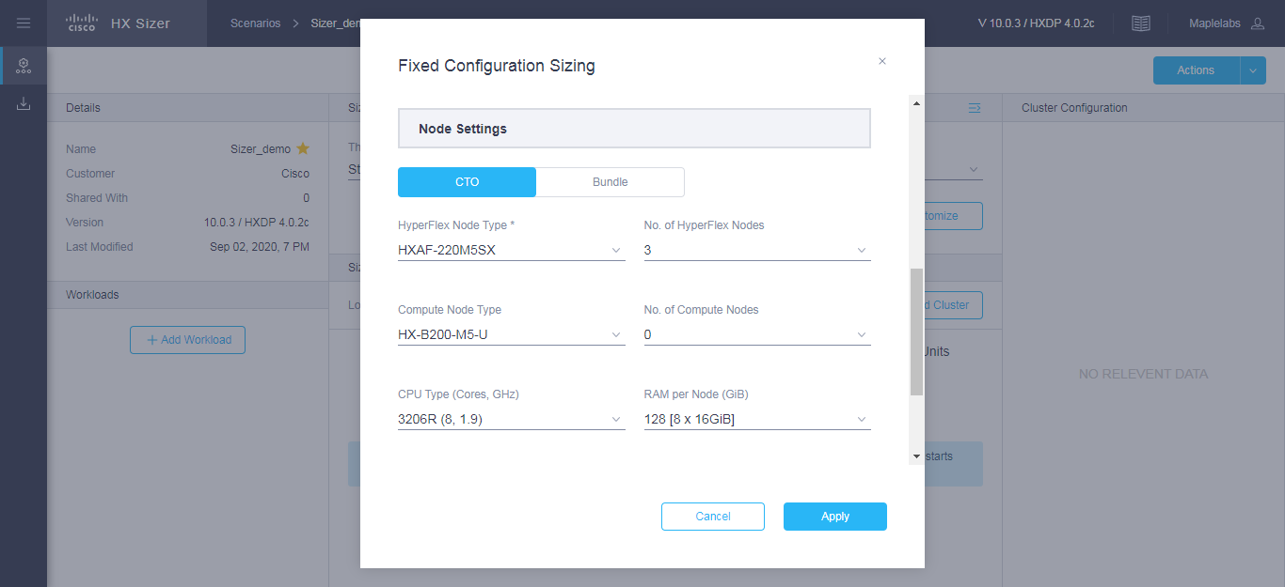

**Step 2** The **Fixed Configuration** tab Shows the following result.

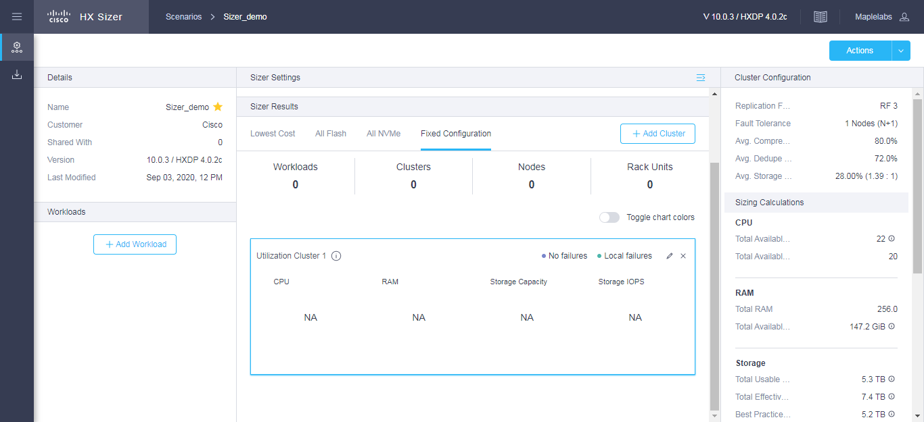

**Step 3** Click the Add Workload button under **Workloads**, which prompts a dialogue box with the various Workload types (shown as follows). Select Assign Fixed Cluster from the dropdown to size for that cluster. If any Workloads are not supported for the chosen fixed configuration a warning message will be shown. The cluster setting can be changed by selecting the edit button in the respective Utilization cluster box.

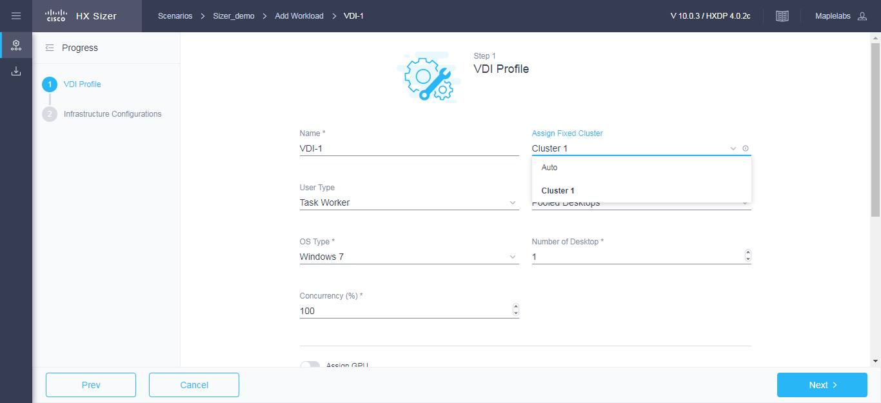

**Alternative Step 3** If the Workload already present under **Workloads**, which you prefer to place into the configured Fixed Cluster, click on the edit button in Cluster box, select desired workload from the Assign Workload dropdown as shown below.

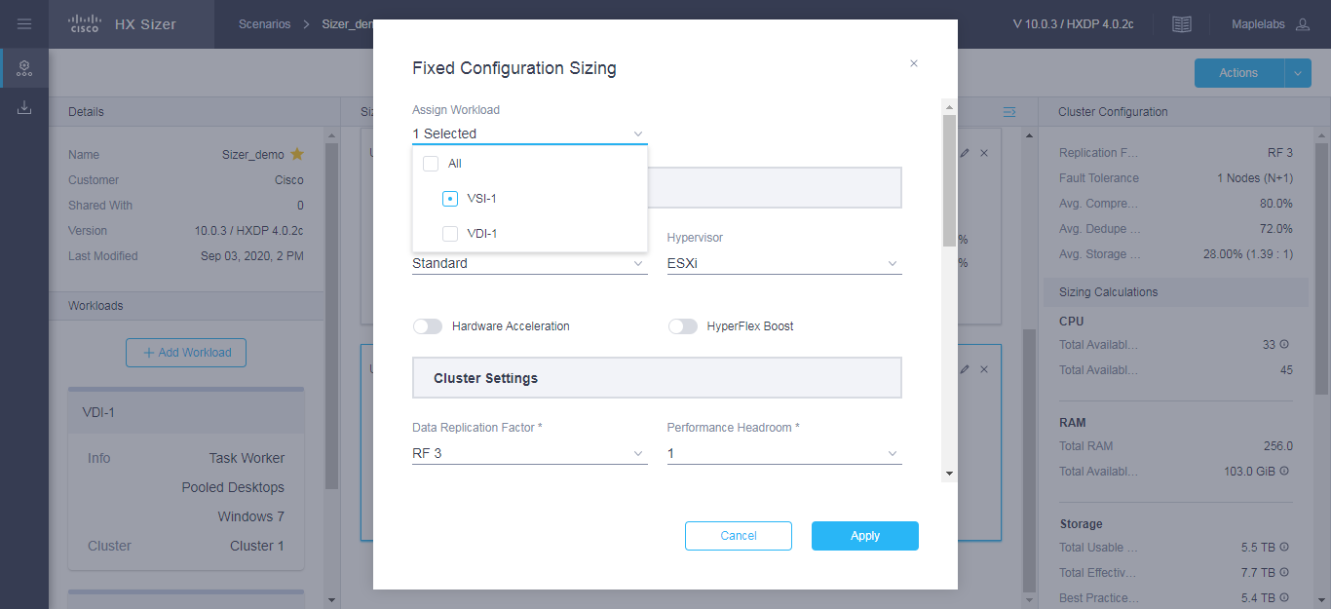

The other Workloads can be added to the Fixed Configuration Sizing based on the clustering of those Workloads that can be placed into one cluster. The standard clustering formats include:

[VDI, RDSH, VDI_INFRA], [VSI, DB, ORACLE], [RAW, RAW_FILE], [EXCHANGE], [ROBO], [EPIC], [VEEAM], [SPLUNK], [CONTAINER], [AIML]

**Note:** For Fixed Configuration Sizing, the Stretch Cluster and Remote replication features are not supported.

**Step 4** Now users can configure multiple clusters in Fixed configuration and select the desired workloads for placement.

The **Fixed Configuration** tab, on the right panel Sizing Calculations section displays the calculated value for the effective resources available after reserve and overhead reductions for a given node configuration.

Click on the respective Utilization Clusters box to see the result.

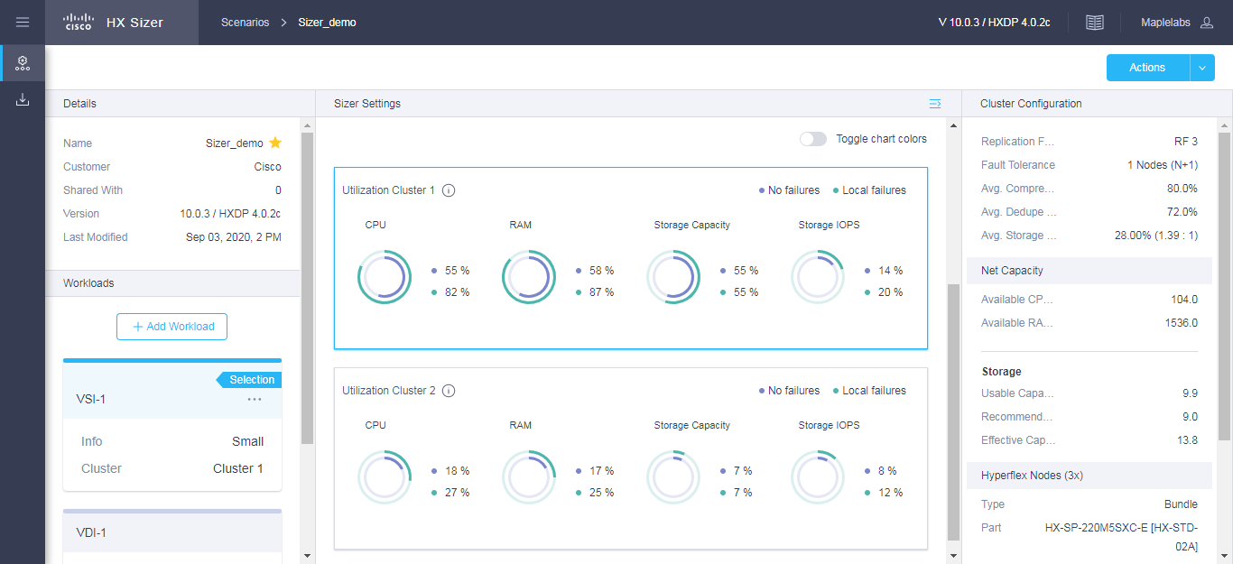



**C H A P T E R 3**

# Workloads

* + **Workloads Pane**
  + **VDI Workloads**
  + Virtual Desktop Infrastructure (VDI) Workload
  + Epic Hyperspace Workload
  + VDI Infrastructure VMs Workload
  + RDSH Workload
  + **Database Workloads**
  + Microsoft SQL database Workload
  + Oracle Workload
  + Splunk Workload
  + Bulk Database Input
  + **Other Workloads**
  + General Server Virtualized Environment (VSI) Workload
  + Microsoft Exchange Server Workload
  + HX Edge (ROBO) Workload
  + Compute and Capacity Sizer (RAW) Workload
  + File Upload on HX
  + Veeam Availability Solution on HX Workload
  + Kubernetes Container Workload
  + Artificial Intelligence/Machine Learning Workload

## Workloads Pane

You can complete the following actions from the Workloads Pane:

#### Edit Workload

Click the *Edit* icon of an existing Workload to edit the Workload profile.

#### Delete Workload

Click the *Delete* icon of an existing Workload to delete the Workload.

## VDI Workloads

## Add VDI Workload

To change the default values, click **Customize**.

**13**



**Attention** The recommended values are based on performance tests and should be changed with care.

**Note**: RAM Overprovisioning can be considered by modifying the input RAM by the appropriate RAM overprovisioning factor.

Example: 4 GB of RAM / Overprovisioning Ratio of 2 = 2 GB of RAM.

Please refer to the following links for more details on the implications of RAM overprovisioning.

<https://kb.vmware.com/s/article/2097593>

<https://kb.vmware.com/s/article/2080735>

The node and parts for sizing are chosen based on CPU normalization.

Normalized cores: The performance of a core in one processor is different from that of another processor. The performance of a CPU varies across generations of processors of the same type.

The HyperFlex Sizer computes the effective core for a node by using the SpecInt and CFP values, and normalizes this to the SpecInt/CFP values of Intel Platinum 8164.

To add a VDI Workload:

**Step 1** Click the Add Workload button under **Workloads**.

**Step 2** On the **Workload Type** page, select **VDI**, (shown as follows). Click **Start**.

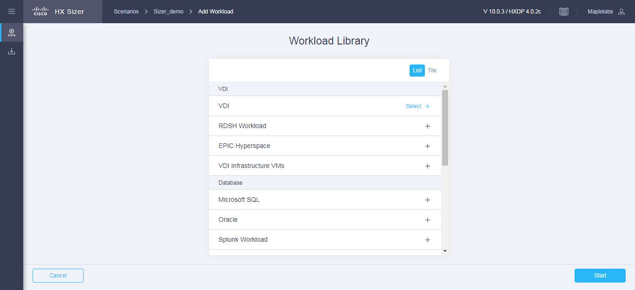

**Step 3** On the **VDI Profile** page (shown as follows), complete the following fields:

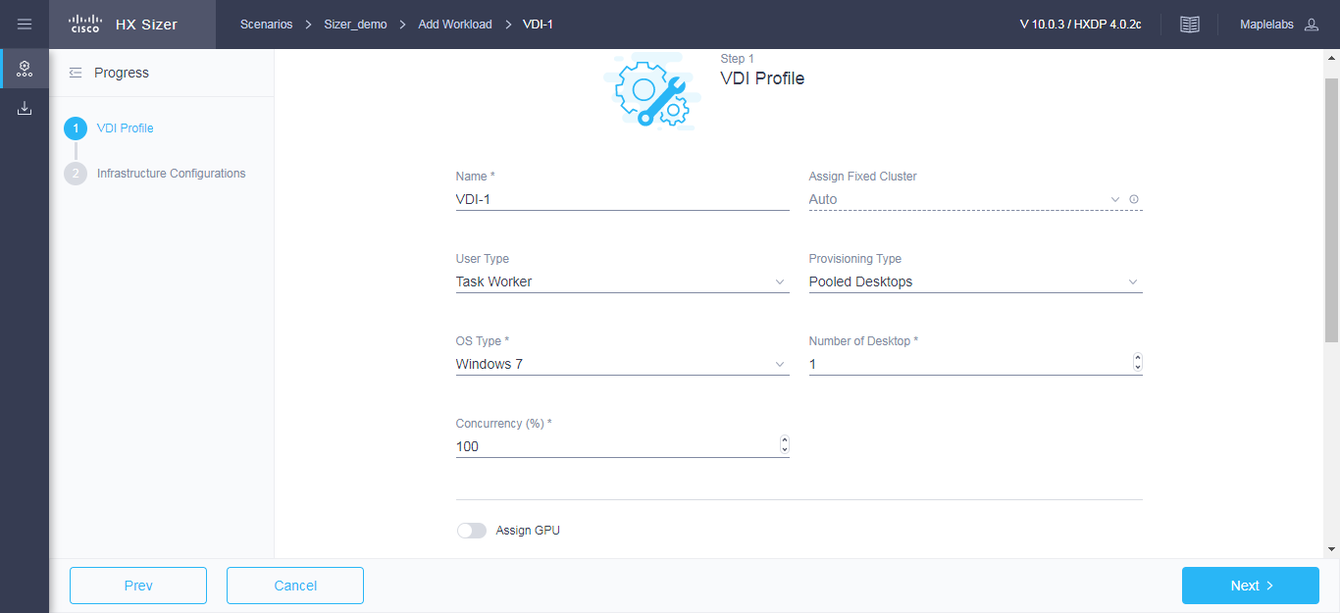

|  |  |
| --- | --- |
| **UI Element** | **Description** |
| **Name** field | Name of the Workload |
| **Assign Fixed Cluster** drop-down list | Choose the Fixed Cluster to assign for workload |
| **User Type** drop-down list | Choose from a list of predefined resource consumption values:   * **Task Worker** * **Knowledge Worker** * **Power User** * **Custom User**—If the predefined resource consumption values in the templates listed do not meet your requirements, select the Custom User option to manually enter the Desktop Compute Profile and Desktop Storage Profile values. |
| **Provisioning Type** drop-down list | You have the following options for data retention:   * **Persistent Desktops**—Retains data on the desktop. * **Pooled Desktops**—Does not retain on the desktop. |
| **OS Type** drop-down list | * **Windows 7** * **Windows 10** |

|  |  |
| --- | --- |
| **UI Element** | **Description** |
| **Number of Desktops** field | Enter the total number of desktops.  The limit is 1 - 30,000 desktops. |
| **Concurrency (%)** field | Enter percentage relevant to the total number of desktops that should remain powered on concurrently. |
| **Assign GPU** toggle button | Enable if the desktops need to use GPUs. |
| **User Home Directories** toggle button | Enable if hosting User Home Directories on HX Cluster. |
| **Workload Profile**  Depending on the User Type you choose, the recommended values will change. | |
| **vCPUs** field | * Task Worker—1 vCPU * Knowledge Worker—2 VCPUs * Power User—2 VCPUs |
| **Clock (MHz)** field | * Task Worker—325 MHz * Knowledge Worker—400 MHz * Power User—400 MHz |
| **RAM (GB)** field | * Task Worker—1 GB * Knowledge Worker—2 GB * Power User—2 GB |
| **Desktop Storage Profile** | |
| **OS IOPS** field | Depending on the User Type you choose, the recommended values will change.   * Task Worker—6 IOPs * Knowledge Worker—8 IOPs * Power User—10 IOPs |
| **OS Image Size (GB)** field | Recommended is 20 GB |
| **Snapshot Count** field | Recommended is 0 GB |
| **Working Set Size (%)** field | Recommended is 10% |

Click **Next**.

**Step 4** On the **Infrastructure Configuration** page (shown as follows), complete the following fields.

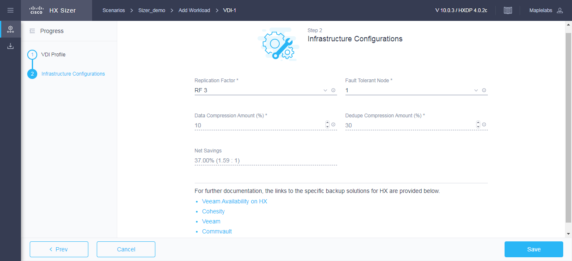

|  |  |
| --- | --- |
| **UI Element** | **Description** |
| **Replication Factor** drop-down list | RF3 is recommended for data redundancy. |
| **Fault Tolerant Node** drop-down list | Enter the number of nodes used for Fault Tolerance. Recommended is 1 node.  Setting Performance Headroom adds additional nodes to the cluster to ensure that there is enough performance bandwidth in case of a node failure. |
| **Data Compression Amount (%)** field | Recommended is 10% |
| **Dedupe Compression Amount (%)** field | Recommended is 30% |

**Step 5** Click **Save.**

## Add Epic Hyperspace Workload

To change the default values, click **Customize**.



**Attention** The recommended values are based on performance tests and should be changed with care.

To add an Epic Hyperspace Workload:

**Step 1** Click the + Add Workload button under **Workloads**.

**Step 2** On the **Workload Type** page, select **Epic Hyperspace** (shown as follows). Click **Start**.

## 

**Step 3** On the **Hyperspace Profile** page, complete the following fields:

## 

|  |  |
| --- | --- |
| **UI Element** | **Description** |
| **Total Users Supported (%)** field | Enter the total users supported for Datacenter 1 and Datacenter 2. |
| **Number of Clusters** field | Enter the Number of Clusters per Datacenter. Max value is 6. |
| **Total Users** field | Enter the Total Users value. |
| **CPU SKU** field | Choose the CPU SKU   * **Intel Gold 6150** * **Intel Platinum 8168** |
| **Users Per Host** field | Enter value for Users per Host |
| **Expected Number of Hosts** field | Enter value for Expected number of hosts. |

**Step 4** On the **Infrastructure Configuration** page, complete the following fields.

## 

|  |  |
| --- | --- |
| **UI Element** | **Description** |
| **Replication Factor** drop-down list | RF3 is recommended for data redundancy. |
| **Fault Tolerant Node** drop-down list | The Fault Tolerance will be 0.  Modify “Total Users Supported” for failover capacity. |
| **Data Compression Amount (%)** field | Recommended is 20% |
| **Dedupe Compression Amount (%)** field | Recommended is 20% |

**Step 5** Click **Save**.

## 

## Add VDI Infrastructure VMs Workload

To change the default values, click **Customize**.



**Attention** The recommended values are based on performance tests and should be changed with care.

**Note**: RAM Overprovisioning can be considered by modifying the input RAM by the appropriate RAM overprovisioning factor.

Example: 4 GB of RAM / Overprovisioning Ratio of 2 = 2 GB of RAM.

Please refer to the following links for more details on the implications of RAM overprovisioning.

https://kb.vmware.com/s/article/2097593

https://kb.vmware.com/s/article/2080735

To add an VDI Infrastructure VMs Workload:

**Step 1** Click the + Add Workload button under **Workloads**.

**Step 2** On the **Workload Type** page, select **VDI Infrastructure VMs** (shown as follows). Click **Start**.

## 

**Step 3** On the **VDI Infrastructure Profile** page, complete the following fields:

## 

|  |  |
| --- | --- |
| **UI Element** | **Description** |
| **Broker Type** drop-down list | Choose from a list of predefined values:   * **Citrix** * **Horizon** |
| **Assign Fixed Cluster** drop-down list | Choose the Fixed Cluster to assign for workload |
| **Broker Type Profile**  Depending on the Broker Type you choose, the recommended values will change.  Modify the vCPUs, RAM, Storage (GB) and Count values. | |

**Step 4** On the **Infrastructure Configuration** page, complete the following fields.

## 

|  |  |
| --- | --- |
| **UI Element** | **Description** |
| **Data Replication Factor** drop-down list | RF3 is recommended for data redundancy. |
| **Performance Headroom (nodes)** field | Enter the number of nodes used for Fault Tolerance. Recommended is 1 node.  Setting Performance Headroom adds additional nodes to the cluster to ensure that there is enough performance bandwidth in case of a node failure. |
| **Compression Savings (%)** field | Recommended is 10% |
| **Deduplication Settings (%)** field | Recommended is 30% |
| **CPU Overprovisioning** field | Enter value for CPU Overprovisioning. Default is 1. |
| **RAM Overprovisioning** field | Enter value for RAM Overprovisioning. Default is 1. |

**Step 5** Click **Save.**

## Add RDSH Workload

To change the default values, click **Customize**.



**Attention** The recommended values are based on performance tests and should be changed with care.

**Note**: RAM Overprovisioning can be considered by modifying the input RAM by the appropriate RAM overprovisioning factor.

Example: 4 GB of RAM / Overprovisioning Ratio of 2 = 2 GB of RAM.

Please refer to the following links for more details on the implications of RAM overprovisioning.

https://kb.vmware.com/s/article/2097593

https://kb.vmware.com/s/article/2080735

To add RDSH Workload:

**Step 1** Click the + Add Workload button under **Workloads**.

**Step 2** On the **Workload Type** page, select **RDSH Workload** (shown as follows). Click **Start**.

## 

**Step 3** On the RDSH Profile page, complete the following fields:

## 

|  |  |
| --- | --- |
| **UI Element** | **Description** |
| **Workload Name** field | Name of the Workload |
| **Assign Fixed Cluster** drop-down list | Choose the Fixed Cluster to assign for workload |
| **User Type** drop-down list | Choose from a list of predefined resource consumption values:   * **Task Worker** * **Knowledge Worker** * **Power User** * **Custom User**—If the predefined resource consumption values in the templates listed do not meet your requirements, select the Custom User option to manually enter the Desktop Compute Profile and Desktop Storage Profile values. |
| **Broker Type** drop-down list | Choose from a list of predefined values:   * **Citrix** * **Horizon** |

|  |  |
| --- | --- |
| **UI Element** | **Description** |
| **Total Users** field | Enter the total number of users.  The limit is 1 - 30,000 users. |
| **Do the desktops require GPU?** | Indicate if the desktops need to use GPUs. |
| **Host User Home Directories on HX Cluster?** | Enable if hosting User Home Directories on HX Cluster. |
| **VM Compute Profile**  Depending on the User Type you choose, the recommended values will change. | |
| **vCPUs** field | * Task Worker—8 vCPU * Knowledge Worker—8 VCPUs * Power User—8 VCPUs |
| **Users per VM** field | * Task Worker—30 * Knowledge Worker—30 * Power User—30 |
| **Clock per Session** field | * Task Worker—325 MHz * Knowledge Worker—375 MHz * Power User—400 MHz |
| **Max vCPU Overprovisioning Ratio** field | * Task Worker—2 * Knowledge Worker—2 * Power User—2 |
| **RAM per VM (GiB)** field | * Task Worker—32 GiB * Knowledge Worker—32 GiB * Power User—32 GiB |
| **VM Storage Profile** | |
| **OS Image Size (GB)** field | Recommended is 50 GB |

**Step 4** On the **Infrastructure Configuration** page, complete the following fields.

## 

|  |  |
| --- | --- |
| **UI Element** | **Description** |
| **Replication Factor** drop-down list | RF3 is recommended for data redundancy. |
| **Fault Tolerant Node** drop-down list | Enter the number of nodes used for Fault Tolerance. Recommended is 1 node.  Setting Performance Headroom adds additional nodes to the cluster to ensure that there is enough performance bandwidth in case of a node failure. |
| **Data Compression Amount (%)** field | Recommended is 20% |
| **Dedupe Compression Amount (%)** field | Recommended is 20% |

**Step 5** Click **Save.**

## Database Workloads

## Add Microsoft SQL Workload

To change the default values, click **Customize**.



**Attention** The recommended values are based on performance tests and should be changed with care.

**Note**: RAM Overprovisioning can be considered by modifying the input RAM by the appropriate RAM overprovisioning factor.

Example: 4 GB of RAM / Overprovisioning Ratio of 2 = 2 GB of RAM.

Please refer to the following links for more details on the implications of RAM overprovisioning.

<https://kb.vmware.com/s/article/2097593>

<https://kb.vmware.com/s/article/2080735>

To add a Microsoft SQL Workload:

**Step 1** Click the + Add Workload button under **Workloads**.

**Step 2** On the **Workload Type** page, select **Microsoft SQL** (shown as follows). Click **Start**.

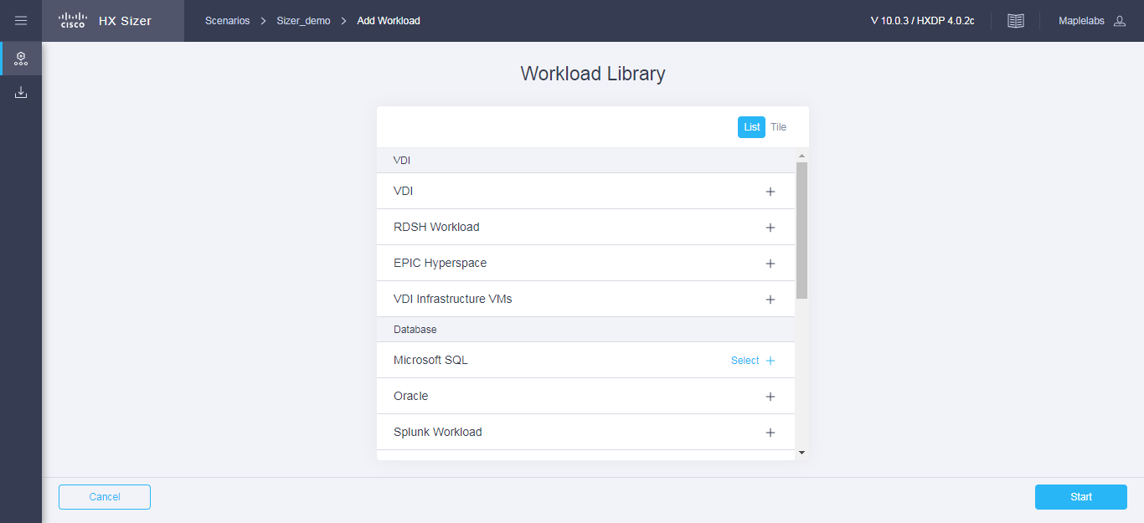

**Step 3** On the **Microsoft SQL Profile** page, complete the following fields:

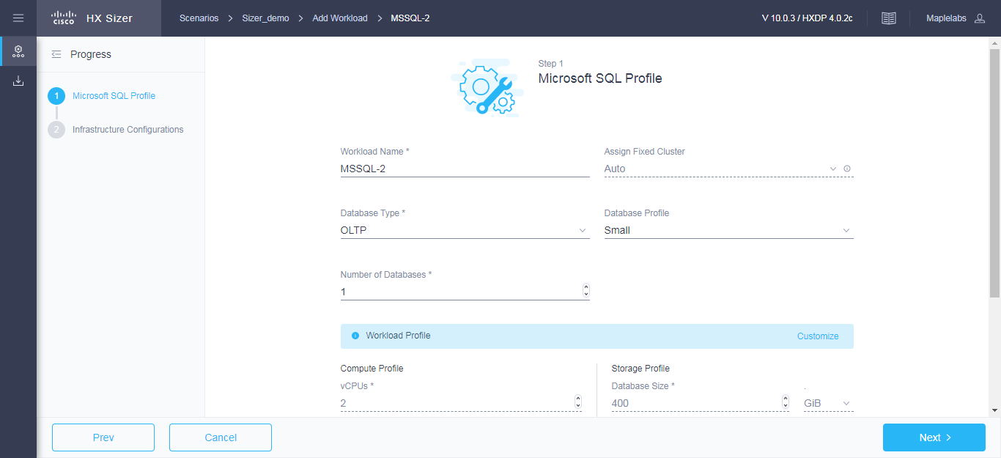

|  |  |
| --- | --- |
| **UI Element** | **Description** |
| **Workload Name** field | Enter a name of the Workload. |
| **Assign Fixed Cluster** drop-down list | Choose the Fixed Cluster to assign for workload. |
| **Database Type** drop-down list | You can choose OLTP or OLAP database type.   * **OLTP**—Represents transactional workloads. The Sizer assigns a workload that consists of 8K 70% read, 30% write; 100% random, when sizing for the specified number of IOPS for OLTP.   **OLAP**—Represents query, reporting, or analytics workloads. The Sizer assigns a workload that consists of large sequential reads when sizing for the specified throughput for OLAP. |
| **Database Profile** drop-down list | Choose from a list of predefined Database Profile values:   * **Small** * **Medium** * **Large** * **Custom**—If the predefined values in the templates listed do not meet your requirements, select the Custom option to manually enter Compute Profile and Storage Profile values. |
| **Number of Databases** field | Enter the total number of databases. |
| **Compute Profile**  Depending on the Database Profile you choose, the recommended values will change. | |
| **vCPUs** field | * Small—2 vCPUs * Medium—4 vCPUs * Large—8 vCPUs |
| **vCPU Provisioning Ratio** field | Recommended is 2 vCPUs. |
| **RAM (GB)** field | * Small—8 GB * Medium—16 GB * Large—32 GB |
| **Storage Profile**  Depending on the Database Profile you choose, the recommended values will change. | |
| **Database Size (GB)** field | * Small—400 GB * Medium—1000 GB * Large—4000 GB |
| **IOPS** field | IOPS changes based on the Database Type you choose.  For OLTP Database Type, the following values are recommended:   * Small—1000 IOPS * Medium—3000 IOPS * Large—10000 IOPS   For OLAP Database Type, the following values are recommended:   * Small—100 MB/s * Medium—200 MB/s * Large—800 MB/s |
| **Database Overhead (%)** field | * Small—45% * Medium—40% * Large—30% |

Click **Next**.

**Step 4** On the **Infrastructure Configuration** page, complete the following fields:

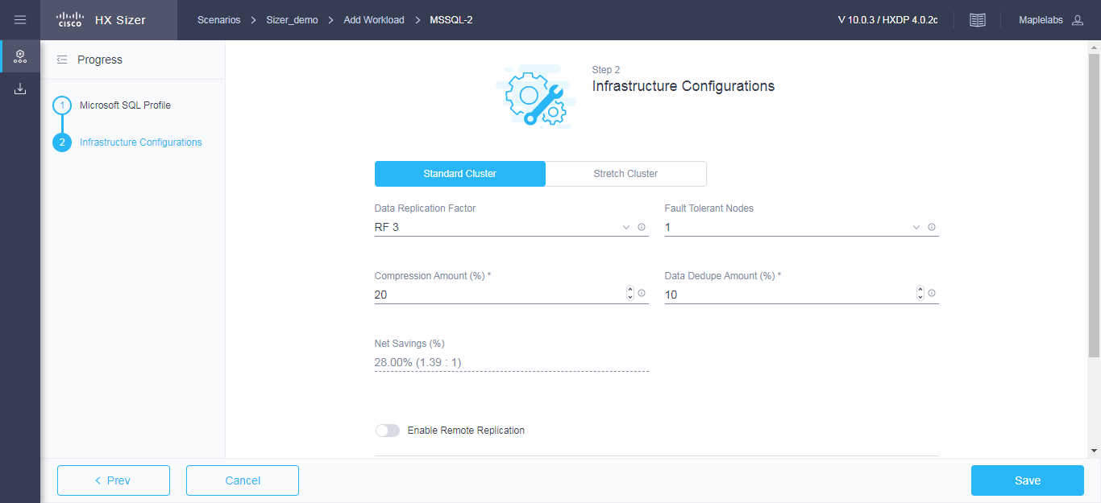

|  |  |
| --- | --- |
| **UI Element** | **Description** |
| **Cluster Type** button | * Normal * Stretch - The Stretch Cluster provides a   high-availability cluster for data of high importance. This cluster is spread across two geographic regions and will be available even if one site goes down completely for any reason, such as a natural disaster. |
| **Data Replication Factor** drop-down list | RF3 is recommended for data redundancy. |
| **Fault Tolerant Node** drop-down list | Enter the number of nodes used for Fault Tolerance. Recommended is 1 node.  Setting Performance Headroom adds additional nodes to the cluster to ensure that there is enough performance bandwidth in case of a node failure. |
| **Compression Amount (%)** field | Recommended is 20% |
| **Data Dedupe Amount (%)** field | Recommended is 10% |
| **Enable Remote Replication?** check box | Choose to enable remote replication. You can now set Workload placement and site failure protection as follows:  **Primary Workload Placement** drop-down list   * **Site A** * **Site B**   **Site Failure Protection (% Workload)**—Recommended is 100% |

**Step 5** Click **Save**.

## Add Oracle Workload

To change the default values, click **Customize**.



**Attention** The recommended values are based on performance tests and should be changed with caution.

**Note**: RAM Overprovisioning can be considered by modifying the input RAM by the appropriate RAM overprovisioning factor.

Example: 4 GB of RAM / Overprovisioning Ratio of 2 = 2 GB of RAM.

Please refer to the following links for more details on the implications of RAM overprovisioning.

<https://kb.vmware.com/s/article/2097593>

<https://kb.vmware.com/s/article/2080735>

**Step 1** Click the + Add Workload icon under **Workloads**.

**Step 2** On the **Workload Type** page, select **Oracle** (shown as follows). Click **Start**.

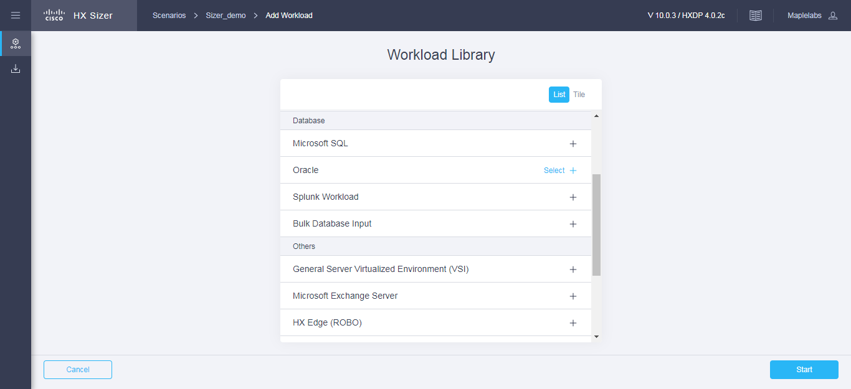

**Step 3** On the **Oracle Profile** page, complete the following fields:

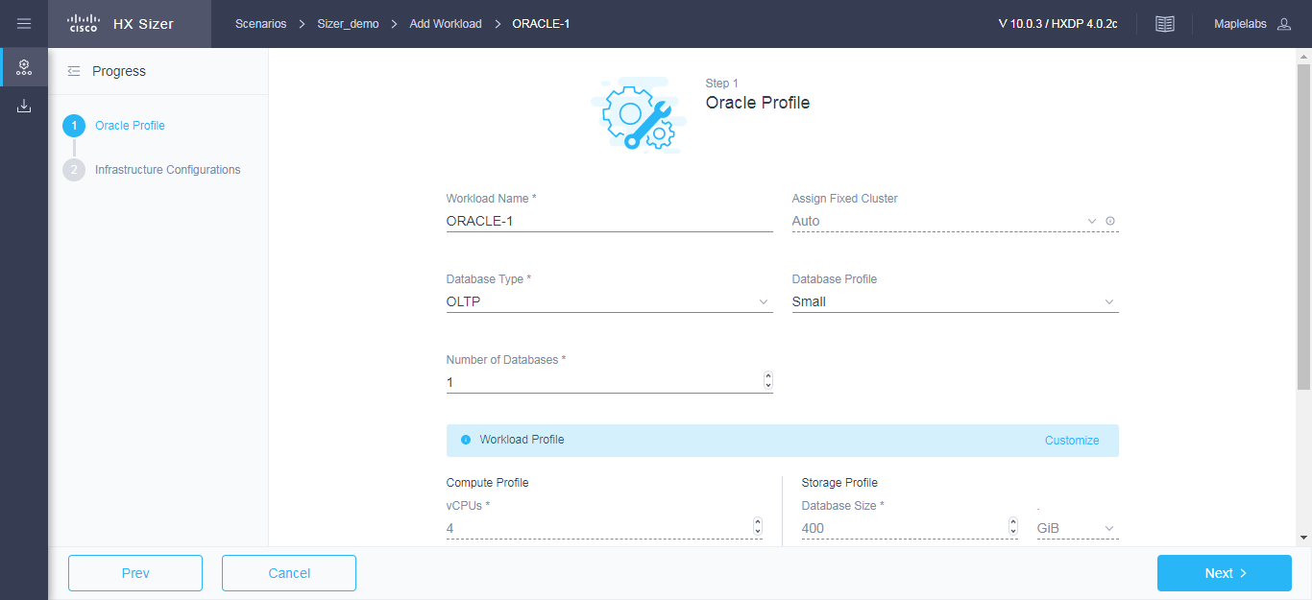

|  |  |
| --- | --- |
| **UI Element** | **Description** |
| **Workload Name** field | Enter a name of the Workload. |
| **Assign Fixed Cluster** drop-down list | Choose the Fixed Cluster to assign for workload. |
| **Database Type** drop-down list | You can choose OLTP or OLAP database type.   * **OLTP**—Represents transactional workloads. The Sizer assigns a Workload that consists of 8K 70% read, 30% write; 100% random, when sizing for the specified number of IOPS for OLTP. * **OLAP**—Represents query, reporting, or analytics workloads. Sizer assigns a workload that consists of large sequential reads, when sizing for the specified throughput for OLAP. |
| **Database Profile** drop-down list | Choose from a list of predefined Database Profile values:   * **Small** * **Medium** * **Large**   **Custom**—If the predefined values in the templates listed do not meet your requirements, select the Custom option to manually enter Compute Profile and Storage Profile values. |
| **Number of Databases** field | Enter the total number of databases. |

|  |  |
| --- | --- |
| **UI Element** | **Description** |
| **Compute Profile**  Depending on the Database Profile you choose, the recommended values will change. | |
| **vCPUs** field | * Small—4 vCPUs * Medium—8 vCPUs * Large—16 vCPUs |
| **vCPU Provisioning Ratio** field | Recommended is 2 vCPUs. |
| **RAM (GB)** field | * Small—16 GB * Medium—64 GB * Large—96 GB |
| **Storage Profile**  Depending on the Database Profile you choose, the recommended values will change. | |
| **Database Size (GB)** field | * Small—400 GB * Medium—1000 GB * Large—4000 GB |
| **IOPS** field | IOPS changes based on the Database Type you choose.  For OLTP Database Type, the following values are recommended:   * Small—6000 IOPS * Medium—10000 IOPS * Large—30000 IOPS   For OLAP Database Type, the following values are recommended:   * Small—200 MB/s * Medium—400 MB/s * Large—1000 MB/s |
| **Database Overhead (%)** field | * Small—45% * Medium—40% * Large—30% |

Click **Next**.

**Step 4** On the **Infrastructure Configuration** page, complete the following fields:

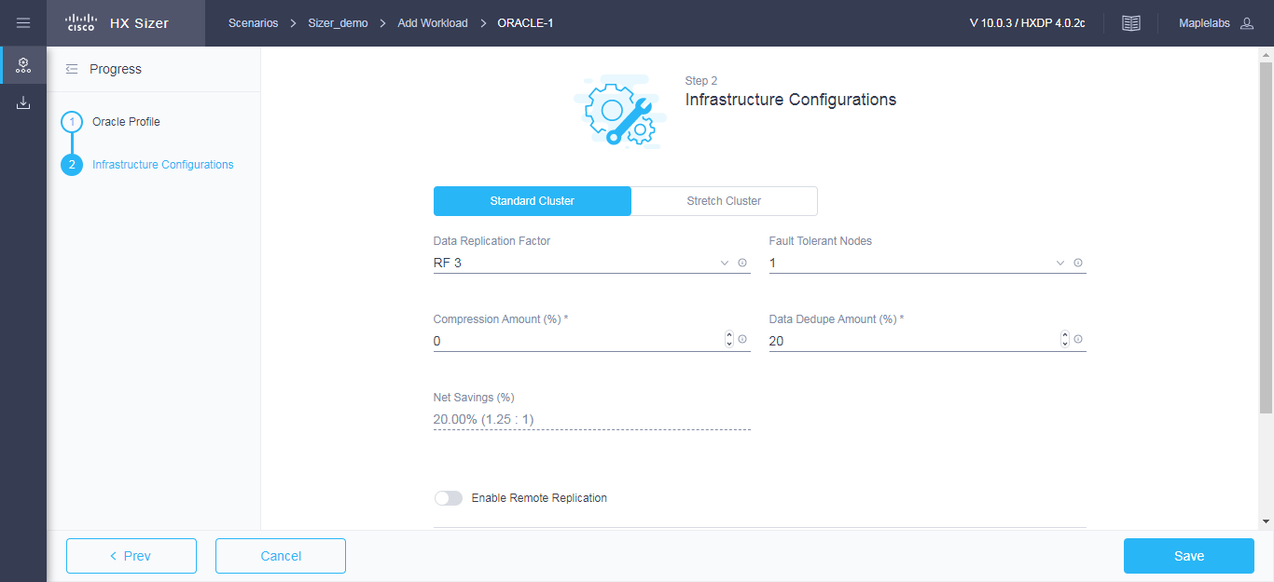

|  |  |
| --- | --- |
| **UI Element** | **Description** |
| **Cluster Type** button | * Normal * Stretch - The Stretch Cluster provides a   high-availability cluster for data of high importance. This cluster is spread across two geographic regions and will be available even if one site goes down completely for any reason, such as a natural disaster. |
| **Data Replication Factor** drop-down list | RF3 is recommended for data redundancy. |
| **Fault Tolerant Node** drop-down list | Enter the number of nodes used for Fault Tolerance. Recommended is 1 node.  Setting Performance Headroom adds additional nodes to the cluster to ensure that there is enough performance bandwidth in case of a node failure. |
| **Compression Amount (%)** field | Recommended is 30% |
| **Data Dedupe Amount (%)** field | Recommended is 0% |
| **Enable Remote Replication?** check box | Choose to enable remote replication. You can now set Workload placement, and site failure protection as follows:  **Primary Workload Placement** drop-down list   * **Site A** * **Site B**   **Site Failure Protection (% Workload)**—Recommended is 100. |

**Step 5** Click **Save**.

## 

## Add Splunk Workload

To change the default values, click **Customize**.



**Attention** The recommended values are based on performance tests and should be changed with care.

**Note**: RAM Overprovisioning can be considered by modifying the input RAM by the appropriate RAM overprovisioning factor.

Example: 4 GB of RAM / Overprovisioning Ratio of 2 = 2 GB of RAM.

Please refer to the following links for more details on the implications of RAM overprovisioning.

<https://kb.vmware.com/s/article/2097593>

<https://kb.vmware.com/s/article/2080735>

To add Splunk Workload:

**Step 1** Click the + Add Workload button under **Workloads**.

**Step 2** On the **Workload Type** page, select **Splunk Workload** (shown as follows). Click **Start**.

## 

**Step 3** On the Splunk Profile page, complete the following fields:

## 

|  |  |
| --- | --- |
| **UI Element** | **Description** |
| **Workload Name** field | Name of the Workload |
| **Assign Fixed Cluster** drop-down list | Choose the Fixed Cluster to assign for workload. |
| **Profile Type** drop-down list | Choose from a list of predefined profile values:   * **Enterprise Security** * **IT Service Intelligence** * **ITOA (IT Operations Analytics)**   Depending on the Profile Type chosen, the VM Type values change. It can also be Customized based on requirement. |
| **Daily data ingest** field | Enter the value for Daily data ingest. |
| **Max Volume per Indexer** field | Enter value for Max Volume per Indexer. |
| **Storage Accumulation** drop-down list | Choose from a list of predefined profile values:   * **HX + Splunk** * **HX + Splunk Smartstore**   Depending on the Storage Accumulation you choose, the recommended values for Hot tier, Cold Tier, Frozen Tier and Splunk Level Replication will change. |

**Step 4** On the **Infrastructure Configuration** page, complete the following fields.

## 

|  |  |
| --- | --- |
| **UI Element** | **Description** |
| **Replication Factor** drop-down list | RF2 is for data redundancy. |
| **Fault Tolerant Node** field | Enter the number of nodes used for Fault Tolerance. Recommended is 1 node.  Setting Performance Headroom adds additional nodes to the cluster to ensure that there is enough performance bandwidth in case of a node failure. |
| **Compression Savings (%)** field | Splunk is assumed to provide net compression savings of 50%  Recommended is 0%. |
| **Deduplication Settings (%)** field | Recommended is 0% |

**Step 5** Click **Save.**

## Add Bulk Database Input Workload

To change the default values, click **Customize**.



**Attention** The recommended values are based on performance tests and should be changed with care.

To add a Bulk Database Input Workload:

**Step 1** Click the + Add Workload button under **Workloads**.

**Step 2** On the **Workload Type** page, select **Bulk Database Input** (shown as follows). Click **Start**.

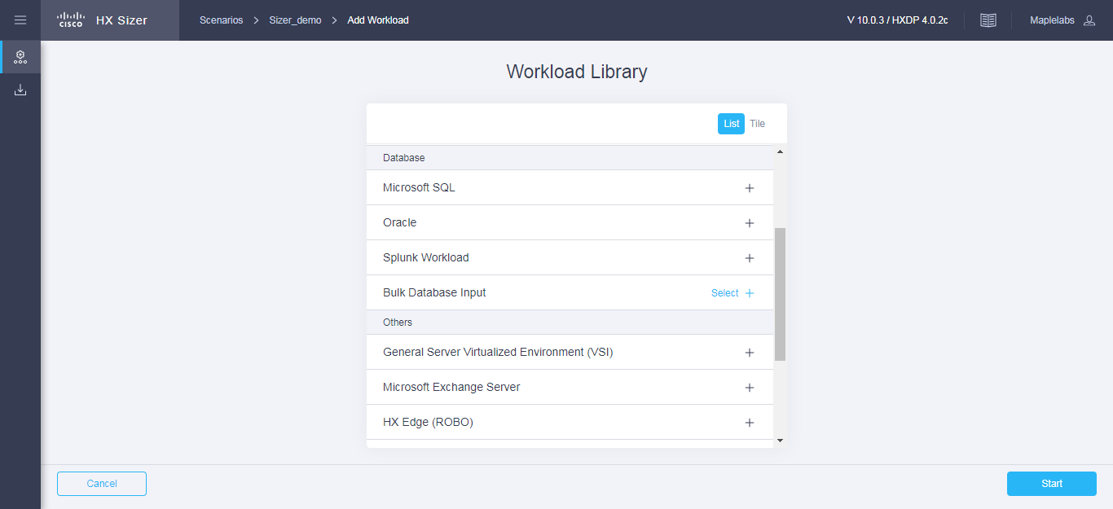

**Step 3** On the **Workload Profile** page, complete the following fields:

Download Bulk Database workload modeling spreadsheet template from the link provided. Fill out workload details properly based on the template provided before uploading. Upload the completed spreadsheet.

|  |  |
| --- | --- |
| **UI Element** | **Description** |
| **Workload Input** field | Upload an Excel file to process workload inputs. |

**Step 4** Click **Save**.

## Other Workloads

## Add General Server Virtualized Environment (VSI) Workload

To change the default values, click **Customize**.



**Attention** The recommended values are based on performance tests and should be changed with care.

**Note**: RAM Overprovisioning can be considered by modifying the input RAM by the appropriate RAM overprovisioning factor.

Example: 4 GB of RAM / Overprovisioning Ratio of 2 = 2 GB of RAM.

Please refer to the following links for more details on the implications of RAM overprovisioning.

<https://kb.vmware.com/s/article/2097593>

<https://kb.vmware.com/s/article/2080735>

To add a General Server Virtualized Environment (VSI) Workload:

**Step 1** Click the + Add Workload button under **Workloads**.

**Step 2** On the **Workload Type** page, select **General Server Virtualized Environment (VSI)** (shown as follows). Click **Start**.

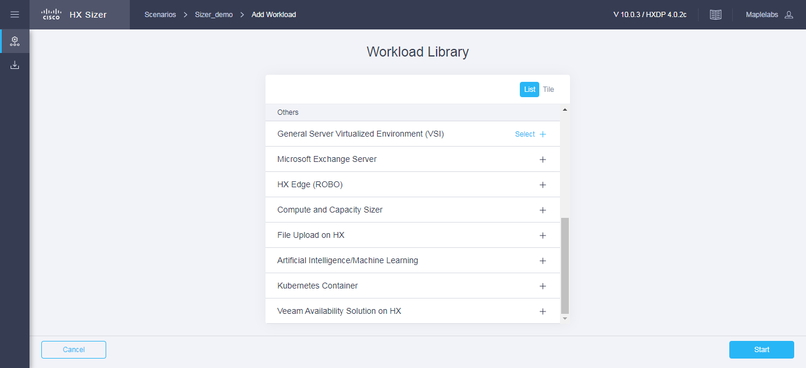

**Step 3** On the **VSI Profile** page, complete the following fields:

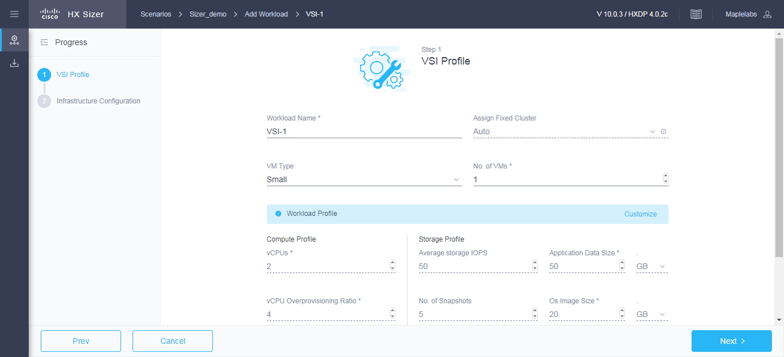

|  |  |
| --- | --- |
| **UI Element** | **Description** |
| **Workload Name** field | Enter a name for the Workload. |
| **Assign Fixed Cluster** drop-down list | Choose the Fixed Cluster to assign for workload. |
| **VM Type** drop-down list | Choose from a list of predefined resource consumptions values:   * **Small** * **Medium** * **Large** * **Custom**—If the predefined resource consumption values in the templates listed do not meet the requirements, select Custom option to enter profile values on the Infrastructure Configuration page. |
| **Number of VMs** field | Enter the number of VMs. |
| **VM Compute Profile**  Depending on the VM Type you choose, the recommended values will change. | |
| **vCPUs** field | * Small—2 vCPUs * Medium—4 vCPUs   Large—8 vCPUs |
| **vCPU Overprovisioning Ratio** field | Recommended value for all VM Types is 4 vCPUs.   * The total number of vCPUs that can be packed per core. |
| **RAM (GB)** field | * Small—8 GB * Medium—16 GB * Large—32 GB |
| **VM Storage Profile**   * Depending on the VM Type you choose, the recommended values will change. | |

|  |  |
| --- | --- |
| **UI Element** | **Description** |
| **Average 8K Storage IOPS** field | * Small—50 IOPS * Medium—100 IOPS * Large—200 IOPS |
| **User / Application Data Size (GB)** field | * Small—50 GB * Medium—200 GB * Large—750 GB |
| **OS Image Size (GB)** field | Recommended is 20 GB.   * Size of the OS image for the VM. |
| **Number of Snapshots** field | Recommended is 5 snapshots. |
| **Working Set Size (%)** field | Recommended is 10% |

Click **Next**.

**Step 4** On the **Infrastructure Configuration** page, complete the following fields.

|  |  |
| --- | --- |
| **UI Element** | **Description** |
| **Cluster Type** button | * Normal * Stretch - The Stretch Cluster provides a   high-availability cluster for data of high importance. This cluster is spread across two geographic regions and will be available even if one site goes down completely for any reason, such as a natural disaster. |
| **Data Replication Factor** drop-down list | RF2 is recommended for better availability. |
| **Fault Tolerant Node** drop-down list | Enter the number of nodes used for Fault Tolerance. Recommended is 1 node.  Setting Performance Headroom adds additional nodes to the cluster to ensure that there is enough performance bandwidth in case of a node failure. |
| **Compression Savings (%)** field | Recommended is 20% |
| **Deduplication Savings (%)** field | Recommended is 10% |
| **Enable Remote Replication?** | Choose to enable remote replication. You can now set Workload placement and site failure protection as follows:  **Primary Workload Placement** drop-down list   * **Site A** * **Site B**   **Site Failure Protection (% Workload)**—Recommended is 100. |

**Step 5** Click **Save**.

## Add Microsoft Exchange Server Workload

To change the default values, click **Customize**.



**Attention** The recommended values are based on performance tests and should be changed with care.

To add a Microsoft Exchange Server Workload:

**Step 1** Click the + Add Workload button under **Workloads**.

**Step 2** On the **Workload Type** page, select **Microsoft Exchange Server** (shown as follows). Click **Start**.

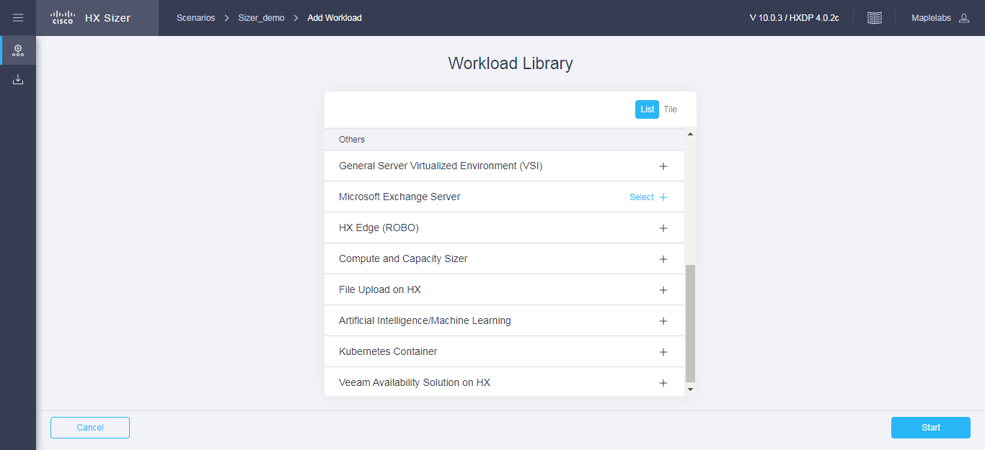

**Step 3** On the **Workload Profile** page, import the values from a file.

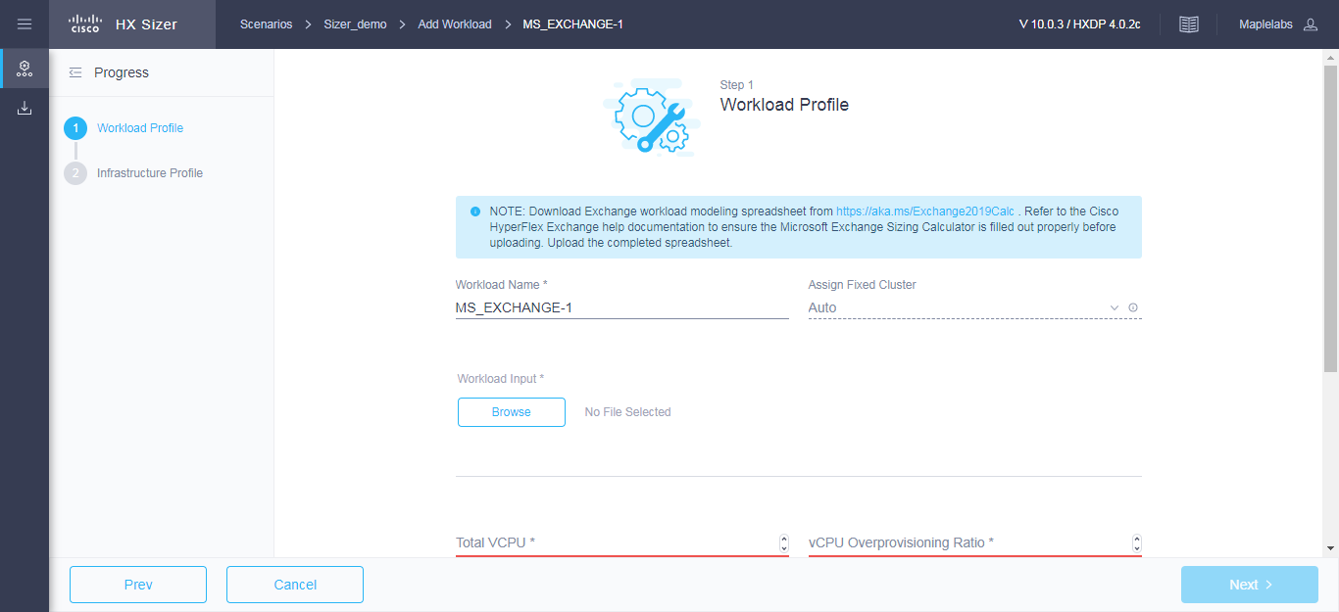

|  |  |
| --- | --- |
| **UI Element** | **Essential Information** |
| **Workload Name** field | Enter a name for the Workload. |
| **Assign Fixed Cluster** drop-down list | Choose the Fixed Cluster to assign for workload. |
| **Workload Input Type** | Download the Microsoft Exchange Workload modeling spreadsheet from [Microsoft Exchange 2013 Server Role](https://blogs.technet.microsoft.com/exchange/2013/05/14/released-exchange-2013-server-role-requirements-calculator/) [Requirements Calculator.](https://blogs.technet.microsoft.com/exchange/2013/05/14/released-exchange-2013-server-role-requirements-calculator/)  **Important** Ensure that the Microsoft Exchange 2013 Sizing Calculator is filled out properly, refer to the Configure the Microsoft Exchange 2013 Server Role Requirements Calculator, on page 41.  Upload the completed *.XLSM* spreadsheet to process workload inputs. |
| **vCPUs** field | Total number of cores required for all the MS Exchange Servers after accounting for system overhead. Intel E5-2630 v4 is used as the reference CPU for core count. |
| **vCPU Overprovisioning Ratio** field | Total number of vCPUs that can be packed per core. |
| **Total RAM (GB)** field | The total RAM required for all guest VMs, after accounting for system overhead. |
| **Effective User Capacity (GB)** field | This value depends on the Dedupe or Compression savings. You can change the Deduplication and compression savings on the Infrastructure Configuration Page. |
| **DB IOPS** field | Average 16KB IOPS, with 100% random 60/40 read/write ratio. |
| **Log IOPS** field | Average 32KB IOPS, with 100% random 60/40 read/write ratio. |
| **Maintenance IOPS** field | Average 64KB IOPS, with 100% random 60/40 read/write ratio. |
| **Future Growth (%)** field | Specify percentage to allow for future growth of the environment for Physical Cores, RAM, and Effective User Capacity. |

Click **Next**.

**Step 4** On the **Infrastructure Configuration** page, complete the following fields.

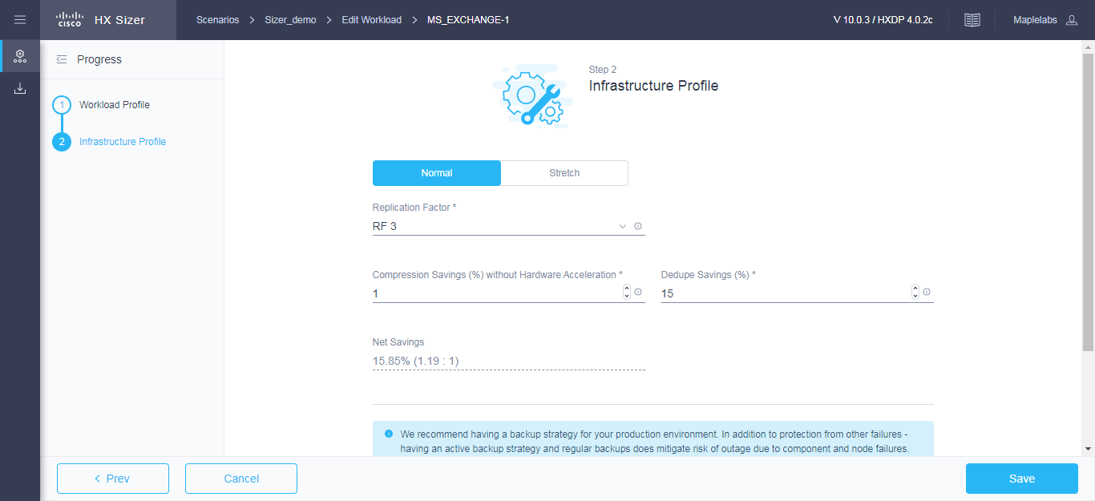

|  |  |
| --- | --- |
| **UI Element** | **Essential Information** |
| **Cluster Type** button | * Normal * Stretch - The Stretch Cluster provides a   high-availability cluster for data of high importance. This cluster is spread across two geographic regions and will be available even if one site goes down completely for any reason, such as a natural disaster. |
| **Data Replication Factor** field | RF3 is recommended for better availability. |
| **Fault Tolerant Node** field | Number of nodes of Fault Tolerance.  Setting Performance Headroom adds additional nodes to the cluster to ensure that there is enough performance bandwidth in case of node failure. |
| **Compression Savings (%)** field | By default is set to 15%.  The allowed range is 0-99% |
| **Deduplication Settings (%)** field | By default is set to 15%.  The allowed range is 0-99% |

**Step 5** Click **Save**.

## Add HX Edge (ROBO) Workload

To change the default values, click **Customize**.



**Attention** The recommended values are based on performance tests and should be changed with care.

**Note**: RAM Overprovisioning can be considered by modifying the input RAM by the appropriate RAM overprovisioning factor.

Example: 4 GB of RAM / Overprovisioning Ratio of 2 = 2 GB of RAM.

Please refer to the following links for more details on the implications of RAM overprovisioning.

<https://kb.vmware.com/s/article/2097593>

<https://kb.vmware.com/s/article/2080735>

To add a HX Edge (ROBO) Workload:

**Step 1** Click the + icon under **Workloads**.

**Step 2** On the **Workload Type** page, select **HX Edge (ROBO)** (shown as follows). Click **Start**.

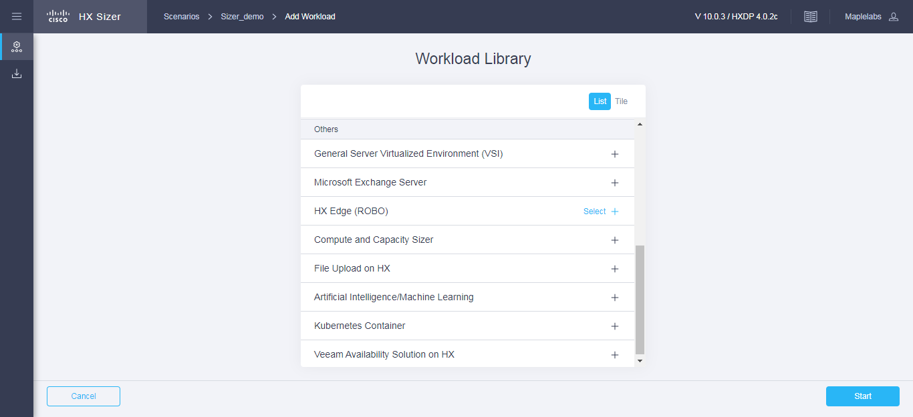

**Step 3** On the **HX** **Edge Profile** page, complete the following fields:

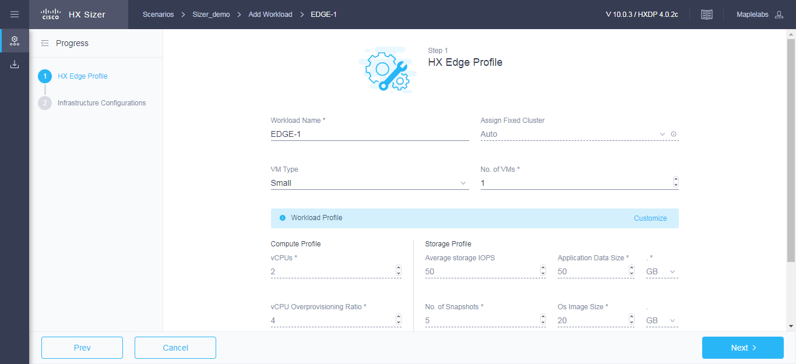

|  |  |
| --- | --- |
| **UI Element** | **Description** |
| **Workload Name** field | Enter a name for the Workload. |
| **Assign Fixed Cluster** drop-down list | Choose the Fixed Cluster to assign for workload. |
| **VM Type** drop-down list | Choose from a list of predefined resource consumptions values:   * **Small** * **Medium** * **Large** * **Custom**—If the predefined resource consumption values in the templates listed do not meet the requirements, select the Custom option to enter profile values on the Infrastructure Configuration page. |
| **Number of VMs** field | Enter the number of VMs. |
| **VM Compute Profile**  Depending on the VM Type you choose, the recommended values will change. | |
| **vCPUs** field | * Small—2 vCPUs * Medium—4 vCPUs * Large—8 vCPUs |
| **vCPU Overprovisioning Ratio** field | Recommended value for all VM Types is 4.   * The total number of vCPUs that can be packed per core. |
| **RAM (GB)** field | * Small—8 GB * Medium—16 GB * Large—32 GB |
| **VM Storage Profile**  Depending on the VM Type you choose, the recommended values will change. | |
| **Average 8K Storage IOPS** field | * Small—50 IOPS * Medium—100 IOPS * Large—200 IOPS |
| **User / Application Data Size (GB)** field | * Small—50 GB * Medium—100 GB * Large—750 GB |
| **OS Image Size (GB)** field | Recommended is 20 GB.  Size of the OS image for the VM. |
| **Number of Snapshots** field | Recommended is 5 snapshots |
| **Working Set Size (%)** field | Recommended is 10% |

Click **Next**.

**Step 4** On the **Infrastructure Configuration** page, complete the following fields.

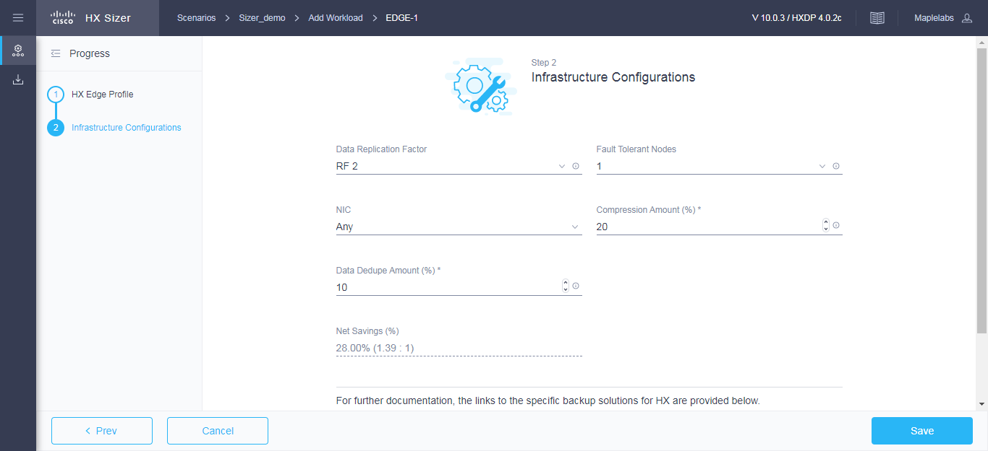

|  |  |
| --- | --- |
| **UI Element** | **Description** |
| **Data Replication Factor** drop-down list | **Caution** Edge workload is supported only with RF 2. |
| **Fault Tolerant nodes** drop-down list | Enter the number of nodes used for Fault Tolerance. Recommended is 1 node.  Setting Performance Headroom adds additional nodes to the cluster to ensure that there is enough performance bandwidth in case of a node failure.  Edge workload is only supported with RF2 and N+0 / N+1 configuration |
| **NIC Details** drop-down list | * Any — Recommended * Single Switch, 1G * Double Switch, 1G * 10G |
| **Compression Savings (%)** field | * Recommended is 20% |
| **Deduplication Savings (%)** field | * Recommended is 10% |

**Step 5** Click **Save**.

## Add Compute and Capacity Sizer (RAW) Workloads

To change the default values, click **Customize**.



**Attention** The recommended values are based on performance tests and should be changed with care.

**Note**: RAM Overprovisioning can be considered by modifying the input RAM by the appropriate RAM overprovisioning factor.

Example: 4 GB of RAM / Overprovisioning Ratio of 2 = 2 GB of RAM.

Please refer to the following links for more details on the implications of RAM overprovisioning.

<https://kb.vmware.com/s/article/2097593>

<https://kb.vmware.com/s/article/2080735>

To add a Compute and Capacity Sizer (RAW) Workload:

**Step 1** Click the + icon under **Workloads**.

**Step 2** On the **Workload Type** tab, select **Compute and Capacity Sizer** (shown as follows). Click **Start**.

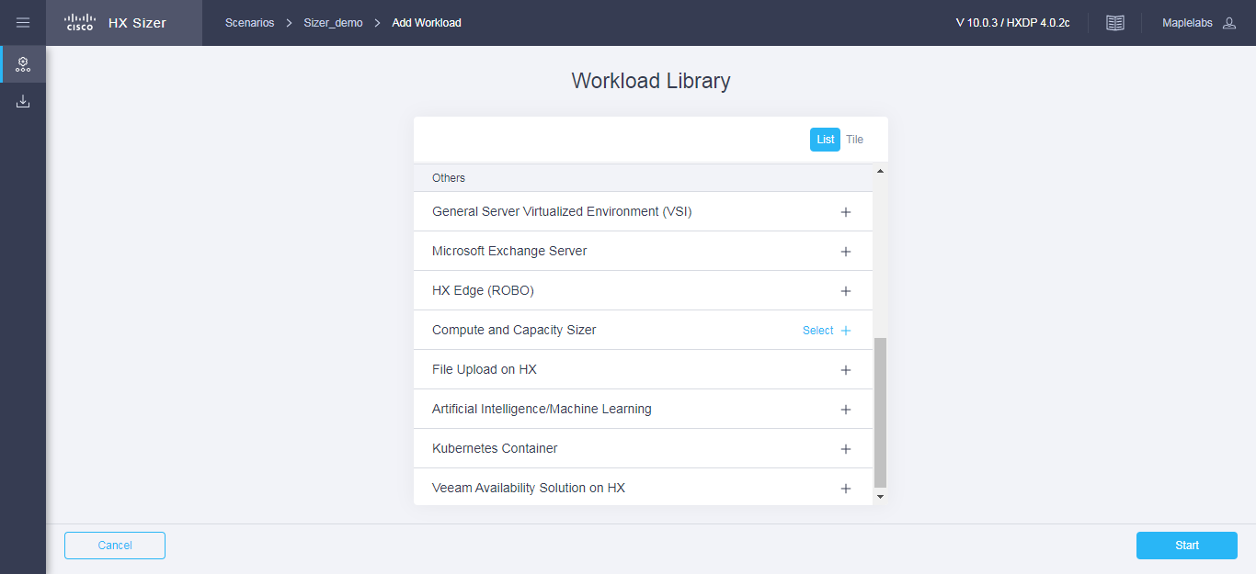

**Step 3** On the **Workload Profile** page, complete the following fields:

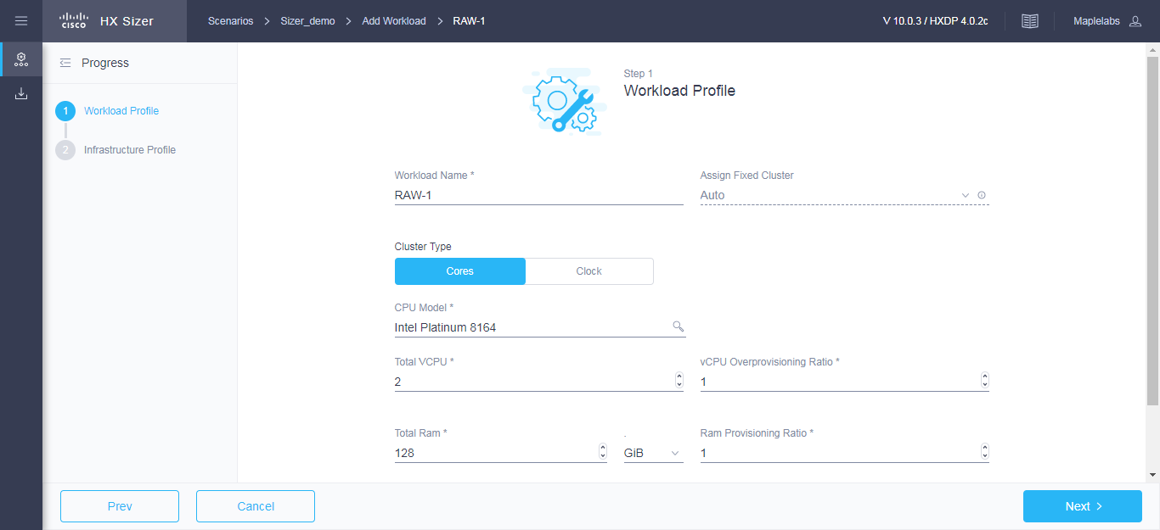

|  |  |
| --- | --- |
| **UI Element** | **Description** |
| **Workload Name** field | Enter a name for the Workload. |
| **Assign Fixed Cluster** drop-down list | Choose the Fixed Cluster to assign for workload. |
| **CPU Unit** field | * Cores by default * Clock |
| **Total vCPUs** field | Default is 2 vCPUs.  The total number of cores required for all the guest VMs after accounting for system overhead. |
| **CPU Overprovisioning Ratio** field | Default is 1 vCPU.  The total number of vCPUs that can be packed per core. |
| **Total RAM (GB)** field | Default is 128 GB.  The total RAM required for all guest VMs after accounting for system overhead. |
| **RAM Overprovisioning Ratio** field | Default is 1.  The Total amount of RAM Provisioned per GB of RAM installed in the system. |
| **Effective User Capacity (GB)** field | Default is 1000 GB.  This value depends on the dedupe or compression savings. You can change the deduplication and compression savings on the Infrastructure Configuration page. |
| **Future Growth (%)** field | Specify the percentage to allow for future growth of the environment for Physical Cores, RAM, and Effective User Capacity. |

Click **Next**.

**Step 4** On the **Infrastructure Configuration** page, complete the following fields.

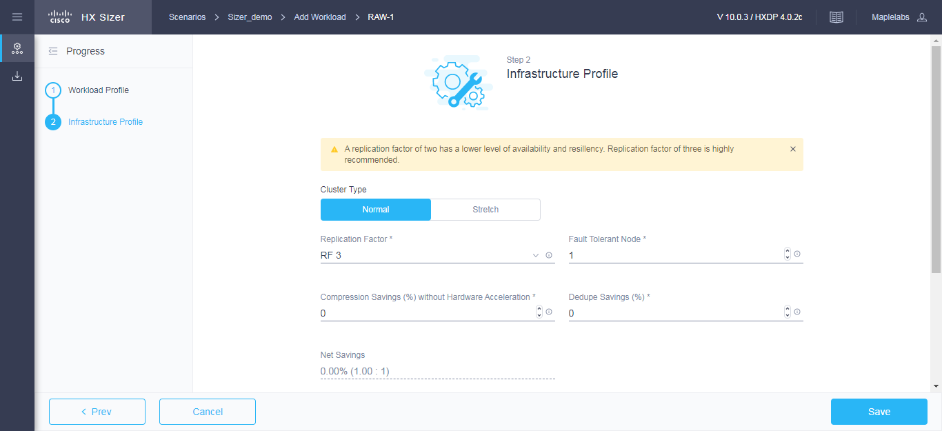

|  |  |
| --- | --- |
| **UI Element** | **Description** |
| **Cluster Type** button | * Normal * Stretch - The Stretch Cluster provides a   high-availability cluster for data of high importance. This cluster is spread across two geographic regions and will be available even if one site goes down completely for any reason, such as a natural disaster. |
| **Data Replication Factor** field | RF3 is recommended for better availability. |
| **Fault Tolerant nodes** drop-down list | Number of nodes of Fault Tolerance.  Setting Performance Headroom adds additional nodes to the cluster to ensure that there is enough performance bandwidth in case of a node failure. |
| **Compression Savings (%)** field | By default set to 0%.  The allowed range is 0-99%. |
| **Deduplication Settings (%)** field | By default, set to 0%.  The allowed range is 0-99%. |

**Step 5** Click **Save**.

## 

## Add File Upload on HX Workloads

To change the default values, click **Customize**.



**Attention** The recommended values are based on performance tests and should be changed with care.

**Note**: RAM Overprovisioning can be considered by modifying the input RAM by the appropriate RAM overprovisioning factor.

Example: 4 GB of RAM / Overprovisioning Ratio of 2 = 2 GB of RAM.

Please refer to the following links for more details on the implications of RAM overprovisioning.

<https://kb.vmware.com/s/article/2097593>

<https://kb.vmware.com/s/article/2080735>

To add the File Upload on HX Workloads:

**Step 1** Click the + Add Workload button under **Workloads**.

**Step 2** On the **Workload Type** tab, select **File Upload on HX** (shown as follows). Click **Start**.

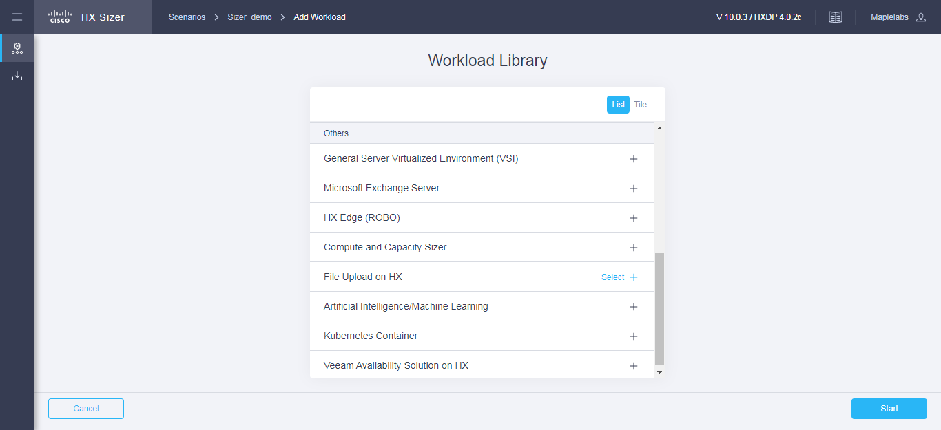

**Step 3** On the **Workload Profile** page, you can choose to enter the values manually or you can import them from a file.

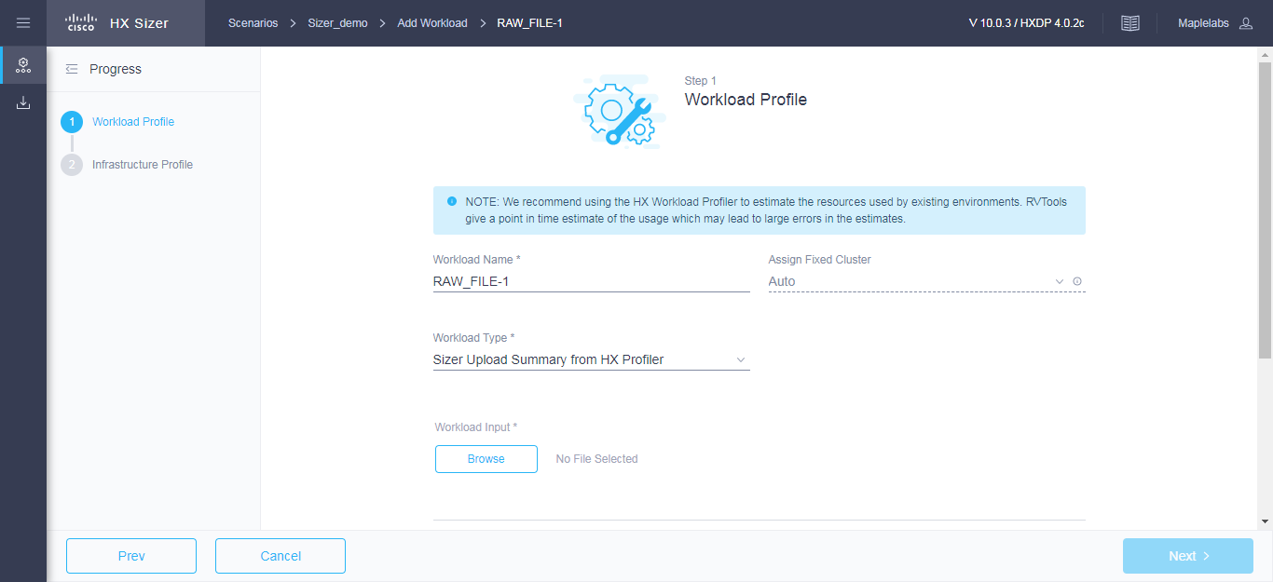

|  |  |
| --- | --- |
| **UI Element** | **Description** |
| **Workload Name** field | Enter a name for the Workload. |
| **Assign Fixed Cluster** drop-down list | Choose the Fixed Cluster to assign for workload. |
| **Workload Input Type** drop down list | * 30-day summary from the HX Profiler tool. (The CSV file can be downloaded from the HX Profiler tool for a 30-day duration period.) * RV Tools Output |
| **Size for** field | * Provisioned - 'Provisioned' will size for the provisioned CPU/Memory/Disk capacity of Hosts & VMs. * Utilized - ‘Utilized’ will size for the actual utilized CPU/Memory/Disk capacity of Hosts & VMs; Utilized will usually be less than provisioned * Recommended is ‘Utilized’. |
| **Total vCPUs** field | Default is 2 vCPUs.  The total number of cores required for all the guest VMs after accounting for system overhead. |
| **CPU Overprovisioning Ratio** field | Default is 1 vCPU.  The total number of vCPUs that can be packed per core. |
| **Total RAM (GB)** field | Default is 128 GB.  The total RAM required for all guest VMs after accounting for system overhead. |
| **RAM Overprovisioning Ratio** field | Default is 1.  The Total amount of RAM Provisioned per GB of RAM installed in the system. |
| **Effective User Capacity (GB)** field | Default is 1000 GB.  This value depends on the dedupe or compression savings. You can change the deduplication and compression savings on the Infrastructure Configuration page. |
| **Future Growth (%)** field | Specify the percentage to allow for future growth of the environment for Physical Cores, RAM, and Effective User Capacity. |

Click **Next**.

**Step 4** On the **Infrastructure Configuration** page, complete the following fields.

|  |  |
| --- | --- |
| **UI Element** | **Description** |
| **Cluster Type** button | * Normal * Stretch - The Stretch Cluster provides a   high-availability cluster for data of high importance. This cluster is spread across two geographic regions and will be available even if one site goes down completely for any reason, such as a natural disaster. |
| **Data Replication Factor** field | RF3 is recommended for better availability. |
| **Fault Tolerant nodes** drop-down list | Number of nodes of Fault Tolerance.  Setting Performance Headroom adds additional nodes to the cluster to ensure that there is enough performance bandwidth in case of a node failure. |
| **Compression Savings (%)** field | By default, set to 0%.  The allowed range is 0-99%. |
| **Deduplication Settings (%)** field | By default, set to 0%.  The allowed range is 0-99%. |

**Step 5** Click **Save**.

## Add Veeam Availability Solution on HX Workloads

To change the default values, click **Customize**.



**Attention** The recommended values are based on performance tests and should be changed with care.

**Note**: RAM Overprovisioning can be considered by modifying the input RAM by the appropriate RAM overprovisioning factor.

Example: 4 GB of RAM / Overprovisioning Ratio of 2 = 2 GB of RAM.

Please refer to the following links for more details on the implications of RAM overprovisioning.

<https://kb.vmware.com/s/article/2097593>

<https://kb.vmware.com/s/article/2080735>

To add a Veeam Availability Solution on HX Workloads:

**Step 1** Click the + Add Workload button under **Workloads**.

**Step 2** On the **Workload Type** tab, select **Veeam Availability Solution on HX** shown as follows). Click **Start**.

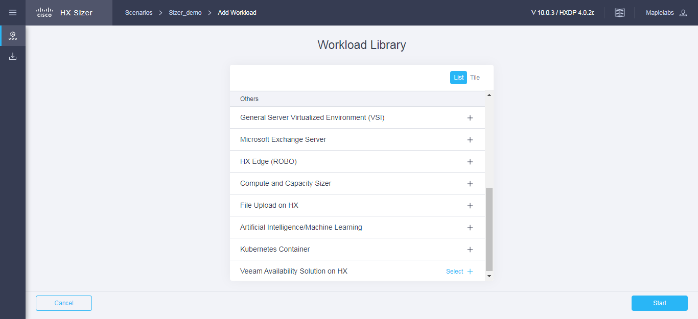

**Step 3** On the **Profile** page, you can choose to enter the values manually or you can input them from a calculation file.

|  |  |
| --- | --- |
| **UI Element** | **Description** |
| **Workload Name** field | Enter a name for the Workload. |
| **Total Storage Capacity Requirement** field | Please visit <http://rps.dewin.me> to perform your calculations. Use the total capacity output and insert into the Total Storage Requirement field. |

For the Infrastructure Configuration values, these are the following non-editable fields values used in Sizing.

|  |  |
| --- | --- |
| **UI Element** | **Description** |
| **Data Replication Factor** field | RF2 is recommended. |
| **Fault Tolerant nodes** drop-down list | 0 Number of nodes of Fault Tolerance.  Setting Performance Headroom adds additional nodes to the cluster to ensure that there is enough performance bandwidth in case of a node failure. |
| **Compression Savings (%)** field | By default, set to 0%.  The external link is already handling Compression savings. |
| **Deduplication Settings (%)** field | By default, set to 0%.  The external link is already handling Compression savings. |

**Step 4** Click **Save**.

## Add Kubernetes Container Workload

To change the default values, click **Customize**.



**Attention** The recommended values are based on performance tests and should be changed with care.

**Note**: RAM Overprovisioning can be considered by modifying the input RAM by the appropriate RAM overprovisioning factor.

Example: 4 GB of RAM / Overprovisioning Ratio of 2 = 2 GB of RAM.

Please refer to the following links for more details on the implications of RAM overprovisioning.

<https://kb.vmware.com/s/article/2097593>

<https://kb.vmware.com/s/article/2080735>

To add a Kubernetes Container Workload:

**Step 1** Click the + Add Workload icon under **Workloads**.

**Step 2** On the **Workload Type** page, select **Kubernetes Container** (shown as follows). Click  **Start**.

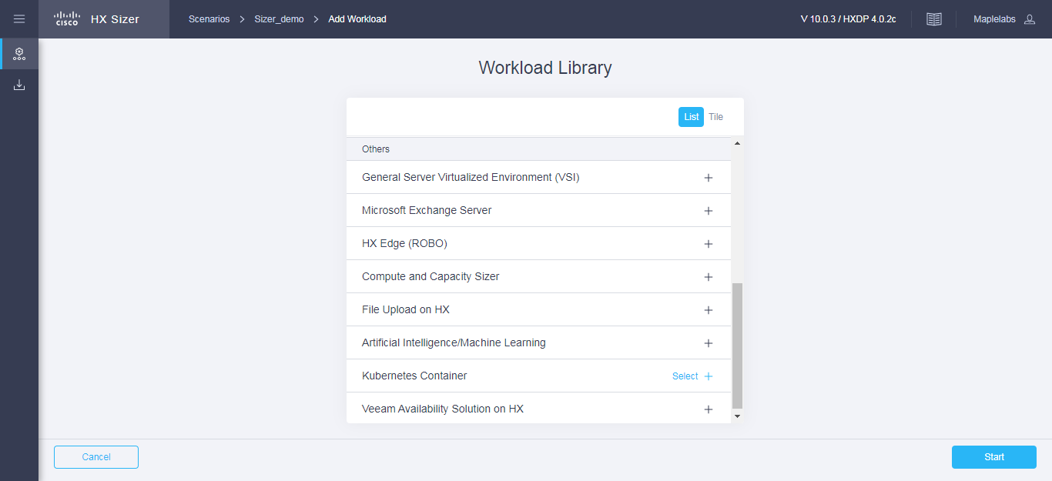

**Step 3** On the **Container Profile** page, complete the following fields:

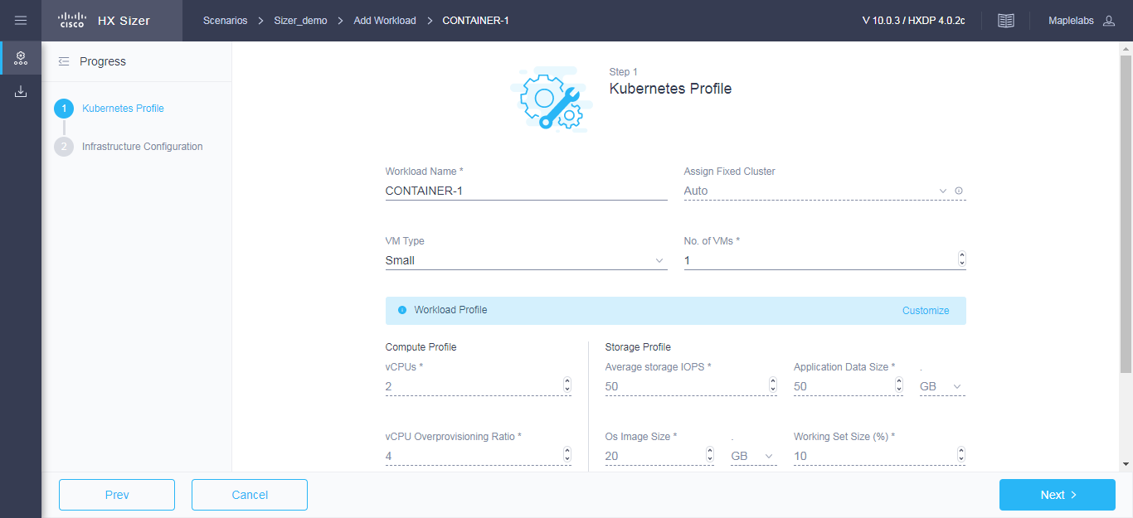

|  |  |
| --- | --- |
| **UI Element** | **Description** |
| **Workload Name** field | Enter a name for the Workload. |
| **Assign Fixed Cluster** drop-down list | Choose the Fixed Cluster to assign for workload. |
| **Container Type** drop-down list | Choose from a list of predefined resource consumptions values:   * **Small** * **Medium** * **Large** * **Custom**—If the predefined resource consumption values in the templates listed do not meet the requirements, select Custom option to enter profile values on the Infrastructure Configuration page. |

|  |  |
| --- | --- |
| **UI Element** | **Description** |
| **Number of Containers** field | Enter the number of Containers. |
| **Container Compute Profile**  Depending on the Container Type you choose, the recommended values will change. | |
| **vCPUs** field | * Small—2 vCPUs * Medium—4 vCPUs * Large—8 vCPUs |
| **vCPU Overprovisioning Ratio** field | Recommended value for all VM Types is 4 vCPUs.  The total number of vCPUs that can be packed per core. |
| **RAM (GB)** field | * Small—8 GB * Medium—16 GB * Large—32 GB |
| **Container Storage Profile**  Depending on the Container Type you choose, the recommended values will change. | |
| **Average Storage IOPS** field | * Small—50 IOPS * Medium—100 IOPS * Large—200 IOPS |
| **User / Application Data Size (GB)** field | * Small—50 GB * Medium—200 GB * Large—750 GB |
| **OS Image Size (GB)** field | Recommended is 20 GB.  Size of the OS image for the VM. |
| **Working Set Size (%)** field | Recommended is 10% |

Click **Next**.

**Step 4** On the **Infrastructure Configuration** page, complete the following fields.

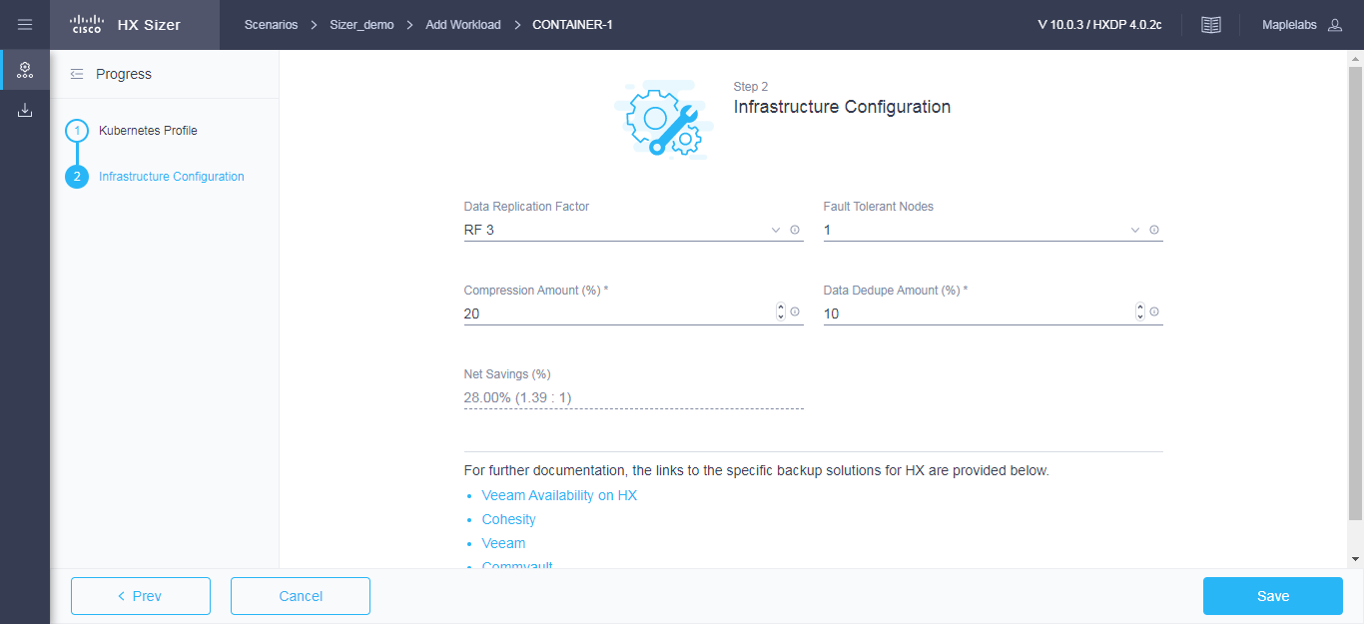

|  |  |
| --- | --- |
| **UI Element** | **Description** |
| **Data Replication Factor** drop-down list | RF3 is recommended for better availability. |
| **Fault Tolerant nodes** drop-down list | Enter the number of nodes used for Fault Tolerance. Recommended is 1 node.  Setting Performance Headroom adds additional nodes to the cluster to ensure that there is enough performance bandwidth in case of a node failure. |
| **Compression Savings (%)** field | Recommended is 20% |
| **Deduplication Savings (%)** field | Recommended is 10% |

**Step 5** Click **Save**.

## Add Artificial Intelligence/Machine Learning Workload

To change the default values, click **Customize**.



**Attention** The recommended values are based on performance tests and should be changed with care.

To add a Artificial Intelligence/Machine Learning Workload:

**Step 1** Click the + icon under **Workloads**.

**Step 2** On the **Workload Type** page, select **Artificial Intelligence/Machine Learning** (shown as follows). Click  **Start**.

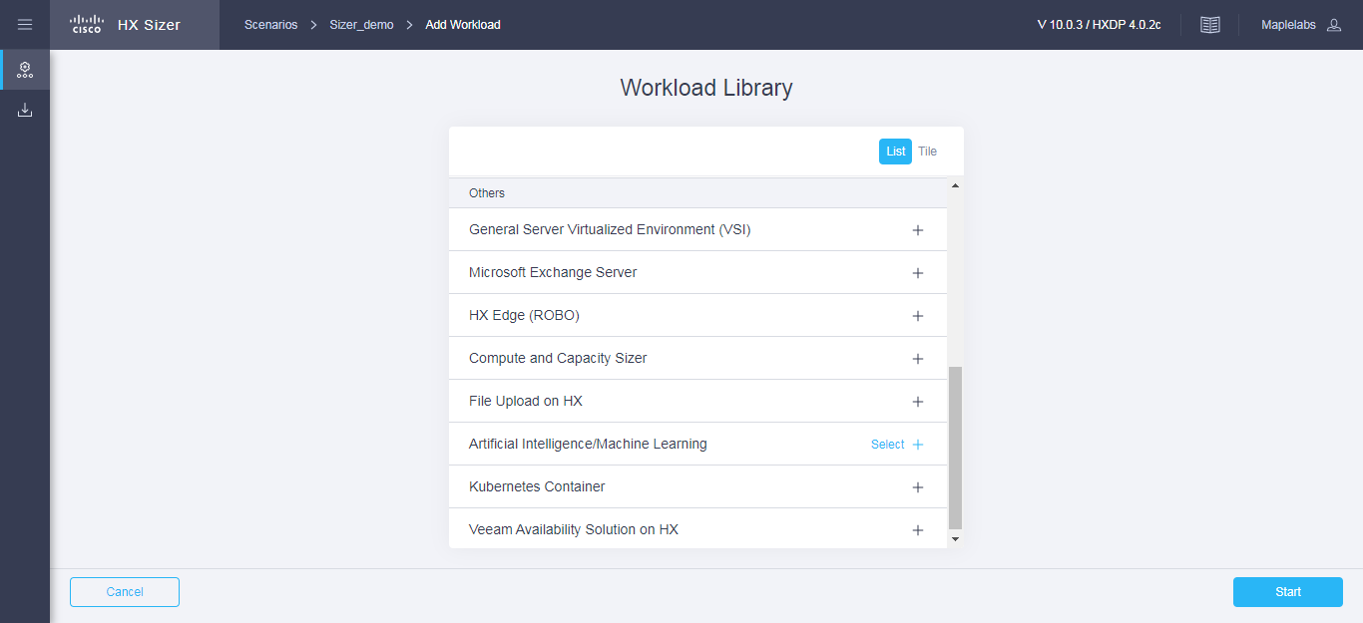

**Step 3** On the **AIML Profile** page, complete the following fields:

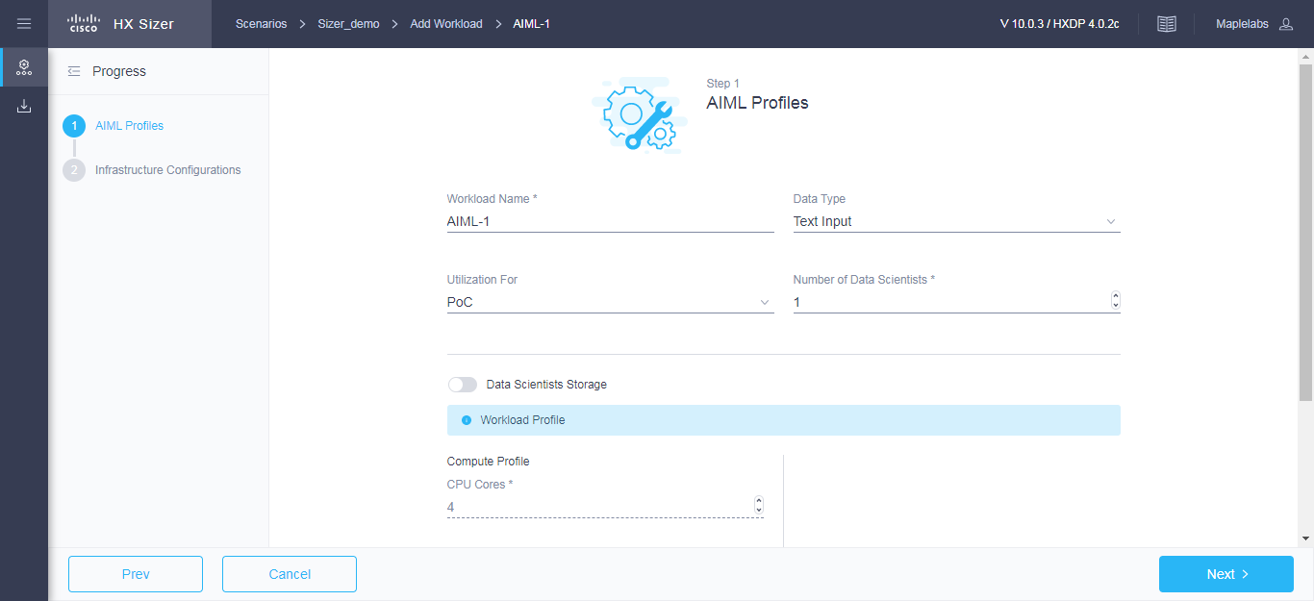

|  |  |
| --- | --- |
| **UI Element** | **Description** |
| **Workload Name** field | Enter a name for the Workload. |
| **Number of Data Scientists** field | Enter the number of Data Scientists. |
| **Input Source** drop-down list | Choose from a list of predefined resource consumptions values:   * **Text Input** * **Video, Voice, Images** |

|  |  |
| --- | --- |
| **UI Element** | **Description** |
| **Expected Utilization** drop-down list | Choose from a list of predefined resource consumptions values:   * **POC** * **Serious Development** |
| **Storage on HX cluster** field | Enable if Storage on HX cluster ? |
| **Compute Profile Per Data Scientist**  Depending on the Input Source and Serious Development you choose, the recommended values will change. | |
| **CPU Cores (**per Data Scientist) field | * Text Input / POC —4 Cores * Text Input / Serious Development —8 Cores * Video, Voice, Images / POC – 8 Cores * Video, Voice, Images / Serious development – 8 Cores |
| **System RAM (**per Data Scientist) field | * Text Input / POC —64 GB * Text Input / Serious Development —128 GB * Video, Voice, Images / POC – 128 GB * Video, Voice, Images / Serious development – 128 GB |
| **GPUs (**per Data Scientist) field | * Text Input / POC — 1 * Text Input / Serious Development —1 * Video, Voice, Images / POC – 1 * Video, Voice, Images / Serious development – 8 |

Click **Next**.

**Step 4** On the **Infrastructure Configuration** page, complete the following fields.

|  |  |
| --- | --- |
| **UI Element** | **Description** |
| **Data Replication Factor** drop-down list | RF3 is recommended for better availability. |
| **Fault Tolerant nodes** drop-down list | Enter the number of nodes used for Fault Tolerance. Recommended is 1 node.  Setting Performance Headroom adds additional nodes to the cluster to ensure that there is enough performance bandwidth in case of a node failure. |
| **Compression Savings (%)** field | Recommended is 0% |
| **Deduplication Savings (%)** field | Recommended is 20% |

**Step 5** Click **Save**.

**41**



**C H A P T E R 4**

# ConfigureMicrosoftExchange2013ServerRole Requirements Calculator

* + Configure the Microsoft Exchange 2013 Server Role Requirements Calculator, on page 41
  + Troubleshooting, on page 44

## Configure the Microsoft Exchange 2013 Server Role Requirements Calculator

#### Overview

Download the Microsoft Exchange Workload modeling spreadsheet from [Microsoft Exchange 2013 Server](https://blogs.technet.microsoft.com/exchange/2013/05/14/released-exchange-2013-server-role-requirements-calculator/) [Role Requirements Calculator.](https://blogs.technet.microsoft.com/exchange/2013/05/14/released-exchange-2013-server-role-requirements-calculator/) Read the Microsoft Exchange Calculator Readme file for comprehensive guidance on using the calculator.

Cisco HyperFlex Sizer provides the BOM for the primary datacenter only. This section provides the parameters that should be configured on the **Input Tab** of the Microsoft Exchange Calculator. Customers who plan to deploy in multiple datacenters and stretch the Database Availability Group (DAG) must complete the input for the secondary datacenter under **Site Resilience Configuration**. Completing this input ensures that the primary datacenter Compute and Storage requirements are properly sized to handle all users in the event that the secondary datacenter is down.

#### Exchange Environment Configuration

|  |  |
| --- | --- |
| **Configuration Settings** | **Value** |
| **Exchange Server Version** | 2016 |
| **Global Catalog Server Architecture** | 64-bit |
| **Server Role Virtualization** | Yes |
| **High Availability Deployment** | Yes  If a DAG is planned, ensure that *High Availability Deployment* is set to **Yes**and that the proper number of database copy instances are selected for each site. |

**Cisco HyperFlex Sizer Getting Started Guide**

**Tier-1 [2,3,4] User Mailbox Configuration**

Ensure that the user mailbox tiers are set to the appropriate initial and maximum mailbox sizes. With HyperFlex, adding additional persistent tier disks or adding converged nodes to the cluster expands the usable storage on the cluster automatically. Adding additional databases, expanding the HyperFlex datastore, or expanding the Windows LUN where an online database is located, is instant and can occur without any downtime.

|  |  |
| --- | --- |
| **Configuration Settings** | **Value** |
| **User Mailbox Configuration Settings** | |
| **Number of Days in a Work Week** field | 5 days |
| **Tier-1 User Mailbox Configuration** field | |
| **Total Number of Tier-1 User Mailboxes / Environment** field | 10000 Tier-1 User Mailboxes/Environment |
| **Projected Mailbox Number Growth Percentage**  field | 0% |
| **Total Send/Receive Capability / Mailbox / Day** field | 200 messages |
| **Average Message Size (KB)** field | 75 KB |
| **Initial Mailbox Size (MB)** field | 2048 MB |
| **Mailbox Size Limit (MB)** field | 10240 MB |

**Configure MicrosoftExchange 2013 Server Role Requirements Calculator**

**Configure the Microsoft Exchange 2013 Server Role Requirements Calculator**

#### Backup Configuration

|  |  |
| --- | --- |
| **Configuration Settings** | **Value** |
| **Backup Methodology** field | Backup Methodology can have a sizing impact. The recommended methodology is to utilize the Cisco HyperFlex native snapshot, along with a third-party backup application that will keep a copy of the backup off the cluster, typically in a backup repository.  The following backup methodology options are available:   * (Recommended) Hardware VSS Backup/Restore—Requires the smallestamount of capacity to restore LUNs. * Software VSS Backup/Restore—Requires a larger capacity to restore LUNs. * Exchange Native Data Protection—Requires a larger capacity to restore LUNs. * VMware redo-log snapshots—Large restore LUNs must be provisioned on each Exchange Server to provide enough space to pull a copy of the backup and then enable roll forward recovery. * Exchange Native Data Protection with lagged database copies—Large restore LUNs must be provisioned on each Exchange Server to provide enough space to pull a copy of the backup and then enable roll forward recovery. |
| **Backup Frequency** field | Weekly Full or Daily Incremental |
| **Backup/Truncation Failure Tolerance** field | 3 |
| **Network Failure Tolerance (Days)** field | 0 days |

**Storage Options**

|  |  |
| --- | --- |
| **Configuration Settings** | **Value** |
| Automatically Calculate Number of Exchange Database Volumes Required | Yes  If set to *No*, carefully size and ensure that enough Exchange Data Volumes are selected so that the databases fit on the server. If they do not fit, you will be unable to upload the spreadsheet into the Cisco HyperFlex Sizer, and a warning will appear on cell G216 on the Role Requirements tab. |
| **Number of AutoReseed Volumes per Server** | 1 AutoReseed Volumes |

**Cisco HyperFlex Sizer Getting Started Guide**

**Server Configuration**

The Microsoft Exchange Calculator is based on a particular baseline CPU. To properly calculate the megacycle to actual CPU consumption, enter both the number of vCPUs for the Microsoft Exchange Server VM in *Processor Cores / Server*, and the *SPECint2006 Rate Value* for the Cisco HyperFlex Server. For example values, refer to [SPEC CINT2006 Result.](http://spec.org/cpu2006/results/res2017q3/cpu2006-20170725-47955.html)

|  |  |  |
| --- | --- | --- |
| **Server Configuration** | **Processor Cores / Server** | **SPECint2006 Rate Value** |
| Primary Datacenter Mailbox Servers | 16 | 2330 |
| Secondary Datacenter Mailbox Servers | 16 | 2330 |

## Troubleshooting

|  |  |
| --- | --- |
| **Error Message** | **Recommended Solution** |
| One or more workloads have exceeded the maximum CPU limits. | Toggle to *HX+Compute* or include *All-Flash* options if not already set. Split the Workload into smaller Workloads. |
| No SmartPlay hyperconverged nodes have been chosen, due to filters. Please change the filters. | For *All-Flash* Option, select *SmartPlay Hyperconverged Nodes* from the *Customize* option. |



**C H A P T E R 5**

# Appendix

## Options for Sizing

To customize options for sizing:

**Step 1** Using the Customize button on the top-right screen, customize the Hyperflex Nodes, Compute Nodes, CPU, RAM Slots, and RAM options (shown as follows):

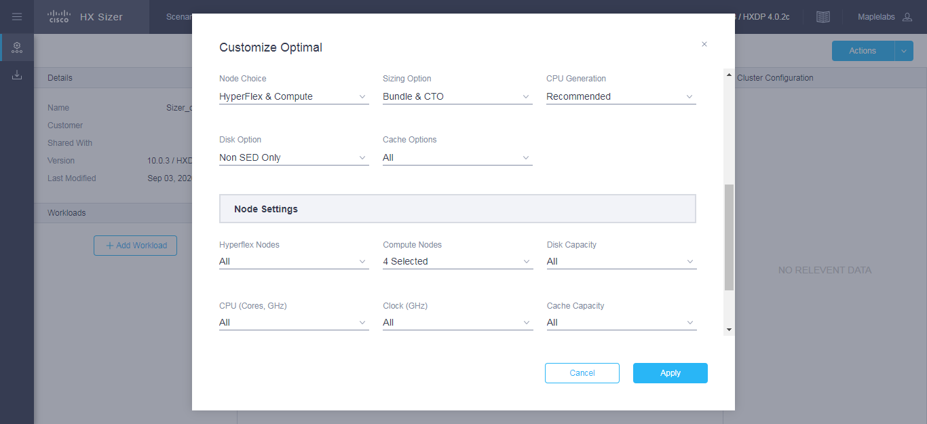

|  |  |
| --- | --- |
| **UI Element** | **Description** |
| **Threshold** button | Set the sizing threshold to one of the following:   * **Standard**—Default * **Conservative** * **Aggressive** * **No Hypervisor Reservation**   The threshold setting controls the target utilization of clusters being sized. |
| **Hypervisor** field | Choose the type of Hypervisor for which you want to do sizing:   * **ESXi**—Default * **Hyper-V** |
| **Discount %** field | Input the Discount % for Bundle and CTO |
| **Include Software Cost** button | * **N/A** * **1 Year** * **3 Years – Default**   Includes HX Software License and Hypervisor License |
| **Hardware Acceleration** field | Choose to include Hyperflex Acceleration Engine   * **Auto - Default** * **On** * **Off** |
| **Single Cluster** field | Choose option for Single Cluster   * **Yes** * **No –** Default |
| **Node Choice** button | Choose the type of node for which you want to size:   * **HyperFlex & Compute**—Default * **HyperFlex Only** |
| **Sizing Option** button | * **Bundle Only**—Size for bundle nodes only. * **Bundle & CTO**—Size both bundle and Configure to Order nodes. * **CTO only –** Size for Configure to Order nodes only. |
| **CPU Generation** button | Choose the type of CPU SKUs to include for size:   * **All** * **Recommended -** Default * **Skylake** * **Cascade Lake** |
| **Disk Option** button | Select the type of disk:   * **All** * **Non-SED Only -** Default * **SED Only** (Self-Encrypting Drive Only) * **FIPS Only** * **LFF Only** (Large Form Factor) |
| **Cache Option** button | Select the type of disk:   * **All -** Default * **SED Only** (Self-Encrypting Drive Only) * **NVMe** (Non-Volatile Memory Express) * **Optane Only** |
| You can also customize **HyperFlex Nodes**, **Compute Nodes**, **CPU**, **RAM**, **Disk Options, Cache Capacity Options and Modular LANs.** | |

**Step 2** You can also choose to customize the Threshold, Node Choice, Sizing Option, and Disk Option.

**Step 3** Click **Apply**. The changed options are saved, and the new result can be viewed from the Scenario Page.