HyperFlex Sizer

Getting Started Guide

Table of Contents

Table of Contents

Introduction 3

Prerequisites 3

User credentials 3

How to use HyperFlex Sizer? 3

HyperFlex Sizer Home Page 4

Add Scenario 5

Scenario Page 6

Add VDI Workload 7

Scenario Page with Workloads 10

How to Modify the VM/Desktop Counts 11

Aggregate Workloads Result 12

Clusterwise Workloads Result 12

Customize Option for Sizing 13

More Options 13

Types of Workloads 14

Add RAW Workload 14

Add HX Edge (ROBO) Workload 18

Handling Errors 20

Download Sizing Report and BOM 21

Scenario Options 22

Clone a Scenario 22

Edit a Scenario 22

Delete a Scenario 23

Share a Scenario 23

Home page with Shared Scenario 24

Shared Scenarios Page 25

Getting Started 25

Feedback 25

# Introduction

Cisco® HyperFlex Sizer is a Web based application which helps in sizing different workloads and match them with appropriate Cisco HyperConverged systems.

The HyperFlex Sizer supports below workloads for sizing.

* VDI,
* General virtualized server environment (VSI),
* Microsoft SQL database,
* Compute & Capacity Sizer (RAW),
* HX Edge (ROBO),
* Oracle

# Prerequisites

Make sure you have latest version of one of the supported Browsers.

* Chrome version 35 (at minimum)
* Firefox version 26 (at minimum)

### User credentials

HyperFlex Sizer is hosted on Cisco LAE infrastructure. To access this server, use your Cisco user id and password.

# How to use HyperFlex Sizer?

Use the below URL to access HyperFlex Sizer.

<https://hyperflexsizer.cloudapps.cisco.com/>

Open your favourite Internet browser such as Chrome or Firefox and visit the above URL. You will be prompted for login.

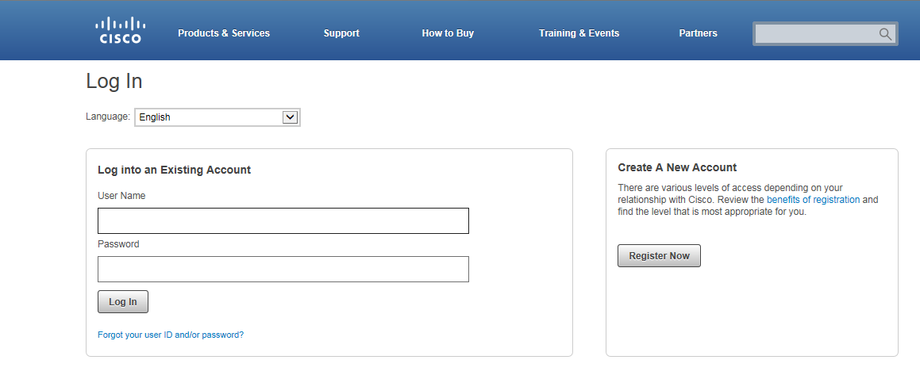

* Enter your Cisco user credentials. You will be redirected to HyperFlex Sizer Home page.

## HyperFlex Sizer Home Page

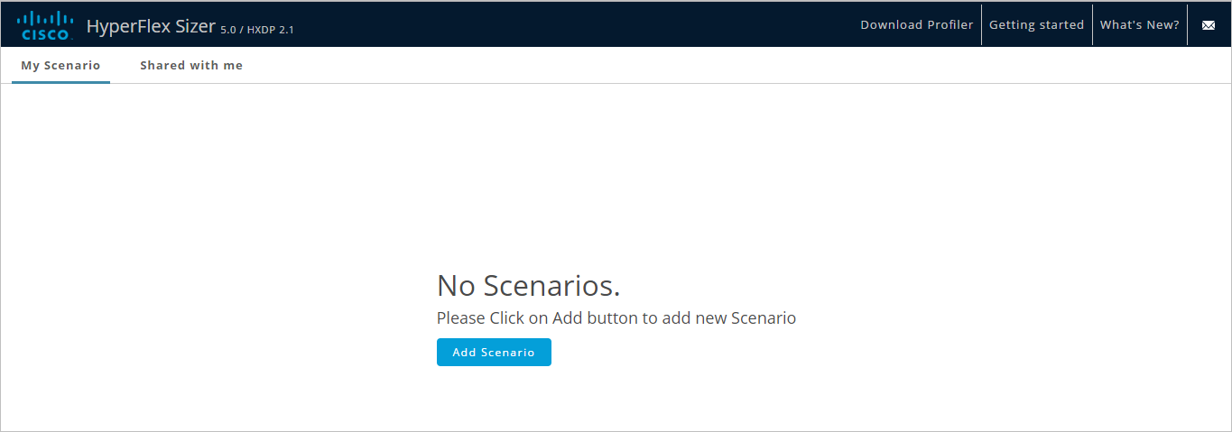

* Home page displays list of all the Scenarios previously created by the user, if any.
* If there are no Scenarios, click on “Add Scenario” button to create.
* If there are any previously created scenarios, the “Add Scenario” button is on top-right corner.
* In Home page under “Shared with me”, user can see list of all the Shared Scenarios to them by other users, if any.
* Provides link to download the Profiler OVA link.
* Provides link to “Getting Started” page to learn about Hyperflex Sizer and Profiler.
* Provides information to know “What’s New?” in the releases.

## Add Scenario

* Click “Add Scenario” button.

Enter a valid scenario name. Scenario name should be only alphanumeric, begins with an alphabet. An underscore or hyphen can be used as separator. Special characters are not allowed.

Enter Account and SFDC Deal ID which are optional.

Click on Save.

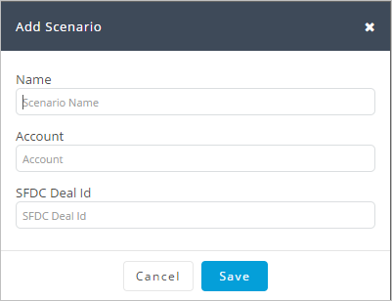

* A Scenario is created and UI is redirected to Scenario details page.

Note: Scenario name should be unique.

## Scenario Page

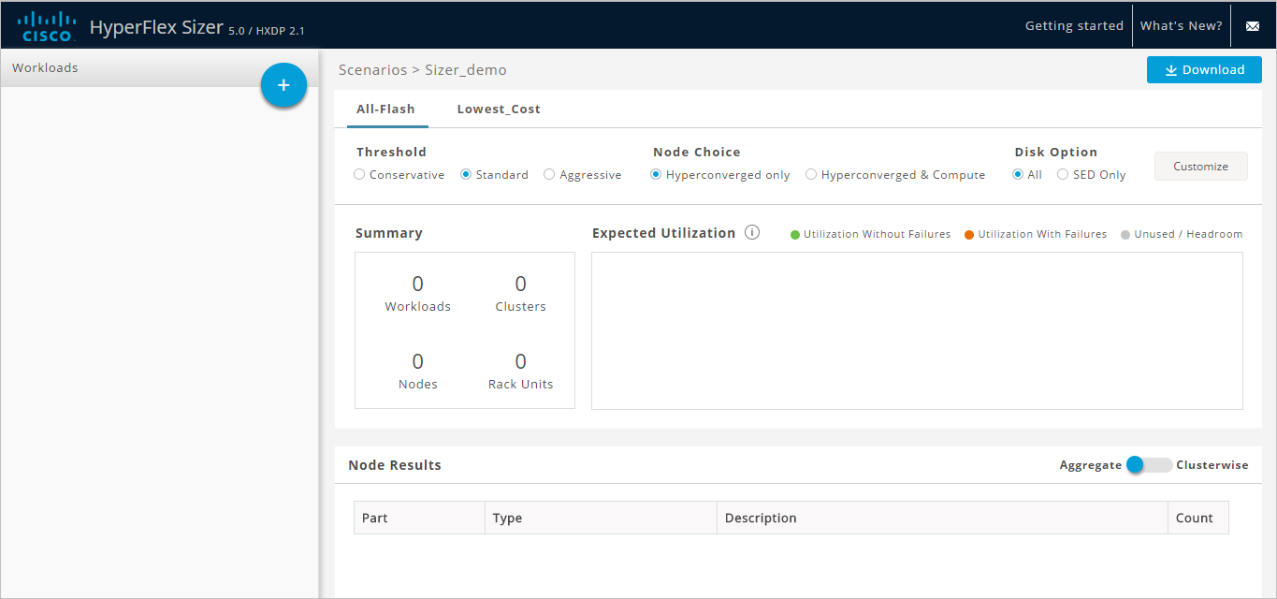

* On the Scenario details page,
  + User can see the list of Workloads created, if any.
  + All-Flash and Lowest cost Option are displayed in tabular manner.
  + Each option displays the default Sizing Configuration used in Sizing.
  + The Customize option provides users more flexibility to modify the configuration, and choose among the HyperFlex nodes, Compute Nodes, CPU & RAM etc.

### Add VDI Workload

* Add a VDI workload by clicking C:\build\cisco\dev-branches\ACISizer\src\main\webapp\images\plus-icon.png icon next to the title “Workloads”.
* This will prompt a Dialogue box with Various Workload types supported.

Select Workload type, for example “VDI”, Click “Next”.

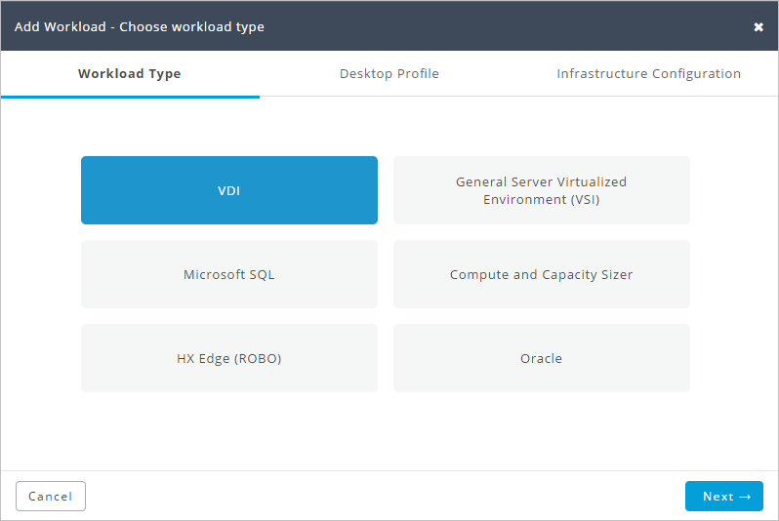

* For the chosen Workload, as in example VDI, Profile window is loaded with default values. It also provides users an option to customize them.

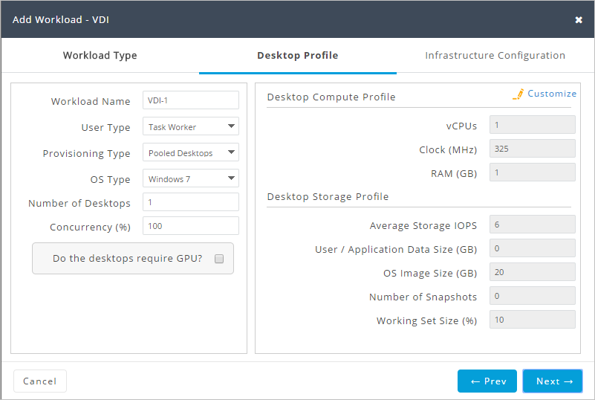

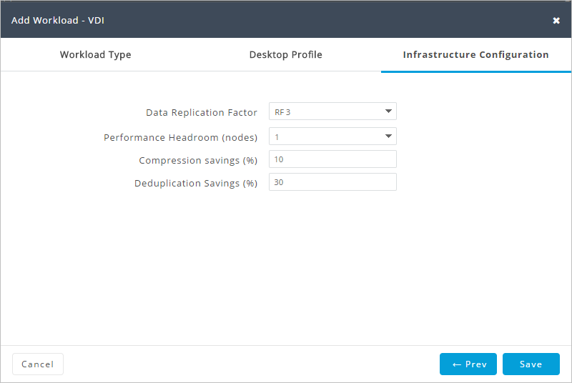

* Click on “Save”. After few seconds the Scenario page is loaded back with the Sizing Result.
* By default “All-Flash” tab option is shown.

### Scenario Page with Workloads

All-Flash Option tab:

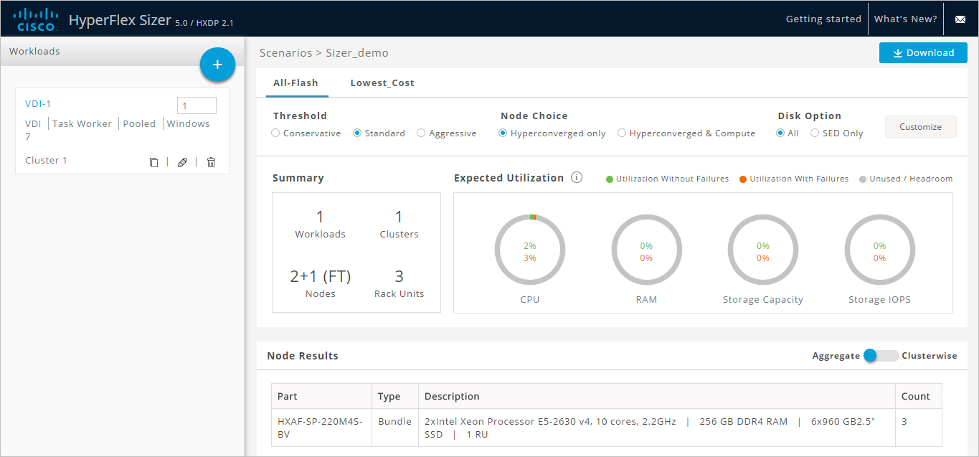

* In the Scenario page, the Summary, Expected Utilization and Node Results are displayed.

The node and parts for sizing is chosen based on CPU normalization.

Normalized cores:

The performance of a core in one processor is different from that of another processor. The performance of CPU varies across generations of a processors of same type. HyperFlex Sizer computes effective core for a node, by using SpecInt and CFP values and normalizes this to SpecInt/CFP values of Intel E5-2630 v4.

* The Summary window shows
  + Total number of Workloads
  + Total number of Clusters
  + Nodes and Rack Units details.
* Expected Utilization shows the CPU, RAM, Storage Capacity and Storage IOPS values.
  + The Resource Utilization is shown as two components:

Utilization without Failures: This shows the resource utilization when there are no failures in the cluster.

Utilization with Failures: This shows the resource utilization when there are no node failures in the cluster. The number of failures assumed matches the sizing parameter used for Performance Headroom.

Lowest Cost Option tab:

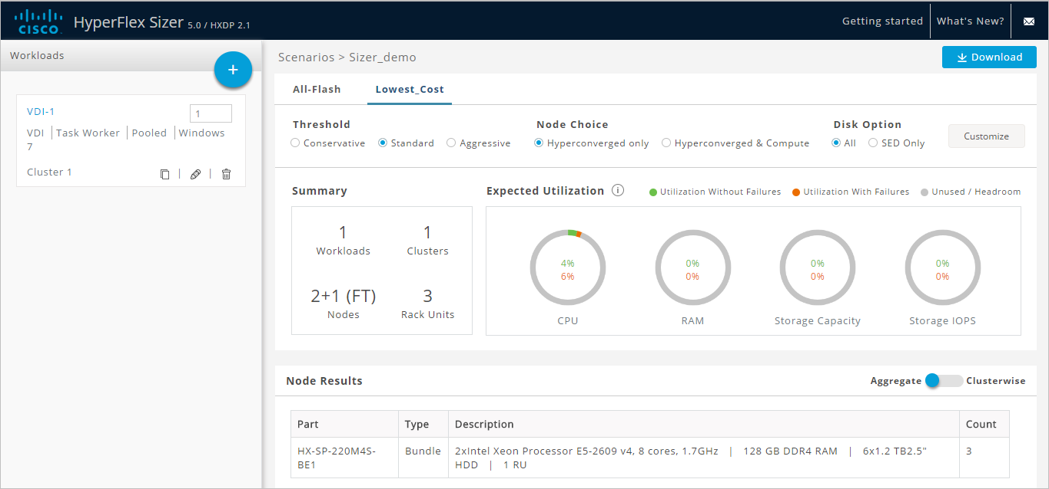

* Add few more workloads to get better understanding, like VSI or Microsoft SQL.

### How to Modify the VM/Desktop Counts

* Modify the number of desktops/VM, by changing the value in Workloads List for any workload in “Count” box. Click on “Save”.

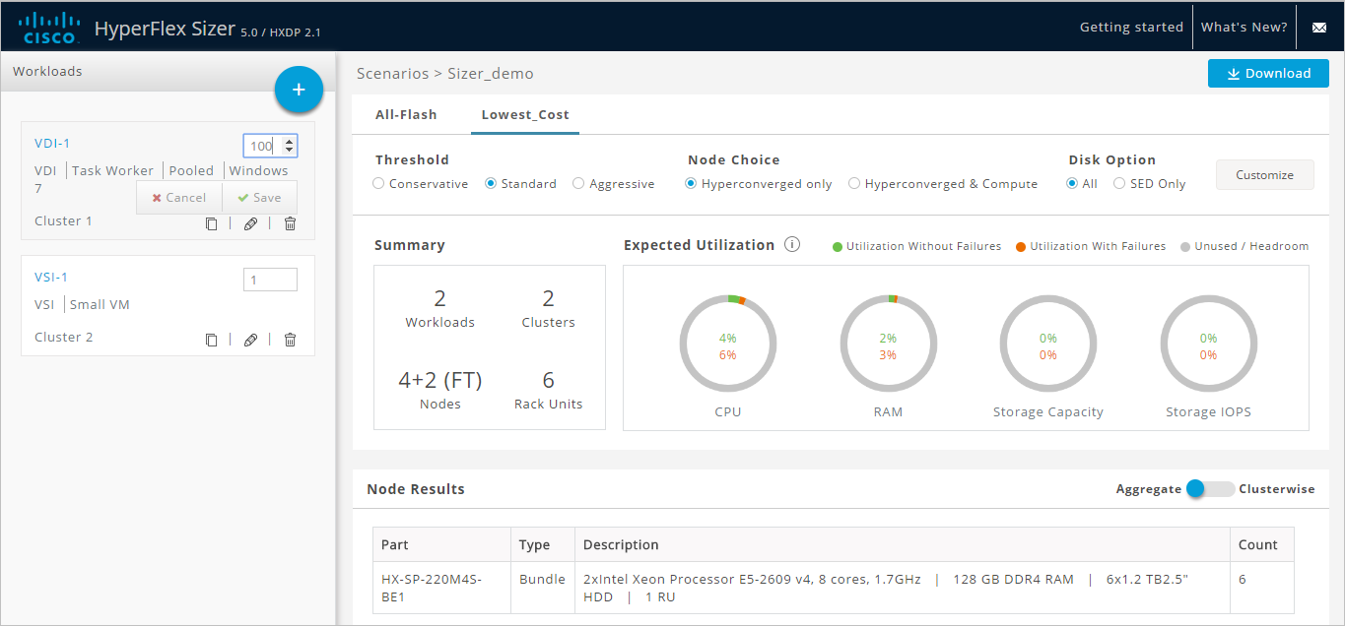

### Aggregate Workloads Result

* The Result displayed is based on the “Aggregate” values.

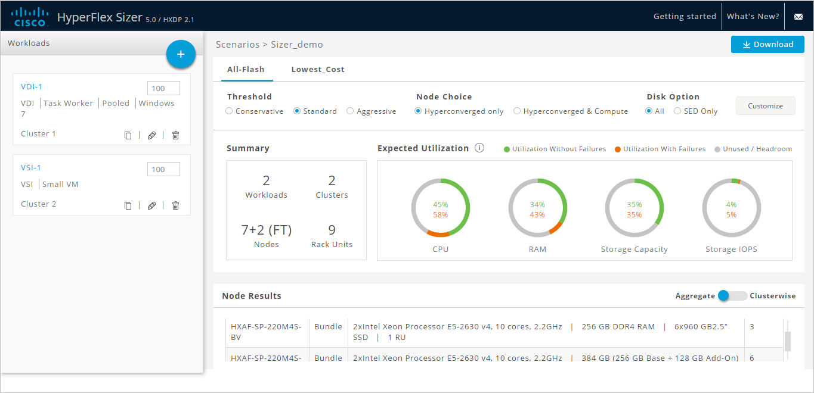

### Clusterwise Workloads Result

* Click the “Aggregate - Clusterwise” button on bottom-right screen.
* Upon change, in Workloads list, all the Workloads belongs to “Cluster 1” are selected. The Summary and Utilization is displayed based on Cluster 1.
* Click on Cluster 2 under Node Results, to know Cluster 2 details.

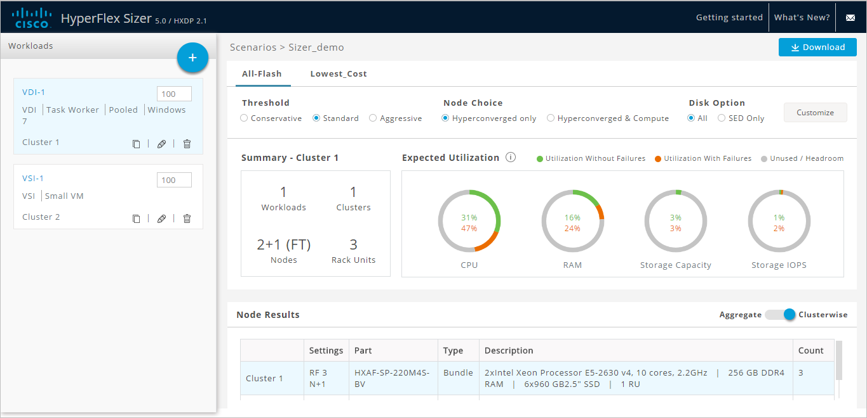

### Customize Option for Sizing

* Customize the HyperFlex nodes, Compute Nodes, CPU and RAM using the Customize button on top-right screen.
* User have option to customise Threshold, Node Choice, Sizing option and Disk options.
* The Disk option provides users to select Storage Encrypted Disks only when Bundle & CTO

nodes are selected.

* By Clicking Apply, the changed options will be saved and new result is updated onto Scenario

Page.

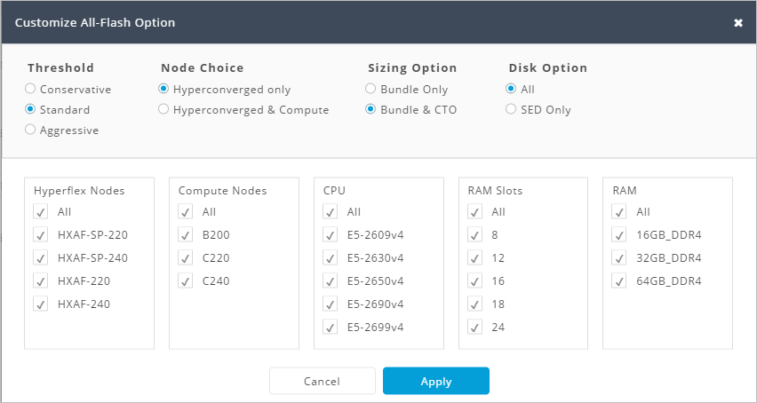

### More Options

* User can Clone the existing Workload by using Clone option.
* Also Edit the Profile through Edit option.
* Can Delete the Workload. User is prompted with Confirmation popup for deletion.

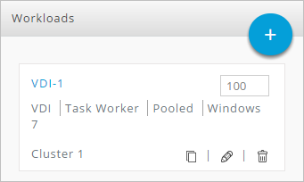

### Types of Workloads

### Add RAW Workload

* Add RAW workload by clicking  icon next to the title “Workloads”.
* This will prompt a Dialogue box with Various Workload types supported.

Select Workload type as “Compute and Capacity Sizer”, Click “Next”.

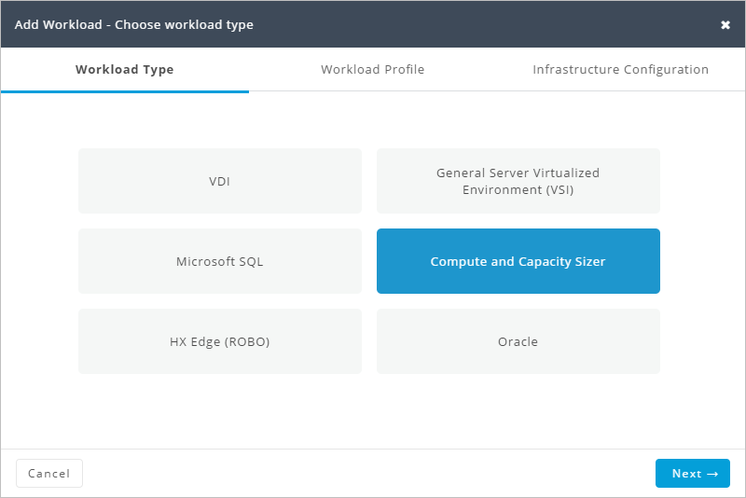

For the chosen Workload, the Workload Profile window provides option to select the input type.

* Manual option is provided with the default values.

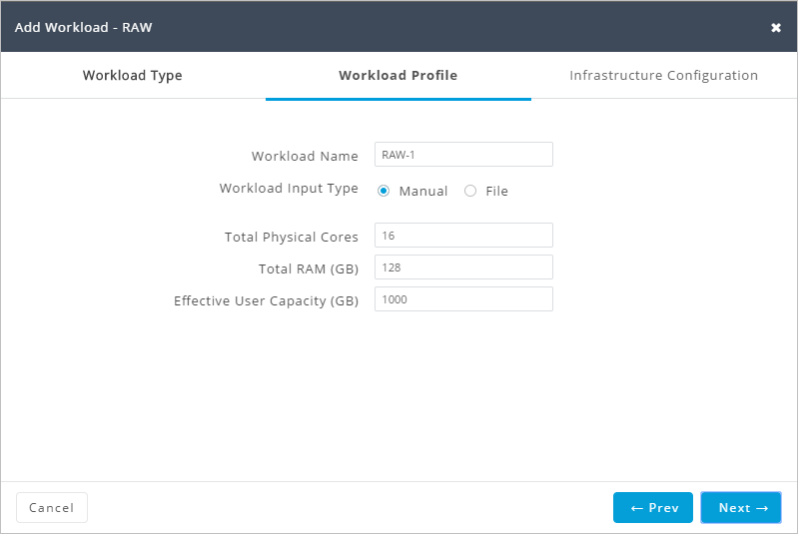

* File Option provides users to input the CSV file which will then be processed and values get populated in text box.
* CSV file can be downloaded from Profiler tool for 30 days duration period.
* For CSV File input, the number of processors is calculated by using the SpecInt and CFP ratings of the host’s processor type and normalized to Intel E5-2630 v4 rating.

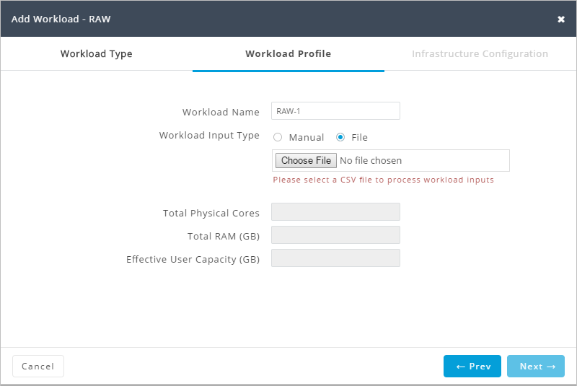

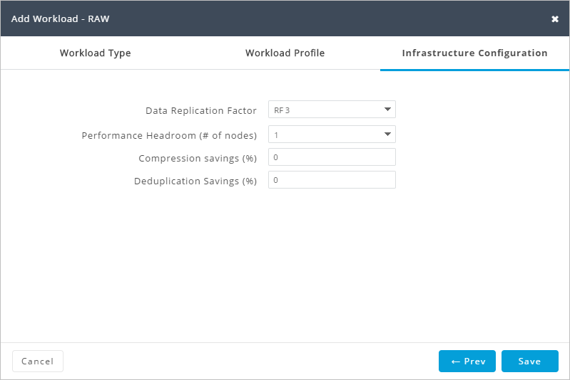

* Click on “Save”. After few seconds the Scenario page is loaded back with the Sizing Result.

### Add HX Edge (ROBO) Workload

* Add a workload by clicking C:\build\cisco\dev-branches\ACISizer\src\main\webapp\images\plus-icon.png icon next to the title “Workloads”.
* This will prompt a Dialogue box with Various Workload type supported.

Select Workload type as “HX Edge (ROBO)”, Click “Next”.

Customize the Profile/Configuration, if required. Click “Save”

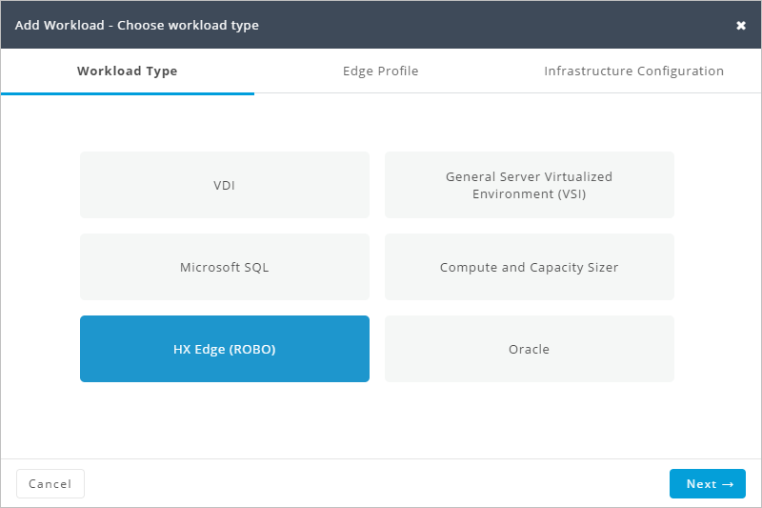

* Since HX Edge (ROBO) is not supported for All-Flash Clusters, now All-Flash tab shows a message. Check Lowest Cost option to know the Sizing results.

All-Flash Option result:

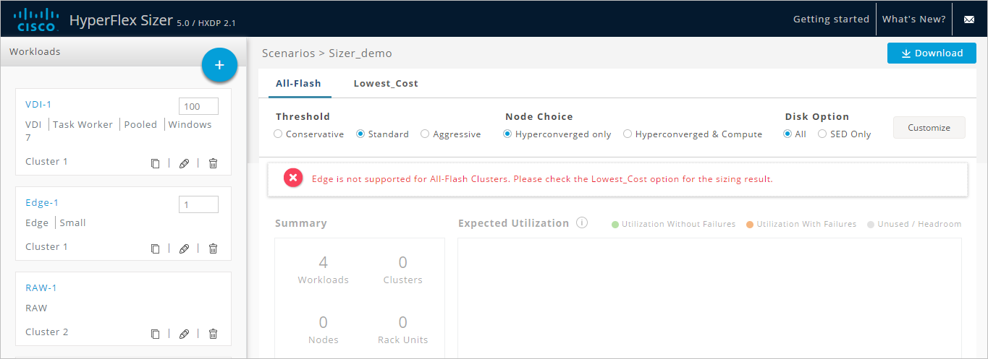

Lowest Cost Option result:

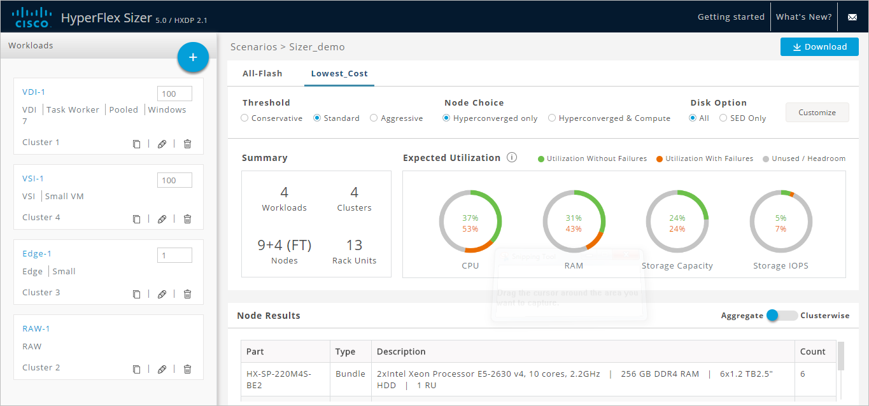

### Handling Errors

1. If user enters the count (VM/Desktops) as high number, an Error message will be displayed along with for which workload failure has occurred.

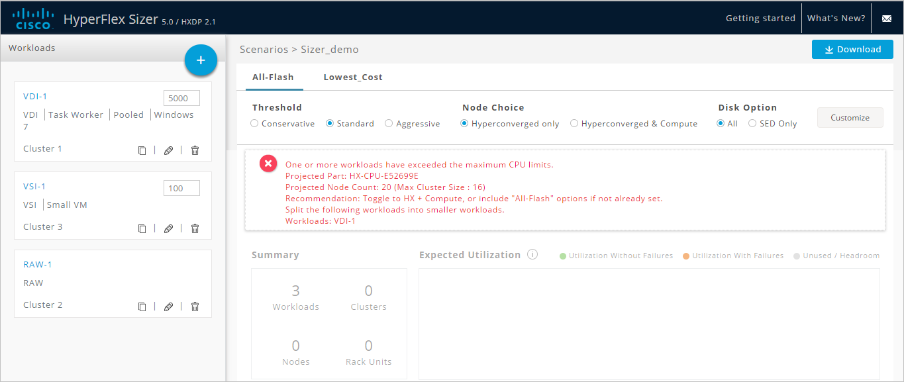

1. For All-Flash Option, if users deselects SmartPlay Hyperconverged nodes from Customize option, an error message will be displayed as below.

Ex: No SmartPlay hyperconverged nodes have been chosen, due to filters. Please change the filters.

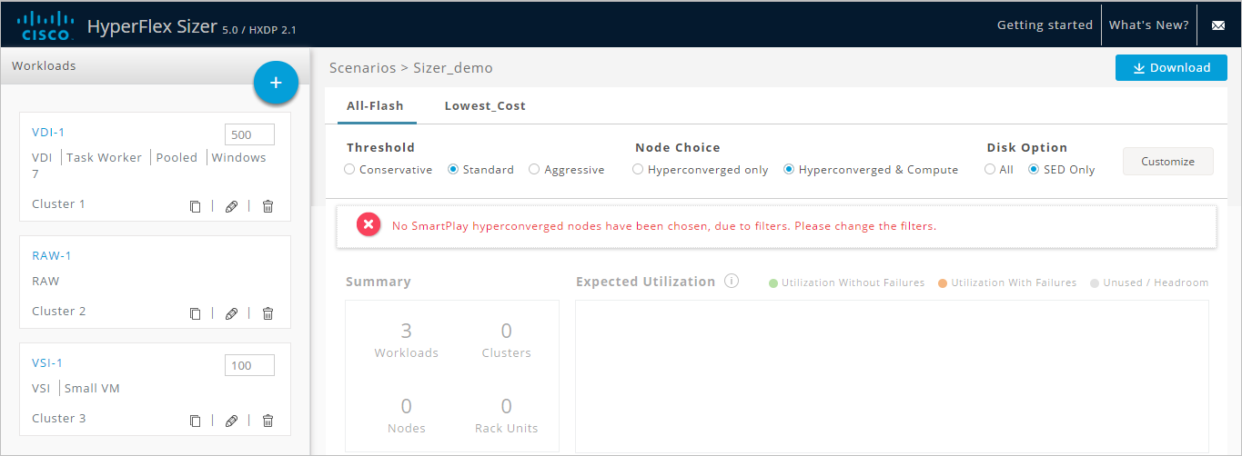

### Download Sizing Report and BOM

* Users can download Sizing report which is a PowerPoint containing details of the sizing input, proposed configuration, workload summary and utilization of resources for that option.
* Users can also download Excel spreadsheet containing the BOM for All-Flash and Lowest Cost (separately), which can be directly loaded in CCW.

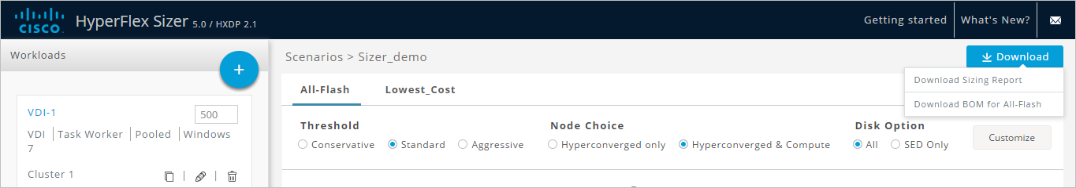

Click on “Scenarios” to go back to Sizer Home page.

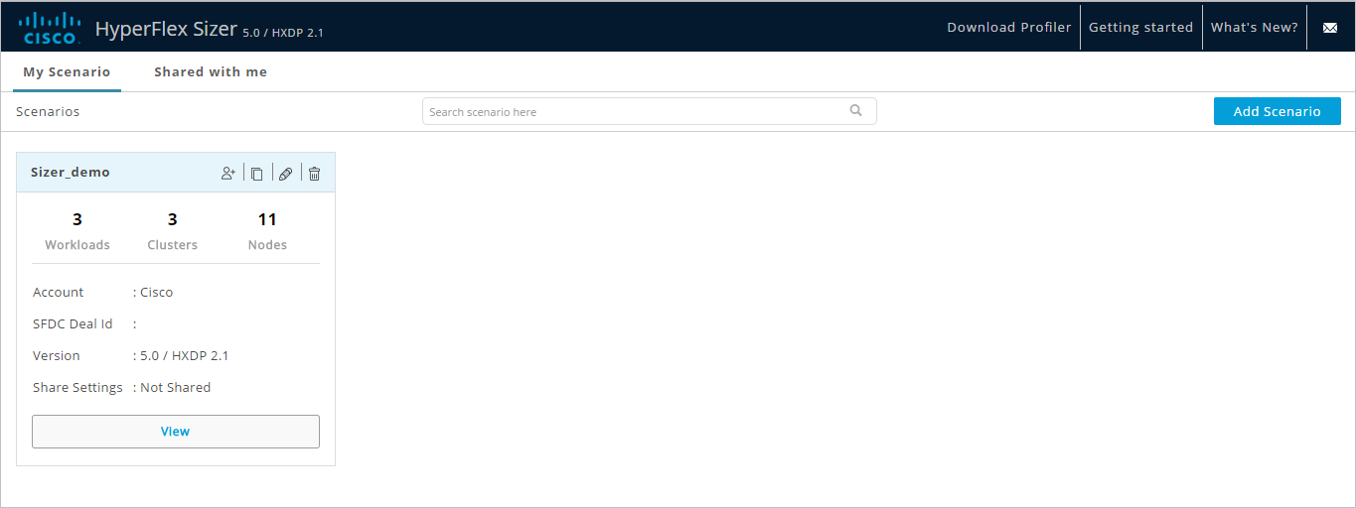

Home page displays a list of all the Scenarios created previously.

* It shows the HyperFlex Sizer Version along with HXDP Version used for Sizing.
* It displays details of Number of Workloads, Clusters and Nodes in Scenario.
* It also provides an option to Clone, Edit or Delete the Scenario.
* There is also option to share the scenario created to other users.

## Scenario Options

### Clone a Scenario

* Click on “Clone” icon of existing scenario to create a copy of scenario.

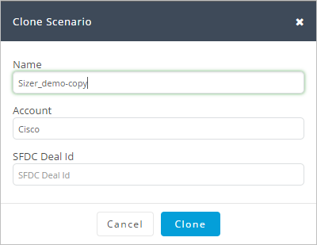

### Edit a Scenario

* Click on “Edit” icon on existing scenario to edit Scenario name, Account or SFDC Deal ID.

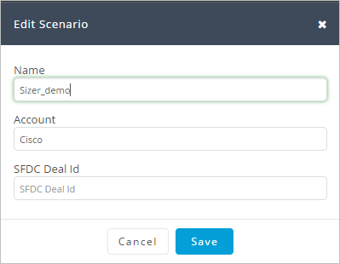

### Delete a Scenario

* Click on “Delete” icon to delete Scenario.

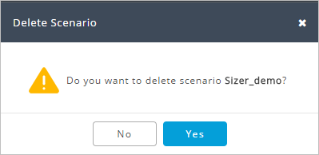

### Share a Scenario

* Click on “Share” icon to Share Scenario.

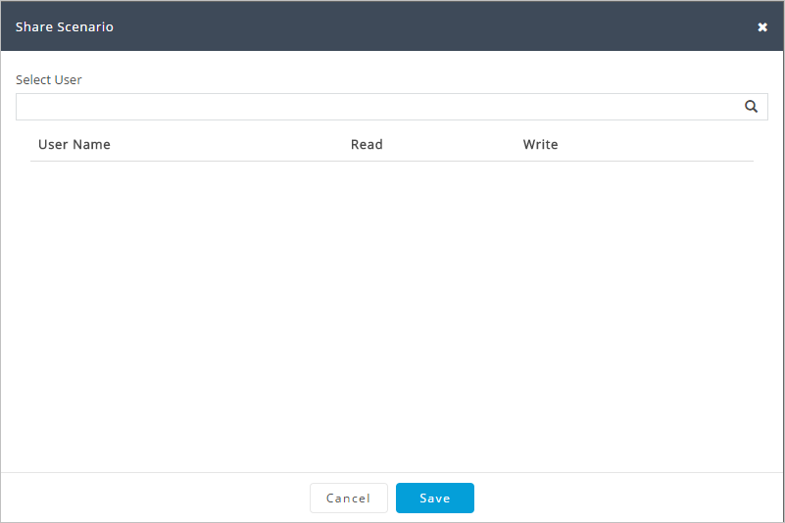

* Add User(s) from the list populated upon clicking Select User drop down menu.
* If Username is not available in the list populated provide the complete valid userid, press Enter. The name will get added to the list below.
* Owner of the scenario has privilege to control the access with Only Read or Read and Write permission.
* The shared users with Write permission, can modify the Scenario, add workloads etc.
* The Delete icon is provided to delete any shared user.
* Click on “Save”.

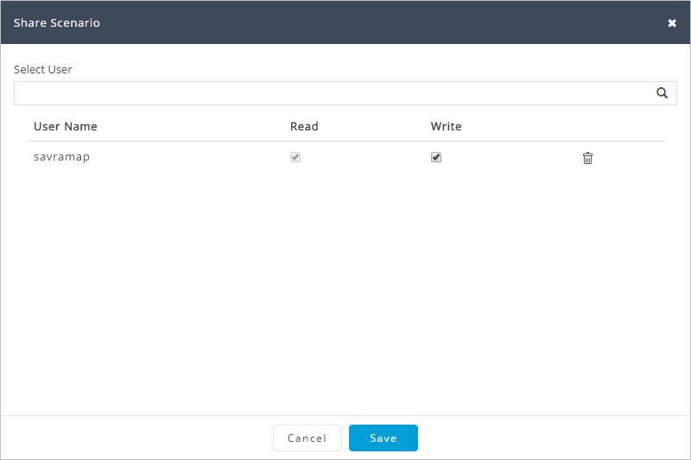

## Home page with Shared Scenario

* Any Shared Scenario shows the icon as group of users in Share Settings.

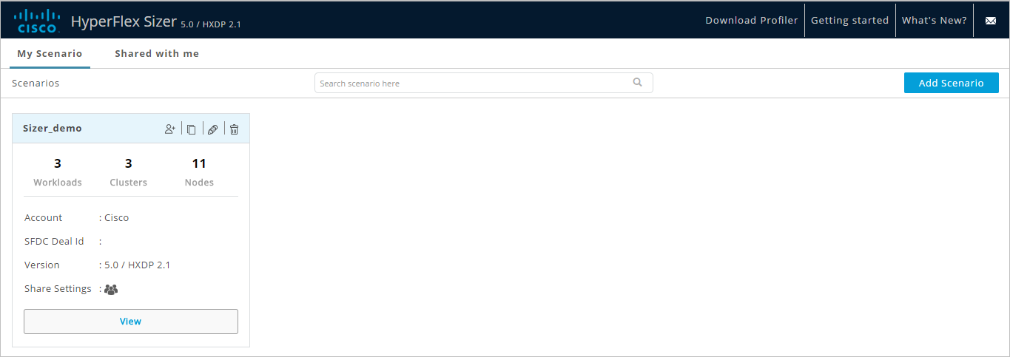

## Shared Scenarios Page

* The Shared scenario will be displayed on “Shared with me” tab for shared user(s).
* It consists of same details as main home page, along with information of Owner of the Scenario.

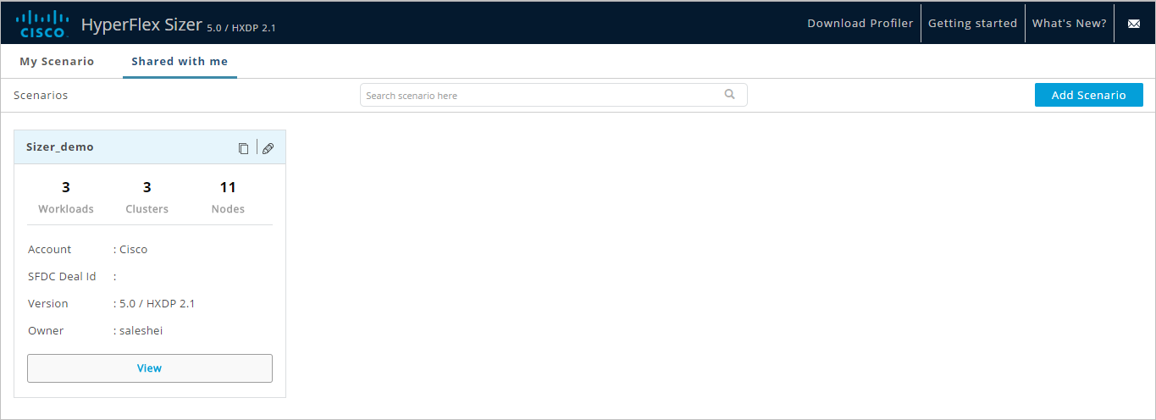

## Getting Started

* Click on “Getting Started” to access User Guide and Videos that gives an overview of the HyperFlex Sizer.
* This also provides User Guide & Videos for HX Workload Profiler.

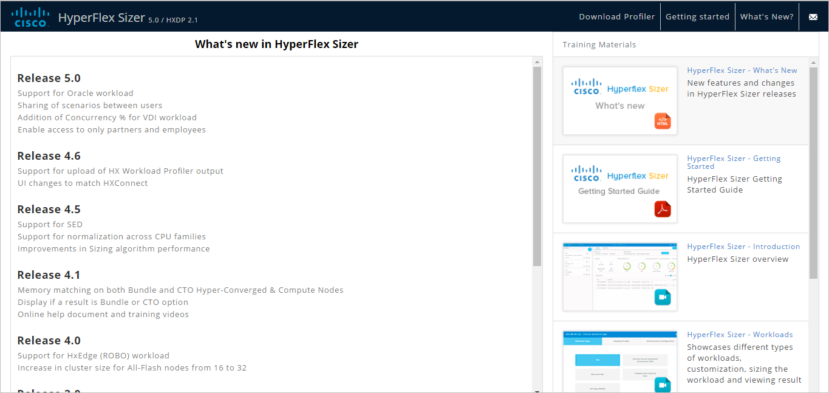

## Feedback

* Click on Envelope icon to send feedback/queries, if any.