VISVESVARAYA TECHNOLOGICAL UNIVERSITY
“JnanaSangama”, Belgaum -590014, Karnataka.

LAB REPORT On
ANALYSIS AND DESIGN OF ALGORITHMS (23CS4PCADA)
Submitted by
Darshan YG (1BM23CS087)

In partial fulfilment of the award of the degree of BACHELOR
OF ENGINEERING
in
COMPUTER SCIENCE AND ENGINEERING



B.M.S. COLLEGE OF ENGINEERING
(Autonomous Institution under VTU) BENGALURU-560019
February-May 2025

B. M. S. College of Engineering,

Bull Temple Road, Bangalore 560019
(Affiliated To Visvesvaraya Technological University, Belgaum) Department of Computer Science and Engineering



This is to certify that the Lab work entitled “ANALYSIS AND DESIGN OF ALGORITHMS” carried out by Darshan YG (1BM23CS087), who is bonafide student of B. M. S. College of Engineering. It is in partial fulfillment for the award of Bachelor of Engineering in Computer Science and Engineering of the Visvesvaraya Technological University, Belgaum during the year 2024-25. The Lab report has been approved as it satisfies the academic requirements in respect of Analysis and Design of Algorithms Lab - (23CS4PCADA) work prescribed for the said degree.

Prof. Sowmya T | Dr. Kavitha Sooda
Assistant Professor, | Professor, and Head
Department of CSE | Department of CSE
BMSCE, Bengaluru | BMSCE, Bengaluru

Index Sheet

Sl.  No. | Experiment Title | Page No.
1 | Write program to obtain the Topological ordering of vertices in a given digraph.  LeetCode Program related to Topological sorting | 5
2 | Implement Johnson Trotter algorithm to generate permutations. | 11
3 | Sort a given set of N integer elements using Merge Sort technique and compute its time taken. Run the program for different values of N and record the time taken to sort.  LeetCode Program related to sorting. | 13
4 | Sort a given set of N integer elements using Quick Sort technique and compute its time taken.  LeetCode Program related to sorting. | 16
5 | Sort a given set of N integer elements using Heap Sort technique and compute its time taken. | 20
6 | Implement 0/1 Knapsack problem using dynamic programming.  LeetCode Program related to Knapsack problem or Dynamic Programming. | 24
7 | Implement All Pair Shortest paths problem using Floyd’s algorithm.  LeetCode Program related to shortest distance calculation. | 28
8 | Find Minimum Cost Spanning Tree of a given undirected graph using Prim’s algorithm.  Find Minimum Cost Spanning Tree of a given undirected graph using Kruskal’s algorithm. | 32
9 | Implement Fractional Knapsack using Greedy technique.  LeetCode Program related to Greedy Technique algorithms. | 38
10 | From a given vertex in a weighted connected graph, find shortest paths to other vertices using Dijkstra’s algorithm. | 42
11 | Implement “N-Queens Problem” using Backtracking. | 45

Course outcomes:

CO1 | Analyze time complexity of Recursive and Non-recursive algorithms using asymptotic notations.
CO2 | Apply various design techniques for the given problem.
CO3 | Apply the knowledge of complexity classes P, NP, and NP-Complete and prove certain problems are NP-Complete
CO4 | Design efficient algorithms and conduct practical experiments to solve problems.

Github : https://github.com/DarshanYG/ADA-LAB
Lab program 1:
Write program to obtain the Topological ordering of vertices in a given digraph. i) using dfs
CODE:
#include <stdio.h> int n, a[10][10], res[10], s[10], top = 0; void dfs(int, int, int[][10]); void dfs_top(int, int[][10]); int main() { printf("Enter the no. of nodes"); scanf("%d", &n);
int i, j; for (i = 0; i < n; i++) { for (j = 0; j < n; j++) { scanf("%d", &a[i][j]);
} } dfs_top(n, a); printf("Solution: "); for (i = n - 1; i >= 0; i--) { printf("%d ", res[i]);
} return 0; } void dfs_top(int n, int a[][10]) {
int i; for (i = 0; i < n; i++) { s[i] = 0; } for (i = 0; i < n; i++) { if (s[i] == 0) {

dfs(i, n, a); }
} } void dfs(int j, int n, int a[][10]) { s[j] = 1; int i; for (i = 0; i < n; i++) { if (a[j][i] == 1 & s[i] == 0) { dfs(i, n, a); } } res[top++] = j;
}
OUTPUT:

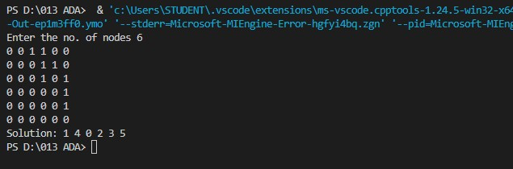

ii) using source removal method
CODE:
#include<stdio.h> int a[10][10],n,t[10],indegree[10]; int stack[10],top=-1; void computeIndegree(int,int [][10]); void tps_SourceRemoval(int,int [][10]); int main(){
printf("Enter the no. of nodes: ");

scanf("%d",&n);
int i,j;
for(i=0;i<n;i++){ for(j=0;j<n;j++){ scanf("%d",&a[i][j]);
} } computeIndegree(n,a); tps_SourceRemoval(n,a);
printf("Solution:"); for(i=0;i<n;i++){ printf("%d ",t[i]); } return 0; } void computeIndegree(int n,int a[][10]){ int i,j,sum=0; for(i=0;i<n;i++){
sum=0;
for(j=0;j<n;j++){ sum=sum+a[j][i]; } indegree[i]=sum;
} } void tps_SourceRemoval(int n,int a[][10]){
int i,j,v;
for(i=0;i<n;i++){ if(indegree[i]==0){ stack[++top]=i;
}
}

int k=0; while(top!=-1){ v=stack[top--]; t[k++]=v; for(i=0;i<n;i++){ if(a[v][i]!=0){ indegree[i]=indegree[i]-1; if(indegree[i]==0){ stack[++top]=i; }
}
}
}
}
OUTPUT:

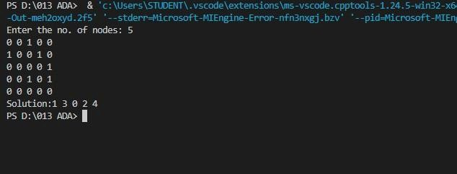

LeetCode Program related to Topological sorting
CODE:
bool dfs(int course, int** prerequisites, int prerequisitesSize, int* prerequisitesColSize, int* visited, int
numCourses) { if (visited[course] == 1) { return false;
} if (visited[course] == 2) { return true;
} visited[course] = 1;
for (int i = 0; i < prerequisitesSize; i++) {

8| Page if (prerequisites[i][0] == course) { int nextCourse = prerequisites[i][1];
if (!dfs(nextCourse, prerequisites, prerequisitesSize, prerequisitesColSize, visited, numCourses)) {
return false;
}
} } visited[course] = 2; return true;
}
bool canFinish(int numCourses, int** prerequisites, int prerequisitesSize, int* prerequisitesColSize) { int visited[numCourses]; for (int i = 0; i < numCourses; i++) { visited[i] = 0;
} for (int i = 0; i < numCourses; i++) { if (visited[i] == 0) { if (!dfs(i, prerequisites,prerequisitesSize, prerequisitesColSize, visited, numCourses)) { return false;
}
} } return true;
}
OUTPUT:

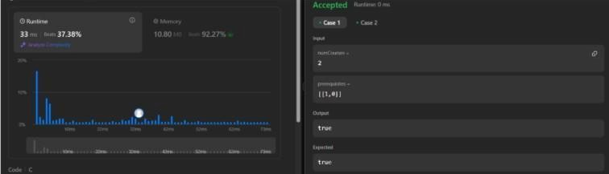

Lab program 2:
Implement Johnson Trotter algorithm to generate permutations.
CODE:
#include <stdio.h> #include <stdlib.h> void swap(int* a, int* b) { int temp = *a; *a = *b;
*b = temp; } void generatePermutations(int arr[], int start, int end) { if (start == end) { for (int i = 0; i <= end; i++)
{ printf("%d ", arr[i]);
} printf("\n"); } else { for (int i = start; i <= end; i++) { swap(&arr[start], &arr[i]); generatePermutations(arr, start + 1, end); swap(&arr[start], &arr[i]); // backtrack
}
} } int main() { int n; printf("Enter the number of elements: "); scanf("%d", &n);

int* arr = (int*)malloc(n * sizeof(int)); printf("Enter the elements: "); for (int i = 0; i < n; i++) { scanf("%d", &arr[i]); } generatePermutations(arr, 0, n - 1); free(arr); return 0;
}
OUTPUT:

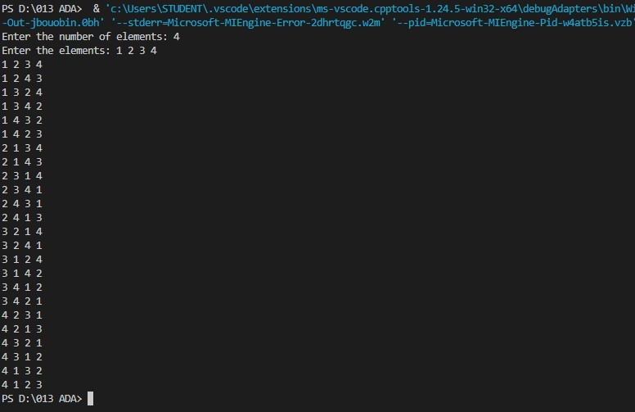

Lab program 3:
Sort a given set of N integer elements using Merge Sort technique and compute its time taken. Run the program for different values of N and record the time taken to sort.

CODE:
#include<stdio.h>
#include<time.h>

int a[20],n; void simple_sort(int [],int,int,int); void merge_sort(int a[],int low, int high){ if(low<high){ int mid=(low+high)/2; merge_sort(a,low,mid); merge_sort(a,mid+1,high); simple_sort(a,low,mid,high);
}
} void simple_sort(int a[],int low, int mid, int high){ int i=low,j=mid+1,k=low;
int c[n];
while(i<=mid && j<=high){
if(a[i]<a[j]){ c[k++]=a[i]; i++;
}else{ c[k++]=a[j]; j++;
}
}

while(i<=mid){ c[k++]=a[i]; i++; } while(j<=high) { c[k++]=a[j]; j++; } for(i=low;i<=high;i++){ a[i]=c[i];
} } int main()
{
int i; clock_t start, end; double time_taken; printf("Enter the no. of elements:"); scanf("%d", &n); printf("Enter the array elements:"); for (i = 0; i < n; i++) { scanf("%d", &a[i]);
} start = clock(); merge_sort(a, 0, n - 1); end = clock(); time_taken = (double)(end - start) / CLOCKS_PER_SEC; printf("Sorted array:"); for (i = 0; i < n; i++) {

printf("%d ", a[i]);
} printf("\n"); printf("Time taken to sort: %f seconds\n", time_taken); return 0; }
OUTPUT:

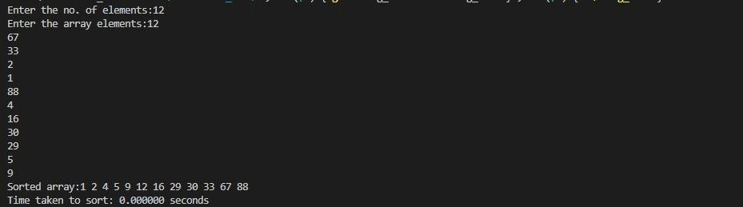

Lab program 4:
Sort a given set of N integer elements using Quick Sort technique and compute its time taken.
CODE:
#include <stdio.h>
#include <stdlib.h> // for rand() #include <time.h> // for clock()

#define MAX 5000

void quicksort(int[], int, int); int partition(int[], int, int);

int main() { int i, n, a[MAX], ch;
clock_t start, end;

while (1) { printf("\nEnter the number of elements: ");
scanf("%d", &n);

// Generate random array elements
for (i = 0; i < n; i++) { a[i] = rand() % 200; // Random number between 0 and 199
}

// Display the random array printf("The random generated array is:\n");
for (i = 0; i < n; i++) { printf("%d ", a[i]);
}
printf("\n");

// Measure the time taken for sorting start = clock(); quicksort(a, 0, n - 1);
end = clock();

// Display the sorted array printf("\nThe sorted array elements are:\n");
for (i = 0; i < n; i++) { printf("%d ", a[i]);
}
printf("\n");

// Calculate and print the time taken for sorting
printf("Time taken = %f seconds\n", (double)(end - start) / CLOCKS_PER_SEC);

// Ask user if they want to continue printf("\nDo you wish to continue? (0/1): "); scanf("%d", &ch); if (ch == 0) { break;
}
}

return 0;
}

// QuickSort function
void quicksort(int a[], int low, int high) { if (low < high) { int mid = partition(a, low, high); quicksort(a, low, mid - 1); // Recursively sort the left part
quicksort(a, mid + 1, high); // Recursively sort the right part

}
}

// Partition function: Returns the partition index int partition(int a[], int low, int high) { int pivot = a[low]; // Pivot is the first element in the array int i = low + 1; int j = high;
int temp;

while (i <= j) {
// Find an element greater than the pivot while (i <= high && a[i] <= pivot) { i++;
}

// Find an element less than the pivot while (a[j] > pivot) {
j--;
}

// If there are elements to swap, swap them
if (i < j) { temp = a[i];
a[i] = a[j];
a[j] = temp;
}
}

// Swap the pivot element with a[j] temp = a[low]; a[low] = a[j];

a[j] = temp;

return j; // Return the partition index
}
OUTPUT:

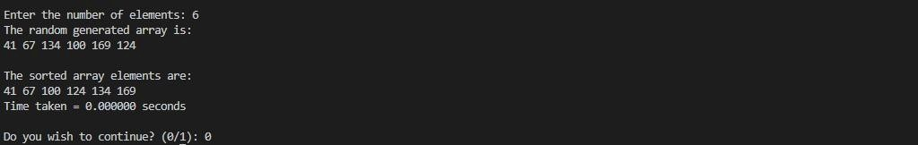

Lab program 5:
Sort a given set of N integer elements using Heap Sort technique and compute its time taken.
CODE:
#include<stdio.h>
#include<conio.h>
#include<time.h>

void heapcom(int a[],int n)
{
int i,j,k,item; for(i=1;i<=n;i++)
{ item=a[i]
; j=i; k=j/2; while(k!=0 && item>a[k])
{ a[j]=a[k]; j=k; k=j/2;
} a[j]=item;
} } void adjust(int a[],int n)
{
int item,i,j; j=1;
item=a[j];

i=2*j; while(i<n)
{ if((i+1)<n)
{ if(a[i]<a[i+1]) i++; } if(item<a[i])
{

a

[
j

} ]
else break; =
} a
[ i
]
; j
=
i ; i
= 2
*
j
;
a[j]=item; } void heapsort(int a[],int n)
{ int i,temp; heapcom(a,n); for(i=n;i>=1;i--)
{ temp=a[1]; a[1]=a[i]; a[i]=temp; adjust(a,i);

} } void main()
{ int i,n,a[20],ch=1; clock_t start,end; while(ch)
{ printf("\n enter the number of elements to sort\n"); scanf("%d",&n); printf("\n enter the elements to sort\n"); for(i=1;i<=n;i++) scanf("%d",&a[i]); start=clock(); heapsort(a,n); end=clock(); printf("\n the sorted list of elemnts is\n"); for(i=1;i<=n;i++) printf("%d\n",a[i]); printf("\n Time taken is %lf CPU cycles\n",(end-start)/CLK_TCK); printf("do u wish to run again (0/1)\n"); scanf("%d",&ch);
}
}
OUTPUT:

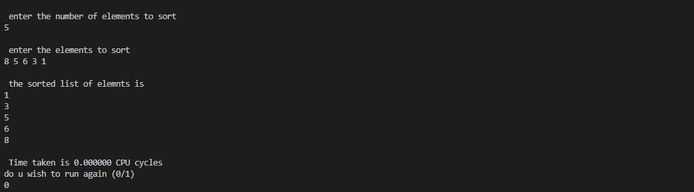

Lab program 6:
Implement 0/1 Knapsack problem using dynamic programming.
CODE:
#include<stdio.h> int i,j,n,c,w[10],p[10],v[10][10]; void knapsack(int n,int w[10],int p[10],int c)
{ int max(int,int); for(i=0;i<=n;i++)
{ for(j=0;j<=c;j++)
{ if(i==0||j==0) v[i][j]=0; else if(w[i]>j) v[i][j]=v[i-1][j]; else
v[i][j]=max(v[i-1][j],(v[i-1][j-w[i]]+p[i]));

} } printf("\n\n Maximum Profit is : %d ",v[n][c]); printf("\n\n\n Table : \n\n"); for(i=0;i<=n;i++)
{ for(j=0;j<=c;j++)
{ printf("\t%d",v[i][j]);
}

printf("\n");
} } int max(int a,int b) { return ((a>b)?a:b); } void main() { printf("\n Enter the no. of objects : "); scanf("%d",&n); printf("\n Enter the weights : "); for(i=1;i<=n;i++) { scanf("%d",&w[i]); } printf("\n Enter the Profits : "); for(i=1;i<=n;i++) { scanf("%d",&p[i]); } printf("\n Enter the capacity : "); scanf("%d",&c); knapsack(n,w,p,c);
}
OUTPUT:

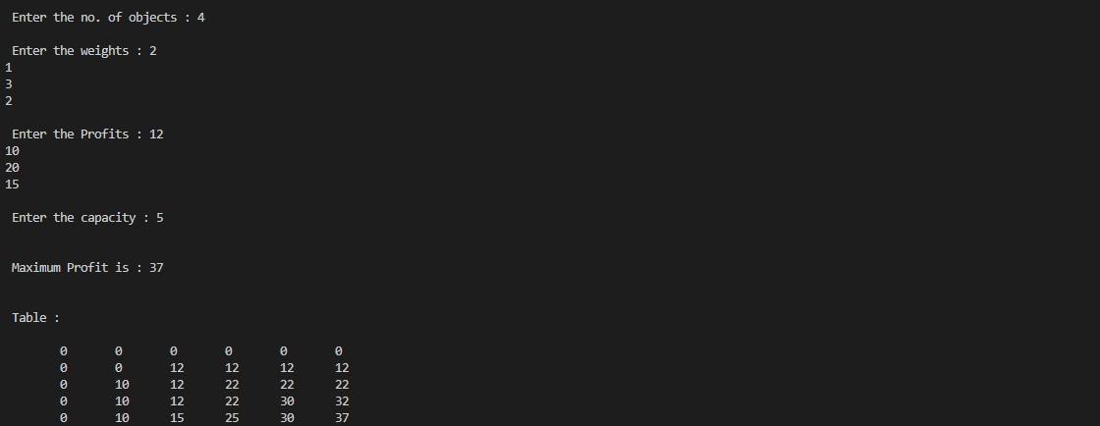

LeetCode Program related to Knapsack problem or Dynamic Programming.
CODE:
class Solution(object): def fib(self, n): if n == 0: return 0 if n == 1: return 1 a, b = 0, 1 for _ in range(2, n + 1):
a, b = b, a + b return b
OUTPUT:

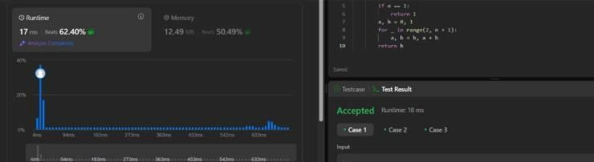

Lab program 7:
Implement All Pair Shortest paths problem using Floyd’s algorithm.
CODE:
#include <stdio.h> int a[10][10],D[10][10],n; void floyd(int [][10],int); int min(int,int); int main() { printf("Enter the no. of vertices:"); scanf("%d",&n); printf("Enter the cost adjacency matrix:\n");
int i,j;
for(i=0;i<n;i++){ for(j=0;j<n;j++){ scanf("%d",&a[i][j]);
} } floyd(a,n); printf("Distance Matrix:\n"); for(i=0;i<n;i++){ for(j=0;j<n;j++){ printf("%d ",D[i][j]);
} printf("\n"); } return 0;
}

void floyd(int a[][10],int
n){ int i,j,k; for(i=0;i<n;i++){ for(j=0;j<n;j++){
D[i][j]=a[i][j];
}
}

for(k=0;k<n;k++){ for(i=0;i<n;i++){ for(j=0;j<n;j++){
D[i][j]=min(D[i][j],(D[i][k]+D[k][j]));
}
}
}
}

int min(int a,int b){ if(a<b){ return a; }else{ return b; }
}
OUTPUT:

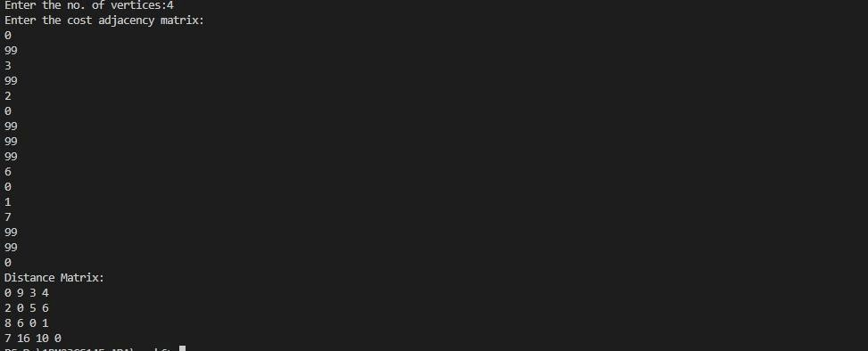

LeetCode Program related to shortest distance calculation.
CODE:
class Solution: def shortestPathLength(self, graph: List[List[int]]) -> int:
n=len(graph) queue=deque([(i,1<<i) for i in range(n)]) seen=set(queue) ans=0 while queue: for _ in range(len(queue)): u,m=queue.popleft() if m==(1<<n)-1:
return ans for v in graph[u]: if (v,m|1<<v) not in seen: queue.append((v,m|1<<v)) seen.add((v,m|1<<v)) ans+=1
OUTPUT:

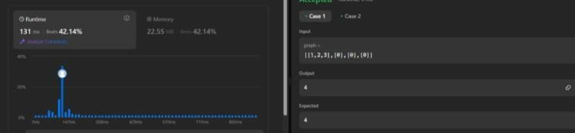

Lab program 8:
Find Minimum Cost Spanning Tree of a given undirected graph using Prim’s algorithm.
CODE:
#include<stdio.h> int cost[10][10], n, t[10][2], sum; void prims(int cost[10][10], int n); int main() {
int i, j;
printf("Enter the number of vertices: "); scanf("%d",&n); printf("Enter the cost adjacency matrix:\n"); for (i = 0; i <n; i++) { for (j = 0; j <n; j++) { scanf("%d",&cost[i][j]);
} } prims(cost, n); printf("Edges of the minimal spanning tree:\n"); for (i = 0; i <n - 1; i++) { printf("(%d, %d) ", t[i][0], t[i][1]);
} printf("\nSum of minimal spanning tree: %d\n", sum); return 0; } void prims(int cost[10][10], int n) {
int i, j, u, v; int min, source; int p[10], d[10], s[10];
min = 999;

source = 0;

for (i = 0; i <n; i++) { d[i] = cost[source][i]; s[i] = 0; p[i] = source;
} s[source] = 1; sum = 0; int k = 0; for (i = 0; i <n - 1; i++) { min = 999; u = -1; for (j = 0; j <n; j++) { if (s[j] == 0 && d[j] <min) { min = d[j]; u = j; } } if (u != -1) { t[k][0] = u; t[k][1] = p[u]; k++; sum += cost[u][p[u]]; s[u] = 1; for (v = 0; v <n; v++) { if (s[v] == 0 && cost[u][v] <d[v]) { d[v] = cost[u][v];
p[v] = u;

}
}
}

}
}
OUTPUT:

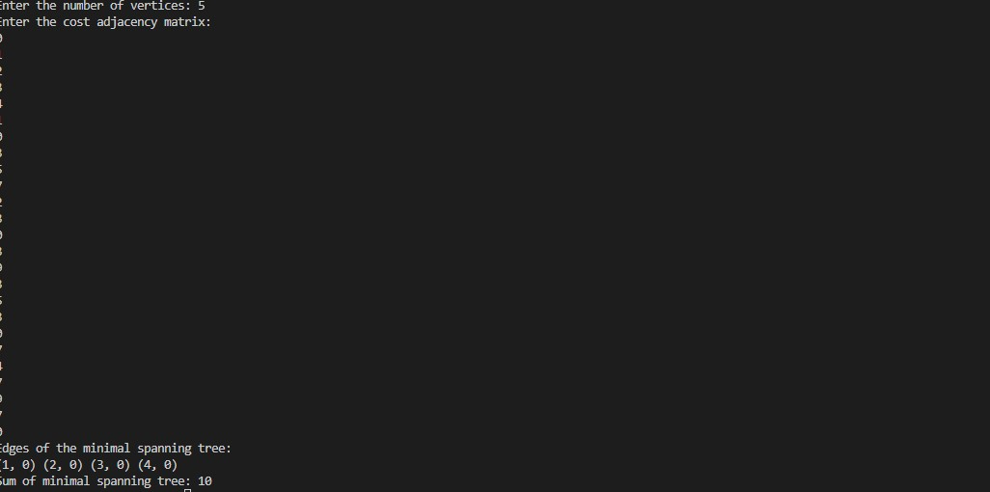

Find Minimum Cost Spanning Tree of a given undirected graph using Kruskal’s algorithm.
CODE:
#include<stdio.h> int cost[10][10], n, t[10][2], sum; void kruskal(int cost[10][10], int n); int find(int parent[10], int i); int main() {
int i, j;
printf("Enter the number of vertices: "); scanf("%d", &n); printf("Enter the cost adjacency matrix:\n"); for (i = 0; i < n; i++) { for (j = 0; j < n; j++) { scanf("%d", &cost[i][j]);
} } kruskal(cost, n);
printf("Edges of the minimal spanning tree:\n");

for (i = 0; i < n - 1; i++) { printf("(%d, %d) ", t[i][0], t[i][1]);
} printf("\nSum of minimal spanning tree: %d\n", sum); return 0; } void kruskal(int cost[10][10], int n) { int min, u, v, count, k; int parent[10]; k = 0;

sum = 0; for (int i = 0; i < n; i++) { parent[i] = i; } count = 0; while (count < n - 1) { min = 999; u = -1; v = -1; for (int i = 0; i < n; i++) { for (int j = 0; j < n; j++) { if (find(parent, i) != find(parent, j) && cost[i][j] < min) { min = cost[i][j]; u = i; v = j; }
} } int root_u = find(parent, u); int root_v = find(parent, v);

if (root_u != root_v) { parent[root_u] = root_v; t[k][0] = u; t[k][1] = v; sum += min; k++; count++;
}
} } int find(int parent[10], int i) { while (parent[i] != i) { i = parent[i]; } return i;
}
OUTPUT:

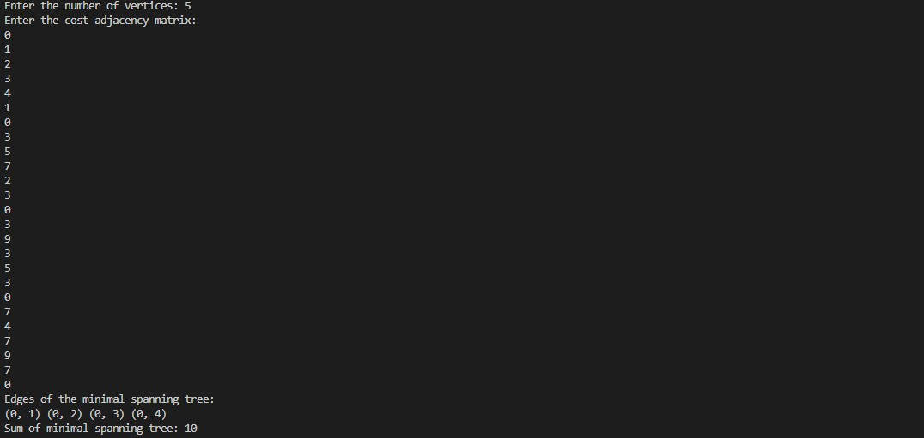

Lab program 9:
Implement Fractional Knapsack using Greedy technique.
CODE:
#include <stdio.h> #define MAX 100
void fractionalKnapsack(int n, float weight[], float profit[], float capacity) { float ratio[MAX],
temp; int i, j;

for (i = 0; i < n; i++)
ratio[i] = profit[i] / weight[i];

for (i = 0; i < n - 1; i++) { for (j = i + 1; j < n; j++) { if (ratio[i] < ratio[j]) { temp = ratio[i]; ratio[i] = ratio[j]; ratio[j] = temp; temp = weight[i]; weight[i] = weight[j]; weight[j] = temp; temp = profit[i]; profit[i] = profit[j]; profit[j] = temp;
}
}
}

float totalProfit = 0; for (i = 0; i < n; i++) {

if (capacity >= weight[i]) { capacity -= weight[i]; totalProfit += profit[i];
} else {
totalProfit += ratio[i] * capacity; break; } }
printf("Total Profit = %.2f\n", totalProfit);

}

int main() { int n;
float weight[MAX], profit[MAX], capacity; printf("Enter the number of items: "); scanf("%d", &n);

printf("Enter the weights of the items: "); for (int i = 0; i < n; i++) { scanf("%f", &weight[i]);
}

printf("Enter the profits of the items: "); for (int i = 0; i < n; i++) { scanf("%f", &profit[i]);
}

printf("Enter the capacity of the knapsack: "); scanf("%f", &capacity);

fractionalKnapsack(n, weight, profit, capacity);

return 0;
}
OTUPUT:

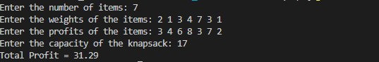

LeetCode Program related to Greedy Technique algorithms.
CODE:
char* largestOddNumber(char* num) { int len = strlen(num);

32| Page for (int i = len - 1; i >= 0; i--) { if ((num[i] - '0') % 2 == 1) { num[i + 1] = '\0'; // Truncate string at that position return num; // Return the longest odd-suffix (greedy)
}
}

return ""; // No odd digit found
}
OUTPUT:

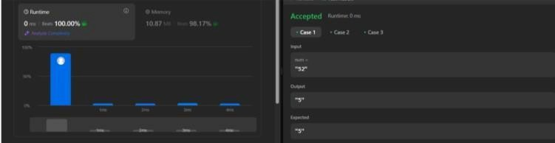

Lab program 10:
From a given vertex in a weighted connected graph, find shortest paths to other vertices using Dijkstra’s algorithm.
CODE:
#include<stdio.h> void main()
{ int i,j,n,v,k,min,u,c[20][20],s[20],d[20]; printf("\n Enter the no. of vertices : "); scanf("%d",&n); printf("\n Enter the cost adjacency matrix : "); printf("\n Enter 999 for no edge "); for(i=1;i<=n;i++)
{ for(j=1;j<=n;j++)
{ scanf("%d",&c[i][j]);
} } printf("\n Enter the source vertex : "); scanf("%d",&v); for(i=1;i<=n;i++)
{ s[i]=0; d[i]=c[v][i];
} d[v]=0; s[v]=1; for(k=2;k<=n;k++)
{

min=999; for(i=1;i<=n;i++){ if((s[i]==0)&(d[i]<min)){ min=d[i]; u=i;
} } s[u]=1; for(i=1;i<=n;i++)
{

if(s[i]==0) { if(d[i]>(d[u]+c[u][i]))
{ d[i]=d[u]+c[u][i];
}
}

} } printf("\n The shortest distance from %d is ",v); for(i=1;i<=n;i++) { printf("\n %d -->; %d = %d ",v,i,d[i]);
}
}
OUTPUT:

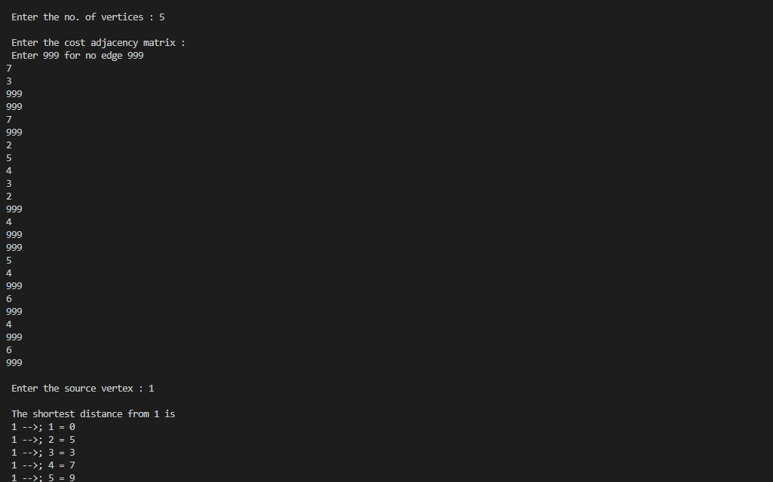

Lab program 11:
Implement “N-Queens Problem” using Backtracking.
CODE:
#include<stdio.h>
#include<conio.h> #include<math.h> int x[20],count=1; void queens(int,int); int place(int,int);

void main()
{ int n,k=1; printf("\n enter the number of queens to be placed\n"); scanf("%d",&n); queens(k,n);
} void queens(int k,int n)
{
int i,j;
for(j=1;j<=n;j++)
{ if(place(k,j))
{ x[k]=j; if(k==n)
{ printf("\n %d solution",count); count++;

} else
queens(k+1,n);
}
} } int place(int k,int j)
{
int i;
for(i=1;i<k;i++)
for(i=1;i<=n;i++) printf("\n \t %d row <---> %d column",i,x[i]); getch();

if((x[i]==j) || (abs(x[i]-j))==abs(i-k)) return 0; return 1;
}
OUTPUT:

