**VISVESVARAYA TECHNOLOGICAL UNIVERSITY**

**“JnanaSangama”, Belgaum -590014, Karnataka.**



# LAB REPORT

**on**

**Operating Systems**

**(22CS4PCOPS)**

***Submitted by:***

# Darshan YG (1BM23CS087)

***in partial fulfillment for the award of the degree of***

## BACHELOR OF ENGINEERING

***in***

**COMPUTER SCIENCE AND ENGINEERING**



**B.M.S. COLLEGE OF ENGINEERING**

**(Autonomous Institution under VTU)**

**BENGALURU-560019**

**September 2024-June 2025**

**B. M. S. College of Engineering,**

**Bull Temple Road, Bangalore 560019**

(Affiliated To Visvesvaraya Technological University, Belgaum) **Department of Computer Science and Engineering**



### CERTIFICATE

This is to certify that the Lab work entitled “Operating Systems” carried out by Darshan YG (1BM23CS087),who is bonafide student of B. M. S. College of Engineering**.** It is in partial fulfillment for the award of Bachelor of Engineering in Computer Science and Engineeringof the Visvesvaraya Technological University, Belgaum during the year 2024-25. The Lab report has been approved as it satisfies the academic requirements in respect of Operating Systems - (22CS4PCOPS) work prescribed for the said degree.

|  |  |
| --- | --- |
| Basavaraj Jakkalli | Dr. Kavitha Sooda |
| Associate Professor | Professor and Head |
| Department of CSE | Department of CSE |
| BMSCE, Bengaluru | BMSCE, Bengaluru |

# Table Of Contents

|  |  |  |
| --- | --- | --- |
| **Lab**  **Program No.** | **Program Details** | **Page No.** |
| 1 | FCFS AND SJF | 3-5 |
| 2 | PRIORITY AND ROUND ROBIN | 6-9 |
| 3 | RATE-MONOTONIC AND EARLIEST DEADLINE FIRST | 10-16 |
| 4 | PRODUCER-CONSUMER PROBLEM | 17-18 |
| 5 | DINERS-PHILOSOPHERS PROBLEM | 19-21 |
| 6 | BANKERS ALGORITHM (DEADLOCK AVOIDANCE) | 22-24 |
| 7 | DEADLOCK DETECTION | 25-26 |
| 8 | CONTIGIOUS MEMORY ALLOCATION (FIRST, BEST, WORST FIT) | 27-29 |
| 9 | PAGE REPLACEMENT (FIFO, LRU, OPTIMAL) | 30-35 |

## Course Outcomes

**CO1:** Apply the different concepts and functionalities of Operating System.

**CO2:** Analyse various Operating system strategies and techniques.

**CO3:** Demonstrate the different functionalities of Operating System.

**CO4:** Conduct practical experiments to implement the functionalities of Operating system.

## LAB-01

**Write a C program to simulate the following non-pre-emptive CPU scheduling algorithm to find turnaround time and waiting time.**

1. **FCFS**
2. **SJF**

**1.1.1 Code:**

#include<stdio.h> int n, i, j, pos, temp, choice, Burst_time[20], Waiting_time[20], Turn_around_time[20],

process[20], total=0;

float avg_Turn_around_time=0, avg_Waiting_time=0;

int FCFS()

{

Waiting_time[0]=0;

for(i=1;i<n;i++)

{

Waiting_time[i]=0; for(j=0;j<i;j++)

Waiting_time[i]+=Burst_time[j]; }

printf("\nProcess\t\tBurst Time\t\tWaiting Time\t\tTurnaround Time");

for(i=0;i<n;i++)

{

Turn_around_time[i]=Burst_time[i]+Waiting_time[i]; avg_Waiting_time+=Waiting_time[i]; avg_Turn_around_time+=Turn_around_time[i];

printf("\nP[%d]\t\t%d\t\t\t%d\t\t\t\t%d",i+1,Burst_time[i],Waiting_time[i],Turn_around_time[i]);

}

avg_Waiting_time =(float)(avg_Waiting_time)/(float)i; avg_Turn_around_time=(float)(avg_Turn_around_time)/(float)i; printf("\nAverage Waiting Time:%.2f",avg_Waiting_time);

printf("\nAverage Turnaround Time:%.2f\n",avg_Turn_around_time);

return 0;

}

int SJF()

{

//sorting for(i=0;i<n;i++)

{

pos=i; for(j=i+1;j<n;j++) {

if(Burst_time[j]<Burst_time[pos]) pos=j;

}

temp=Burst_time[i];

Burst_time[i]=Burst_time[pos];

Burst_time[pos]=temp;

temp=process[i]; process[i]=process[pos];

process[pos]=temp;

}

Waiting_time[0]=0;

for(i=1;i<n;i++)

{

Waiting_time[i]=0;

for(j=0;j<i;j++)

Waiting_time[i]+=Burst_time[j];

total+=Waiting_time[i];

}

avg_Waiting_time=(float)total/n; total=0; printf("\nProcess\t\tBurst Time\t\tWaiting Time\t\tTurnaround Time");

for(i=0;i<n;i++)

{

Turn_around_time[i]=Burst_time[i]+Waiting_time[i]; total+=Turn_around_time[i];

printf("\nP[%d]\t\t%d\t\t\t%d\t\t\t\t%d",process[i],Burst_time[i],Waiting_time[i],Turn_around_time[i]);

}

avg_Turn_around_time=(float)total/n;

printf("\n\nAverage Waiting Time=%f",avg_Waiting_time); printf("\nAverage Turnaround Time=%f\n",avg_Turn_around_time);

}

int main()

{

printf("Enter the total number of processes:"); scanf("%d",&n);

printf("\nEnter Burst Time:\n"); for(i=0;i<n;i++)

{

printf("P[%d]:",i+1); scanf("%d",&Burst_time[i]); process[i]=i+1;

}

while(1)

{ printf("\n-----MAIN MENU ---- \n"); printf("1. FCFS Scheduling\n2. SJF Scheduling\n");

printf("\nEnter your choice:"); scanf("%d", &choice);

switch(choice)

{

case 1: FCFS();

break;

case 2: SJF();

break;

default: printf("Invalid Input!!!");

}

}

return 0;

}

**1.1.2 Output:**

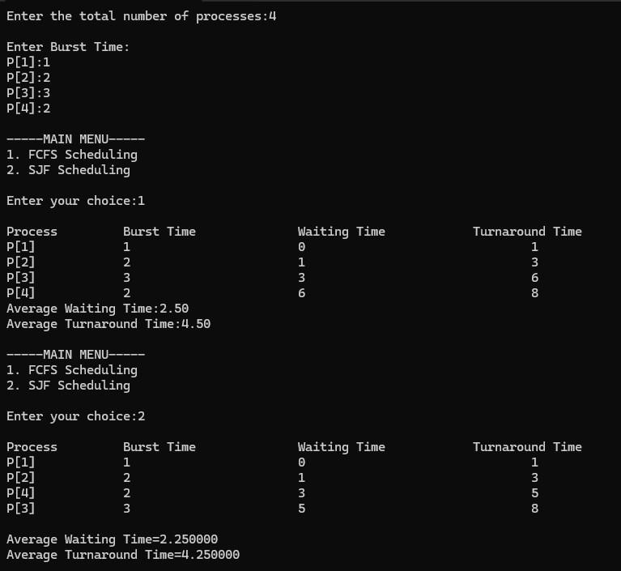

## LAB-02

**Write a C program to simulate the following non-pre-emptive CPU scheduling algorithm to find turnaround time and waiting time. c) ROUND ROBIN:**

#include<stdio.h> void main()

{

Int i,j,n,bu[10],wa[10],tat[10],t,ct[10],max; float awt=0,att=0,temp=0; printf("Enter the no of processes -- "); scanf("%d",&n);

for(i=0;i<n;i++)

{

printf("\nEnter Burst Time for process %d -- ", i+1); scanf("%d",&bu[i]);

ct[i]=bu[i];

}

printf("\nEnter the size of time slice -- "); scanf("%d",&t); max=bu[0];

for(i=1;i<n;i++) if(max<bu[i]) max=bu[i];

for(j=0;j<(max/t)+1;j++){ for(i=0;i<n;i++){ if(bu[i]!=0){ if(bu[i]<=t)

{ tat[i]=temp+bu[i];

temp=temp+bu[i];

bu[i]=0;

}

else

{ bu[i]=bu[i]-t;

temp=temp+t;

}}}}

for(i=0;i<n;i++) { wa[i]=tat[i]-ct[i]; att+=tat[i];

awt+=wa[i];} printf("\nThe Average Turnaround time is -- %f",att/n);

printf("\nThe Average Waiting time is -- %f ",awt/n);

printf("\n\tPROCESS\t BURST TIME \t WAITING TIME\tTURNAROUND TIME\n");

for(i=0;i<n;i++) printf("\t%d \t %d \t\t %d \t\t %d \n",i+1,ct[i],wa[i],tat[i]); OUTPUT:

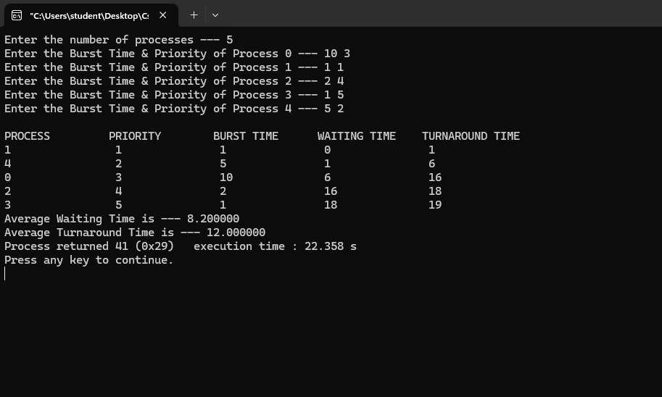

**d) PRIORITY:**

#include<stdio.h> void main()

{

int p[20],bt[20],pri[20], wt[20],tat[20],i, k, n, temp; float wtavg, tatavg; printf("Enter the number of processes --- "); scanf("%d",&n); for(i=0;i<n;i++){

p[i] = i;

printf("Enter the Burst Time & Priority of Process %d --- ",i); scanf("%d%d",&bt[i], &pri[i]);

}

for(i=0;i<n;i++){ for(k=i+1;k<n;k++) {

if(pri[i] > pri[k])

{ temp=p[i]; p[i]=p[k]; p[k]=temp; temp=bt[i];

bt[i]=bt[k]; bt[k]=temp; temp=pri[i]; pri[i]=pri[k]; pri[k]=temp;

}}}

wtavg = wt[0] = 0; tatavg = tat[0] = bt[0]; for(i=1;i<n;i++)

{

wt[i] = wt[i-1] + bt[i-1]; tat[i] = tat[i-1] + bt[i];

wtavg = wtavg + wt[i];

tatavg = tatavg + tat[i];

}

printf("\nPROCESS\t\tPRIORITY\tBURST TIME\tWAITING TIME\tTURNAROUND TIME");

for(i=0;i<n;i++) printf("\n%d \t\t %d \t\t %d \t\t %d \t\t %d ",p[i],pri[i],bt[i],wt[i],tat[i]); printf("\nAverage Waiting Time is --- %f",wtavg/n); printf("\nAverage Turnaround Time is --- %f",tatavg/n);

}

OUTPUT:

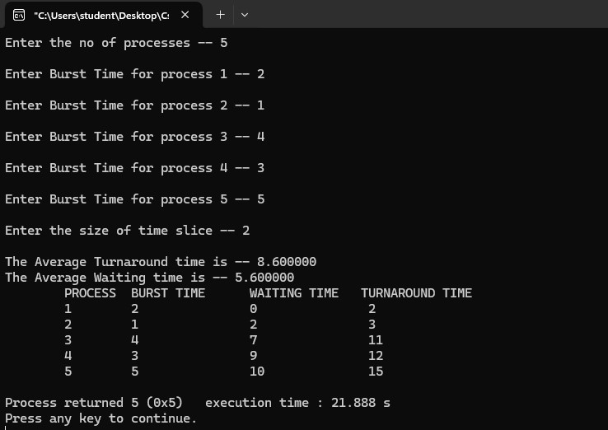

## LAB- 03

### 1.RATE MONOTONIC and EARLIEST DEADLINE FIRST

#include <stdio.h>

#include <stdlib.h>

#include <math.h>

#include <stdbool.h> #define MAX_PROCESS 10

typedef struct { int id; int burst_time; float priority;

} Task;

int num_of_process; int execution_time[MAX_PROCESS], period[MAX_PROCESS], remain_time[MAX_PROCESS], deadline[MAX_PROCESS], remain_deadline[MAX_PROCESS];

void get_process_info(int selected_algo)

{

printf("Enter total number of processes (maximum %d): ", MAX_PROCESS); scanf("%d", &num_of_process); if (num_of_process < 1)

{

exit(0);

}

for (int i = 0; i < num_of_process; i++)

{

printf("\nProcess %d:\n", i + 1); printf("==> Execution time: "); scanf("%d", &execution_time[i]); remain_time[i] = execution_time[i]; if (selected_algo == 2)

{

printf("==> Deadline: "); scanf("%d", &deadline[i]);

}

else

{

printf("==> Period: "); scanf("%d", &period[i]); }

}

}

int max(int a, int b, int c)

{

int max; if (a >= b && a >= c)

max = a;

else if (b >= a && b >= c) max = b;

else if (c >= a && c >= b)

max = c;

return max;

}

int get_observation_time(int selected_algo)

{

if (selected_algo == 1)

{

return max(period[0], period[1], period[2]);

}

else if (selected_algo == 2)

{

return max(deadline[0], deadline[1], deadline[2]);

}

}

int uti_time=0; void ut_time(int selected_algo){

if(selected_algo==1)

{

for (int i = 0; i < num_of_process; i++)

{

uti_time+=(execution_time[i]/period[i]);

}

}

else if(selected_algo==2)

{

for (int i = 0; i < num_of_process; i++)

{

uti_time+=(execution_time[i]/deadline[i]);

}

}

}

void print_schedule(int process_list[], int cycles)

{

printf("\nScheduling:\n\n"); printf("Time: ");

for (int i = 0; i < cycles; i++)

{ if (i < 10) printf("| 0%d ", i);

else printf("| %d ", i);

}

printf("|\n"); for (int i = 0; i < num_of_process; i++)

{

printf("P[%d]: ", i + 1); for (int j = 0; j < cycles; j++)

{

if (process_list[j] == i + 1) printf("|####");

else

printf("| ");

}

printf("|\n");

}

}

void rate_monotonic(int time)

{

int process_list[100] = {0}, min = 999, next_process = 0; float utilization = 0.0; for (int i = 0; i < num_of_process; i++)

{

utilization += (float)(execution_time[i] / period[i]);

}

int n = num_of_process; float m = (n * (pow(2, 1.0 / n) - 1)); if (utilization > m)

{

printf("\nGiven problem is not schedulable under the said scheduling algorithm.\n");

}

for (int i = 0; i < time; i++)

{

min = 1000; for (int j = 0; j < num_of_process; j++)

{

if (remain_time[j] > 0)

{

if (min > period[j])

{

min = period[j]; next_process = j;

}

}

}

if (remain_time[next_process] > 0)

{

process_list[i] = next_process + 1; remain_time[next_process] -= 1;

}

for (int k = 0; k < num_of_process; k++)

{

if ((i + 1) % period[k] == 0)

{

remain_time[k] = execution_time[k]; next_process = k;

}

}

}

printf("Utilisation time %d",utilization); print_schedule(process_list, time);

}

void earliest_deadline_first(int time){

float utilization = 0; for (int i = 0; i < num_of_process; i++){

utilization += (1.0*execution_time[i])/deadline[i];

}

int n = num_of_process;

int process[num_of_process]; int max_deadline, current_process=0, min_deadline,process_list[time]; bool is_ready[num_of_process];

for(int i=0; i<num_of_process; i++){

is_ready[i] = true; process[i] = i+1;

}

max_deadline=deadline[0];

for(int i=1; i<num_of_process; i++){

if(deadline[i] > max_deadline)

max_deadline = deadline[i];

}

for(int i=0; i<num_of_process; i++){

for(int j=i+1; j<num_of_process; j++){

if(deadline[j] < deadline[i]){

int temp = execution_time[j]; execution_time[j] = execution_time[i]; execution_time[i] = temp; temp = deadline[j]; deadline[j] = deadline[i]; deadline[i] = temp; temp = process[j]; process[j] = process[i]; process[i] = temp;

}

}

}

for(int i=0; i<num_of_process; i++){ remain_time[i] = execution_time[i]; remain_deadline[i] = deadline[i];

}

for (int t = 0; t < time; t++){

if(current_process != -1){ --execution_time[current_process]; process_list[t] = process[current_process];

}

else

process_list[t] = 0;

for(int i=0;i<num_of_process;i++){

--deadline[i]; if((execution_time[i] == 0) && is_ready[i]){

deadline[i] += remain_deadline[i]; is_ready[i] = false;

}

if((deadline[i] <= remain_deadline[i]) && (is_ready[i] == false)){ execution_time[i] = remain_time[i]; is_ready[i] = true;

}

}

min_deadline = max_deadline; current_process = -1; for(int i=0;i<num_of_process;i++){ if((deadline[i] <= min_deadline) && (execution_time[i] > 0)){ current_process = i; min_deadline = deadline[i];

}

}

}

print_schedule(process_list, time);

}

int main()

{

int option; int observation_time;

while (1)

{

printf("\n1. Rate Monotonic\n2. Earliest Deadline first\n3. Proportional Scheduling\n\nEnter your

choice: "); scanf("%d", &option); switch(option)

{

case 1: get_process_info(option); observation_time = get_observation_time(option); rate_monotonic(observation_time); break;

case 2: get_process_info(option); observation_time = get_observation_time(option); earliest_deadline_first(observation_time); break;

case 3: exit (0); default: printf("\nInvalid Statement");

}

}

return 0;

}

OUTPUT:

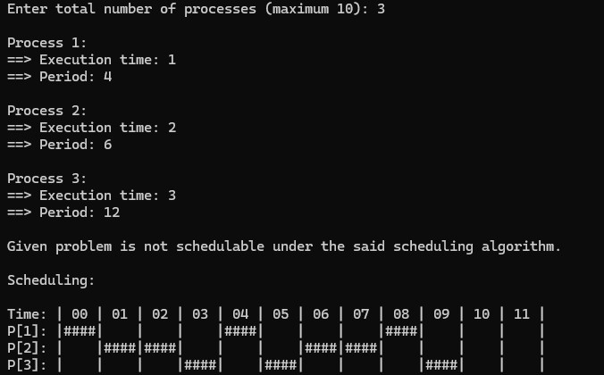

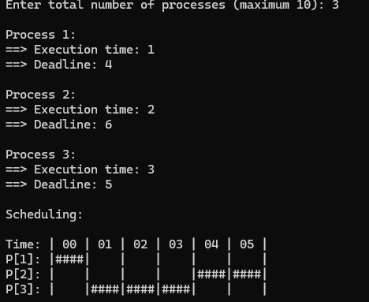

### LAB -04 Producer consumer problem

#include<stdio.h> #include<stdlib.h> int mutex=1,full=0,empty=3,x=0; int main()

{

int n; void producer(); void consumer(); int wait(int); int signal(int); printf("\n1.Producer\n2.Consumer\n3.Exit"); while(1)

{

printf("\nEnter your choice: "); scanf("%d",&n); switch(n)

{

case 1: if((mutex==1)&&(empty!=0))

producer(); else printf("Buffer is full!!"); break;

case 2: if((mutex==1)&&(full!=0))

consumer(); else printf("Buffer is empty!!"); break;

case 3: exit(0);

break;

}

}

return 0;

}

int wait(int s) { return (--s);} int signal(int s)

{

return(++s);

}

void producer()

{

mutex=wait(mutex);

full=signal(full);

empty=wait(empty); x++; printf("\nProducer produces the item %d",x); mutex=signal(mutex);

}

void consumer()

{

mutex=wait(mutex);

full=wait(full); empty=signal(empty); printf("\nConsumer consumes item %d",x);

x--;

mutex=signal(mutex);

}

OUTPUT:

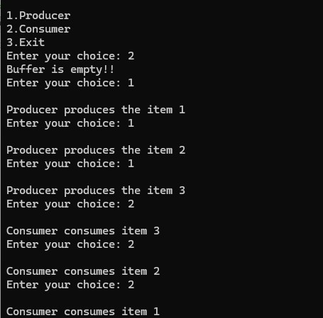

### LAB-05 Dining philosophers problem

#include <stdio.h>

#include <pthread.h>

#include <semaphore.h>

#define N 5

#define THINKING 2

#define HUNGRY 1

#define EATING 0

#define LEFT (i + 4) % N #define RIGHT (i + 1) % N int state[N]; int phil[N] = {0,1,2,3,4}; sem_t mutex; sem_t S[N];

void test(int i)

{

if (state[i] == HUNGRY && state[LEFT] != EATING && state[RIGHT] != EATING)

{

state[i] = EATING; sleep(2); printf("Philosopher %d takes fork %d and %d\n", i +1, LEFT +1, i +1); printf("Philosopher %d is Eating\n", i +1); sem_post(&S[i]);

}

}

void take_fork(int i)

{

sem_wait(&mutex); state[i] = HUNGRY; printf("Philosopher %d is Hungry\n",i+1); test(i);

sem_post(&mutex); sem_wait(&S[i]); sleep(1);

}

void put_fork(int i)

{

sem_wait(&mutex); state[i] = THINKING; printf("Philosopher %d putting fork %d and %d down\n",i +1, LEFT +1, i +1); printf("Philosopher %d is thinking\n", i+1); test(LEFT); test(RIGHT); sem_post(&mutex);

}

void* philosopher(void* num)

{

while (1)

{

int* i = num;

sleep(1); take_fork(*i); sleep(0); put_fork(*i); }

} int main()

{

int i;

pthread_t thread_id[N];

sem_init(&mutex,0,1);

for (i =0; i < N; i++) sem_init(&S[i],0,0);

for (i =0; i < N; i++)

{

pthread_create(&thread_id[i], NULL, philosopher, &phil[i]); printf("Philosopher %d is thinking\n", i +1);

}

for (i =0; i < N; i++)

{

pthread_join(thread_id[i], NULL);

}

}

**OUTPUT:**

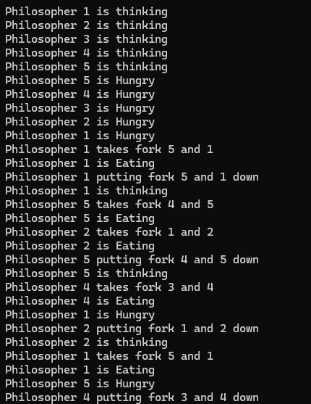

**LAB-06**

**Write a C program to simulate Bankers algorithm for the purpose of deadlock avoidance**. #include <stdio.h>

int main()

{ int n, m, i, j, k;

printf("Enter the number of processes: "); scanf("%d", &n);

printf("Enter the number of resources: ");

scanf("%d", &m);

int allocation[n][m];

printf("Enter the Allocation Matrix:\n");

for (i = 0; i < n; i++)

{

for (j = 0; j < m; j++)

{

scanf("%d", &allocation[i][j]);

}

}

int max[n][m];

printf("Enter the MAX Matrix:\n");

for (i = 0; i < n; i++)

{

for (j = 0; j < m; j++)

{

scanf("%d", &max[i][j]);

}

}

int available[m];

printf("Enter the Available Resources:\n"); for (i = 0; i < m; i++)

{

scanf("%d", &available[i]);

}

int f[n], ans[n], ind = 0; for (k = 0; k < n; k++)

{

f[k] = 0;

}

int need[n][m]; for (i = 0; i < n; i++)

{

for (j = 0; j < m; j++)

{

need[i][j] = max[i][j] - allocation[i][j];

}

}

int y = 0; for (k = 0; k < n; k++)

{

for (i = 0; i < n; i++)

{ if (f[i] == 0)

{

int flag = 0;

for (j = 0; j < m; j++)

{

if (need[i][j] > available[j])

{

flag = 1;

break;

}

}

if (flag == 0)

{

ans[ind++] = i;

for (y = 0; y < m; y++)

{

available[y] += allocation[i][y];

} f[i] = 1;

}

}

}

}

int flag = 1; for (i = 0; i < n; i++)

{

if (f[i] == 0)

{

flag = 0;

printf("The following system is not safe\n"); break;

}

}

if (flag == 1)

{

printf("Following is the SAFE Sequence\n"); for (i = 0; i < n - 1; i++)

{

printf(" P%d ->", ans[i]);

}

printf(" P%d\n", ans[n - 1]);

}

return 0;

}

**Output:**

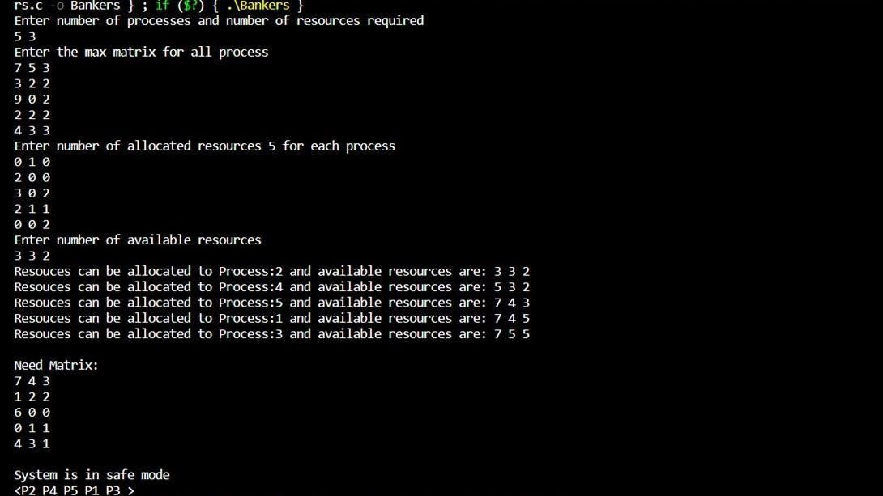

**LAB-07**

**Write a C program to simulate deadlock detection.**

#include<stdio.h> static int mark[20];

int i,j,np,nr;

int main()

{

int alloc[10][10],request[10][10],avail[10],r[10],w[10]; printf("\nEnter the no of process: ");

scanf("%d",&np);

printf("\nEnter the no of resources: ");

scanf("%d",&nr); for(i=0;i<nr;i++)

{

printf("\nTotal Amount of the Resource R%d: ",i+1);

scanf("%d",&r[i]);

}

printf("\nEnter the request matrix:");

for(i=0;i<np;i++) for(j=0;j<nr;j++)

scanf("%d",&request[i][j]);

printf("\nEnter the allocation matrix:"); for(i=0;i<np;i++) for(j=0;j<nr;j++) scanf("%d",&alloc[i][j]); /*Available Resource calculation*/

for(j=0;j<nr;j++)

{ avail[j]=r[j]; for(i=0;i<np;i++)

avail[j]-=alloc[i][j]; }

for(i=0;i<np;i++)

{

int count=0;

for(j=0;j<nr;j++)

{ if(alloc[i][j]==0) count++;

else

break;

}

if(count==nr)

mark[i]=1;

}

for(j=0;j<nr;j++) w[j]=avail[j]; for(i=0;i<np;i++)

{

int canbeprocessed=0;

if(mark[i]!=1)

{

for(j=0;j<nr;j++)

{

if(request[i][j]<=w[j]) canbeprocessed=1;

else

{

canbeprocessed=0;

break; }

}

if(canbeprocessed)

{

mark[i]=1; for(j=0;j<nr;j++)

w[j]+=alloc[i][j];

}

}

}

int deadlock=0; for(i=0;i<np;i++) if(mark[i]!=1) deadlock=1; if(deadlock) printf("\n Deadlock detected"); else

printf("\n No Deadlock possible");

}

**Output:**

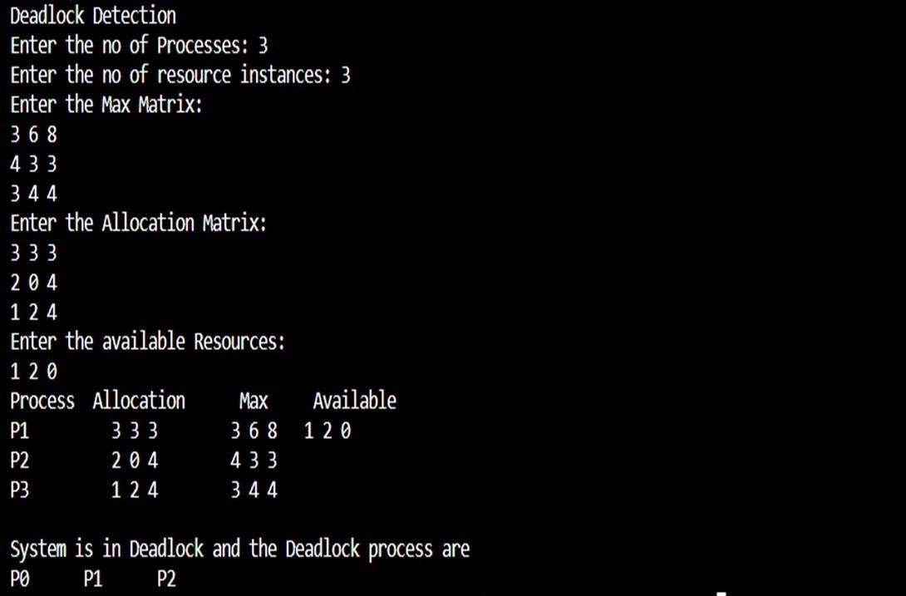

**LAB-08**

**Write a C program to simulate the following contiguous memory allocation techniques:**

1. Worst-fit
2. Best-fit
3. First-fit #include <stdio.h>

#define max 25

void firstFit(int b[], int nb, int f[], int nf); void worstFit(int b[], int nb, int f[], int nf); void bestFit(int b[], int nb, int f[], int nf);

int main()

{

int b[max], f[max], nb, nf;

printf("Memory Management Schemes\n");

printf("\nEnter the number of blocks:");

scanf("%d", &nb);

printf("Enter the number of files:");

scanf("%d", &nf);

printf("\nEnter the size of the blocks:\n");

for (int i = 1; i <= nb; i++)

{

printf("Block %d:", i);

scanf("%d", &b[i]);

}

printf("\nEnter the size of the files:\n"); for (int i = 1; i <= nf; i++)

{

printf("File %d:", i); scanf("%d", &f[i]);

}

printf("\nMemory Management Scheme - First Fit"); firstFit(b, nb, f, nf);

printf("\n\nMemory Management Scheme - Worst Fit"); worstFit(b, nb, f, nf);

printf("\n\nMemory Management Scheme - Best Fit"); bestFit(b, nb, f, nf); return 0;

}

void firstFit(int b[], int nb, int f[], int nf)

{

int bf[max] = {0}; int ff[max] = {0}; int frag[max], i, j; for (i = 1; i <= nf; i++)

{

for (j = 1; j <= nb; j++)

{ if (bf[j] != 1 && b[j] >= f[i])

{ ff[i] = j; bf[j] = 1; frag[i] = b[j] - f[i]; break;

}

}

}

printf("\nFile_no:\tFile_size:\tBlock_no:\tBlock_size:\tFragment"); for (i = 1; i <= nf; i++) printf("\n%d\t\t%d\t\t%d\t\t%d\t\t%d", i, f[i], ff[i], b[ff[i]], frag[i]);}

void worstFit(int b[], int nb, int f[], int nf)

{

int bf[max] = {0}; int ff[max] = {0};

int frag[max], i, j, temp, highest = 0;

for (i = 1; i <= nf; i++)

{

for (j = 1; j <= nb; j++)

{ if (bf[j] != 1)

{ temp = b[j] - f[i];

if (temp >= 0 && highest < temp)

{ ff[i] = j;

highest = temp;

}

}

}

frag[i] = highest; bf[ff[i]] = 1;

highest = 0;

}

printf("\nFile_no:\tFile_size:\tBlock_no:\tBlock_size:\tFragment"); for (i = 1; i <= nf; i++)

{

printf("\n%d\t\t%d\t\t%d\t\t%d\t\t%d", i, f[i], ff[i], b[ff[i]], frag[i]);

}

}

void bestFit(int b[], int nb, int f[], int nf)

{

int bf[max] = {0}; int ff[max] = {0};

int frag[max], i, j, temp, lowest = 10000;

for (i = 1; i <= nf; i++)

{

for (j = 1; j <= nb; j++)

{ if (bf[j] != 1)

{ temp = b[j] - f[i];

if (temp >= 0 && lowest > temp)

{ ff[i] = j;

lowest = temp;

}

}

}

frag[i] = lowest; bf[ff[i]] = 1;

lowest = 10000;

}

printf("\nFile_no:\tFile_size:\tBlock_no:\tBlock_size:\tFragment"); for (i = 1; i <= nf && ff[i] != 0; i++)

{

printf("\n%d\t\t%d\t\t%d\t\t%d\t\t%d", i, f[i], ff[i], b[ff[i]], frag[i]);

}

}

**Output:**

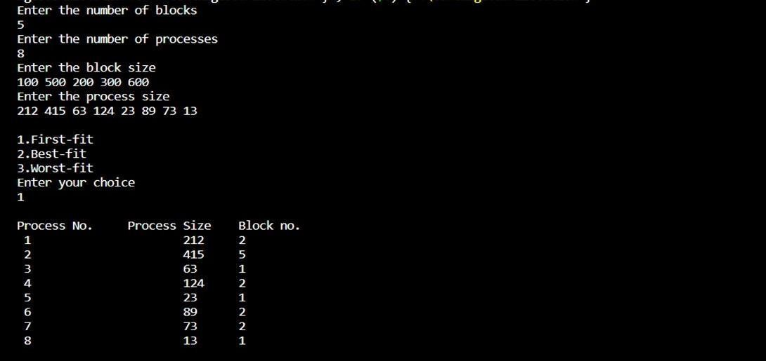

**LAB-09**

**Write a C program to simulate page replacement algorithms:**

1. **FIFO**
2. **LRU**
3. **Optimal**

#include<stdio.h>

int n, f, i, j, k; int in[100]; int p[50]; int hit=0;

int pgfaultcnt=0;

void getData()

{

printf("\nEnter length of page reference sequence:"); scanf("%d",&n);

printf("\nEnter the page reference sequence:"); for(i=0; i<n; i++) scanf("%d",&in[i]);

printf("\nEnter no of frames:"); scanf("%d",&f);

}

void initialize()

{

pgfaultcnt=0; for(i=0; i<f; i++) p[i]=9999; }

int isHit(int data)

{

hit=0;

for(j=0; j<f; j++)

{

if(p[j]==data)

{

hit=1;

break;

} } return hit;

}

int getHitIndex(int data)

{ int hitind;

for(k=0; k<f; k++)

{

if(p[k]==data)

{

hitind=k;

break;

}}

return hitind;

}

void dispPages()

{

for (k=0; k<f; k++)

{

if(p[k]!=9999)

printf(" %d",p[k]); }}

void dispPgFaultCnt()

printf("\nTotal no of page faults:%d",pgfaultcnt);

void fifo()

{

getdata(); initialize(); for(i=0; i<n; i++)

{

printf("\nFor %d :",in[i]);

//not a hit if(isHit(in[i])==0)

{

for(k=0; k<f-1; k++)

p[k]=p[k+1];

p[k]=in[i]; pgfaultcnt++;

dispPages();

}

else

printf("No page fault");

}

dispPgFaultCnt();

}

void optimal()

{ initialize(); int near[50];

for(i=0; i<n; i++)

{

printf("\nFor %d :",in[i]);

if(isHit(in[i])==0)

{

for(j=0; j<f; j++)

{

int pg=p[j]; int found=0;

for(k=i; k<n; k++)

{

if(pg==in[k])

{

near[j]=k; found=1;

break;

}

else found=0;

}

if(!found)

near[j]=9999;

}

int max=-9999; int repindex; for(j=0; j<nf; j++)

{

if(near[j]>max)

{

max=near[j];

repindex=j;

}

}

p[repindex]=in[i];

pgfaultcnt++;

dispPages();

}

else

printf("No page fault");

}

dispPgFaultCnt();

}

void lru()

{ initialize();

int least[50];

for(i=0; i<n; i++)

{

printf("\nFor %d :",in[i]);

if(isHit(in[i])==0)

{

for(j=0; j<nf; j++)

{

int pg=p[j]; int found=0; for(k=i-1; k>=0; k--)

{

if(pg==in[k])

{

least[j]=k; found=1;

break;

}

else

found=0;

}

if(!found) least[j]=-9999;

}

int min=9999; int repindex;

for(j=0; j<nf; j++)

{

if(least[j]<min)

{

min=least[j];

repindex=j;

}

}

p[repindex]=in[i];

pgfaultcnt++;

dispPages();

}

else printf("No page fault!");

}

dispPgFaultCnt();

}

int main()

{

int choice;

while(1)

{

printf("\nPage Replacement Algorithms\n

1.Enter data\n 2.FIFO\n 3.Optimal\n 4.LRU\n 5.Exit\n Enter your choice:"); scanf("%d",&choice);

switch(choice)

{

case 1: getData(); break;

case 2: fifo(); break;

case 3: optimal(); break;

case 4: lru(); break;

default: return 0;

break;

}

}

}

**Output:**

1. **Enter Data:**

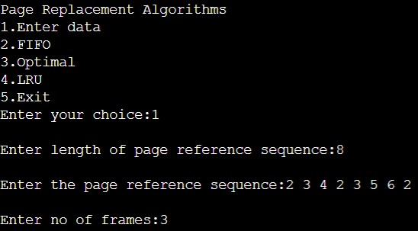

1. **FIFO:**

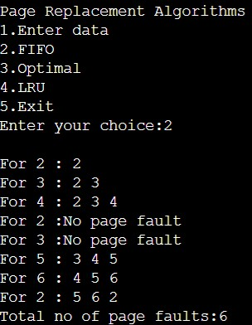

1. **OPTIMAL:**

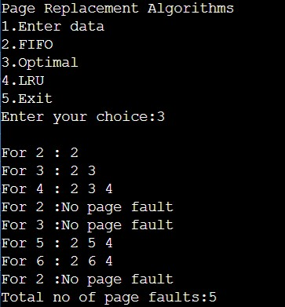

1. **LRU:**

