Greenclassify: Vegetable Image Classification
Deep Learning Based Flask Web Application

PROJECT OVERVIEW

The project titled “Vegetable Image Classification using Deep Learning” focuses on automatically identifying different types of vegetables from images using a Convolutional Neural Network (CNN) model.
In traditional systems, vegetable classification is done manually, which is time-consuming and sometimes inaccurate. Farmers, sellers, and supermarkets often need fast and accurate classification for sorting and packaging. This project provides an intelligent automated solution using Artificial Intelligence.
The system takes an image of a vegetable as input, processes it using image preprocessing techniques, and then passes it through a trained deep learning model. The CNN model extracts important features from the image such as shape, color, and texture, and predicts the correct vegetable category.
This project uses Python and Deep Learning libraries such as TensorFlow and Keras for model building and training. The dataset consists of multiple vegetable images divided into different classes. The model is trained and tested to achieve high classification accuracy.
The main goal of this project is to:
- Reduce manual effort in vegetable classification
- Improve speed and accuracy
- Apply Deep Learning in real-world agriculture applications
This system can be further extended into a mobile application or real-time camera-based detection system for practical usage.

Project Member:
Darshana Ajit Deshmukh
(Data Science - final year)
2. OBJECTIVES

- Know fundamental concepts and techniques of Convolutional Neural Networks.
- Gain a broad understanding of image data.
- Know how to pre-process/clean the data using different data preprocessing techniques.
- know how to build a web application using the Flask framework.

3. KEY FEATURES

The Vegetable Image Classification system includes the following key features:
- Automatic Image Classification
The system automatically identifies the type of vegetable from the uploaded image without human intervention.
- Deep Learning-Based Model
The project uses a Convolutional Neural Network (CNN), which is highly effective for image classification tasks.
- Image Preprocessing
Before training, images are resized and normalized to improve model accuracy and performance.
- High Accuracy
The trained model achieves good accuracy on both training and testing datasets.
- User-Friendly Interface
The system allows users to upload an image and receive instant classification results.
- Scalable Architecture
New vegetable categories can be added easily by retraining the model with additional data.
- Performance Visualization
The system displays:
- Accuracy graph
- Loss graph
- Confusion matrix
These help in evaluating model performance.

4. USE CASE SCENARIOS

Scenario 1: Supermarkets and Grocery Stores
Stores can use the system to automatically sort vegetables and reduce manual classification errors.

Scenario 2: Agriculture Industry
Farmers can use the system to quickly identify vegetable types during harvesting and packaging.

Scenario 3: Wholesale Markets
The system can assist in bulk vegetable classification, improving operational efficiency.

Scenario 4: E-commerce Platforms
Online grocery platforms can use the model to verify product images uploaded by sellers.

Scenario 5: Smart Farming Systems
This model can be integrated into automated farming systems for intelligent crop monitoring.

Scenario 6: Educational Purpose
Students and researchers can use this project to understand how Deep Learning works in real-world image classification problems.

5. TECHNICAL APPROACH
The technical approach of this project is based on Deep Learning using a Convolutional Neural Network (CNN) model for image classification.
- Data Collection
A dataset containing multiple vegetable images was collected from a reliable source (e.g., Kaggle). The dataset contains different vegetable categories such as tomato, potato, onion, carrot, etc.
- Data Preprocessing
Before training the model, the following preprocessing steps were performed:
- Image resizing (e.g., 150x150 pixels)
- Normalization (scaling pixel values between 0 and 1)
- Splitting dataset into training and testing sets
- Data augmentation (optional)
- Model Development
A CNN model was built using TensorFlow/Keras with:
- Convolutional Layers (Conv2D)
- MaxPooling Layers
- Flatten Layer
- Fully Connected (Dense) Layers
- Softmax Output Layer
- Model Training
- Loss Function: Categorical Crossentropy
- Metrics: Accuracy
- Number of Epochs: (mention your value)
- Model Evaluation
The model performance was evaluated using:
- Training accuracy
- Validation accuracy
- Loss graph
- Confusion matrix
- Prediction
The trained model takes a new vegetable image as input and predicts its category.

6. IMPLEMENTATION PLAN

Phase No. | Phase Name | Activities Included | Duration
Phase 1 | Requirement Analysis | Understanding problem statement, defining objectives, identifying dataset requirements | 4 Days
Phase 2 | Data Collection & Preprocessing | Collect dataset, clean data, resize images, normalization, split into train/test sets | 6 Days
Phase 3 | Exploratory Data Analysis (EDA) | Visualizing class distribution, checking image quality, identifying imbalance, plotting sample images | 4 Days
Phase 4 | Model Development & Training | Build CNN architecture, compile model, train with epochs, tune hyperparameters | 8 Days
Phase 5 | Model Evaluation | Evaluate using accuracy, loss graphs, confusion matrix, validation performance | 3 Days
Phase 6 | Deployment | Save trained model, create prediction script, integrate simple interface (optional) | 3 Days
Phase 7 | Testing & Final Validation | Test with new images, debug errors, performance verification | 2 Days

7. BENEFITS
The project provides several advantages:

- Time Saving
Reduces manual effort in vegetable classification.

- High Accuracy
Deep Learning ensures better prediction performance.

- Automation
Minimizes human errors and improves efficiency.

- Real-World Application
Can be used in agriculture, supermarkets, and food industries.

- Scalable System
New vegetable classes can be added easily.

- Learning Opportunity
Helps students understand practical implementation of CNN and image classification.

8. PROJECT FLOW
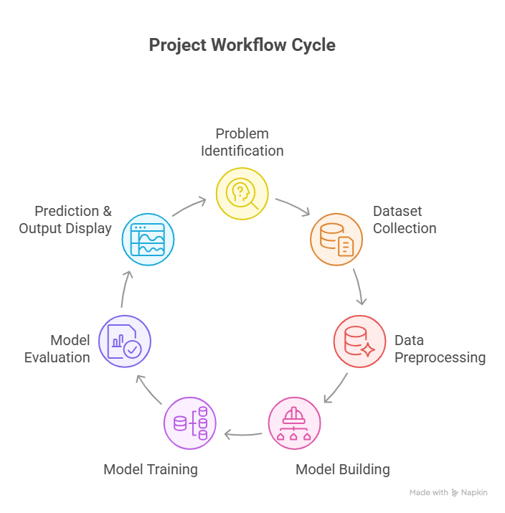
Fig. no 1: Project Flow of Greenclassify

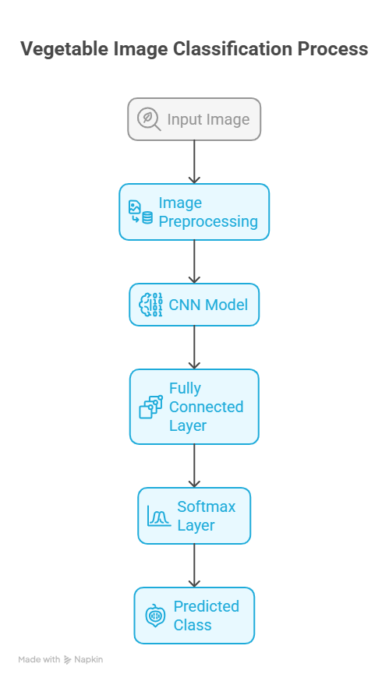
Fig. no 2: System Architecture Diagram of Greenclassify
9. SYSTEM ARCHITECTURE DIAGRAM
10. REQUIREMENTS SPECIFICATION

Hardware Requirements

Processor: Intel i3 or higher

RAM: Minimum 4GB (8GB recommended)

Storage: 10GB free space

GPU (Optional for faster training)

Software Requirements

Operating System: Windows / Linux / Mac

Programming Language: Python

Libraries:

TensorFlow / Keras

NumPy

OpenCV

Matplotlib

Scikit-learn

Development Environment: Jupyter Notebook / VS Code

11. RISKS AND MITIGATIONS
REQUIREMENTSSPECIFICATION

- Risk: Low Model Accuracy
If the dataset is small or unbalanced, the model may give poor predictions.
Mitigation:
- Use a larger dataset
- Apply data augmentation
- Tune hyperparameters

- Risk: Overfitting
The model may perform well on training data but poorly on testing data.
Mitigation:
- Use Dropout layers
- Use regularization
- Increase validation data

- Risk: High Training Time
Deep learning models may take longer time to train.
Mitigation:
- Use GPU for faster training
- Reduce image size
- Optimize batch size

- Risk: Limited Scalability
System may not support new vegetable classes easily.
Mitigation:
- Design modular architecture
- Retrain model with extended dataset

12. FUTURE ENHANCEMENTS
- Real-Time Detection
Integrate camera-based live vegetable detection.

- Mobile Application
Develop Android/iOS app for farmers and sellers.

- Cloud Deployment
Deploy model on cloud platforms for online access.

- More Vegetable Categories
Increase number of vegetable classes for better coverage.

- Transfer Learning
Use advanced pre-trained models like:
- VGG16
- ResNet
- MobileNet
This can improve accuracy.

- Integration with Smart Agriculture Systems
Connect with IoT devices for intelligent farming solutions

13. CONCLUSION
The Vegetable Image Classification project successfully demonstrates the application of Deep Learning in real-world agricultural scenarios. By using a Convolutional Neural Network (CNN), the system is able to classify vegetable images with good accuracy. The preprocessing techniques improved model performance, and evaluation metrics confirmed the effectiveness of the system.
This project reduces manual effort, improves efficiency, and provides an intelligent automated solution for vegetable classification. Overall, the project proves that Deep Learning can be effectively applied in agriculture and food industries, and it has strong potential for real-world implementation.

14. REFERENCES
- Kaggle. (2023). Vegetable Image Dataset. Retrieved from
https://www.kaggle.com
- TensorFlow Team. (2023). TensorFlow Documentation. Retrieved from
https://www.tensorflow.org
- Chollet, F. (2015). Keras Documentation. Retrieved from
https://keras.io
- Goodfellow, I., Bengio, Y., & Courville, A. (2016).
Deep Learning. MIT Press. Retrieved from
https://www.deeplearningbook.org
- OpenCV Team. (2023). OpenCV Documentation. Retrieved from
https://docs.opencv.org

