**Basics of Networking:**

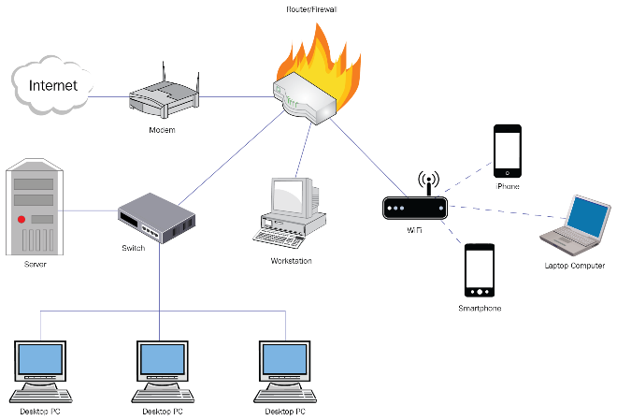

* Computer Networks: connection of two or more computer together to enable communication and data exchange. For easy communication.
* Node: a device for communication like modem, router, or a data terminal like a computer.
* IP address: Each Device on a network has an IP address, helps in identifying the device easily.
* Protocol: a set of rules and standards that govern how data is transmitted over a network.
* Network Topology: Physical and logical arrangement of nodes on a network. It includes bus, star, ring, mesh, and tree.
* Network Interface Card (NIC): Each node has a NIC, which creates a physical connection to the network. It also has a MAC address which is a unique identifier.
* Packet: Information sent over a network is broken into smaller pieces called packets. These are like the individual letters that make up a word or the words that make up a page.
* Bandwidth: This reflects the maximum amount of data that can be sent over a network connection in a given time. It can be likened to the width of a highway: a wider highway can accommodate more cars (But cars still need to be the same width and size).
* MAC Address: This 'Media Access Control' address is a unique identifier assigned to a NIC by its manufacturer. It's like your device's postal address on the network.
* Firewall: Security device. For monitoring and controlling incoming and outgoing network traffic. It used for protecting networks from unauthorized access and another security threats.
* DNS: Domain Name Service is translating human-readable domain names into IP addresses that computers can understand.
* **Different Name of Nodes and its uses:**
* Router: forward data packets between computer networks. Subnetworks can be connected by router. By sending data packets to their intended IP addresses, it manages traffic between different networks and permits several devices to share an Internet connection.
* Switch: can act as a controller, connecting computers, printers and serves toa network in a building or a campus.
* Hub:
* Gateway:
* **Types of Computer Networks:**
  + PAN (Personal Area Network): covers small area like room and used to connect with personal devices like computers, phone, etc.
  + LAN (Local Ara Network): covers small area, such as office or a home.
  + WLAN (Wireless Local Area Network): Similar to LAN but wireless.
  + WAN (Wide Area Network): covers a huge area like city, country, or even entire world.
  + MAN (Metropolitan Area Network): Larger than LAN but smaller than WAN. Used to connect LAN within large campus, city, country.
  + VPN (Virtual Private Network): extends a private network across public networks. employees connecting to their company’s network remotely from different geographical locations.
  + CAN (Campus Area Network): A CAN is larger than a LAN but smaller than a MAN and is typically used to connect various buildings.
  + EPN (Enterprise Private Network): An EPN is built and used exclusively by an organization, connecting local and wide-area networks.
  + DCN (Data Center Network): provides communication between data center resources (storage systems and servers) for reliability and scalability.
  + SAN (Storage Area Network): connects servers to data storage devices, providing access to shared storage, crucial for environments handling large data volumes.
  + SAN/CAN (System/Cluster Area Network): offers high-speed connections for high-performance computing environments like clusters.
  + Cloud Networks: it can be hosted on public or private cloud service providers.
* **Types of Network Architecture:**
  + Peer-to-peer: no central server required. Each devices acts as both client and server.
  + Client/server: central server or group of servers manages resources and deliver them to client devices. Client communicates with other clients through server. called as Tiered model.
* **Wireless Networking:**
  + Centralized deployment: buildings and networks are proximity. Consolidates wireless networks, which makes upgrades easier and facilitates advanced wireless functionality. Controllers are based on on-premises and are installed in a centralized location.
  + Converged deployment: for small area converged deployments offer consistency in wireless and wired connections. This deployment on one network device – an access switch and performs the dual role of both switch and wireless controller.
  + Cloud-based deployment: it uses cloud manage network devices deployed on-premises at different locations.