**The Impact of DevOps on Software Development: A Deep Dive into CI/CD Pipeline**

Darshana Chauhan[1]

Deutsche Bank, India.

*Abstract –* **This paper explores the transformative impact of DevOps practices on software development, focusing on the continuous integration and continuous delivery (CI/CD) pipeline. By examining case studies, tools, best practices, and the latest advancements, we highlight how CI/CD pipelines streams development process, enhance collaboration, and improve software quality and delivery speed.**

*Keywords* **– Kubernetes, orchestration, container, services, nodes.**

1. INRODUCTION

DevOps is a software development methodology that combines software development (Dev) and IT operations (Ops) into a coherent framework. The primary objective of DevOps is to enhance and expedite the software development process by promoting cooperation between the operations and development teams.

The development and operations lifecycle, from planning, building, and deployment to testing, monitoring, and iterating, is done by DevOps. Communication, transparency, adaptability, and automation are essential for DevOps.

DevOps promotes ideas that support quick software delivery, including automation, infrastructure as code (IaC), continuous integration, and continuous delivery/deployment (CI/CD). Outline the main goals of research, focusing on understanding the CI/CD pipeline’s role in DevOps.

1. LITERATURE REVIEW

Fundamentally, DevOps is a cultural revolution that encourages cross-functional teams to work together, communicate, and integrate. DevOps emerged as a transformative approach in the late 2000s. The term “DevOps” was coined in 2009 by Patrick Debois, a Belgian IT consultant. DevOps was needed for faster releases, improved productivity, and better team collaboration. It aimed to break down the silos between the development and operations teams.

A CI/CD pipeline automates your software delivery process, reducing manual errors, providing feedback to developers, and allowing for fast product iterations. It’s a critical component of a DevOps methodology, bringing developers and IT operations teams together to deploy software. In the world of technology, the companies are getting differentiated by a custom application on the rate at which code can be released, this is the key for differentiation.

1. METHODOLOGY

DevOps Principles: Here are some key principles that help DevOps teams deliver applications and services at a faster pace and higher quality:

* Collaboration
* Automation
* Continuous Improvement
* Customer centric action
* Create with the end in mind.

Before DevOps, software development was done by the waterfall methodology. In this method of development each development phase was handled by a different team or department, which often led to delays, miscommunication, and projects running over budget and behind schedule. So, the new method for development came into use is “Agile” methodology, which laid the groundwork for DevOps by emphasizing iterative development, collaboration, and customer feedback.

The DevOps Software Development Life Cycle (SDLC) covers the levels for developing a website like building, deploying, planning, etc. A seamless and iterative workflow integration of these level lets in groups to deliver the software faster, reliably.

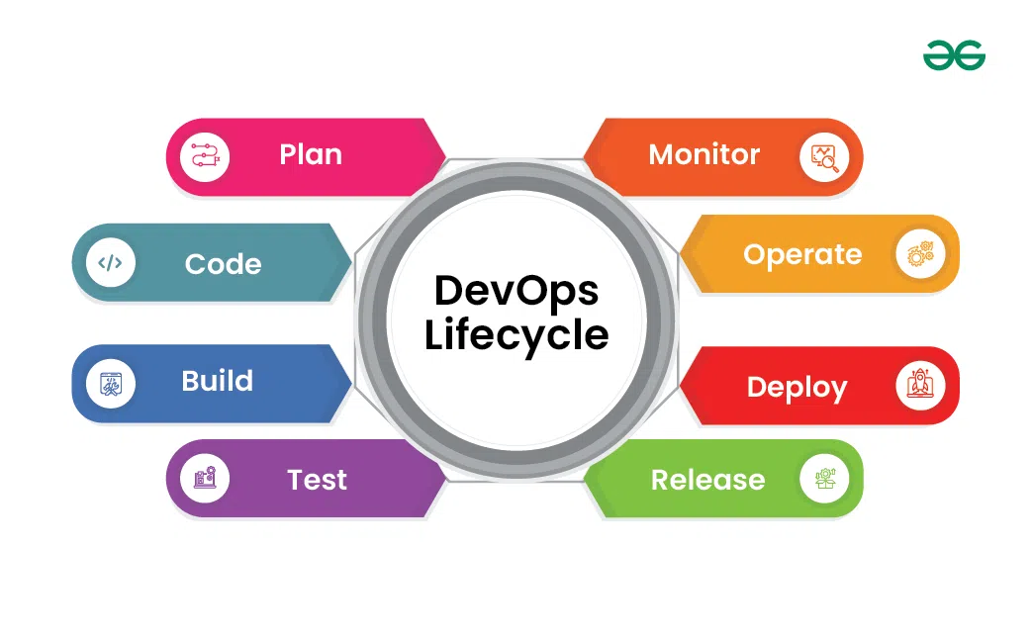

Pillars of DevOps:

* Culture: Encourages trust, open communication, and continuous learning.
* Automation: To automate repetitive task so that team can reduce the errors and improve efficiency.
* Measurement: Teams measures the performance, track key indicators and use data to make informed decision.
* Sharing: to share feedback and knowledge among the team, increasing transparency, improving collective intelligence, and removing constraints.

The 7C’s of DevOps: These principles for “continuity” work together to create a seamless and efficient software development and delivery process.

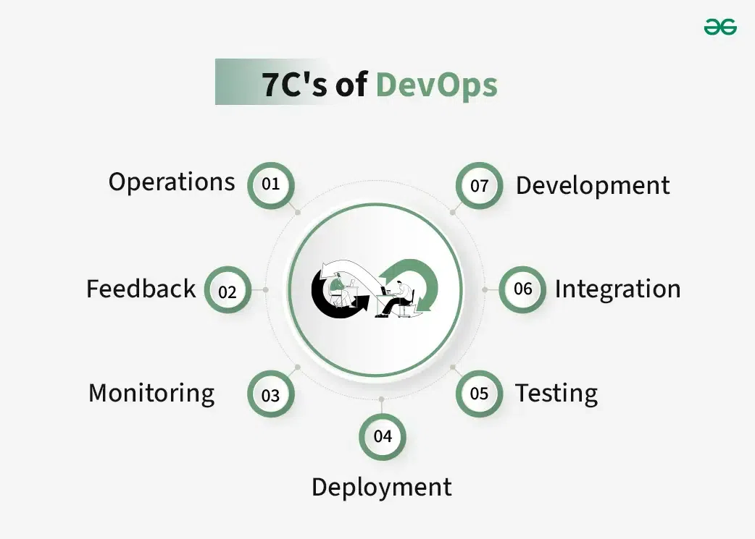

1. CI (Continuous Integration):

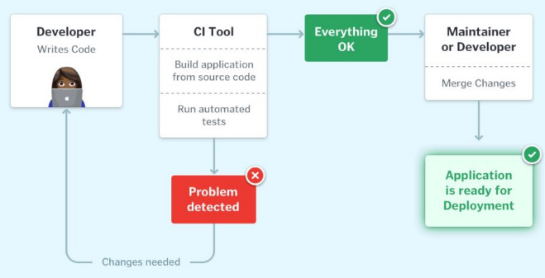

When the developers in a team, work in isolation and only merge their changes to the master branch after the complete code is ready. This makes the merging of code very difficult, prone to conflicts, and time-consuming and also results in bugs accumulating. These factors make it harder to deliver updates to customers quickly.

With Continuous Integration, developers frequently commit to a shared common repository using a version control system such as Git. A continuous integration pipeline can automatically run builds, store the artifacts, run unit tests, and even conduct code reviews using specific tools. The CI pipeline can be triggered every time there is a commit/merge happens in the codebase.

1. CD (Continuous Delivery):

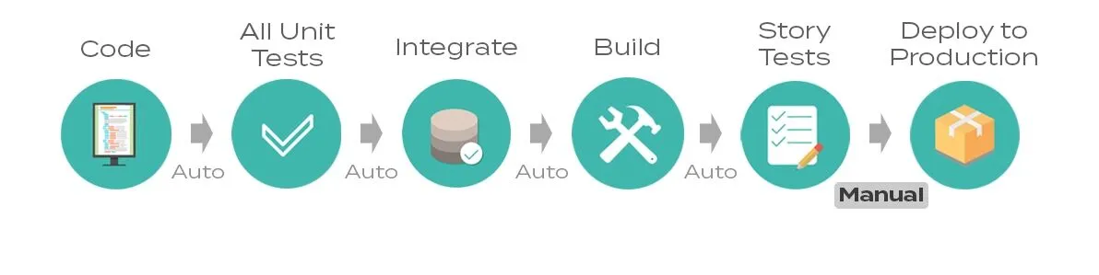

CD or Continuous Delivery is carried out after Continuous Integration, to make sure that building, testing, and releasing software happen with greater speed and frequency. A build server compiles and packages the code after a change is committed to a source control repository. Continuous delivery helps developers test their code in a production-similar environment. These tests may include UI testing, load testing, integration testing, etc. by developers to discover and resolve bugs.

CD contributes to low-risk releases, lower costs, better software quality, improved productivity levels, and deliver updates faster and more frequently. CD ensures to automate the software delivery process and commits to deliver the integrated code into the production stage without any bugs or delay. If the deployment to production is a manual step, in that case, the process is called Continuous Delivery.

1. CD (Continuous Deployment):

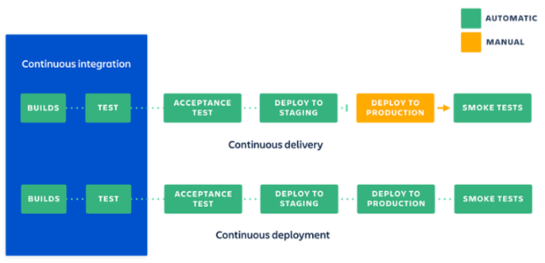

Whenever there is an important change in the code, the corresponding build and deployment occur simultaneously. As such, continuous deployment can be viewed as a more complete form of automation than continuous delivery. If the deployment to the production environment is automated, it is referred to as Continuous Deployment. A major motivation for continuous deployment is that deploying software into the field more often makes it easier to find, catch, and fix bugs.

CD will automate the related app for production purpose because there is not having any manual gate at the stage of the pipeline before production, continuous deployment relies on high automation. When they commit code to the repository, the CD pipeline picks it up and deploys it. This ensures that the latest changes are quickly reflected in the live application, and it will live within a few minutes of writing pass with the automated testing.

1. CI/CD pipeline Architecture:

The aim of any software application is to reach to as many customers as possible, and CI/CD pipeline offers the same to any business model with less risk in each build and helps in the product to meet the goal.

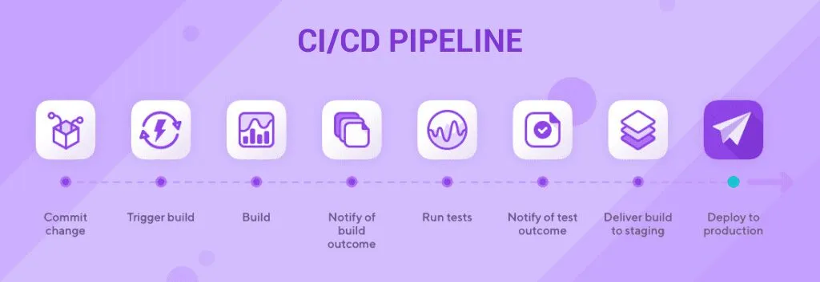

The implementation can be done either with a DevOps or SRE (Site Reliability Engineering) approach. In CI/CD pipeline the developers can achieve faster feedback through CI tools, greater visibility to the whole process of new builds, test results and early bug detects by different types of automated testing.

Stages of CI/CD pipeline implementation:

* **Commit:** new feature and new codes are integrated with the base in this stage. Feedback system will help in checking the code quality.
* **Build:** Once code is tested and integrated the next step is build where developers push the artifacts into the registry. Here, application is compiled by putting together the codes and related dependencies.
* **Test:** It becomes a safety trap that stops reproducible bugs from reaching the end-user. Failure in the testing exposes the problems with the codes. Two types of deployment take place at the testing phase:
  + **Alpha**: check the performance of the new builds and interactions between them.
  + **Beta**: manual testing, which double checks if the application works correctly or not.
* **Production deployment:** final stage where application goes live. There can be multiple layers in the deployment of the version which depends on project type. Once build has gone through all the testing scenarios successfully, it is ready to the production stage for end-user environment.

The process of CI/CD pipeline includes the below properties.

* Source code management, where we store and manage the code in a controlled repository.
* Continuous Integration, automatically integrate the code changes from multiple contributors.
* Artifact creation, from the successful CI build, i.e., create deployable artifacts like container images.
* Automated testing, which validates code changes through automated testing to catch defects early.
* Continuous deployment, which automatically deploy the application to a staging or production environment.
* Monitoring and feedback, to manage the deployable application to detect the issues and gather feedback.
* Rollback, if necessary, then roll back to previous version in the case of deployment issues.

The below aspects will detect the performance of the CI/CD pipelines:

* Quick feedback: It is always required to obtain quick feedback on the exactness.
* Duration of Setting up the pipeline: The implementation requires quick execution and more accuracy.
* Meeting the scalable development standards: A certain number of CI/CD Pipelines can run at a given point in time.

Orchestration ensures that the deployment process is managed efficiently and minimizes disruptions to live services. It’s tightly coupled with CI/CD to guarantee a healthy service. Security and Compliance:

**Monitoring and Feedback:** Monitoring is a crucial aspect of CI/CD pipeline feedback loops. It enables teams to identify issues before they impact releases or production environments. By implementing real-time monitoring and effective logging strategies, developers can receive timely feedback on application performance. Here are some key metrics to consider:

* **Lead Time:** This metric measures the time from code being committed to deployment. It allows you to focus on the stages within the scope of your CI/CD pipeline.
* **Deployment Frequency:** How often you deploy changes to production.
* **Change Failure Rate:** The percentage of deployments that result in failure.
* **Mean Time to Recovery (MTTR):** The average time it takes to recover from a failure.

**Tools and technology:**

* Jenkins
* CircleCI
* AWS CodeBuild
* Azure DevOps
* Atlassian Bamboo
* Argo CD
* Buddy
* Drone
* Travis CI

**CI/CD with Kubernetes and Serverless architecture:**

Many teams operating CI/CD pipelines in cloud environments also use containers such as Docker and orchestration systems such as Kubernetes. Containers allow for packaging and shipping applications in a standard, portable way. Containers make it easy to scale up or down environments with variable workloads.

Next is to use a serverless architecture to deploy and scale the applications. In a serverless environment, the cloud service provider manages the infrastructure, and the application consumes resources as needed based on its configuration. On AWS, for example, serverless applications run as Lambda functions and deployments can be integrated into a Jenkins CI/CD pipeline with a plugin. Azure serverless and GPS serverless computing are similar services.

1. RESULTS

CI/CD Pipeline:

**Benefits:**

* **Reducing time to deployment through automation:** Automated testing makes the development process more efficient, reducing the software delivery time. Also, CD and automated provisioning allow a developer’s changes to a cloud application quickly.
* **Decreasing the costs associated with traditional software development:** Fast development, testing and production with automation means less time to develop and hence less cost.
* **Continuous feedback for improvement:** The CI/CD pipeline is a continuous cycle of build, test and deploy. When code is tested, developers can quickly act on the feedback and improve the code.
* **Improving the ability to address error detection earlier in the development process**: In CI, testing is automated for each version of code built for integration. In early, these issues are easier to fix in the pipeline that they become bigger.
* **Improving team collaboration and system integration:** Changing the code, respond to feedback, and respond to any issues that occur can be solved by any of the team members. Developers can work in smaller, more manageable code increments, reducing conflicts and making collaboration smoother.
* **Faster Development:** A CI/CD pipeline automates manual processes, thereby reducing the time it takes to release new features or bug fixes.
* **Reliable Deployments:** Automation reduces the risk of human error during delivery, leading to more consistent and predictable releases.

**CI/CD pipeline example:**

Below is a brief example of a CI/CD pipeline diagram:

* **Source code control:** Host code on GitLab to integrate your app with major software and services.
* **GitLab:** Use GitLab CI/CD to commit all code, build and run the required tests.
* **Deploy code to UAT:** Configure GitLab CI/CD to deploy code to the UAT server.
* **Deploy to production:** Repeat the CI/CD step to deploy code to UAT.

**Challenges and Limitations:**

* This might need a discipline strategy to address an issue by the CI/CD pipeline, otherwise the whole fast feedback is in vain.
* Slower builds eventually take place as newer builds keep adding to the product.
* Integrating security practices within the CI/CD pipeline without slowing down the delivery process requires careful planning and implementation.
* Setting up and maintaining CI/CD pipelines can be complex, requiring a good understanding of both the tools and the development process. Failure to train the resources to adapt to new tools and patterns.
* Adopting CI/CD practices often requires a significant shift in team culture and collaboration, moving away from traditional approaches to a more integrated and responsive methodology.

**Future Trends and Developments:**

* **Rise of GitOps:** GitOps is gaining traction as a powerful approach for managing infrastructure and applications. It leverages Git repositories as the single source of truth for defining and deploying infrastructure, making CI/CD pipelines more efficient and reliable.
* **Performance Optimization:** Teams are increasingly focusing on optimizing the performance of their CI/CD pipelines. This includes reducing build times, enhancing test parallelization, and improving overall efficiency to deliver software faster and with higher quality.
* **Shift Towards Cloud-Native Tools:** As organizations embrace cloud-native architectures, CI/CD pipelines are evolving to support containerization, microservices, and serverless deployments. Expect to see more integration with Kubernetes and other cloud-native technologies.
* **Emphasis on Collaboration and Remote Work:** With remote work becoming the norm, CI/CD pipelines are adapting to facilitate collaboration among distributed teams. Tools that enhance communication, code reviews, and automated testing across remote environments will continue to evolve.

1. DISCUSSION

CI/ CD enables organizations to develop software quickly and efficiently. CI/CD enables an effective process for getting products and software to market faster than before, continuously moving code into production, and ensuring a steady flow of new features.

CI/CD is defined as a set of development practices that enable the rapid and reliable delivery of code changes. DevOps is defined as a collection of ideas, practices, processes, and technologies that allow development and operations teams to work together to streamline product development. CI/CD focuses more on software defined lifecycle, tools that emphasize automation on the other hand DevOps focuses more on cultural highlighting roles that emphasize responsiveness. CI/CD helps to put together all code changes into single repository and run automated tests and DevOps helps in putting together more streamlined, agile, and efficient process of software production. CI/CD’s main aim is to allow team to release constant flow of software updates into production quickly and get faster feedback on the other hand DevOps’ main aim is to better combine roles of dev and ops to achieve same shared business goal.

1. CONCLUSION

DevOps is an approach that integrates software development and IT operations teams, emphasizing automation to enhance the development life cycle. It aims to break down silos and faster collaboration between these traditionally separate functions.

CI/CD practices promote collaboration, reliability, and agility — key principles in today’s fast-paced and dynamic software development landscape.

1. REFERENCE
2. [The Role of DevOps in Modern Software Development - GeeksforGeeks](https://www.geeksforgeeks.org/the-role-of-devops-in-modern-software-development/)
3. [History of DevOps - Scaler Topics](https://www.scaler.com/topics/devops-tutorial/history-of-devops/)
4. <https://www.startechup.com/blog/history-of-devops/>
5. <https://www.atlassian.com/devops/what-is-devops>
6. <https://www.redhat.com/en/topics/devops/what-cicd-pipeline>
7. [What is CI/CD? - GeeksforGeeks](https://www.geeksforgeeks.org/what-is-ci-cd/?ref=header_search)
8. [What is CI/CD and CI/CD Pipeline? - Processes, Stages, Benefits (opsmx.com)](https://www.opsmx.com/blog/what-is-a-ci-cd-pipeline/)
9. [What is a CI/CD pipeline? | GitLab](https://about.gitlab.com/topics/ci-cd/cicd-pipeline/)
10. [What is CI/CD? Continuous integration and continuous delivery explained | InfoWorld](https://www.infoworld.com/article/3271126/what-is-cicd-continuous-integration-and-continuous-delivery-explained.html)
11. Chatbot
12. [Continuous delivery - Wikipedia](https://en.wikipedia.org/wiki/Continuous_delivery)
13. [What is CI/CD Implementation? Steps to Implement CI/CD Pipeline (octalsoftware.com)](https://www.octalsoftware.com/blog/steps-to-implement-ci-cd-pipeline#what-is-the-cicd-implementation-plan)
14. [How to Implement an Effective CI/CD Pipeline - DevOps.com](https://devops.com/how-to-implement-an-effective-ci-cd-pipeline/)
15. [What Is CI/CD And The CI/CD Pipeline? | IBM](https://www.ibm.com/think/topics/ci-cd-pipeline)

1. Darshana.chauhan@db.com