­[About Google Distributed Cloud air-gapped  |  Google Cloud](https://cloud.google.com/distributed-cloud/hosted/docs/latest/gdch/overview)

[Google Distributed Cloud Hosted is GA | Google Cloud Blog](https://cloud.google.com/blog/products/infrastructure-modernization/google-distributed-cloud-hosted-is-ga/)

**Google Distributed Cloud Hosted:**

**What is Google Distributed Cloud Hosted?**

Google Distributed Cloud Hosted is an independent cloud platform that enables users to modernize through secure and reliable on-premises deployment. It allows managing infrastructure, services, APIs, or tools without the need for a constant connection to Google Cloud, utilizing the local control plane provided by Anthos. It's designed to run sensitive workloads and supports public-sector.

**How does it work?**

Google Distributed Cloud works by extending public cloud services hosted on Google Cloud Platform to private servers, IoT devices, or other infrastructure. It provides, deploys, operates, and maintains the dedicated Distributed Cloud Edge hardware and software. Workloads run in containers and virtual machines. Google Cloud remotely runs and manages a Kubernetes control plane that governs these nodes.

**Key Components of Google Distributed Cloud:**

1. **Distributed Cloud Edge:** An integrated hardware and software solution that runs general-purpose and specialized network function-enabled workloads⁶.

2. **Distributed Cloud Edge Appliance:** A rack-mount server machine providing local storage, machine learning (ML) inference, transformation, and export of data collected on your premises for processing to the Google Cloud Platform.

3. **Distributed Cloud Software**: Extends Google Cloud's infrastructure and services into your data center, with Google-provided software running on your own hardware⁶.

**Pros and Cons of GDC Edge:**

**Pros:**

* **Open ecosystem:** Leveraging open source and commercial prebuilt hardware tapping into industry innovation and open ISV ecosystem.
* **Intelligence:** Based on the Google AI portfolio, enabling real time decisioning and automation in the platform and as a service.
* **Consistent:** Provides a consistent application experience across Google Cloud, Google edges, operator edges and customer edges, and data centers.
* **Modern:** Modern Cloud approach based on Google leadership in Kubernetes and GKE Enterprise leading hybrid-cloud solution.
* **Proven:** Leveraging proven best practices at scale and technologies used for Google core services.
* **Secure:** Security spanning Core Google Cloud, Google Global Network, Google Edge Infrastructure, and end-user devices.
* **Full isolation:** GDC Hosted is air-gapped and does not require connectivity to Google Cloud or the public internet at any time to manage the infrastructure, services, APIs, or tooling. This ensures that data remains secure and private.
* **Integrated cloud services**: GDC Hosted delivers Google Cloud services, including data and machine learning technologies.
* **Data sovereignty:** GDC Hosted allows customers to control their data entirely and meet strict data security and privacy requirements.
* **Open ecosystem:** GDC Hosted is designed around Google Cloud’s open cloud strategy. It is built on the Kubernetes API and uses leading open-source components in its platform and managed services.
* **Flexibility:** GDC Hosted offers customers the flexibility to deploy a completely managed cloud in their own data centers or other facilities while taking advantage of cloud services' functionality, flexibility, and scale.
* **Configurable operations:** While the technology at the core of every GDC Hosted deployment is the same, the operating model can be configured to meet each customer’s unique specifications and regulations. Customers can enjoy a consistent developer experience and access to a robust set of managed services, while being able to tailor deployment and operations to address their specific requirements. GDC Hosted can be operated by Google, a trusted partner, or a combination of the two with the ability to customize elements like operator citizenship and clearance requirements.

**Cons:**

- Some geographic regions may be at a disadvantage when it comes to edge implementation. In areas with fewer people and financial or technical resources, there will likely be fewer active edge devices and local servers on the network.

**Industries where GDCH is used:**

* **Financial Services:** GDC Hosted provides a flexible option for financial services firms to meet regional regulatory requirements and protect sensitive financial information. In addition, a fully disconnected solution allows them to build resilience against any interruption in the public cloud, run closer to legacy computing systems, like mainframes, to reduce latency, and process data that cannot be put in a public cloud environment.
* **Healthcare:** GDC Hosted provides a platform to improve latency for the local operation of medical equipment, and to enable the development and protection of sensitive clinical trial data. Healthcare providers also require secure storage capabilities to process sensitive data, including patient and disease registries for chronic conditions like cancer, asthma, or diabetes.
* **Manufacturing:** Modern manufacturing is a digital business, and GDC Hosted provides a solution that allows manufacturers to ensure operations will not go offline or be disrupted. In cases where organizations, such as auto manufacturers, want to run AI against proprietary or patented data, and are unwilling to move to the public cloud or need low latency to process data tied to industrial devices in their facility, GDC Hosted is a great option.

**Difference of GDC Hosted and traditional hosting method:**

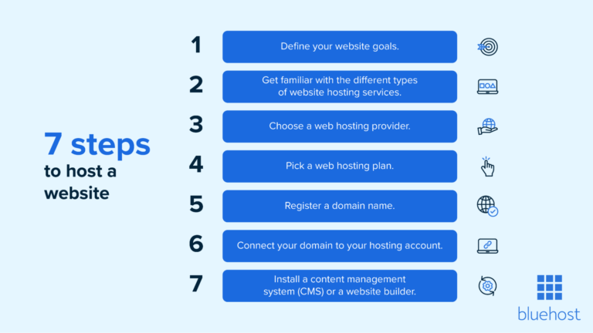

In traditional method, we go to some website and there we push the code and then according to our use we prefer some method of hosting like shared hosting, virtual private server (VPS) hosting, and dedicated hosting, etc. then we put the dns name, and storage accordingly and then our website is getting hosted. Like “You don’t want users to have to type your entire IP address into their address bar to access your website, though. Instead, they can visit your website by typing a domain name associated with it.” Now for GDC hosting, it provides the infrastructure to the computer. So, in our own computer, we can host the website with the help of GDCH. Here, the database is getting created in our own server.

**Google Distributed Cloud Virtual:**

It integrates Google’s software services with enterprise hardware, allowing businesses to concurrently utilize their own systems to run services while managing connections through Google’s control plane.

Key features: AI innovation, Uniform Developer Environment, Data residency and Operational Sovereignty, Cloud Native Agility.

Google announced that Anthos on-prem and on bare metal now power Google Distributed Cloud Virtual. This allows customers to run virtual machines (VMs) alongside containers on a single, unified, Google Cloud-connected platform in their data center or at the edge. This means customers can bring Google Cloud’s software stack to their own data center servers and operate various on-premises applications using the same Google Cloud APIs, control planes, hardware, and tooling as their cloud-hosted apps.

**Benefits:**

Hybrid and multi cloud flexibility

Operational Efficiency

Data security and compliance

Innovation and speed

Cost saving

Unified management

Scalability

Region: a region is a large, indefinite, and continuous part of a surface or space. It can be an area considered as a unit for geographical, functional, social, or cultural reasons. For example, an Azure region is made up of multiple data centers.

Availability Zone: An availability zone is a public cloud provider’s data center that contains its own power and network connectivity. There are typically multiple availability zones in a region. Each region is a separate geographic area, and each region generally has multiple, isolated locations known as availability zones. They are designed so that if one zone experiences an outage, then regional services, capacity, and high availability are supported by the remaining zones.