**Google Distributed Cloud Edge: Architecture, Application, and Implications for Edge Computing**

Darshana Chauhan[1]

Deutsche Bank, India.

*Abstract –* **This paper investigates Google Distributed Cloud Edge (GDCE), a solution designed to extend Google Cloud infrastructure and services to the edge of the network. We analyze its architecture, key applications, benefits, and challenges, providing insights into how GDC Edge computing capabilities and supports various industries.**

*Keywords* **– Google Distributed cloud, Edge computing, Anthos, Google Distributed Cloud Edge.**

1. INRODUCTION

Google distributed Cloud Edge is fully managed hardware and software stack includes an open cloud-native execution environment, operational infrastructure, Anthos. It is designed to bring Google Cloud’s infrastructure and services closer to where your data is being generated, computed, and consumed. With the combination of flexibility and power of Google Cloud and the speed and efficiency of edge computing, it is an ideal solution for a wide range of applications and industries.

In this paper we will walk through all the important aspects of Google Distributed Cloud and Edge computing to understand the concept of Google Distributed Cloud Edge. This paper includes Google Distributed cloud, Introduction to Edge computing, GDC Edge architecture, and Key applications of GDC Edge. Google provides, deploys, operates, and maintains the dedicated Distributed Cloud Edge hardware and software components.

1. LITERATURE REVIEW

In October 2021, Google Cloud introduced Google Distributed Cloud, a portfolio of solutions that extends their infrastructure to the edge and into data centers. The main purpose of it was to adopt cloud computing services (such as infrastructure, platforms, or software) to store, manage, and process data for organizations. Google’s Distributed Cloud bridges the gap between cloud and edge, offering flexibility, security, and scalability for diverse workloads.

1. METHODOLOGY

Google Distributed Cloud is a portfolio of hardware and software solutions that enables your team to build, deploy, and scale with a Kubernetes-based developer workflow and leverage an active ecosystem of partners. It is designed to support workload like cellular network infrastructure, facial recognition, and other latency-sensitive, processing-intensive applications.

Communications service providers can take advantage of cloud to deploy their networks and edge services. It means enterprises and retailers can transform their business operations and creating efficiencies with real-time analysis, provide applications at the edge, and crowd management to improve customer interactions by bringing intelligence to the edge and manufacturers can save time and cost by using video for visual inspections.

1. EDGE COMPUTING

Edge computing is the computing that takes place at the edge of corporate networks. “The edge” being defined as the place where end devices like phones, laptops, and sensors access the rest of the network. The edge used to be a place where the devices connected so they could deliver data to and receive instruction and download software updates from a data center or the cloud.

Now with the explosion of the Internet of Things, IoT devices gather so much data that share the volume requires larger and more expensive connections to the data centers and cloud. This nature of the IoT devices is also creating a need for much faster connections between the data center or cloud and the devices. For example, if sensors in valves at a petroleum refinery detect dangerously high pressure in the pipes, shut offs need to be triggered as soon as possible. With analysis of the pressure data taking place at distant processing centers, the automatic shutoff instruction may come too late.

With processing power placed local to the end devices, latency is less, and that roundtrip time can be significantly reducing, potentially saving downtime, damage to property and even lives. Even with the introduction of edge devices that provide local computing and storage, there will still be a need to connect them to data centers, whether they are on premises or in the cloud.

Edge devices can collect, sort, and perform preliminary analysis of the data, then send it along to where it need to go to centralized applications or some form of long-term storage. Because this traffic may not be time-sensitive, slower, less expensive connection – possibly over the internet – can be used. As the data is presorted, the volume of traffic that needs to be sent at all may be reduces.

The upside of edge computing is faster response time for applications that require it and slowing the growth of expensive long-haul connections to processing and storage centers. The downside can be security. With data being collected and analyzed at the edge, it’s important to include security for the IoT devices that connect to the edge devices and for the edge devices themselves. They contain valuable data, but they are also network elements that, if exploited, could compromise other devices that contain stores of valuable assets.

With edge computing becoming more essential, it’s also important to make sure that the edge devices themselves don’t become a single point of failure. Network architects need to build in redundancy and provide failover contingencies to avoid crippling downtime if a primary node goes down. Edge computing is becoming mainstream. Its importance is likely to grow even more as the use of real-time applications becomes more prevalent.

1. GDC EDGE ARCHITECTURE

The stack of hardware and software gives communication service providers the ability to run 5G Core and radio access network (RAN) functions at the edge. The main use of this is for enterprise applications such as anomaly detection using video and AI, computing sensitive data locally before sending it to the cloud.

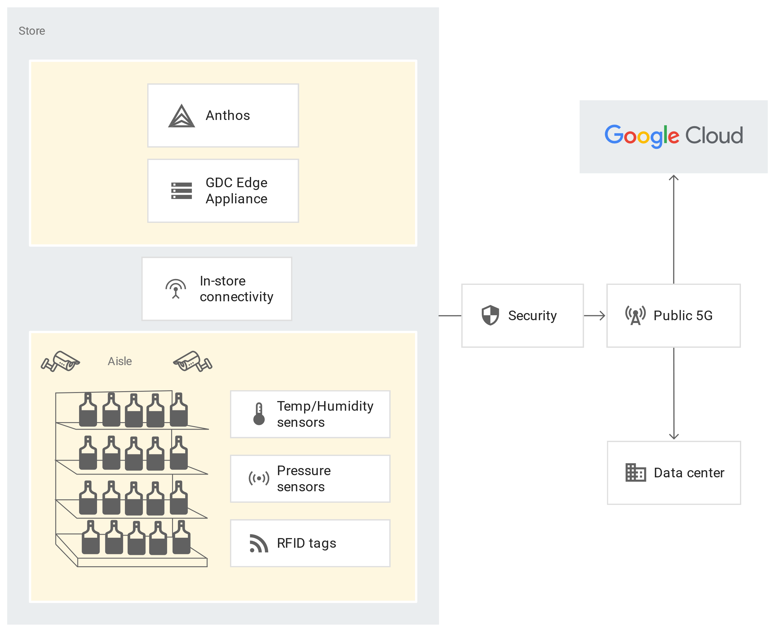

**Core components:**

GDC Edge initially comes in two form factors: rack-based configuration and GDC Edge appliance.

**Distributed Cloud Rack:** This form factor supports both local control plane and Cloud control plane clusters. There are two types of Distributed Cloud racks:

* Standalone Rack: A single rack of six Distributed Cloud connected servers and two top-of-rack (ToR) switches, cabling, and optics, which can be configured for AC or DC power.
* Base Rack: A pair of racks, each containing six Distributed Cloud connected servers, two top-of-rack (ToR) switches, and two aggregator switches.

**Edge Appliances:** Edge Appliance is a Google Cloud-managed, secure, high-performance appliance for edge locations. This appliance includes local storage, ML inference, data transformation, and export. Google Distributed Cloud Edge Appliance simplifies data collection, analytics, and processing at far edge locations. The data is stored on the appliance, where containerized applications process the data locally using ML inference, aggregation, and custom logic to generate insights.

**Anthos**: An open-source-based platform that lets you build and manage modern applications across on-premises, edge, and in multiple public clouds. Build on open-source technologies pioneered by Google including Kubernetes – Anthos enables consistency between on-premises and strategically enables your business with transformational technologies such as service mesh, containers and microservices. It works as a orchestration tool and manages the load between cluster and control plan.

**Networking Components:**

* + Connectivity to your local network
  + Connectivity to the internet
  + Connectivity to a VPC network
  + Connectivity to Google cloud API and Services
  + Network Security
* **Integration with google cloud:**

Anthos is integrated with GDC Edge, providing a services platform on which to run applications securely and remotely. This allows you to migrate or modernize applications and process data locally with Google Cloud services, including databases, machine learning, data analytics, and container management.

Google remotely manages the physical machines and ToR switches that constitute your Distributed Cloud Edge installation. This includes installing software updates and security patches and resolving configuration issues. Your network administrator can also monitor the health and performance of Distributed Cloud Edge clusters and nodes and work with Google to resolve any issues.

After Google has successfully deployed the Distributed Cloud Edge hardware in your designated location, your cluster administrator can begin configuring the Distributed Cloud Edge cluster in a way that's similar to a conventional Kubernetes cluster. They can assign machines to node pools, and node pools to clusters, and grant application owners’ access as required by their roles. The cluster administrator must, however, keep in mind the processing and storage limitations of the machines in your Distributed Cloud Edge rack and plan cluster and workload configuration accordingly.

Distributed Cloud Edge provides an API for configuring clusters and node pools.

* **Deployment model:**

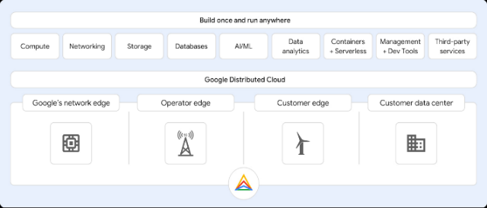

* Deploying GDC Edge as a fully managed service means you can leverage unparalleled processing power and focus on what matters most to your business.
* **Google Edge Network:** This model leverages Google’s global network with 140+ edge computing points. It’s ideal for applications that require low latency and high bandwidth.
* **Carrier/Operator Edge:** This model is designed for edge networks owned by telecommunications carriers (Communication Service Providers, or CSPs). It’s suitable for telecom use cases, including 5G core network functions and virtual radio access network functions.
* **Customer Edge:** This model is suitable for industries like retail and manufacturing that require on-site computational processing at the edge to ensure data processing efficiency and operational effectiveness. It consists of three small-form-factor servers that directly connect to a location’s network equipment.
* **Customer Data Centers:** It allows customer-owned data centers and colocation facilities to address strict data security and privacy requirements, and to modernize on-premises deployments while meeting regulatory compliance.
* **Security and Compliance:**
* **Infrastructure Data Security:** When you return an appliance, it is received at one of Google’s data centers. Securing customer data is Google’s top priority and responsibility.
* **Securing the Appliance in Transit:** When you receive your appliance, you run the Edge Appliance Attestation Application. This application validates the appliance identity and its state, to ensure that the appliance is in the same state as it was when it was shipped to you.
* **Data Encryption:** Your data is encrypted during upload, during transit to Google’s data centers, and after it has been uploaded to Cloud Storage. This includes:
  + During transit to Cloud Storage: Your data is encrypted on the Edge Appliance with dm-encrypt and partition-level encryption, using the AES-256 encryption algorithm.
  + During upload to Cloud Storage: Your data is encrypted using secure TLS connections. Your data is encrypted on Cloud Storage by default.
* **Encrypting Data on Your Appliance:** Google uses two keys to encrypt data on your appliance: A key encryption key, which is applied to the data encryption key before you return the appliance to Google, and a data encryption key, which is applied to your data before it is written to the appliance’s disks.
* **Compliance:** GDC Edge ensures that retailers can confidently comply with data protection regulations. This comprehensive security is not just limited to data at rest but extends to data in transit, offering peace of mind and a secure framework for handling customer information.

1. KEY APPLICATION OF GDC EDGE:

* Google Distributed Cloud Edge enables CSPs to deploy 5G packet core and radio access network elements and provides an ecosystem of partner applications.
* **Industrial IoT:** GDC Edge can bring intelligence to the edge with Cloud IoT. It allows manufacturing companies to detect anomalies in high-velocity assembly lines in real time. It also enables the creation of distributed twin infrastructures that can be easily adopted by SMEs**.**
* **Retail and E-commerce:** GDC Edge can unlock use cases such as inventory detection, visual inspection, large scale data analysis among others. It can also enable retailers to leverage edge capabilities such as associate productivity solutions, contactless checkout, in-store product scans, mobile contactless checkout, visual check-out monitoring, and unattended retail shops.
* **Telecommunications:** GDC Edge is ideal for running local data processing, low latency edge workloads, and modernizing telecom networks. It allows organizations to introduce local private cellular networks to complement existing WiFi and public cellular connectivity. It also brings 5G core and radio access network (RAN) capabilities to the edge of customer or service provider networks.
* **Healthcare:** In healthcare, real-time processing of patient data at the edge enhances diagnostics, remote patient monitoring, and facilitates the efficient exchange of critical information. Edge computing offers a new, cost-effective solution for healthcare informatics.
* **Smart Cities:** The distributed nature of cloud edge computing contributes to the development of smart cities, supporting the management of IoT devices and enabling real-time analysis of urban data.

1. RESULTS

**Benefits:**

* **Innovate Faster with AI**: GDC Edge allows you to leverage Google’s AI, data analytics, and databases solutions to uncover insights and remove traditional constraints of scale, performance, and cost. This enables faster innovation and improved decision-making.
* **High Levels of Data Security:** It ensures the highest levels of data security without compromise. Your data is encrypted during upload, during transit to Google’s data centers, and after it has been uploaded to Cloud Storage.
* **Consistent Applications Platform**: It provides a consistent applications platform, allowing you to leverage common tools, policies, and processes that you use in the cloud for mission-critical use cases running on the edge.
* **Variety of Fully Managed Hardware Options:** It offers a range of hardware options that allow you to right-size the infrastructure for your solution. This helps optimize your total cost of ownership (TCO).
* **Real-Time Insights with Low Latency:** GDC Edge enables you to gain real-time insights from data locally with low latency. This is particularly beneficial for applications that require immediate data processing and decision-making.
* **Optimized Managed Service for Network Functions and RAN:** GDC Edge offers customized hardware that leverages an optimized data plane for high throughput packet processing to enable telecom use cases.
* **Enhanced Performance:** By distributing computing resources closer to end-users, applications experience reduced latency, ensuring faster response times and a smoother user experience.
* **Scalability and Flexibility:** GDC Edge enables businesses to scale their applications easily while maintaining flexibility.

**Real-world Implementation:**

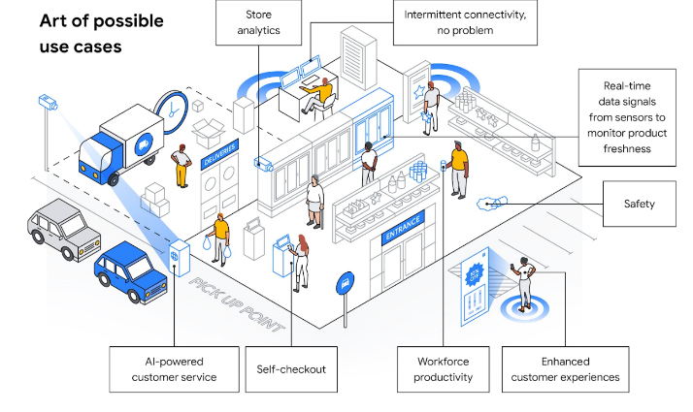

* Bell Canada
* Retail and Manufacturing
* AI use Cases

**Case Studies:**

**Manufacturing, Retail, and Automotive:**

* GDCE addresses common use cases in these sectors. It allows for consistent container and VM operations with Kubernetes-style declarative configuration and policy enforcement.
* The Google Distributed Cloud Edge service runs on Google Cloud and serves as a control plane for the nodes and clusters running on your appliance. To perform remote management of the appliance and to collect metrics, the Distributed Cloud Edge service must be always connected to Google Cloud, allowing you to manage your workloads on the edge hardware through the Google Cloud Console.

**Challenges and Limitations:**

* **Network Connectivity:** The effectiveness of Distributed Cloud Edge heavily relies on robust network connectivity. Any disruptions in the network can impact the performance of the edge computing solution.
* **Security Concern:** Data privacy and Edge device security are two main points in security. Data protection regulations becomes challenging when dealing with decentralized processing. Edge devices may be more vulnerable to physical attacks or unauthorized access, requiring robust security measures to safeguard against potential threats.
* **Infrastructure Management:** Managing the infrastructure at the edge can be complex due to the distributed nature of the devices and the need for remote management.
* **Standardization:** There is a lack of standardization in edge computing, which can pose challenges in terms of interoperability and integration with other systems.
* **Scalability:** Dynamic scaling and resource constraints are possibly the concern for the scaling.
* **Hardware Failure and Serviceability:** Hardware failures at the edge can lead to serviceability challenges. So, architects also need to plan during the discovery phase for how to deploy to and configure remote systems at the again online time.
* **Cost Management:** Edge computing can bring cost benefits in terms of reduced data transmission costs, the costs associated with managing and maintaining the edge infrastructure can be significant.
* **Edge Application Development:** Developing applications for the edge requires a different approach compared to traditional application development, considering factors like intermittent connectivity, limited resources, and the need for real-time processing.

**Future Trends and Innovations:**

* **5G and Telecom Applications:** GDC Edge is targeted at telecom providers wanting to run 5G core and radio access network (RAN) functions at the edge. This includes hardware and software components, and deployment options include a rack-based configuration that has the rack, six servers, a pair of top-of-rack switches, cabling, and optics.
* **AI and Edge Computing:** Google Distributed Cloud Edge is set to unleash data at the edge, delivering engaging customer experiences, storing, and leveraging data from edge to cloud, creating the foundation for cloud networks, deploying vRAN and O-RAN at the edge, and removing other sensitive information at the edge.
* **Data Security and Privacy:** As data privacy and security become increasingly important, Google Distributed Cloud Edge is expected to continue innovating in this area to provide robust security measures and encryption protocols.
* **Hybrid and Multi-Cloud Deployments:** With the rise of hybrid and multi-cloud deployments, Google Distributed Cloud Edge is likely to see increased adoption as organizations look to accelerate their cloud adoption while simultaneously reducing their technology risk.

1. DISCUSSION

Google Distributed Cloud Edge provides AI model that’s being provisioned at the retailer’s edge and running on GDC Edge. Using GDC Edge is secure, simple, and straight forward with a familiar Google Kubernetes engine interface. To access and provision your GDC Edge through the Google Cloud admin console and manage your business with ease.

GDC can be deployed anywhere, Google’s network edge, the operator edge, or at the customer edge. Bringing the same technology that provides you, with powerful AI and ML from data center to edge, a consistent user experience, security, and scale to grow your business. GDC Edge, powering your network and edge.

1. CONCLUSION

GDC Edge is a powerful tool for businesses looking to leverage the power of edge computing, providing a seamless and efficient way to manage and process data at the edge of the network. It combines the flexibility and power of Google Cloud with the speed and efficiency of edge computing, making it an ideal solution for a wide range of applications and industries.

1. REFERENCES
2. [Google Distributed Cloud Edge (youtube.com)](https://www.youtube.com/watch?v=DKHDWFOz42k) – A video
3. <https://youtu.be/3hScMLH7B4o> - A video om edge computing
4. [Google Distributed Cloud overview](https://cloud.google.com/distributed-cloud/docs/overview)
5. [Google Releases its Distributed Cloud Edge Offering into General Availability](https://www.infoq.com/news/2022/05/google-distributed-cloud-edge-ga/)
6. [Anthos – APIs & Services – Google Cloud console](https://console.cloud.google.com/apis/library/anthos.googleapis.com?_ga=2.248402180.247290263.1718604651-747961988.1717389726)
7. [Overview | Distributed Cloud Edge Appliance | Google Cloud](https://cloud.google.com/distributed-cloud/edge-appliance/docs/overview)
8. [Announcing Google Distributed Cloud Edge and Hosted | Google Cloud Blog](https://cloud.google.com/blog/topics/hybrid-cloud/announcing-google-distributed-cloud-edge-and-hosted)
9. [Security and encryption | Distributed Cloud Edge Appliance | Google Cloud](https://cloud.google.com/distributed-cloud/edge-appliance/docs/security-and-encryption)
10. [Google Distributed Cloud Edge - The Futurum Group](https://futurumgroup.com/insights/google-distributed-cloud-edge/)
11. [Google Cloud Blog | News, Features and Announcements](https://cloud.google.com/blog)
12. [Google Distributed Cloud Edge - Cloud Computing Gate](https://cloudcomputinggate.com/google-distributed-cloud-edge/)
13. Chatbot

1. Darshana.chauhan@db.com