**Software-defined Networking:**

* An approach to dynamically and programmatically efficient network configuration to improve performance and monitoring to cloud computing.
* To improve static architecture of traditional networks and employed to centralized network intelligence in one network component by disassociating the forwarding process of network packets from routing process.
* Control planes consist of one or more controllers in each.
* Controllers-> considered as the brains of the SDN network, whole intelligence is incorporated.
* Centralization has certain drawbacks for security, scalability, and elasticity.
* Commonly associated with the OpenFlow protocol for remote communication with network plane elements to determine the path of network packets across network switches.
* Virtualization to networking == Software defining networking
* Traditional networking uses integrated hardware and software to direct traffic across a series of routers and switches.
* SDN virtualizes networking by separating the control plane and manages the network from the data plane where traffic flows.
* A smart controller running specialized software that manages all network traffic in a data center and a series of routers and switches that forward packets of traffic.
* Virtualizing network: Advantages: Network can be span up and down dynamically, they can be fine-tuned for specific application use cases, and security policies can be installed on each individual network.
* The SDN market has evolved ant it’s breaking out of the data center.
* It is being used in the WAN to control how enterprises connect to their branch offices. This is called SD-WAN, which uses software to aggregate multiple types of network connections, like broadband, MPLS or wireless to create strong and cost-effective connections.
* SDN has been applied to security using what is called micro segmentation, which is the idea of segmenting network traffic for security purposes.
* Certain network can be ultra-secure and carry sensitive data and other can be public facing. So, if hacker gets into the data center, they are restricted to only a specific part of the network, limiting their impact.
* It is also used in an area called Network Function Virtualization (NFV). This is the idea of replacing specialized hardware like firewalls and load balancers with software running on off-the-shelf server hardware.
* Some vendors are using SDN to connect data centers to public cloud providers, creating a hybrid cloud network that includes micro segmentation or dynamic scaling abilities.
* Other SDNs could be used to help manage the deluge of traffic from the IoT, segmenting network traffic and helping to organize data.
* SDN has evolve from a specific use case to being applied to many different areas of networking both within the data center, out of the cloud and in the new world of IoT, computer network, NVF.
* As software is used to control the network, it becomes more agile, easier to manage and ready to adapt the use cases emerge in the future.
* Key Points:
  + SDN is the abstraction of Control Plane from Data Plane
  + Centrally manage the network
  + IBN uses AI to add Assurance.
  + Fully automate the network
  + Reduce network complexity.

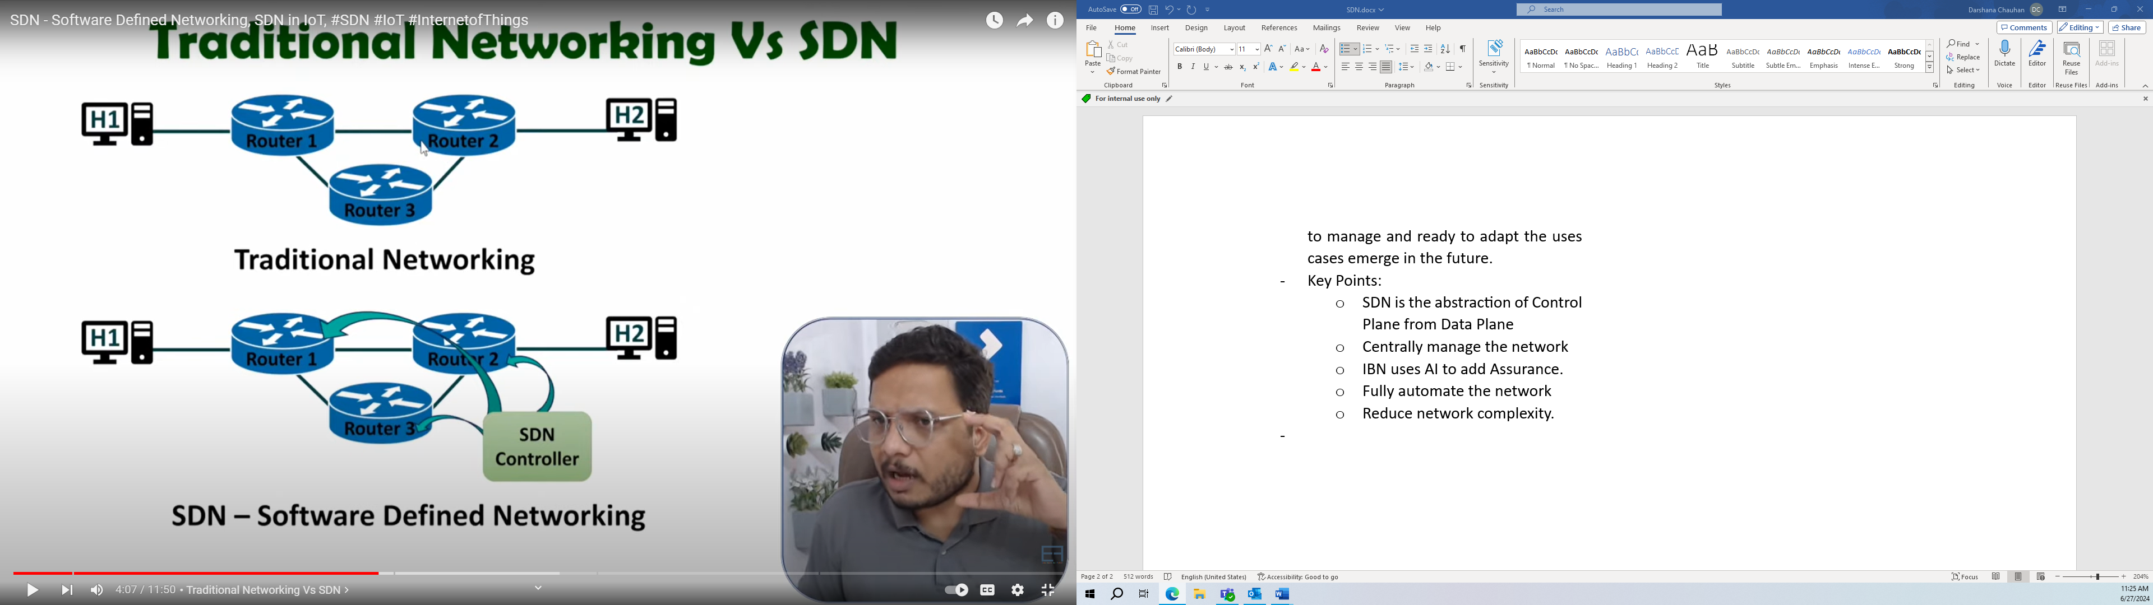

* In traditional method of forwarding data, the router has to define by control plane to whom to send the data and forwarding plane will send the data accordingly.
* But in SDN there is controller, which has all the information about routers, and it will send the command to router to send the data to another router accordingly. So, software inside the router defines the algorithm to forward the data.
* SDN simply removes the control plane task of the routers.
* SDN controllers maintain a unified view of the network and make configuration, management, and provisioning simpler.
* OpenFlow: If one device is added to the network then it should perform in the future too.
* SDN Architecture:

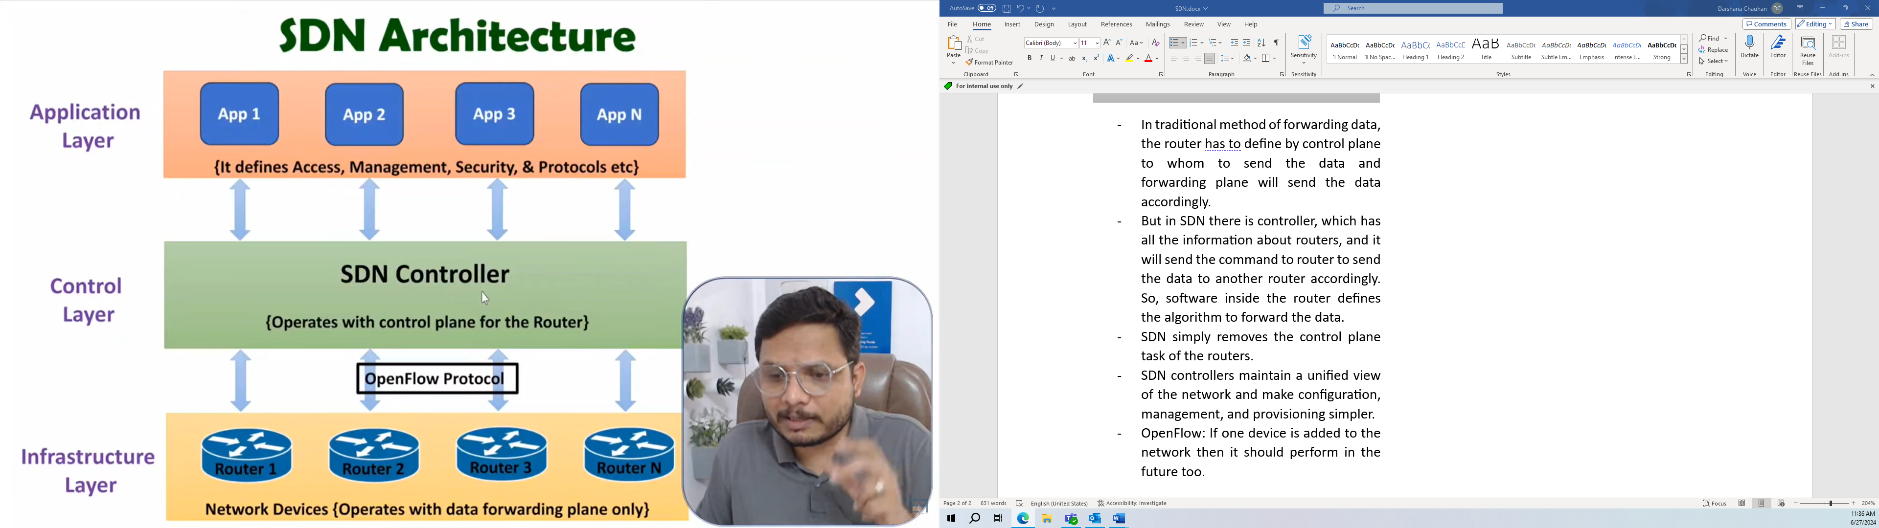

* + Application layer: network application layer and programs.
  + Control Layer: brain, or network OS, manages the movement of traffic and data.
  + Infrastructure Layer: physical switches and routers, move data packets and network traffic.
* Benefits of SDN:
  + Easier to management of the network
  + Programmable Network
  + Centralized management of the network
  + Agility
  + Improved Visibility of the Network
  + Cost Effective Network
  + Improved Security to the network
* Increases flexibility and visibility into network behavior.
* SDN architectures decouple network control and forwarding functions, enabling the network control to become directly programmable and the underlying infrastructure to be abstracted from applications and network services.
* Network control is directly programmable because it is decoupled from forwarding functions.
* Administrator dynamically adjust network-wide traffic flow to meet changing needs.
* SDN Architectural Components:

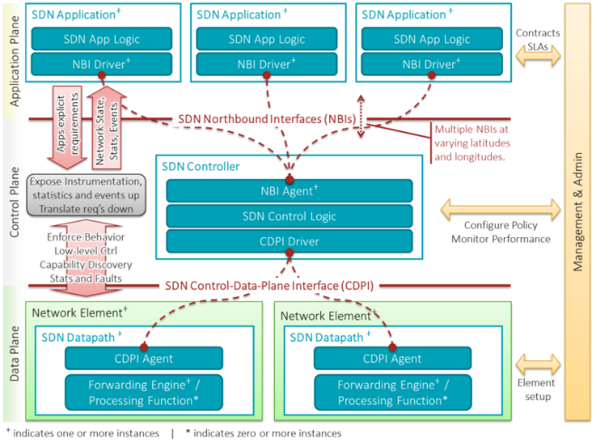

[Software-defined networking - Wikipedia](https://en.wikipedia.org/wiki/Software-defined_networking)