Solar Mosquito Repellent using Ultrasound

## Group Members

* Varun Vyas – 202101468
* Sakshi Patadiya – 202101469
* Keyur Rathva – 202101465
* Darshana Chauhan – 202101467
* Meet Dhangar - 202101466

## Faculty Mentor

* Shweta Rao Garg – Ph.D. (English), IIT Roorkee

## Introduction of the Project

The mosquito repellent that would work on ultrasound wave principles and _____

## The motivation of the Project

* The constant irritation and frustration caused by the mosquitoes in our day-to-day life.
* Already available solutions to the problem have various issues
  + Mosquito Nets – A lot of time taking to implement and needs special arrangements at the application spot to function, which comes with a great risk of human error in adjustment which would allow mosquitoes to enter in.
  + Odomos - based products – Comes with a fear of affecting the skin in unwanted ways, also the smell is annoying to the human nose which could cause headaches to some people.
  + Insecticides – Prallethrin is the main ingredient for such machines which may prove to be affecting human health in other ways, especially that of kids. They also cause suffocation and breathing issues which would severely affect health in long run.

## Principle

Male mosquitoes generate ultrasound in the range of 20kHz to 40kHz, female mosquitoes respond to those signals but after breeding, they tend to avoid such signals and this fact can be used to repel away the mosquitoes as generally, only female mosquitoes spread dengue-like diseases by feeding on human blood.

We can make an Ultrasound wave generator that would generate waves in the same frequency range as male mosquitoes which would lead to the repulsion of mosquitoes.

## Implementation

## Ultrasound Generator

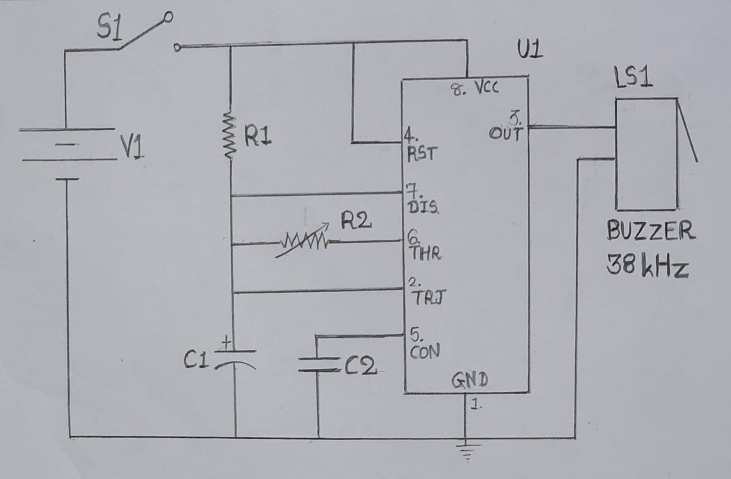

Pin 1 – connected to the ground or negative terminal of the battery

Pin 2 – active low pin connected directly to pin 6 and the timer is triggered when the signal is less than 1/3rd of the supply voltage

Pin 3 – output pin

Pin 4 – reset pin and connected to the positive rail of the battery

Pin 5 – controlling pin

Pin 6 – threshold pin, timer output is back to its stable state when the voltage at this pin is greater than or equal to 2/3rd of the supply voltage. It connected to pin 7 using a resistor

Pin 7 – discharge pin for capacitor

## What exactly happens when we turn it on?

By turning it on the 555 timer gets the power supply. As shown in the circuit initially, the Vc would be zero and so the voltage at the threshold pin(Pin 6) will be zero. As the capacitor starts charging, at a certain point voltage at pin 6 would be less than Vc. This will cause a change in timer output. The capacitor would start to discharge through resistor R2(Pin 7) and would continue so until the output voltage is back to the original. Thus, we will get an oscillating signal with a frequency of 38 kHz.  The output from this unstable multivibrator circuit drives a 38 kHz piezo buzzer, producing ultrasound at regular repetitions.

## Hardware requirements

* NE555N timer 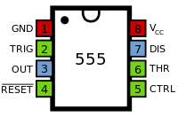
* Capacitors
* Resistors
* Piezoelectric transducer (As an indication for frequency)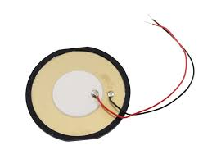
* SPST Switch (A Single Pole Single Throw)
* Solar Battery

## Estimated Budget

* NE555N timer – 70 rupees
* Capacitors – 200 rupees
* Resistors – 50 rupees
* Piezoelectric transducer – 300 rupees
* Switch – 20 rupees
* Solar Battery – 2000 rupees