|  |  |  |  |  |  |  |  |  |
| --- | --- | --- | --- | --- | --- | --- | --- | --- |
| **MAD Project Evaluation 1 – Regular Intake 2020** | | | | | | | | |
| **Group Name:** |  | | **Group ID:** |  | **Batch:** | **Pro rata** | | |
| Student ID | Student Name | Consistency (Out of 2) | Appropriateness and Professionalism (Out of 3) | Usage of resource manager (Out of 4) | Out of box design ideas (Out of 3) | Report (Out of 8) | Total (Out of 20) | Comments |
| **IT18184754** | **Darshana k. k** |  |  |  |  |  |  |  |
|  |  |  |  |  |  |  |  |
|  |  |  |  |  |  |  |  |
|  |  |  |  |  |  |  |  |
|  |  |  |  |  |  |  |  |

Git Repository Link:

----------------------------------------------------------------------------------------------------------For Evaluators use only---------------------------------------------------------------------------------------------

Evaluator’s name: **Darshana k.k**

Others: No others

**Introduction**

There are so many juice shops in Sri Lanka,But most of them are non-automated .so I decided to do this project .so that I decided to make an app for juice delivery.as I mentioned above I’m going to build an mobile app for a juice and soft drinks delivery system .it mainly keep connection with juice delivery, place orders, rating the app by users and payment methods. The main four functions are, item delivery. Place orders, payments and customers.

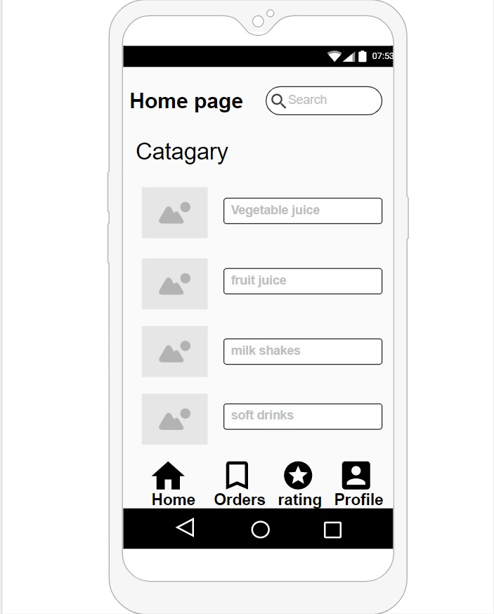**01)Home page**

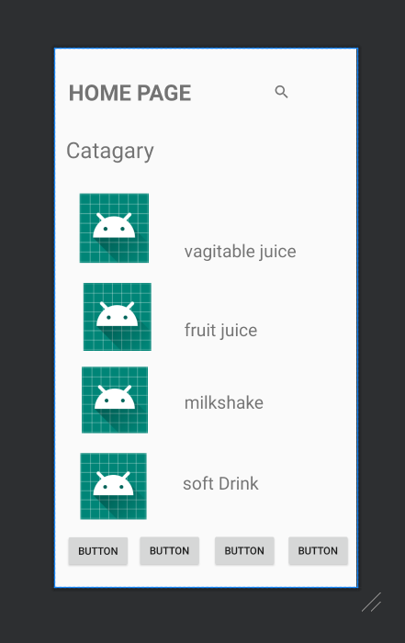

This is the wireframe and the interface of the home page. This interface is used to select the categories in the app. There are four main categories namely vegetable juice, fruit juice, milk shakes and soft drinks. Interface display the four buttons to navigate to the home page, orders, ratings and to the user profile.

**02)Item Pages**

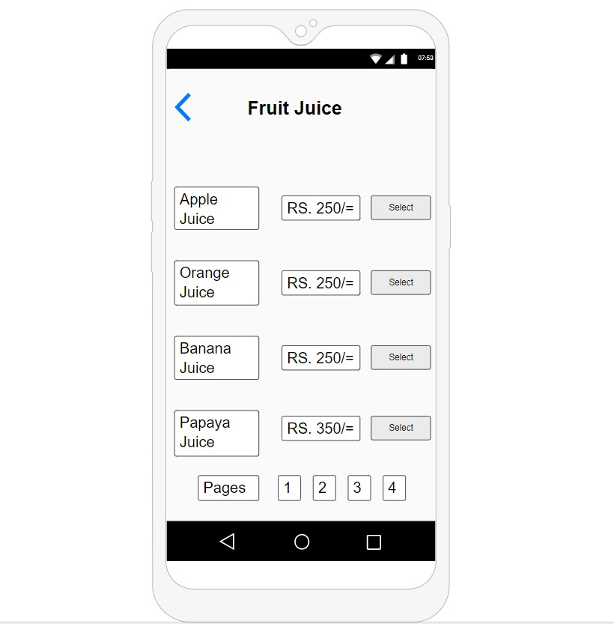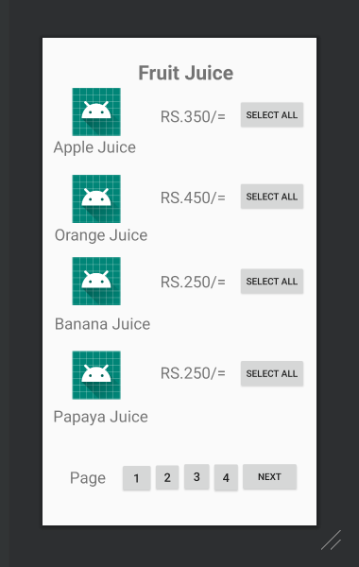 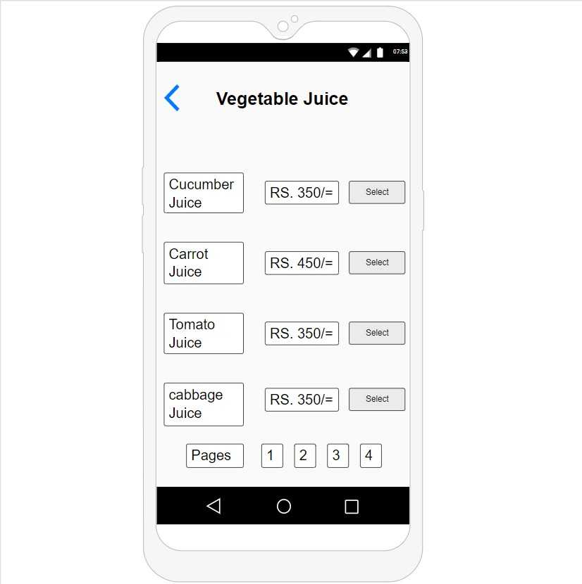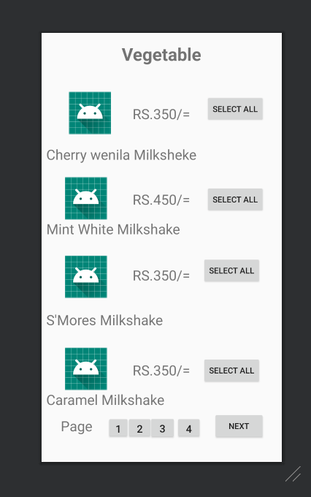

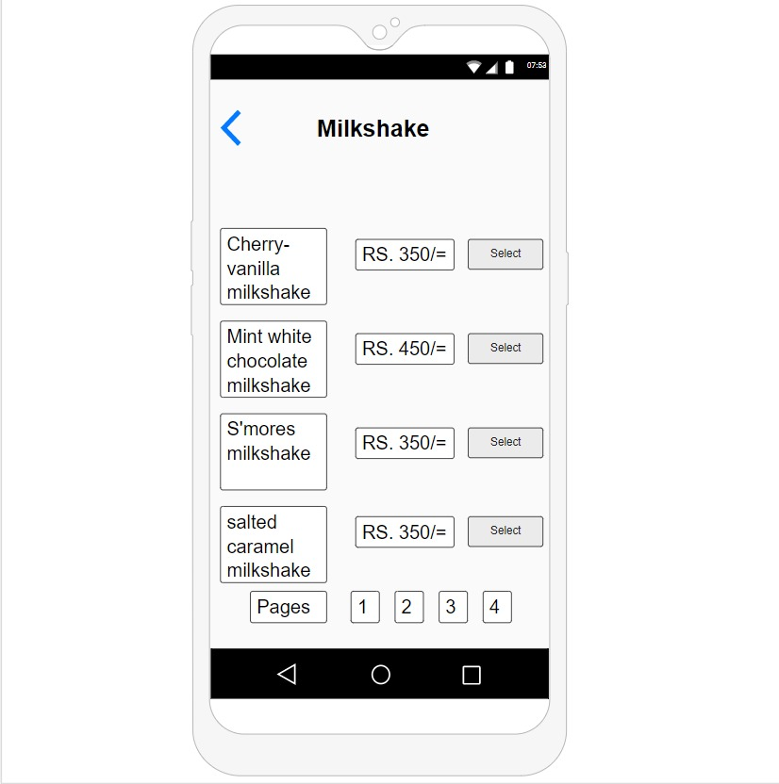

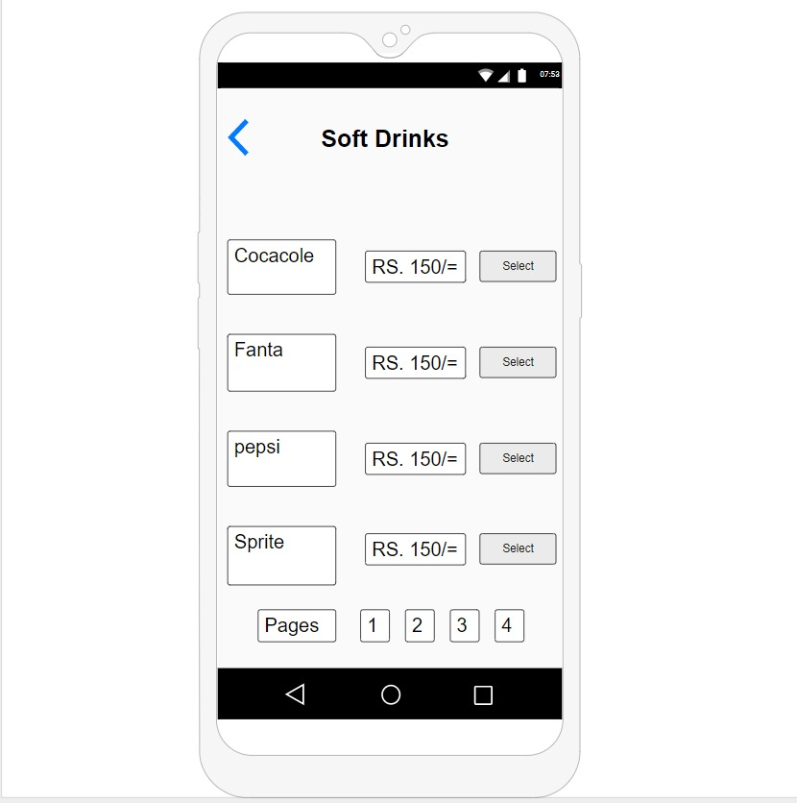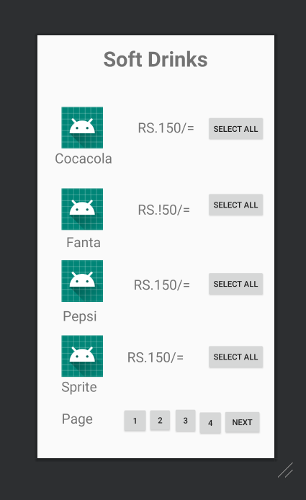

These are the interfaces to the item pages.there are four item pages namely vegetabal juice,fruit juice,milkshakes and soft drinks.in each item page interface display the category and the items and there prices.and there is a navigation to the same category item pages.

**03)Order Pages**

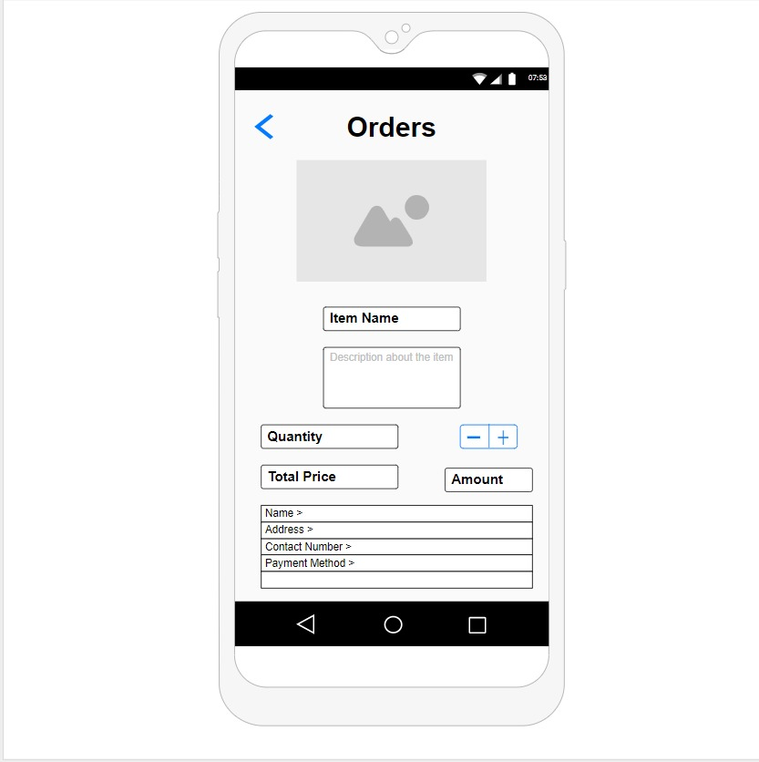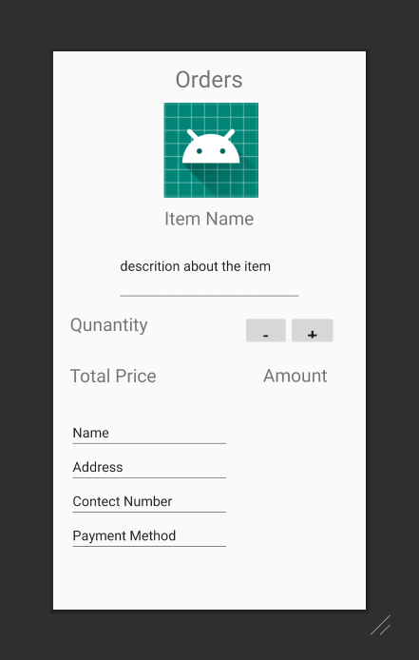

Customer can order a juice from the category pages .as the above interface when selecting a juice then the order page indicate the description of the above item, quantity, payment method, name of the customer, contact number, address and the total amount of the order. If customer wants to modify the payment method, name, address and contact number in the above interface. If all the details are correct then customer can place the order.

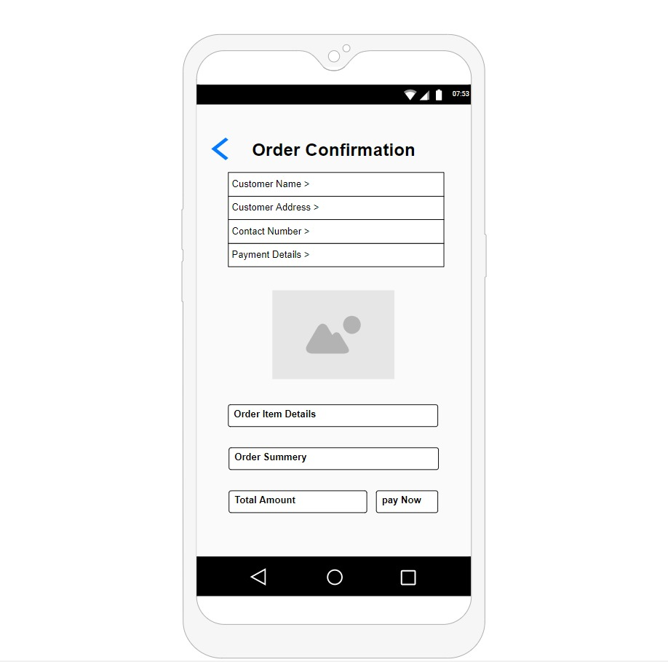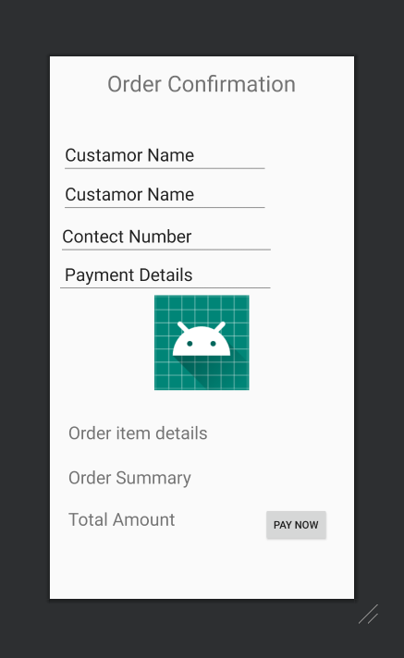

When customer place the order the order page direct to the order confirmation interface displays the customer name, customer address, contact number, payment details of the item, ordered item details, order summery and the total amount. Customer name, contact number, customer address and payment details can change. After finalizing the above details customer can pay for the order.in the interface there is a “Pay Now” button to confirm the order payment.

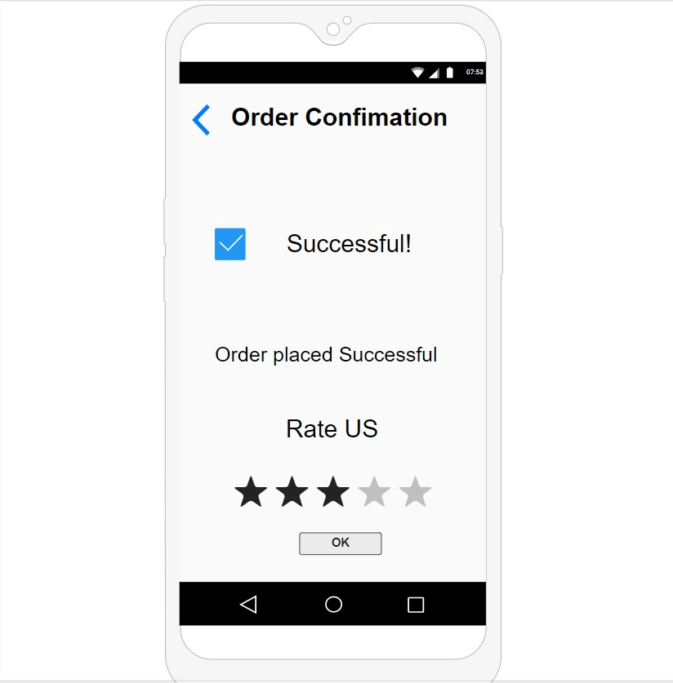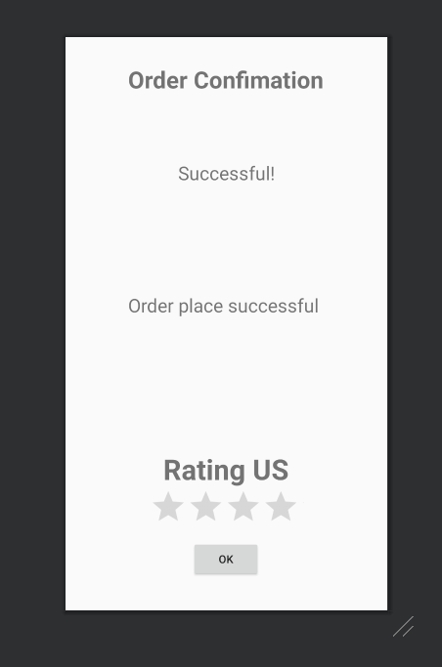

If all the order details and the payment details are successfully done, then display the successful message to the customer, and as the above in the interface customer can rate the service of the app.

**04)Rating page**

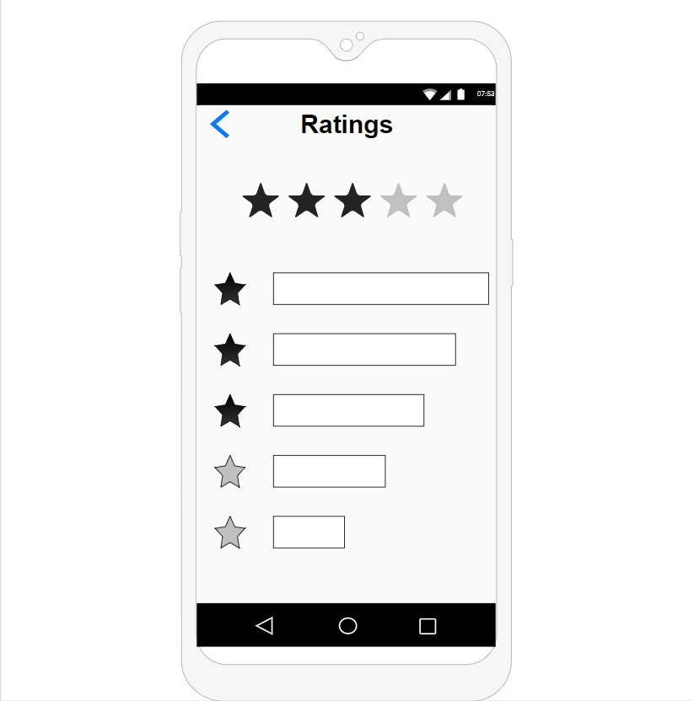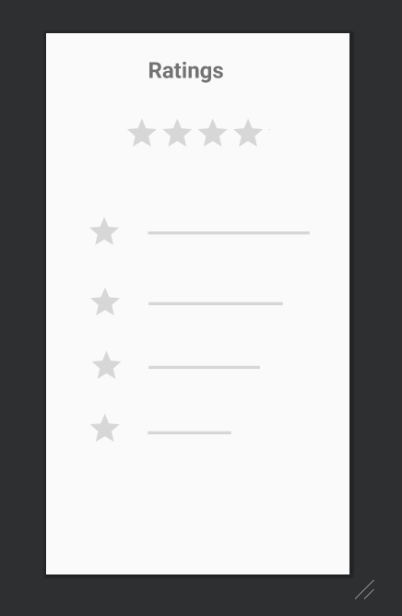

This is the rating interface and any customer can rate the service of the app using these stars.

**05)Payment page**

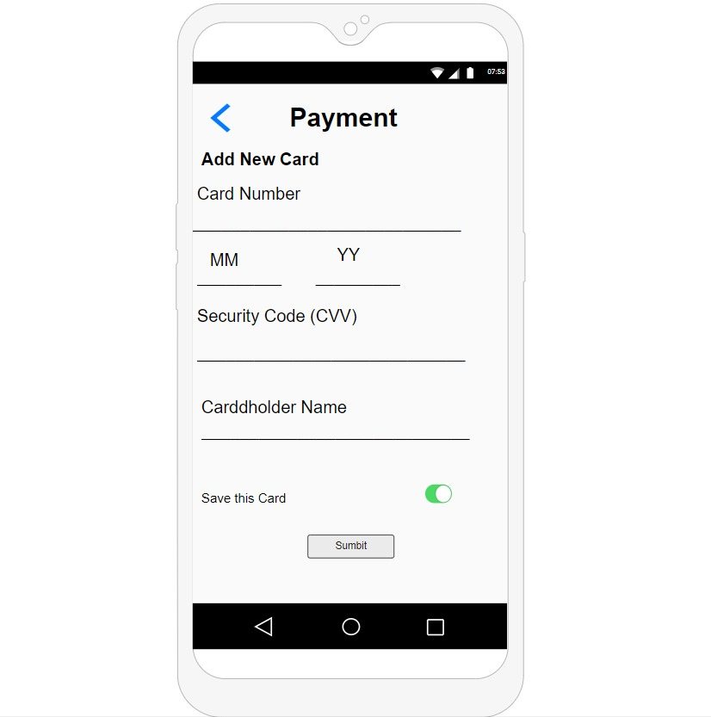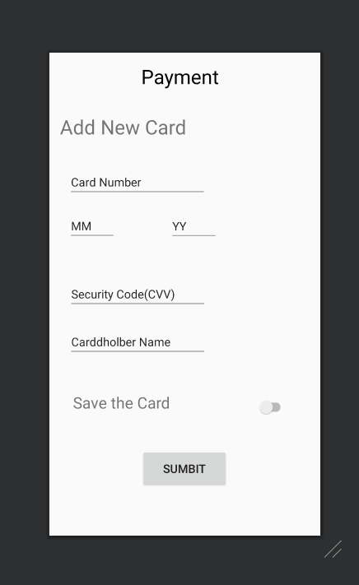

This is the payment interface. Customer can add new card details to the app and customer have to add the new card number, month and year of expire of the card, security code (CVV), the card holder name and save the card details. Then submit the card details by using the submit button.

**Usage of resource files.**



