1.Valid Parenthses:
Code:
class Solution{
public boolean isValid(String s){
Stack<Character> stack = new Stack<>();
for(char ch : s.toCharArray()){
if(ch == '(' || ch == '{' || ch == '['){
stack.push(ch);
}
else{
if(stack.isEmpty()) return false;
char top = stack.pop();
if(ch == ')' && top!= '(') return false;
if(ch == '}' && top!= '{') return false;
if(ch == ']' && top!= '[') return false;
}
}
return stack.isEmpty();
}
}

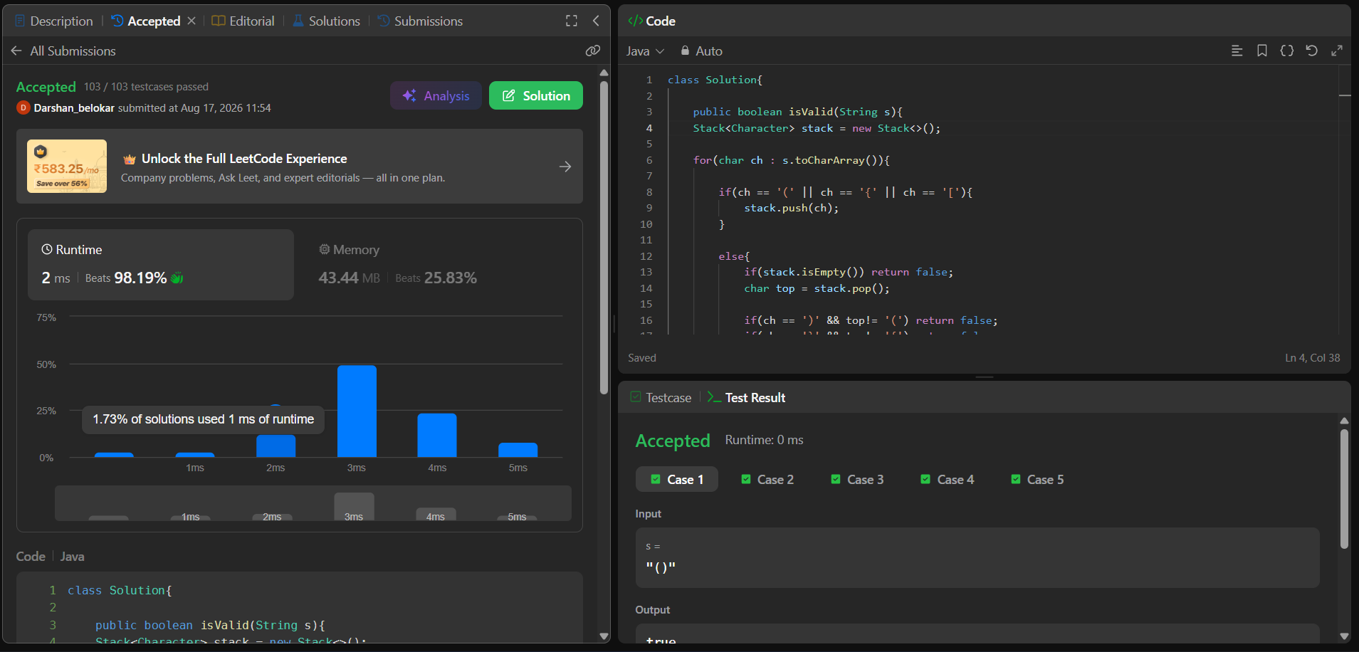
2. Group Anagrams:
Code:
class Solution {
public List<List<String>> groupAnagrams(String[] strs) {
Map <String,List<String>> map = new HashMap<>();

for(String st : strs){
char[] ch = st.toCharArray();
Arrays.sort(ch);

String key = new String(ch);

if(!map.containsKey(key)){
List<String> string = new ArrayList<>();
string.add(st);
map.put(key,string);
}

else{
map.get(key).add(st);
}
}
return new ArrayList<>(map.values());
}
}

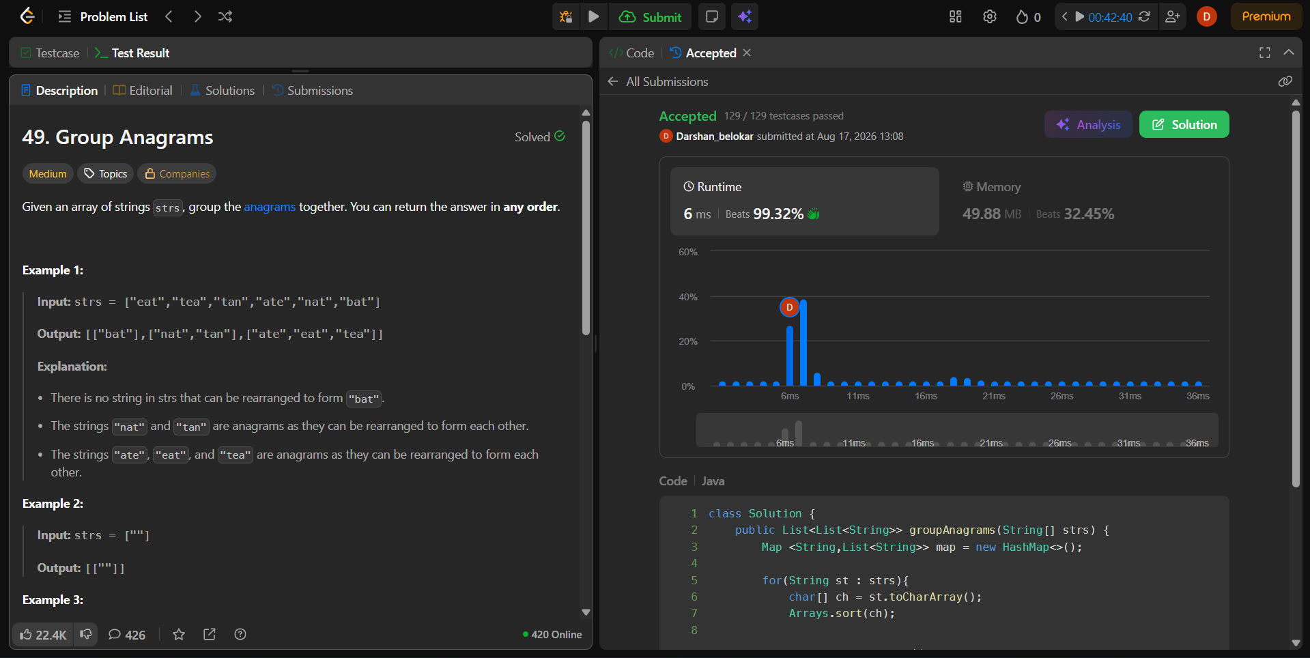

3.Trapping Rain Water:
class Solution {
public int trap(int[] height) {
int left = 0;
int right = height.length - 1;

int leftMax = 0;
int rightMax = 0;

int water = 0;

while(left < right){
if(height[left] <= height[right]){
if(height[left] >= leftMax){
leftMax = height[left];
}
else{
water += leftMax - height[left];
}
left ++;
}

else{
if(height[right] >= rightMax){
rightMax = height[right];
}
else{
water += rightMax - height[right];
}
right -- ;
}
}
return water;
}
}
