1. Two Sum
class Solution {
public static int[] twoSum(int[] nums,int target){
HashMap<Integer,Integer> prevMap = new HashMap<>();

for(int i=0;i<nums.length;i++){
int num = nums[i];
int diff = target - num;
if(prevMap.containsKey(diff)){
return new int[] {prevMap.get(diff),i};
}
prevMap.put(num,i);
}
return new int[] {-1,-1};
}
}

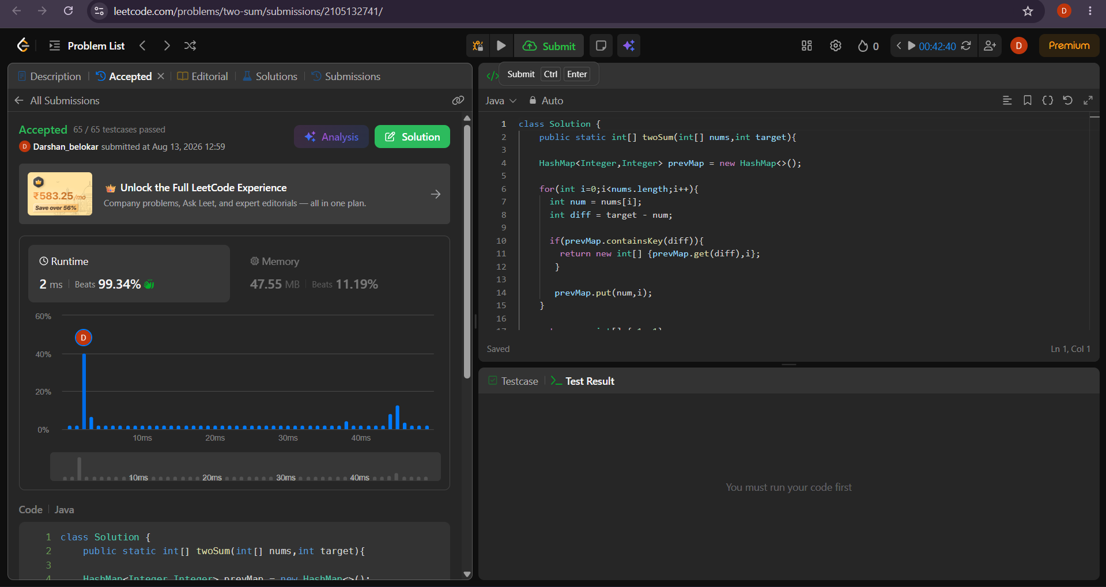
2.3Sum
class Solution {
public List<List<Integer>> threeSum(int[] nums) {
List<List<Integer>> res = new ArrayList<>();

int n = nums.length;

Arrays.sort(nums);

for(int i=0;i<n-2;i++){
if(i>0 && nums[i]==nums[i-1]) continue;

int l=i+1,r=n-1;

while(l<r){
int sum = nums[i] + nums[l] + nums[r];

if (sum == 0) {
res.add(Arrays.asList(nums[i], nums[l], nums[r]));

l++;
r--;

while (l < r && nums[l] == nums[l - 1]) {
l++;
}

while (l < r && nums[r] == nums[r + 1]) {
r--;
}
}
else if(sum>0){
r--;
}
else{
l++;
}
}
}
return res;
}
}
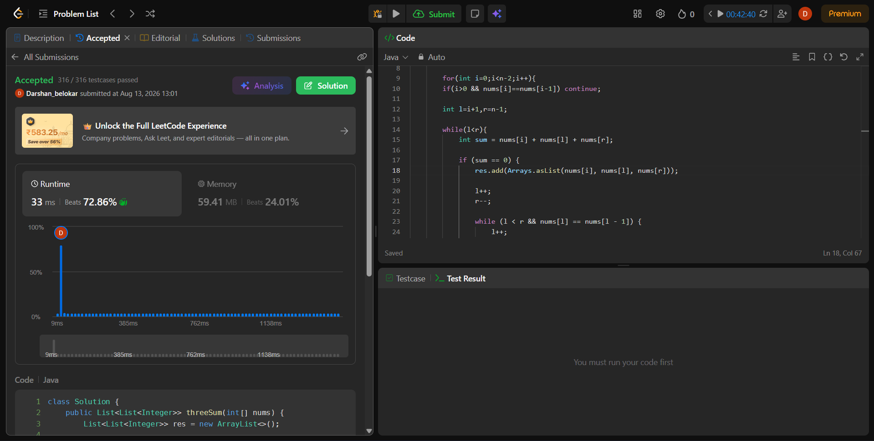

3.Median of Two Sorted Arrays
class Solution {
public double findMedianSortedArrays(int[] nums1, int[] nums2) {
int[] arr = new int[nums1.length + nums2.length];

int i = 0 ;
int j = 0;
int k = 0;

while(i < nums1.length && j < nums2.length){
if(nums1[i] < nums2[j]){
arr[k] = nums1[i];
i++;
}
else{
arr[k] = nums2[j];
j++;
}
k++;
}

while(i < nums1.length){
arr[k] = nums1[i];
i++;
k++;
}

while (j<nums2.length) {
arr[k] = nums2[j];
j++;
k++;
}

//Median

int n = arr.length;
if(n % 2 == 1){
return arr[n/2];
}
else{
return (arr[n/2-1] + arr[n/2] ) / 2.0;
}
}
}

