Chapter 1: Introduction

**1.1 Purpose of Software**:

Aim of this project is to create doctor patient handling management system that will help doctors in their work and will also help patients to book doctor appointments and view medical progress. The system allows doctors to manage their booking slots online. Patients are allowed to book empty slots online and those slots are reserved in their name. The system manages the appointment data for multiple doctors of various date and times. Each time a user visits a doctor his/her medical entry is stored in the database by doctor. Next time a user logs in he may view his/her entire medical history as and when needed. At the same time a doctor may view patient’s previews medical history while the patient visits him. The system also consists of Blood donor module. This module allows for Blood donation registration as well as Blood group search. The module is designed to help urgent Blood requirements through easy/instant searches.

**1.2** **Scope**:

Scope of the project is very broad in terms of other doctor appointment portal.

Few of them are.

* Patient and doctor get SMS from the system.
* There is huge collection of doctor information.
* You have diseases find information about disease
  1. **Objective:**

1. To Create Android based application Doctor Appointment management system.
2. To manage all patients related information.

Chapter 2:

System Analysis

**2.1 USER CHARACTERISTIC**

**USER (Android Application):**

* **Book Appointment:** User can book appointment.
* **Select Doctor’s Category:** User can set choice Doctor’s Category.
* **Set Appointment date:** User can set date.
* **Medical Query:** User can select diseases information.

**2.2 TOOLS AND TECHNOLOGY**

**2.2.1 TOOLS AND LANGAUGE USED:**

**1. Android studio:**

Android Studio is the official Integrated Development Environment (IDE) for Android app development, based on [IntelliJ IDEA](https://www.jetbrains.com/idea/). On top of IntelliJ's powerful code editor and developer tools, Android Studio offers even more features that enhance your productivity when building Android apps, such as:

* A flexible Gradle-based build system
* A fast and feature-rich emulator
* A unified environment where you can develop for all Android devices
* Instant Run to push changes to your running app without building a new APK
* Code templates and GitHub integration to help you build common app features and import sample code
* Extensive testing tools and frameworks
* Lint tools to catch performance, usability, version compatibility, and other problems
* C++ and NDK support
* Built-in support for [Google Cloud Platform](https://cloud.google.com/tools/android-studio/docs/), making it easy to integrate Google Cloud Messaging and App Engine.

## **2.** 000webhost: Our passion is to power up internet society and provide absolutely free, easy & very useful website management & free web hosting services all around the world. Our team has grown drastically since 2004 and become top class web hosting industry leaders among free hosting providers all over the net. 000webhost.com's daily task is to serve millions of free hosting users and customers with hundreds of servers around. We listen to & hear our customers needs and manage on the basis of latest technologies.

We're a part of elite ICANN accredited registrars community. Our company has been verified by ICANN as a trusted web hosting company with guranteed financial base and secured domain name services

**3. Java:**

Java is a programming language created by James Gosling from Sun Microsystems (Sun) in 1991. The target of Java is to write a program once and then run this program on multiple operating systems. The first publicly available version of Java (Java 1.0) was released in 1995. Sun Microsystems was acquired by the Oracle Corporation in 2010. Oracle has now the steermanship for Java. In 2006 Sun started to make Java available under the GNU General Public License (GPL). Oracle continues this project called OpenJDK.

Over time new enhanced versions of Java have been released. The current version of Java is Java 1.8 which is also known as Java 8.

**2.2.2 HARDWARE AND SOFTWARE CONFIGURATION:**

* **API level:** API level required is API 22.
* **Operating System:**  Android
* **RAM:** 1024 MB
* **ROM:** 4096 MB
* **Display size:** 4.7 inch

Chapter 3:

**SYSTEM DESIGN**

**3.1.1Flow of the system:**

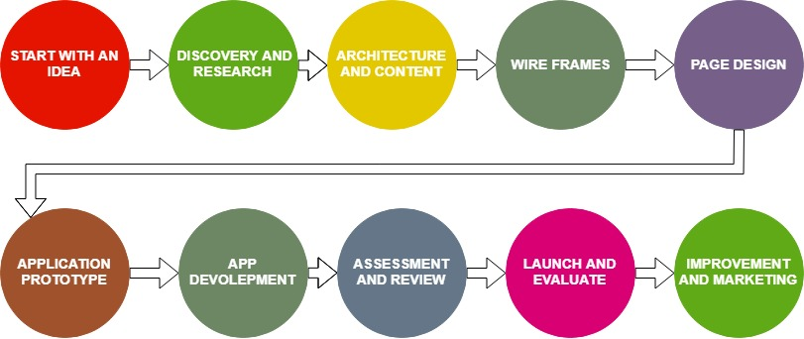

**3.2.1 Data Dictionary**

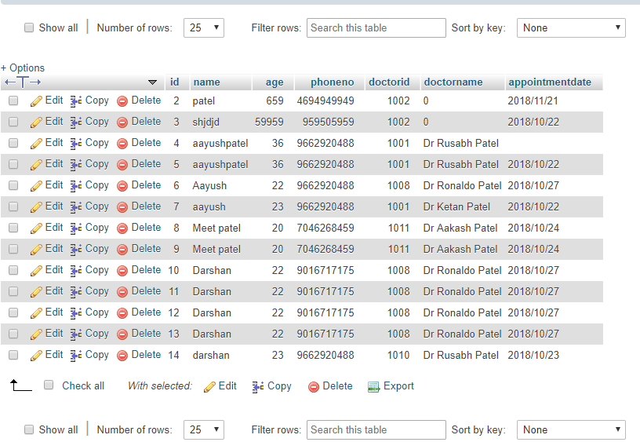

Users

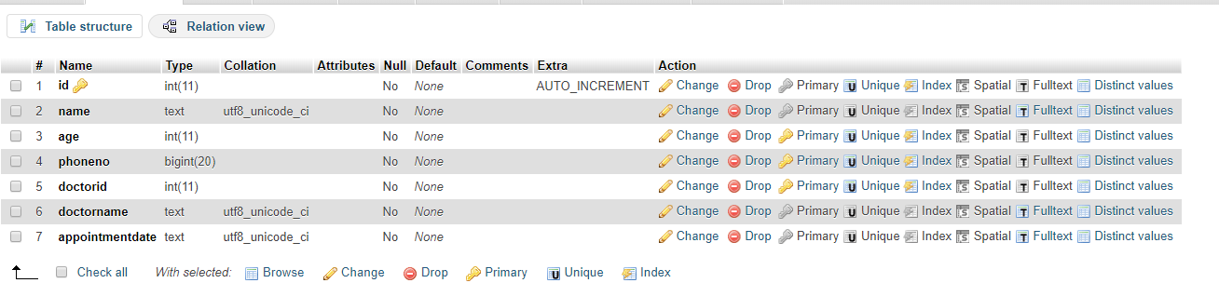

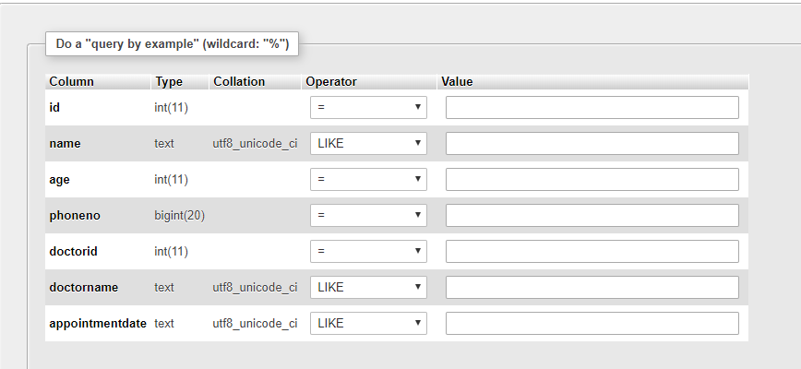

**Chapter 4: Implementation**

**4.1 IMPLEMENTATION ENVIREMENT**

**Hardware/Software Interface:**

This section list the minimum hardware and software requirement needed to run the system efficiently.

**Hardware:**

* **Processor :** Pentium Dual –core 2.7 GHz
* **Ram :** 1 GB
* **Secondary Memory (Hard Disk):** 16 GB minimum
* **Video Display Unit:** VGA Monitor.
* **Compact Disk Drives:** 52x CD-ROM.
* **Keyboard:** 101 Key Enhanced Keyboard.
* **Mouse:** Serial Mouse.

**Software:**

* **Operating system :** windows 7 or above
* **Your Virtual Devices :** Android Phone or Emulator
* **IDE :** Android Studio

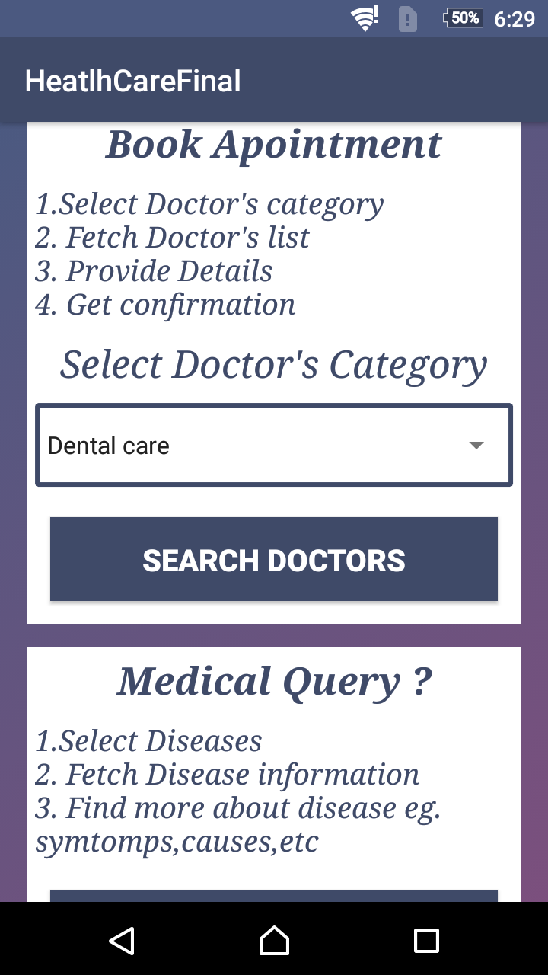**4.2 SNAPSHOT OF PROJECT**

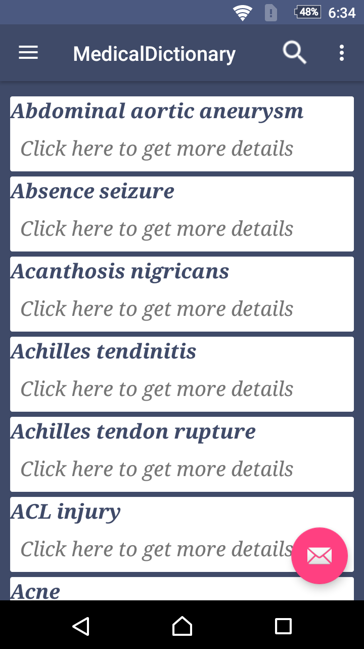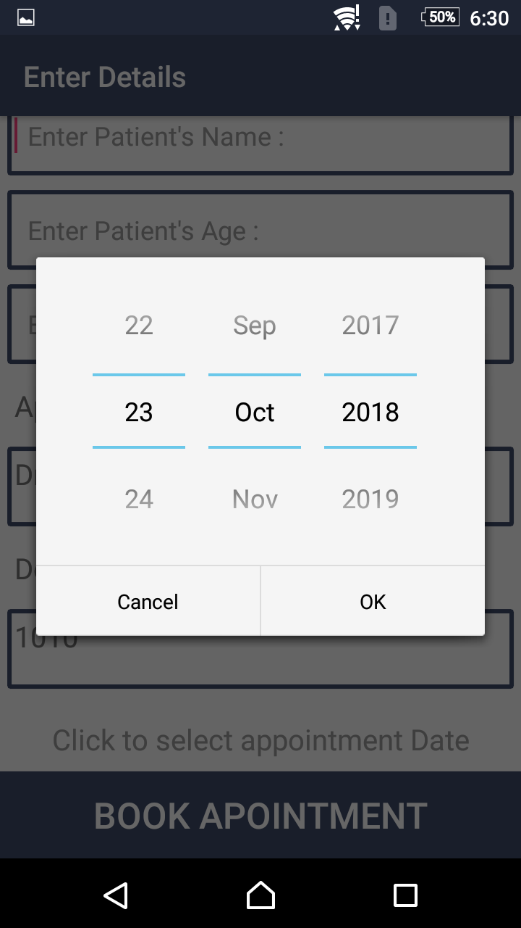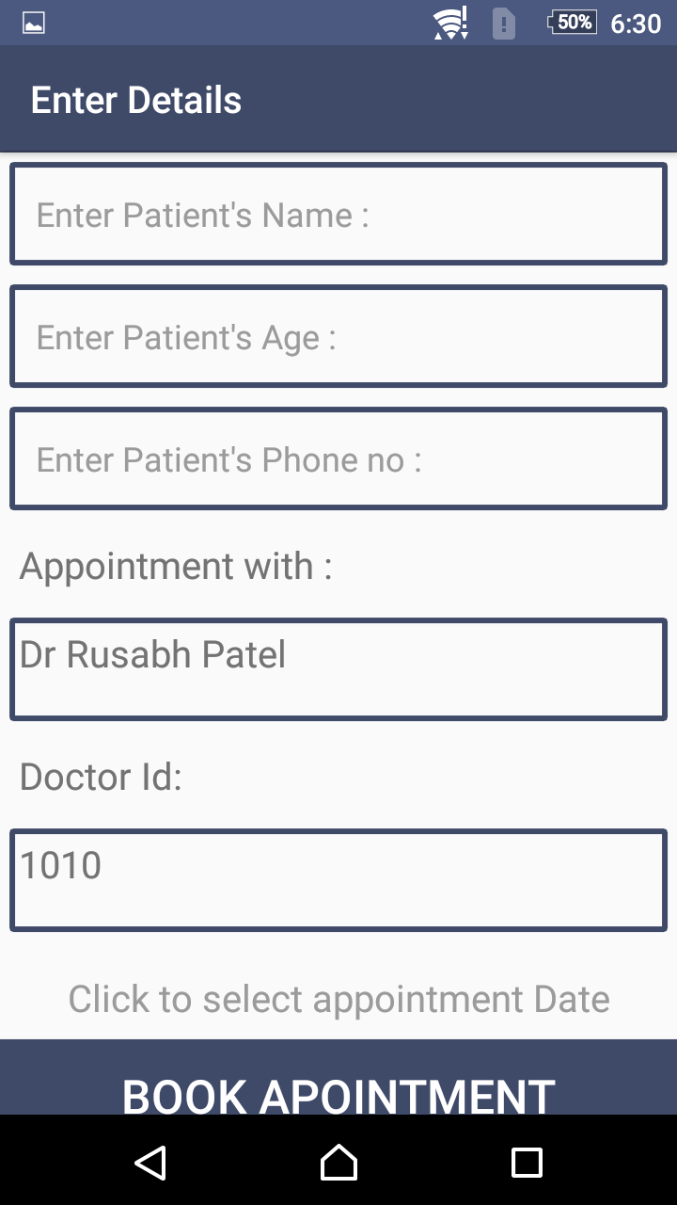

**Chapter 5: Future Enhancement**

**FUTURE WORK**

1.Fetch Diseases information

2.Find more about diseases e.g. Symptoms, causes,etc.

3.Direct book the appointment.

**Chapter 6: Conclusion**

**CONCLUSION:**

# The core reason for the establishment of computerizing Doctor Appointment System is to enable the hospital administrators in a convenient, fair and timely manner. Therefore, the IT used should support the core objective of the system if it is to remain relevant to the hospital. A lot still needs to be done in the IT department in order to make available technology effective. IT and computer systems need to be kept being upgraded as more and more IT facilities software are introduced in two days IT market. The researcher acknowledges the fact this system does not handle all patient doctor and hospital. The researcher therefore suggests that for further research, the following can be researched on. The most cost-effective way of handling all Health Care.

* **REFERECES**

**1:** Android Studio

**-**https://developer.android.com/studio/

**-**https://www.youtube.com/watch?v=cp2rL3sAFmI&t=260s

**-**https://www.youtube.com/watch?v=s_u5OJIF7w0&t=206s