Q1. What happens when you use .find() and .limit() combination ?
Q2. Try out the operators- $gt, $lt, $gte, $lte, $ne.
Q3. Tryout the combination of .sort() with .limit() and see what happens.
Q4. What does .count() returns?
Q5. What happens if you update a record without giving all the field values?
Q6. What happens if you update a match that does not exist?
Q7. We have seen what insert does. Try out and find what upsert does?
Q8. What happens when you use ‘upsert:true’ with update statement?

1)If we use limit with find then the specified number of records will be selected.
For example,
db.customer.find().limit(1).pretty(); // in limit(1), 1 is specified then first record will print
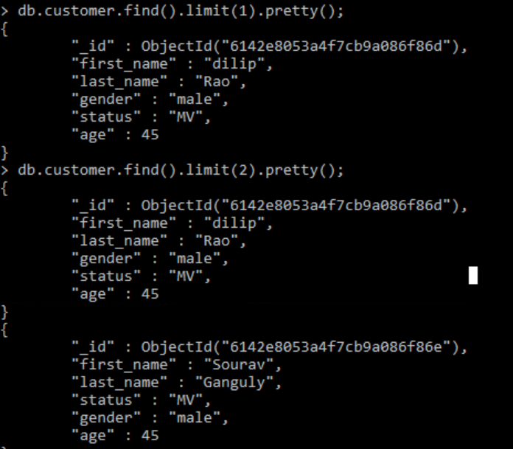
=========================================================================

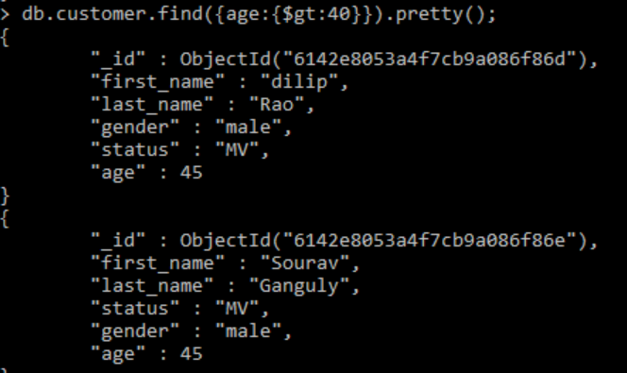
2) greater than (gt):

less than (lt)
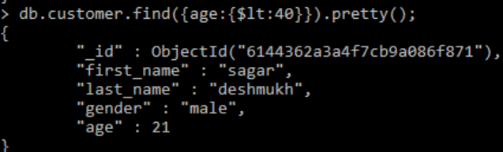

$gte
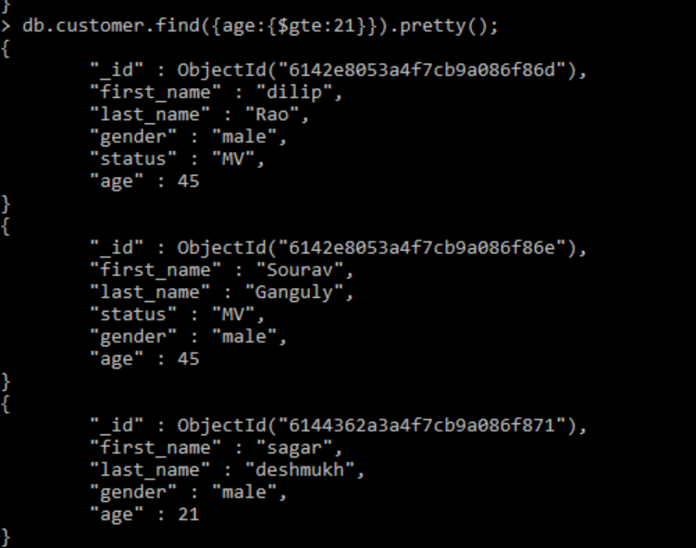

$lte
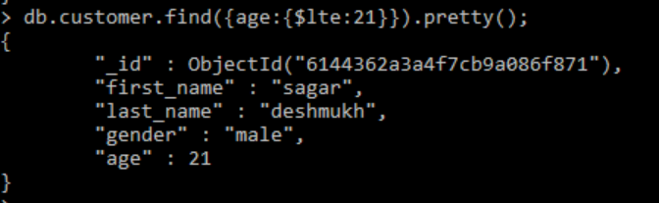
$ne
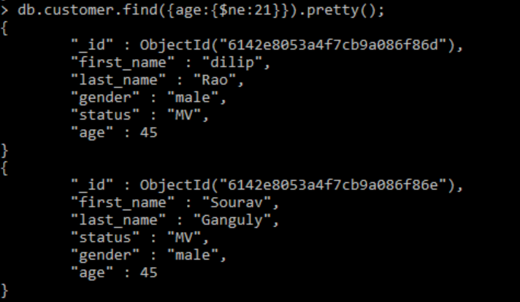
$eq
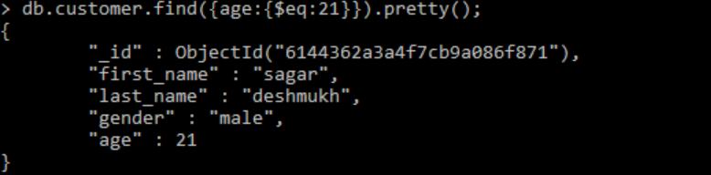

3)sort with limit function.
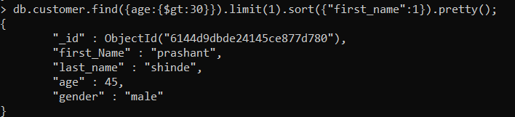
4) db.customer.find().count(); //the command will return number of records in a customer collection. 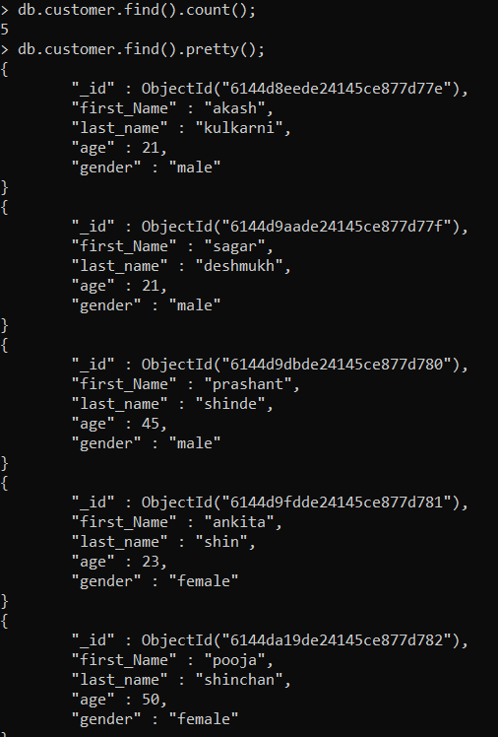

5) update function requires query or object to update

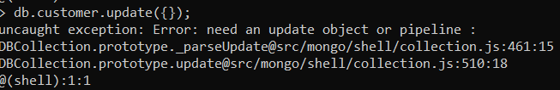

6)if we update a match that does not exist then it will not get modified.
first_Name akash1 is not present in customer collection.
As shown below it shows nMatched:0 and nModified:0

7)Upsert is a combination of update and insert.
It updates the data if there is a matching in and it inserts new data if there is no matching document.
db.customer.update({first_name:"girish"},{first_name:"girish1",last_name:"kulkarni"},{upsert:true});

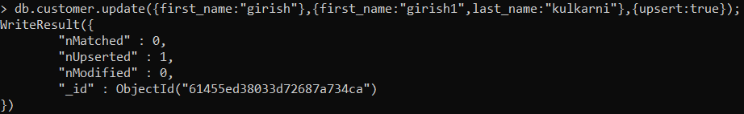

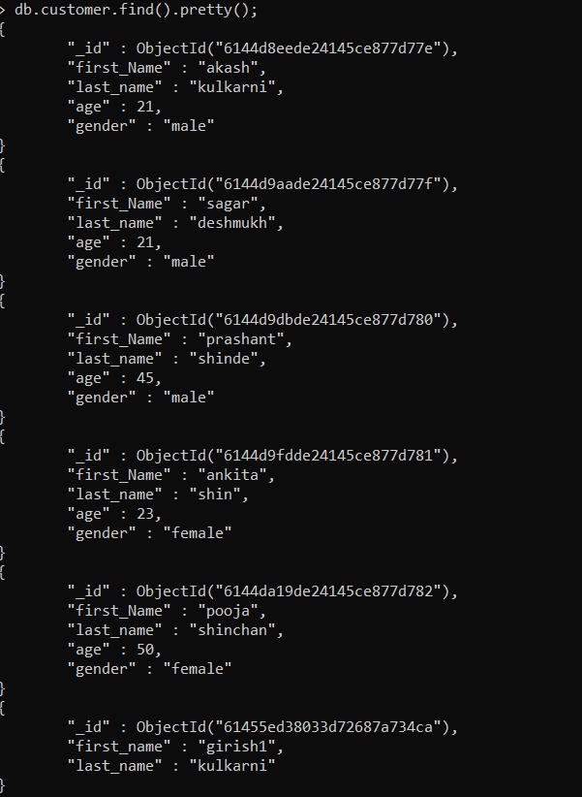

8) db.customer.update({first_name:"girish"},{first_name:"girish1",last_name:"kulkarni"},{upsert:true});

