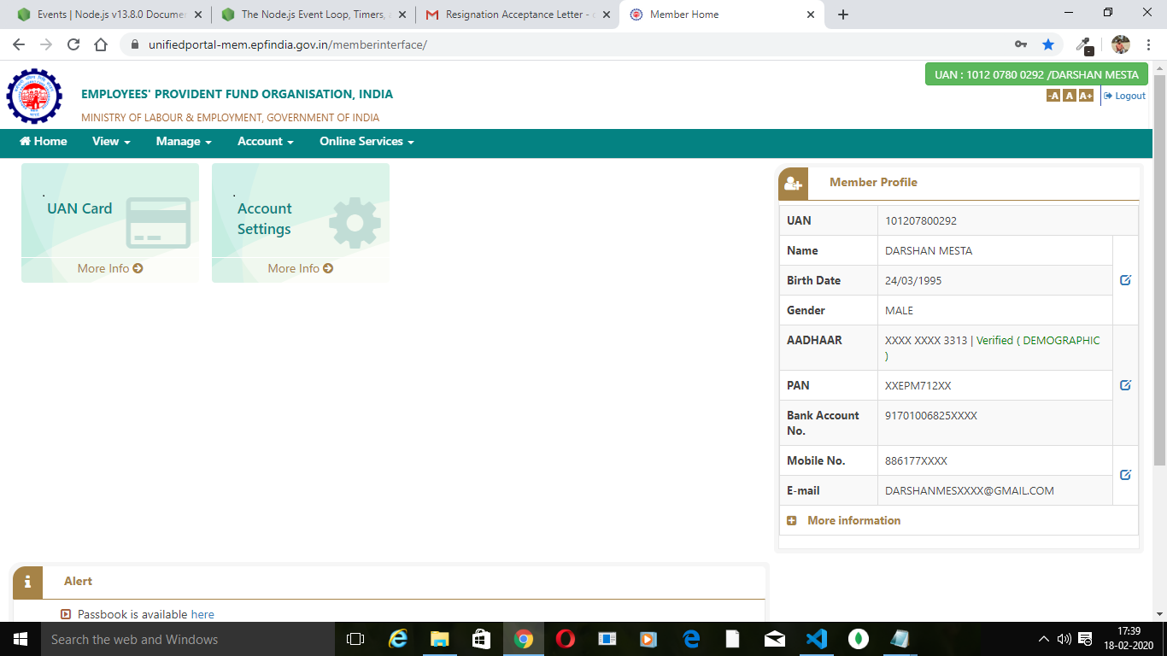

The issue described is on this Page under the member profile we have only the status for Aadhar as verified and PAN don’t have status as verified.

Previously it was showing as verified when i got it updated being inb your organisation.