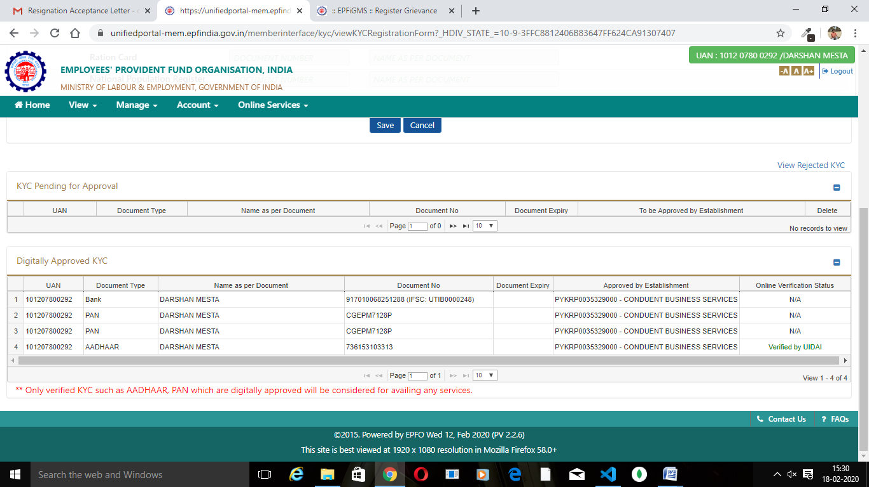

KYC for PAN has been completed from the employer side.

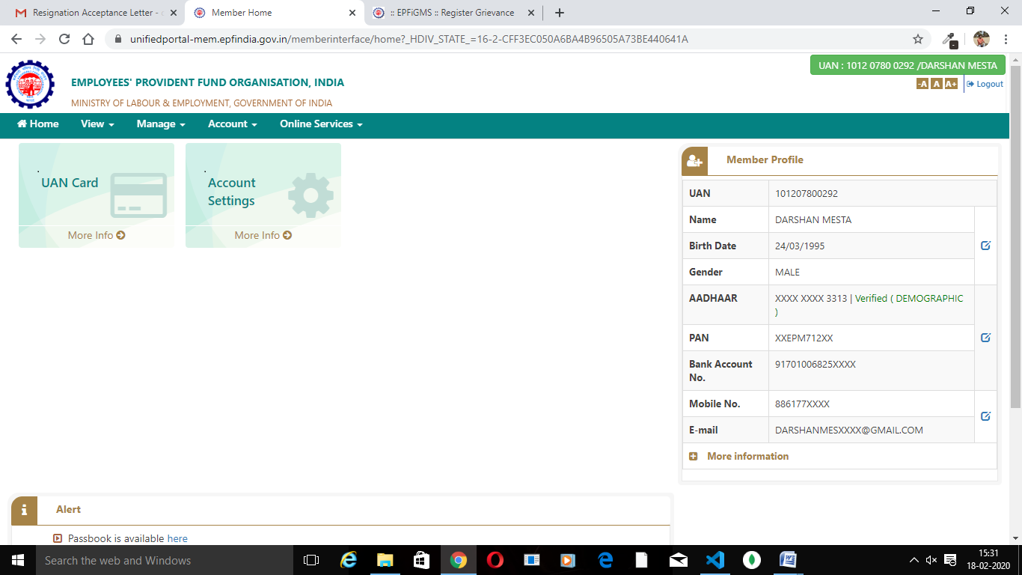

Only the Aadhar is showing as Verified with the online verification status.

But the PAN Though KYC has been completed is not showing any status.