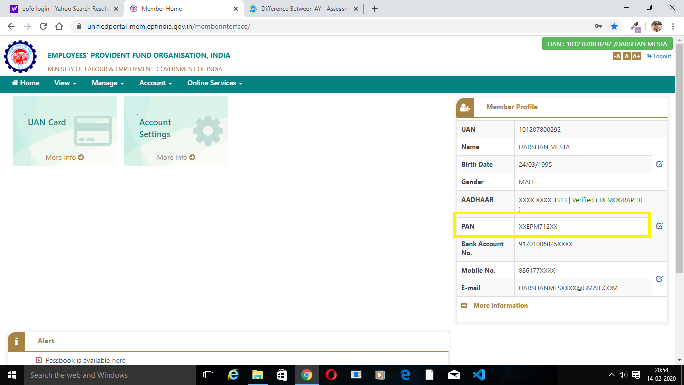

Status needs to show as Verified infront of PAN ( If claimed without this being verified maximum Tax is going to be deducted )

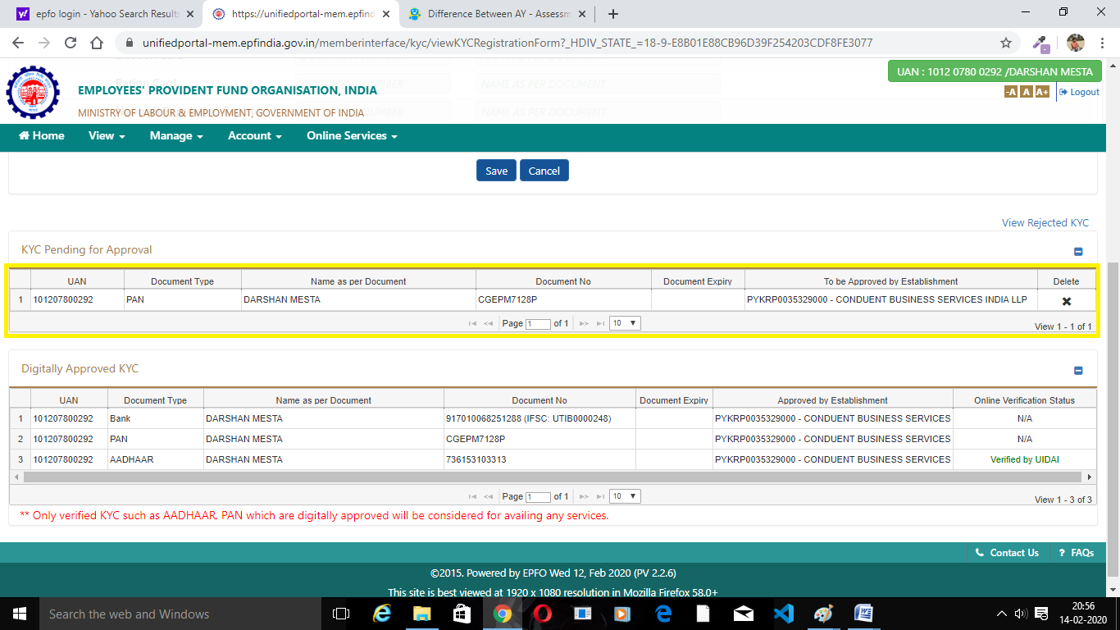

A new Request has been submitted kindly Approve the same from your side.