LAB REPORT- 5

SUBJECT:-ESE-2014

GROUP -

*Submitted By*

*Darshan Mistry:- C0749864*

*Dixaben Shah:-C0748229*

*Date:- 11-JUN-2019.*

*Professor - linchen*

*Email id - Linchen.wang@cestarcollege.com*

1. **Convolution function in Mat lab :-**

**X(n) = {2,-4,5,3,-1,-2,6}**

**H(n)= {1,-1,1,-1,1}**

**ANS;-**

* **Convolution function: -**

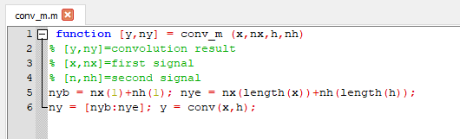

**Output:-**

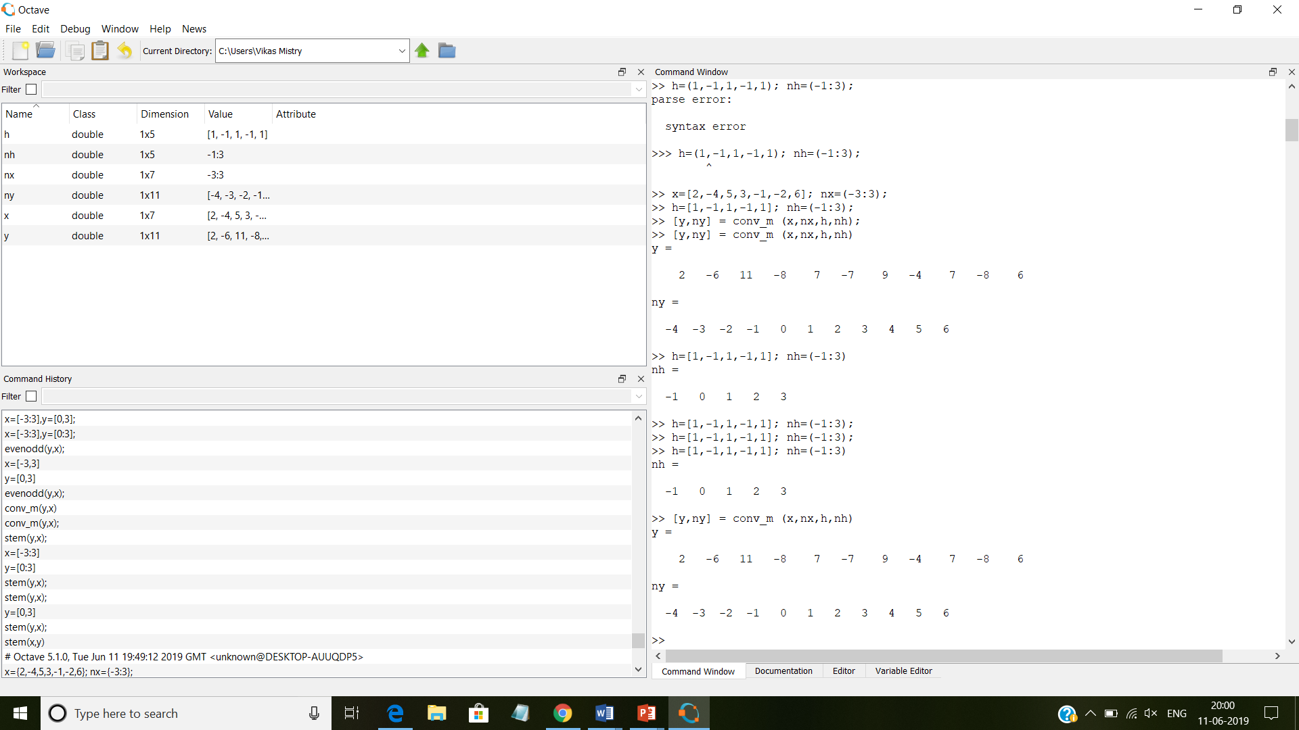

1. **x=[1,1,0,1,1]; nx=(-2:2); h = [1,-2,-3,4]; nh = (-3:0)**

**ANS:-**

**Output:-**

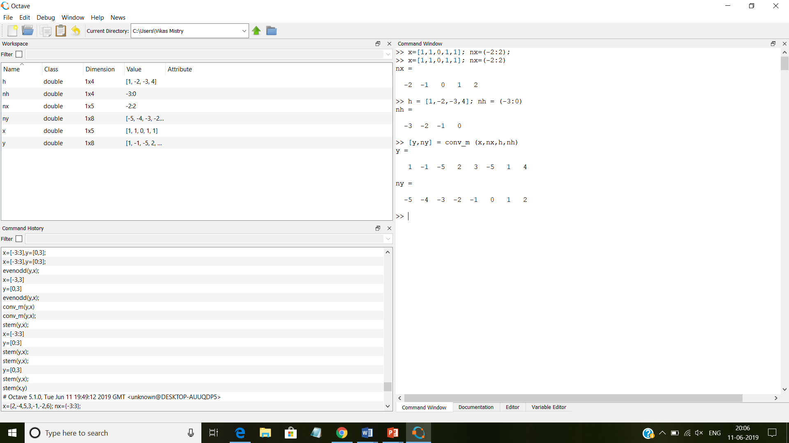

* **Step function: -**

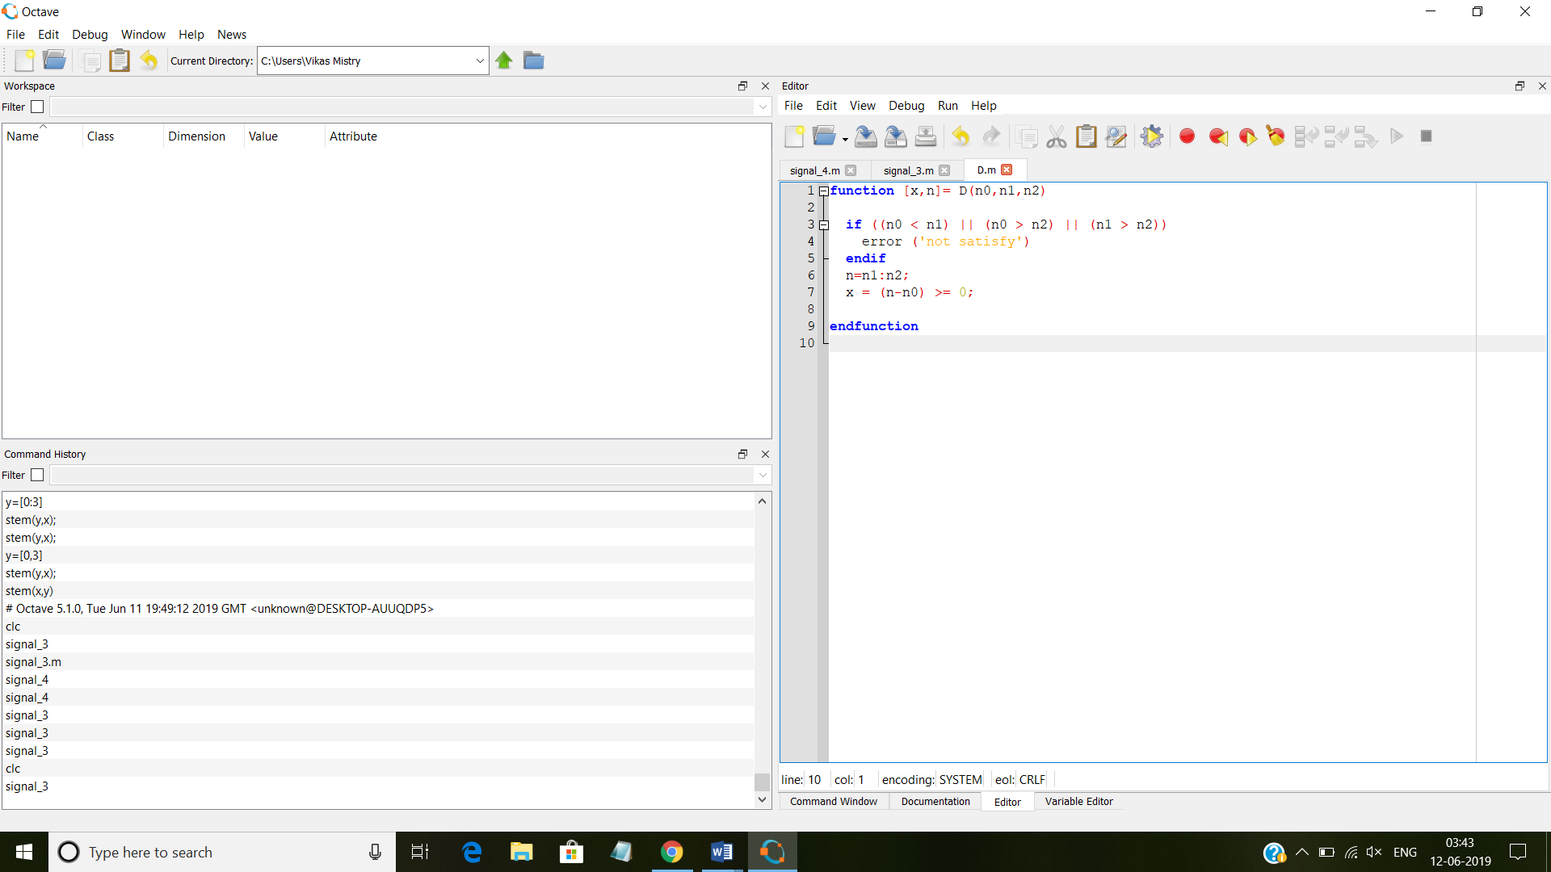

**Function:-**

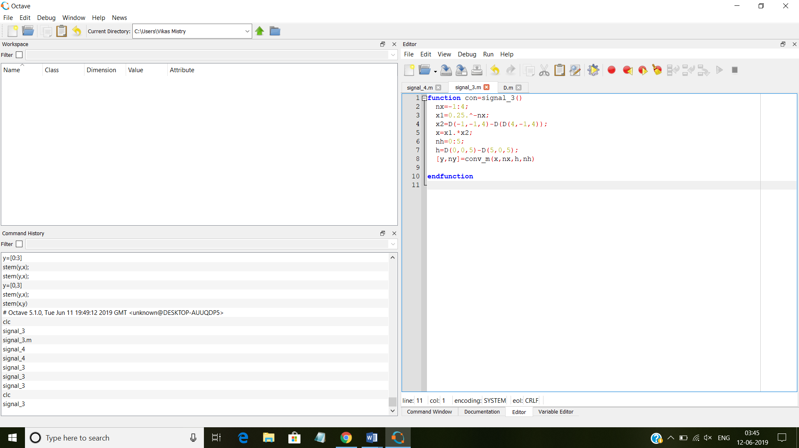

**Output:-**

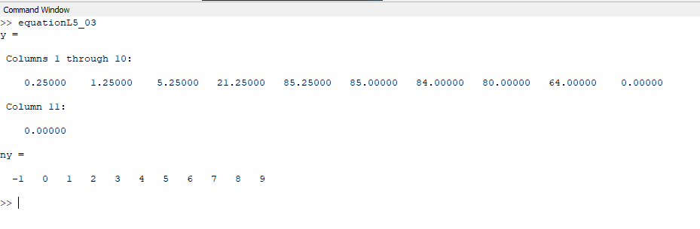

**4.**

**Function:-**

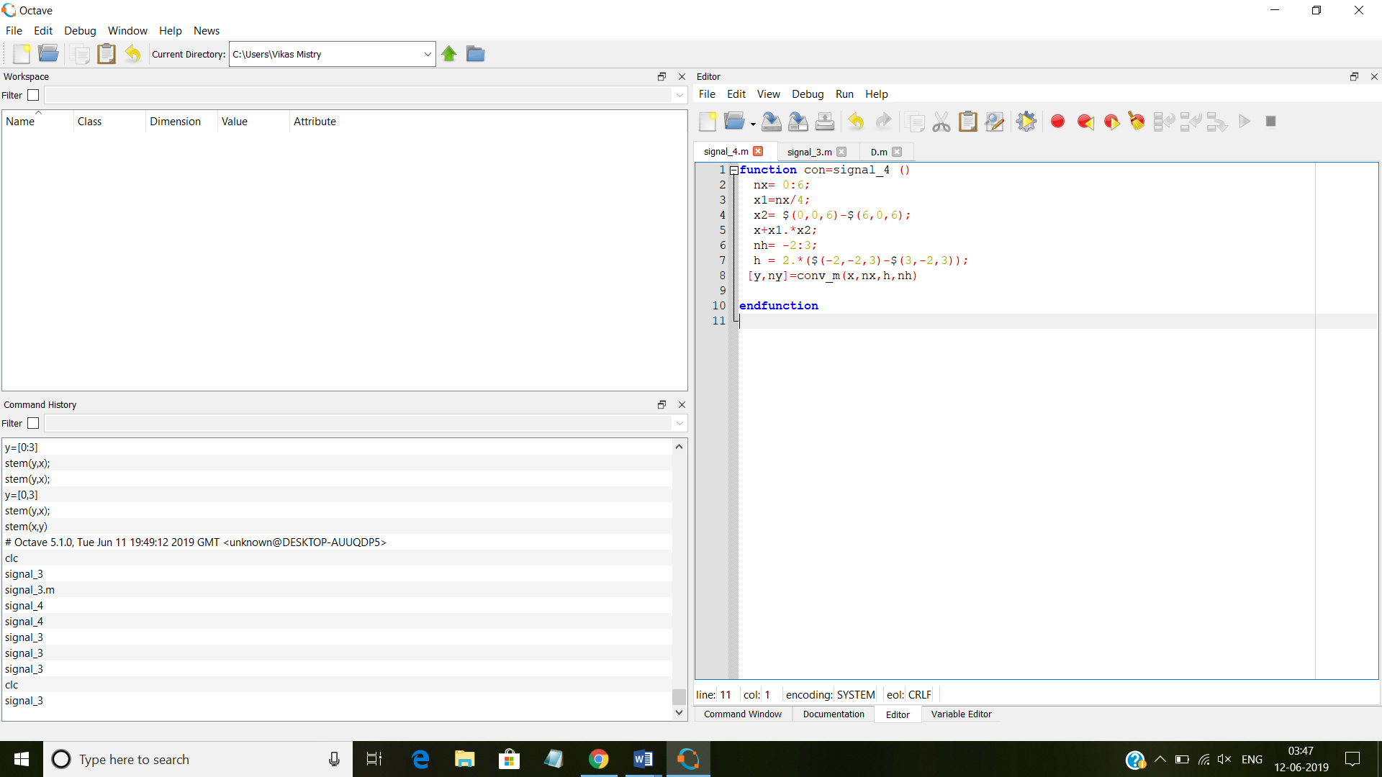

**Output:-**

