FreeRTOS Enhanced Blinky Project
Now that you're getting a handle on FreeRTOS applications, your next assignment should take your embedded-C RTOS skills another step higher.
See if you can refine your non-overlapping-colours Blinky project so that only one task function is needed (you will need to use pvParameters). Strive to make your code as streamlined as possible.
Next, for periodic applications, vTaskDelayUntil() is preferred, because it operates on a kind of absolute clock (rather than relative to when it was last called). Read up on vTaskDelayUntil() in the Mastering FreeRTOS documentation, and modify your code to incorporate this function, rather than vTaskDelay().
Finally, look into incorporating two buttons in your project. Look at the schematic of the LPC1769 board provided in the documentation folder of the teaching repository on github.com. Identify two GPIOs that you can use for push buttons. Check out board.h/board.c to identify suitable API functions to setup your GPIO pins as inputs and include (if possible) internal pull-up or pull-down resistors. Now, designate one button to increase the 0.5-second sampling period of this application. The other button should decrease the interval. Use steps corresponding to 125-milliseconds, and the minimum allowed sampling period should be 0.125 seconds (corresponding to 125 ticks). Allow a user to adjust the period of your program and record the results.

Solution:-
First Intialization of the push Button to the GPIO pins into a scope in both the Blinky main program as well as into the board.h file
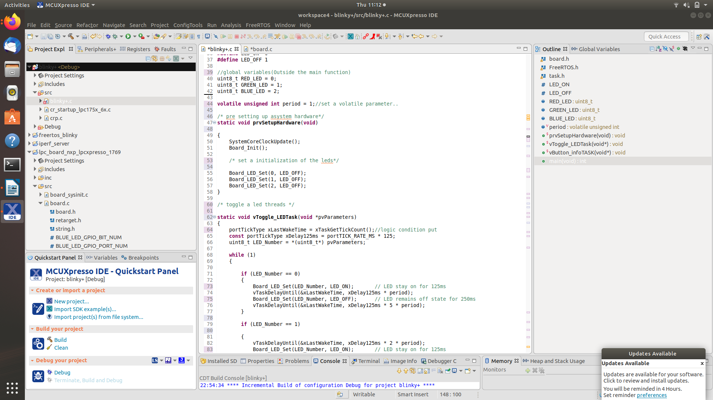

Declair a task to get status of the button pressing from the user and get them action according to that ..

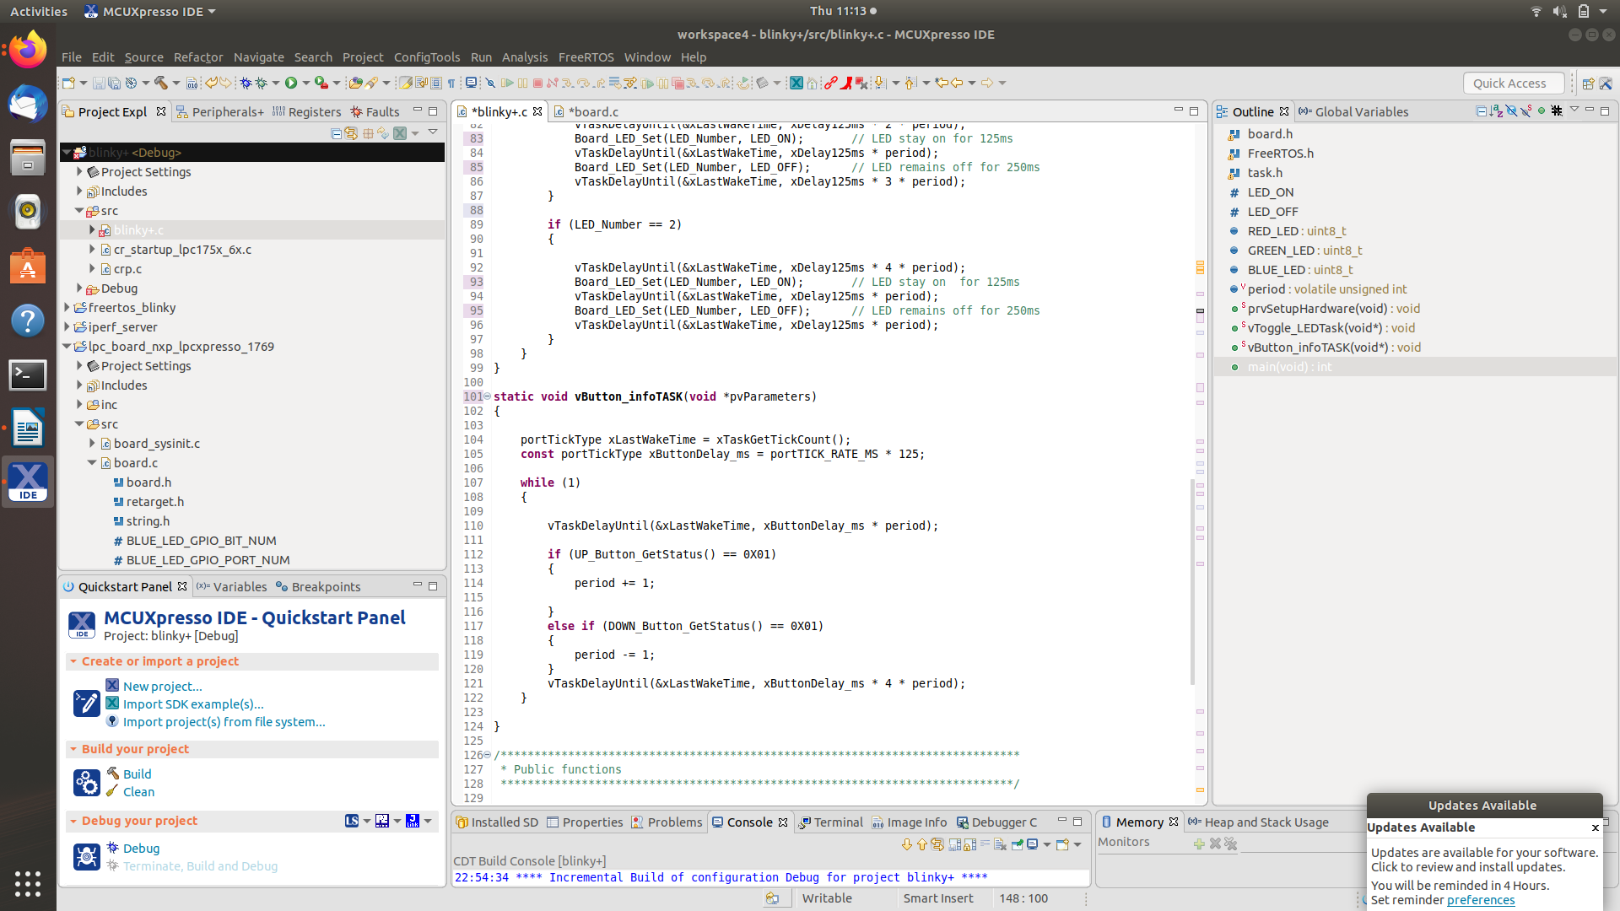

According action after a read button info and change in the toggle time of the leds by the 0.s second at every press..

