#What is NumPy?
NumPy is a Python library used for working with arrays.
In Python we have lists that serve the purpose of arrays, but they are slow to process.
NumPy aims to provide an array object that is up to 50x faster than traditional Python lists.
Data Science: is a branch of computer science where we study how to store, use and analyze data for deriving information from it.

Why is NumPy Faster Than Lists?
NumPy arrays are stored at one continuous place in memory unlike lists, so processes can access and manipulate them very efficiently.
github: enables many people to work on the same codebase.

#What is cmake?
CMake is a cross-platform free and open-source software tool for managing the build process of software using a compiler-independent method. It supports directory hierarchies and applications that depend on multiple libraries.

Setting up Environment Variable
Step 1: Open https://cmake.org/ and click on Downloads
Step 2: Download the Zip file of CMake.
Step 3: Extract the file and copy the bin file path.
Step 4: Go to Control Panel -> System and Security -> System
Under Advanced System Setting option click on Environment Variables as

This article was published as a part of the Data Science Blogathon


Introduction
OpenCV is a great tool for image processing and performing computer vision tasks. It is an open-source library that can be used to perform tasks like face detection, objection tracking, landmark detection, and much more. It supports multiple languages including python, java C++. Although, For this article, we will be limiting to python only.
It can process images and videos to identify objects, faces, or even the handwriting of a human. When it is integrated with various libraries, such as Numpy which is a highly optimized library for numerical operations, then the number of weapons increases in your Arsenal i.e whatever operations one can do in Numpy can be combined with OpenCV.

What is dlib used for?
What is Dlib? It's a landmark's facial detector with pre-trained models, the dlib is used to estimate the location of 68 coordinates (x, y) that map the facial points on a person's face like image below.

What is dlib in OpenCV?
OpenCV - image processing library.
Dlib - machine learning library. They are different and solving different tasks.

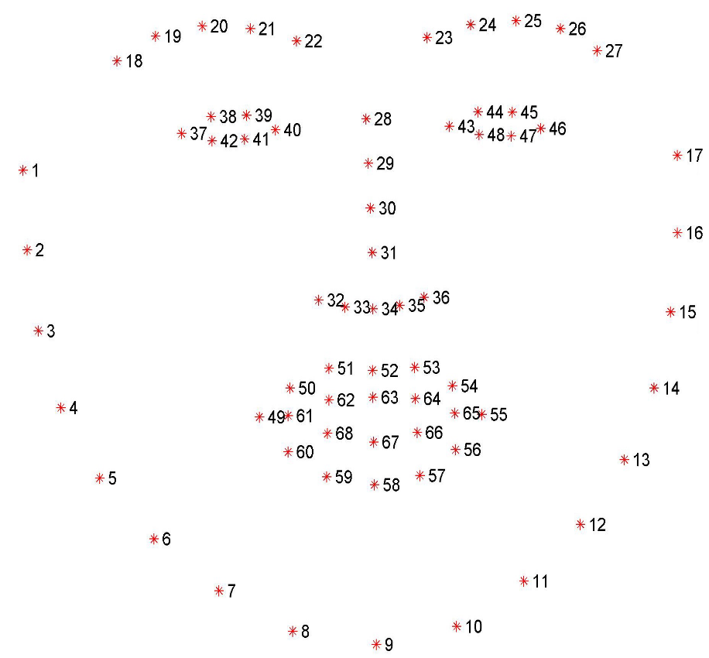

#Is dlib CNN?

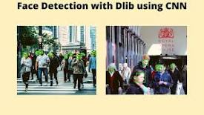

Due to this, there are many state-of-the-art deep learning libraries present today. Dlib is one of them. Therefore, in this post, we will carry out Face Detection with Dlib using CNN (Convolutional Neural Networks). In the previous post, we covered face detection with Dlib using HOG and Linear SVM.05-Jul-2021

What is TensorFlow.js?
A popular JavaScript library for Machine Learning.
Lets us train and deploy machine learning models in the Browser.
Lets us add machine learning functions to any Web Application.

Tensors
TensorFlow.js is a JavaScript library to define and operate on Tensors.
A Tensor is much the same as a multidimensional array.
A Tensor contains numeric values in a (one or more) dimensional shape.
A Tensor has the following main properties:
Property | Description
dtype | The data type
rank | The number of dimensions
shape | The size of each dimension

Tensor Data Types
A Tensor can have the following data types:
- bool
- int32
- float32 (default)
- complex64
- string

