**1. Program to write the first 10 numbers.**

for (let i = 0; i <10; i++) {

console.log(i)

}

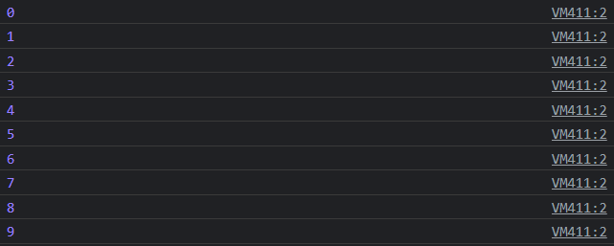

**2. Program to calculate the sum of first 10 numbers**

let s = 0;

for (let i = 1; i <= 10; i++) {

s = s + i;

console.log(s)

}

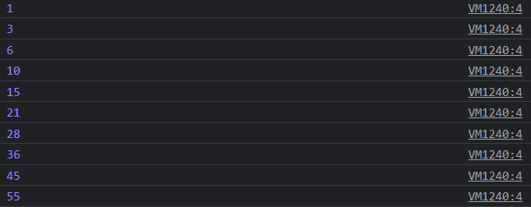

**3. Make the loop stop when i is 5.**

for (i = 0; i < 10; i++) {  
console.log(i);  
if (i == 5) {   
  
Break;  
}  
}

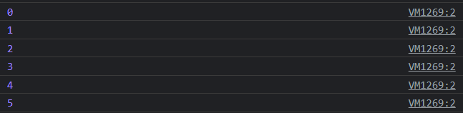

**4. Write a program to print day of week name using switch case.**

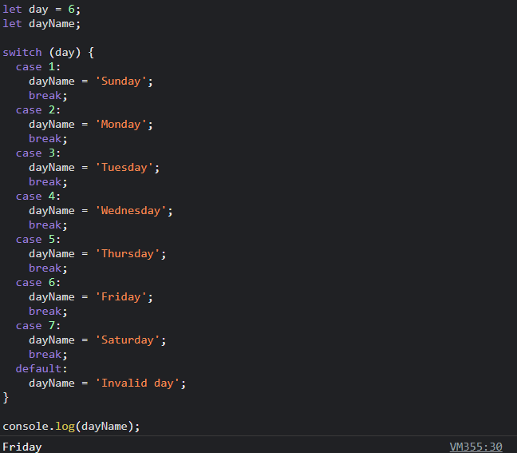

**5. Write a program print total number of days in a month using switch case.**

