PES UNIVERSITY
DEPARTMENT OF COMPUTER SCIENCE AND ENGINEERING
ACADEMIC YEAR 2025-2026 | FIFTH SEMESTER B.TECH

SOFTWARE ARCHITECTURE AND DESIGN
(SAD Specification)
PROJECT: SPRINTFLOW -- PROJECT MANAGEMENT SYSTEM
(Workflow, Visibility, Estimation, and Kanban)

SUBMITTED BY: TEAM 11 (SECTION 5C)

Student Name | USN | Role | Assigned System Component
Darshan P Pawar | PES2UG24CS143 | Team Lead & Full-Stack Architect | Architecture, Component Diagram, Security
DHATRI SHIVAPRASAD | PES2UG24CS158 | Frontend & UI/UX Lead | Design, Sequence Diagrams, UX, API
CHANDAN KUMAR K | PES2UG24CS128 | Backend & Database Architect | Test Plan Core, Strategy, Environment
GURUBELLI YEKAMBAR ESHWAR RAO | PES2UG24CS173 | Full-Stack & QA/DevOps Lead | Test Execution, Metrics, Traceability

Version: 1.0 (Final Submission) | Date: 15-09-2026 | Status: Approved
Repository: https://github.com/Darshanpawar7/SE-SRS-2

Document Revision History & Approvals
Version | Date | Author | Change Summary | Approval Status
1.0 | 15-09-2026 | Team 11 | Complete SAD with UML Component Diagram, 2 Sequence Diagrams, API Design & STRIDE Threat Model | Approved for Submission

Role | Name | Department / Contact | Sign / Date
Team Lead | Darshan P Pawar | PES2UG24CS143 (CSE) | Darshan P Pawar / 15-09-2026
Course Coordinator | Software Engineering Faculty | Dept of CSE, PES University | Approved / 15-09-2026

Table of Contents
1. Introduction ...................... Page 3
1.1 Purpose 1.2 Scope 1.3 Audience 1.4 Definitions
2. Document Overview ................. Page 3
2.1 How to Use This Document 2.2 Related Documents
3. Architecture ...................... Page 4
3.1 Goals & Constraints 3.2 Stakeholders 3.3 Component Diagram
3.4 Component Descriptions 3.5 Architecture Pattern 3.6 Technology Stack
3.7 Risks & Mitigations 3.8 Traceability 3.9 Security Architecture
4. Design ............................ Page 8
4.1 Overview 4.2 Sequence Diagrams 4.3 API Design
4.4 Error Handling 4.5 UX Design 4.6 Open Issues
5. Appendices ........................ Page 11

1. Introduction

1.1 Purpose
This Software Architecture and Design (SAD) document specifies the architecture, component structure, design patterns, API contracts, and security architecture of SprintFlow, an enterprise-grade Agile Project Management System. It serves as the authoritative technical reference for developers, quality assurance engineers, and assessment evaluators, providing complete traceability from architectural decisions to the functional and non-functional requirements defined in the Software Requirements Specification (SRS v1.0).

1.2 Scope
This document covers the complete software architecture and detailed design of SprintFlow, including: component-based layered architecture of the React 18 single-page application; dual-mode data persistence layer (Supabase PostgreSQL cloud sync and browser LocalStorage offline fallback); UML component diagram illustrating all system modules; UML sequence diagrams modeling two core workflows; RESTful API design for Supabase backend; STRIDE-based threat modeling and security architecture; and technology stack rationale.
Out of scope: Supabase internal infrastructure, browser rendering engine internals, and third-party CDN operations.

1.3 Audience
Developers, QA Engineers, Security Auditors, Course Evaluators, and Maintenance Engineers.

1.4 Definitions
Term | Definition
SAD | Software Architecture and Design Specification
SRS | Software Requirements Specification
STP | Software Test Plan
SPA | Single Page Application
RLS | Row Level Security (PostgreSQL policy-based access control)
STRIDE | Spoofing, Tampering, Repudiation, Information Disclosure, Denial of Service, Elevation of Privilege
API | Application Programming Interface
CI/CD | Continuous Integration / Continuous Deployment
TLS | Transport Layer Security
XSS | Cross-Site Scripting
RBAC | Role-Based Access Control

2. Document Overview

2.1 How to Use This Document
Section 3 (Architecture) provides the high-level system decomposition, component relationships, technology stack decisions, and security architecture. Section 4 (Design) contains detailed design specifications including sequence diagrams, API contracts, error handling, and UX principles. Section 5 (Appendices) contains the glossary, references, and tooling documentation.

2.2 Related Documents
Document | Version | Repository
Software Requirements Specification (SRS) | 1.0 | SE-SRS (GitHub)
Software Test Plan (STP) | 1.0 | SE-SRS-2 (GitHub)
Database Schema (DDL) | 1.0 | database/schema.sql
CI/CD Workflow Definition | 1.0 | .github/workflows/ci.yml

3. Architecture

3.1 Goals and Constraints
Architectural Goals: Modularity (independent module development), Resilience (dual-mode persistence for uninterrupted operation), Security (defense-in-depth with RLS, input sanitization, TLS), Performance (sub-50ms UI transitions), Maintainability (clear component boundaries), Availability (99.9% uptime target).
Architectural Constraints: Must operate as client-side SPA; must support zero-configuration deployment; must integrate with Supabase PostgreSQL via @supabase/supabase-js v2; must pass CI/CD validation on every push; technology stack must align with course-approved options.

3.2 Stakeholders and Concerns
Stakeholder | Primary Concerns
Team Lead (Darshan) | System reliability, architecture coherence, deployment simplicity
Frontend Developer (Dhatri) | UI responsiveness, component reusability, drag-and-drop performance
Backend Developer (Chandan) | Data integrity, schema design, RLS policy correctness
DevOps/QA Lead (Eshwar) | Test coverage, CI/CD reliability, build reproducibility
Course Evaluators | IEEE compliance, documentation quality, collaboration evidence

3.3 Component (UML) Diagram
The following UML Component Diagram illustrates the high-level decomposition of SprintFlow into its constituent modules, their provided/required interfaces, and inter-component dependencies:

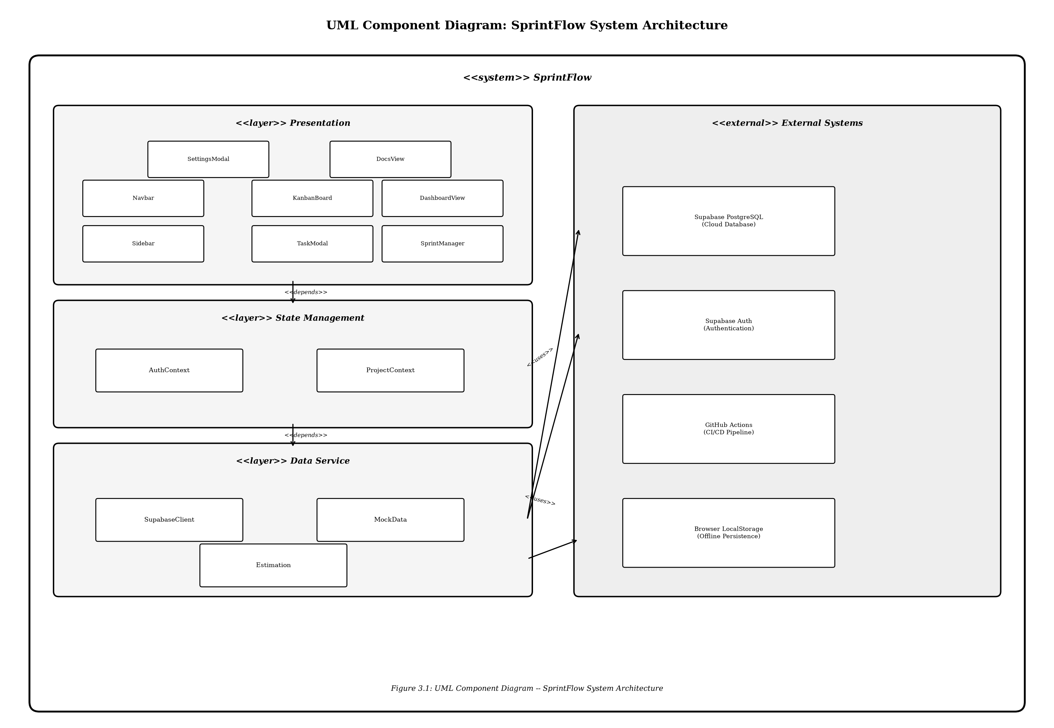
Figure 3.1: UML Component Diagram -- SprintFlow System Architecture

3.4 Component Descriptions
Component | Module Path | Responsibility
App Shell | src/App.jsx | Root container; manages view routing and layout
Navbar | src/components/layout/Navbar.jsx | Top navigation with user profile and view switching
Sidebar | src/components/layout/Sidebar.jsx | Side navigation with project filters
KanbanBoard | src/components/kanban/KanbanBoard.jsx | 5-column workflow with HTML5 drag-and-drop
TaskModal | src/components/kanban/TaskModal.jsx | Task creation/editing with Fibonacci points
DashboardView | src/components/dashboard/DashboardView.jsx | KPI dashboard with SVG burndown chart
SprintManager | src/components/sprint/SprintManager.jsx | Sprint lifecycle and capacity planning
SettingsModal | src/components/settings/SettingsModal.jsx | Supabase connection configuration
AuthContext | src/context/AuthContext.jsx | Authentication state and session management
ProjectContext | src/context/ProjectContext.jsx | Project data state and CRUD mutations
SupabaseClient | src/services/supabaseClient.js | Dual-mode data service (cloud + offline)
Estimation | src/utils/estimation.js | Fibonacci point calculation engine

3.5 Chosen Architecture Pattern and Rationale
Selected Pattern: Layered Component Architecture (React Component-Based SPA)
Rationale: Layered Component Architecture was selected because it provides strong separation of concerns through React component encapsulation while maintaining deployment simplicity essential for academic evaluation. Microservices architecture was rejected as overly complex, requiring container orchestration infrastructure. Monolithic MVC was rejected due to limited team-parallel development support and poor offline capability.
Criterion | Layered Components | Microservices | Monolithic MVC
Separation of Concerns | Strong | Very Strong | Moderate
Development Complexity | Low-Medium | High | Low
Team Parallelism | High | Very High | Low
Deployment Simplicity | Very High | Low | Medium
Offline Capability | Native | Complex sync needed | Difficult

3.6 Technology Stack and Data Stores
Layer | Technology | Version | Justification
UI Framework | React | 18.x | Industry-standard with hooks-based state
Build Toolchain | Vite | 5.x | Sub-second HMR, native ES modules
State Management | React Context API | Built-in | Sufficient for project scope
Cloud Database | Supabase PostgreSQL | Latest | Managed DB with RLS and REST API
Offline Storage | Browser LocalStorage | Web API | Zero-dependency persistent store
Unit Testing | Vitest | 2.x | Vite-native with Jest-compatible API
CI/CD | GitHub Actions | Latest | Integrated multi-job pipeline
Transport Security | TLS 1.3 | Latest | Enforced by Supabase

3.7 Risks and Mitigations
Risk ID | Risk Description | Probability | Impact | Mitigation
RISK-01 | Supabase unavailability during evaluation | Medium | High | Dual-mode architecture with LocalStorage fallback
RISK-02 | LocalStorage quota exceeded (5MB) | Low | Medium | Data pruning for audit logs exceeding 1000 entries
RISK-03 | Cross-browser DnD inconsistencies | Medium | Medium | HTML5 native API with polyfill; multi-browser testing
RISK-04 | State sync conflicts (cloud vs offline) | Low | High | Last-write-wins with timestamp ordering
RISK-05 | CI/CD pipeline failure blocking merges | Low | Medium | Independent job isolation; manual override
RISK-06 | npm dependency vulnerabilities | Medium | Medium | Automated npm audit in CI; Dependabot alerts

3.8 Traceability to Requirements
The following table traces architectural components to the 18 functional and 6 non-functional requirements defined in SRS v1.0:
Req ID | Requirement | Component(s)
PMS-F-001 | User authentication | AuthContext, SupabaseClient
PMS-F-002 | Task card creation | TaskModal, ProjectContext
PMS-F-003 | 5-column Kanban display | KanbanBoard
PMS-F-004 | Drag-and-drop transitions | KanbanBoard (HTML5 DnD)
PMS-F-005 | 1-click advancement | KanbanBoard
PMS-F-006 | Fibonacci story points | TaskModal, Estimation
PMS-F-007 | Sprint creation | SprintManager, ProjectContext
PMS-F-008 | Sprint capacity calc | SprintManager, Estimation
PMS-F-009 | SVG burndown chart | DashboardView
PMS-F-010 | KPI dashboard | DashboardView
PMS-F-011 | Task filtering | KanbanBoard, ProjectContext
PMS-F-012 | Audit trail | ProjectContext, SupabaseClient
PMS-F-013 | Supabase cloud sync | SupabaseClient, SettingsModal
PMS-F-014 | Offline LocalStorage | SupabaseClient
PMS-F-015 | Settings configuration | SettingsModal
PMS-F-016 | Task priority | TaskModal
PMS-F-017 | Workload balance | DashboardView
PMS-F-018 | Documentation viewer | DocsView
PMS-NF-001 | Sub-50ms transitions | KanbanBoard (optimized render)
PMS-NF-002 | 99.9% availability | Dual-mode SupabaseClient
PMS-NF-003 | Cross-browser compat | Vite ES module targets
PMS-NF-004 | TLS encryption | Supabase enforced TLS 1.3
PMS-NF-005 | 100+ concurrent tasks | ProjectContext (efficient state)
PMS-NF-006 | Network recovery | SupabaseClient offline fallback

3.9 Security Architecture
Threat Modeling (STRIDE Analysis):
STRIDE Category | Threat | Countermeasure | Component
Spoofing | Unauthorized user impersonation | Supabase Auth with session token validation | AuthContext
Tampering | Data modification in transit | TLS 1.3 encryption; input validation | SupabaseClient
Repudiation | User denying performed actions | Immutable audit log with timestamps | ProjectContext
Information Disclosure | Unauthorized data access | PostgreSQL RLS policies | database/schema.sql
Denial of Service | Excessive API requests | Client-side debouncing; Supabase rate limiting | SupabaseClient
Elevation of Privilege | Regular user accessing admin functions | Role-based UI rendering; server-side RLS | AuthContext, RLS

4. Design

4.1 Design Overview
SprintFlow is designed as a modular, component-based single-page application following the principle of separation of concerns at every layer. The Presentation Layer uses React functional components with hooks-based lifecycle management. The State Management Layer uses two React Context providers (AuthContext and ProjectContext) as centralized state containers. The Data Access Layer uses a unified DataService abstraction that transparently selects between Supabase PostgreSQL and browser LocalStorage.

4.2 UML Sequence Diagrams

4.2.1 Sequence Diagram 1: User Authentication and Task Creation
This sequence diagram models the end-to-end flow from user authentication through task creation on the Kanban board:
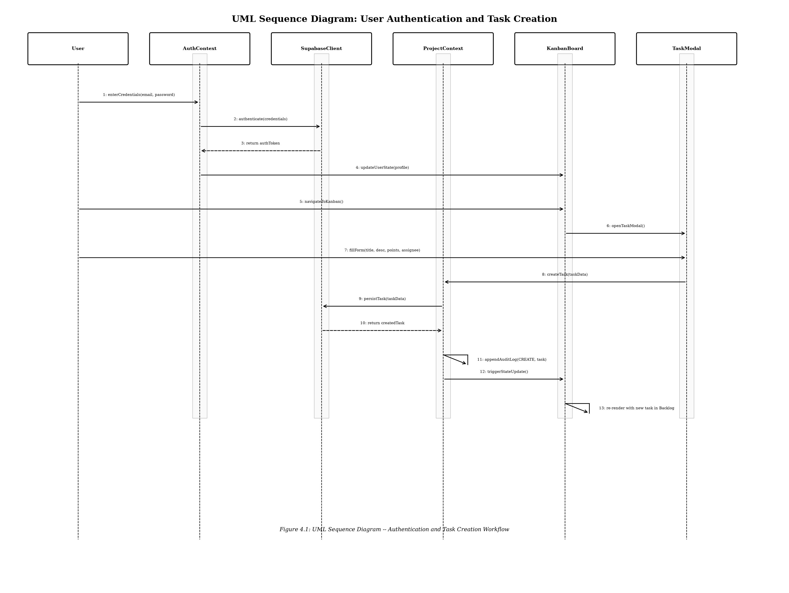
Figure 4.1: UML Sequence Diagram -- Authentication and Task Creation Workflow

4.2.2 Sequence Diagram 2: Sprint Estimation and Burndown Generation
This sequence diagram models the sprint planning and burndown visualization workflow:
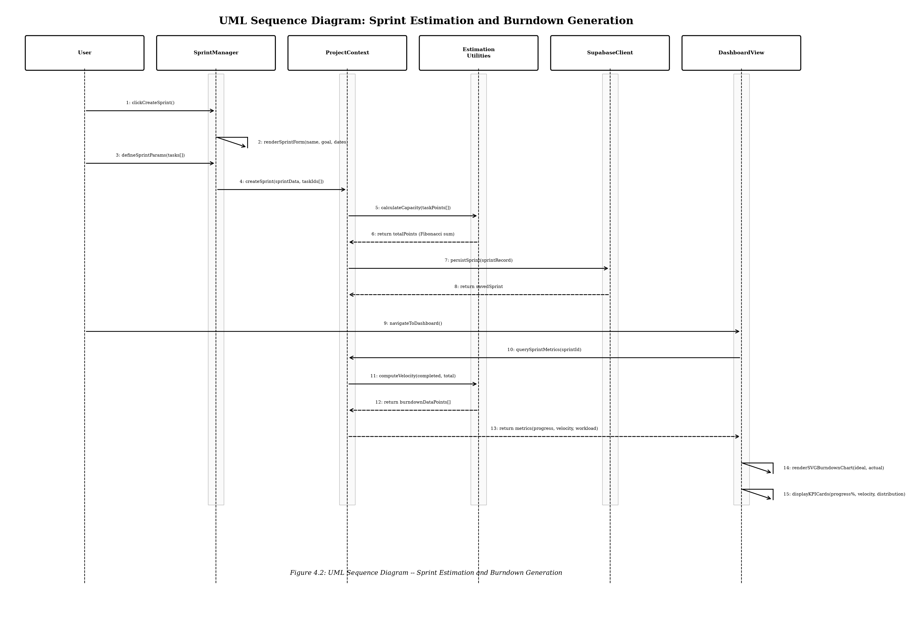
Figure 4.2: UML Sequence Diagram -- Sprint Estimation and Burndown Generation

4.3 API Design
SprintFlow interfaces with Supabase PostgreSQL through the auto-generated REST API. The following documents the primary API contracts:

4.3.1 Tasks API
Endpoint | Method | Description
/rest/v1/tasks | GET | Retrieve all tasks for the authenticated project
/rest/v1/tasks | POST | Create a new task record
/rest/v1/tasks?id=eq.{taskId} | PATCH | Update an existing task
/rest/v1/tasks?id=eq.{taskId} | DELETE | Delete a task record

Request Schema (POST): title (string, required), description (string), status (enum: backlog|todo|in_progress|review|done), priority (enum: low|medium|high|critical), story_points (integer: 1|2|3|5|8|13|21), assignee (string), sprint_id (uuid, optional).
Error Responses: 401 Unauthorized (invalid token), 403 Forbidden (RLS violation), 422 Unprocessable Entity (validation failure).

4.3.2 Sprints API
Endpoint | Method | Description
/rest/v1/sprints | GET | Retrieve all sprints for the project
/rest/v1/sprints | POST | Create a new sprint
/rest/v1/sprints?id=eq.{id} | PATCH | Update sprint status or goal

Request Schema (POST): name (string, required), goal (string, required), start_date (ISO 8601), end_date (ISO 8601), status (enum: planning|active|completed).

4.4 Error Handling, Logging and Monitoring
Error Handling: All API calls wrapped in try-catch with standardized error parsing. Network failures trigger automatic LocalStorage fallback with user notification. Form validation errors displayed inline. React Error Boundary catches unrecoverable errors.
Logging: All mutations recorded in audit log (timestamp, user ID, action type, entity). No sensitive information in logs. Audit entries persisted through dual-mode data service.
Monitoring: CI/CD pipeline provides automated build health monitoring. Vitest results captured in GitHub Actions logs. Client-side performance measurable through browser DevTools.

4.5 UX Design
Design Principles: Immediate Feedback (sub-50ms visual response), Progressive Disclosure (advanced features in modals), Consistency (uniform visual language), Accessibility (high-contrast dark theme, keyboard navigation, semantic HTML), Responsive Layout (1024px to 1920px viewport support).

4.6 Open Issues and Next Steps
Issue | Status | Next Step
Real-time collaborative editing | Deferred | Evaluate Supabase Realtime subscriptions
Offline-to-online data reconciliation | Partial | Implement queue-based sync with conflict detection
Granular role-based permissions | Basic | Extend with permission matrix
Sprint report PDF export | Not started | Integrate client-side PDF generation
Mobile-responsive Kanban | Not started | Touch-friendly card interactions

5. Appendices

5.1 Glossary
Term | Definition
Kanban | Visual workflow management using cards and columns
Sprint | Time-boxed iteration in Agile methodology (1-4 weeks)
Burndown Chart | Graph of remaining work versus time in a sprint
Story Points | Effort measure using Fibonacci scale (1,2,3,5,8,13,21)
Velocity | Story points completed per sprint for capacity planning
RLS | Row Level Security for fine-grained database access control
STRIDE | Threat modeling framework with six threat categories

5.2 References
Reference | Description
IEEE 42010:2011 | Systems and Software Engineering -- Architecture Description
OWASP Top 10 (2021) | Web Application Security Risks
NIST SP 800-160 | Systems Security Engineering
React Documentation | Official React 18 documentation (react.dev)
Supabase Documentation | Official Supabase platform documentation
Vite Documentation | Official Vite 5 build tool documentation

5.3 Tools
Tool | Purpose
Visual Studio Code | Primary development IDE
Git / GitHub | Version control and collaboration
GitHub Actions | CI/CD pipeline automation
Vitest | Unit testing framework
Supabase Dashboard | Database management and RLS configuration
Python (Matplotlib) | UML diagram generation

