PES UNIVERSITY
DEPARTMENT OF COMPUTER SCIENCE AND ENGINEERING
ACADEMIC YEAR 2025–2026 | FIFTH SEMESTER B.TECH
SOFTWARE REQUIREMENTS SPECIFICATION (SRS)
PROJECT: SPRINTFLOW — PROJECT MANAGEMENT SYSTEM
(Workflow, Visibility, Estimation, and Kanban)
SUBMITTED BY: TEAM 11 (SECTION 5C)
Student Name | USN | Role | Assigned System Component
Darshan P Pawar | PES2UG24CS143 | Team Lead & Full-Stack Architect | Auth, Shell, Dashboard & Visibility
DHATRI SHIVAPRASAD | PES2UG24CS158 | Frontend & UI/UX Lead | Kanban Board, Drag & Drop, Task UI
CHANDAN KUMAR K | PES2UG24CS128 | Backend & Database Architect | Supabase PostgreSQL Schema, RLS, DataService
GURUBELLI YEKAMBAR ESHWAR RAO | PES2UG24CS173 | Full-Stack & QA/DevOps Lead | Agile Estimation, Sprints, Burndown, CI/CD

Version: 1.0 (Final Submission) | Date: 05-09-2026 | Status: Model Answer / Approved
Repository: https://github.com/Darshanpawar7/SE-SRS

Document Revision History & Approvals
Version | Date | Author | Change Summary | Approval Status
1.0 | 05-09-2026 | Team 11 | Complete SRS with 18 FRs, 6 NFRs, 2 UML Diagrams & RTM | Approved for Submission

Role | Name | Department / Contact | Sign / Date
Team Lead | Darshan P Pawar | PES2UG24CS143 (CSE) | Darshan P Pawar / 05-09-2026
Course Coordinator | Software Engineering Faculty | Dept of CSE, PES University | Approved / 05-09-2026

Table of Contents
1. Introduction ............................................................................................ Page 3
1.1 Purpose 1.2 Scope 1.3 Intended Audience 1.4 Definitions
2. Overall Description ................................................................................... Page 3
2.1 Product Perspective 2.2 Major Functions 2.3 User Roles 2.4 Environment 2.5 Constraints
3. External Interface Requirements ................................................................ Page 4
3.1 User Interfaces 3.2 Hardware Interfaces 3.3 Software Interfaces 3.4 Communications
4. System Features (Detailed 18 Functional Requirements) ............................... Page 4
5. Non-Functional Requirements (Security & Quality Attributes) ...................... Page 6
5.1 Security Objectives & Requirements 5.2 Performance, Usability & Availability
6. Quality Attributes & Acceptance Test Criteria ........................................... Page 7
7. System Models & UML Use-Case Diagrams ................................................. Page 7
7.1 UML Diagram 1: Workflow & Kanban 7.2 UML Diagram 2: Estimation & Cloud Sync
8. Requirements Traceability Matrix (RTM) ................................................... Page 9
9. Git Branching Strategy & Team Collaboration Record ................................. Page 10

1. Introduction
1.1 Purpose
This Software Requirements Specification (SRS) document formalizes the requirements, architecture, data schemas, and verification plans for SprintFlow, an enterprise-grade Agile Project Management System. It serves as the primary technical contract between the student engineering team (Team 11) and the assessment evaluators for the Software Engineering course.
1.2 Scope
SprintFlow delivers an end-to-end web-based project tracking ecosystem. It encapsulates an interactive 5-column Kanban board, Agile Fibonacci estimation (1, 2, 3, 5, 8, 13, 21), sprint lifecycle execution, real-time burndown velocity charting, executive visibility KPI metrics, and a dual-mode database engine utilizing Supabase PostgreSQL with local persistent fallback.
1.3 Intended Audience
Course Instructors, Academic Evaluators, Software Engineers, Quality Assurance Technicians, and Agile Team Leads.
1.4 Definitions and Acronyms
• SRS: Software Requirements Specification
• RTM: Requirements Traceability Matrix
• FR / NFR: Functional Requirement / Non-Functional Requirement
• RLS: Row Level Security (PostgreSQL security policy enforced in Supabase)
• SP: Story Points (Fibonacci scale complexity estimation)
• CI/CD: Continuous Integration / Continuous Deployment (GitHub Actions automation)
• Kanban: Visual method for managing knowledge work with focus on continuous delivery

2. Overall Description
2.1 Product Perspective
SprintFlow is a high-performance, single-page web application built with React 18 and Vite. It addresses the inefficiencies of traditional project tracking tools by offering sub-50ms reactive drag-and-drop state updates, instant visibility metrics, and zero-configuration offline demonstration capabilities alongside cloud database connectivity.
2.2 Major Product Functions
1. Interactive Kanban Workflow: 5 stages (Backlog, To Do, In Progress, Code Review, Done) with HTML5 drag-and-drop.
2. Agile Story Point Estimation: Strict Fibonacci assignment and dynamic sprint capacity recalculation.
3. Sprint Lifecycle Management: Planning, activating, and completing iterations with defined goals.
4. Burndown Velocity Analytics: Visual curve comparing ideal burn rate against actual remaining story points.
5. Executive Visibility Dashboard: Aggregate cards for Total Points, Velocity Delivered, and Completion %.
6. Team Capacity Balancing: Workload distribution metrics computed per student USN to avoid bottlenecks.
7. Dual-Mode Supabase Engine: Managed PostgreSQL cloud database paired with resilient offline browser persistence.
8. Automated CI/CD Pipeline: GitHub Actions workflow gating pull requests with linting and unit test execution.
2.3 User Roles and Characteristics
• Team Lead (Darshan): Manages project metadata, configures database endpoints, tracks overall delivery KPIs.
• Frontend Developer (Dhatri): Interacts with Kanban boards, executes card transitions, filters workflow items.
• Backend Developer (Chandan): Oversees PostgreSQL relational schema, manages RLS security policies and audit logs.
• Full-Stack & DevOps Lead (Eshwar): Estimates user stories, triggers sprint cycles, oversees CI/CD automated gates.
• Academic Evaluator: Audits code quality, verifies bidirectional RTM traceability, tests local and cloud features.
2.4 Operating Environment
Any standard modern web browser (Google Chrome 110+, Microsoft Edge 110+, Firefox 115+, Safari 16+) with Node.js 18+ runtime.
2.5 Constraints
Zero mandatory local database server installation (Supabase cloud + offline mode), strict adherence to IEEE 830 format.

3. External Interface Requirements
3.1 User Interfaces
• Modern dark glassmorphic interface built using curated HSL color palettes and high-contrast typography (Inter & JetBrains Mono).
• Fluid drag-and-drop card physics with drag previews and dashed drop indicator targets.
• In-app Database Settings Modal featuring 1-click cloud sync and full SQL schema extraction.
3.2 Hardware Interfaces
Standard personal computer or laptop (x86_64 / ARM64) with display resolution of 1280x720 or higher.
3.3 Software Interfaces
• Supabase Managed PostgreSQL: Real-time queries and upserts executed through @supabase/supabase-js v2.
• Vite 5 Build Engine: Fast local development server and optimized rollup production bundler.
• Vitest Test Runner: High-speed native ESM test execution matching Vite configuration.
3.4 Communications
Encrypted HTTPS/TLS 1.3 protocol enforced for all Supabase API calls. Client-side state operates synchronously in-memory.

4. System Features (Functional Requirements)
As required by the course guidelines (requiring >= 15 FRs), SprintFlow formalizes 18 Functional Requirements with strict acceptance criteria and test references:
Req ID | Requirement (shall...) | Type | Priority | Stakeholder | Acceptance Criteria / Test Ref | Assigned Lead
PMS-F-001 | The system shall authenticate users and support profile switching among 4 team roles. | Functional | High | Security | AC-F-001: Profile switches and persists without reload. Test: TC-AUTH-01 | Darshan P Pawar
PMS-F-002 | The system shall maintain project metadata (key, title, target dates, description). | Functional | High | Business | AC-F-002: Metadata updates reflect globally across views. Test: TC-PROJ-01 | Darshan P Pawar
PMS-F-003 | The system shall render a 5-column Kanban board (Backlog, Todo, Progress, Review, Done). | Functional | Critical | Workflow | AC-F-003: All 5 columns render with correct counts. Test: TC-KAN-01 | Dhatri Shivaprasad
PMS-F-004 | The system shall allow dragging and dropping task cards between workflow columns. | Functional | Critical | Workflow | AC-F-004: Card drop updates task status and logs audit. Test: TC-KAN-02 | Dhatri Shivaprasad
PMS-F-005 | The system shall provide 1-click step buttons to quickly advance tasks to the next stage. | Functional | Medium | Usability | AC-F-005: Step button moves task to next sequential column. Test: TC-KAN-03 | Dhatri Shivaprasad
PMS-F-006 | The system shall allow creating and editing tasks with title, description, and priority. | Functional | High | Productivity | AC-F-006: Task modal validates fields and persists data. Test: TC-TASK-01 | Dhatri Shivaprasad
PMS-F-007 | The system shall assign labels and tags to categorize tasks into sub-domains. | Functional | Medium | Productivity | AC-F-007: Tags render as colored pills on task cards. Test: TC-TASK-02 | Dhatri Shivaprasad
PMS-F-008 | The system shall enforce Fibonacci story point estimation (1, 2, 3, 5, 8, 13, 21). | Functional | Critical | Agile | AC-F-008: Non-Fibonacci numbers are rejected. Test: TC-EST-01 | Eshwar Rao
PMS-F-009 | The system shall calculate total planned points and completion percentages in real time. | Functional | High | Agile | AC-F-009: Completion % = (Done / Total) * 100. Test: TC-EST-02 | Eshwar Rao
PMS-F-010 | The system shall support sprint lifecycle states: planned, active, and completed. | Functional | High | Agile | AC-F-010: Active sprint filters cards and controls metrics. Test: TC-SPR-01 | Eshwar Rao
PMS-F-011 | The system shall compute and plot visual SVG burndown velocity curves. | Functional | High | Visibility | AC-F-011: SVG graphs ideal trajectory vs actual points. Test: TC-BURN-01 | Eshwar Rao
PMS-F-012 | The system shall display executive KPI widgets (Total Points, Velocity, Progress). | Functional | High | Management | AC-F-012: Dashboard figures update reactively on change. Test: TC-DASH-01 | Darshan P Pawar
PMS-F-013 | The system shall compute team member capacity and workload balancing per student. | Functional | Medium | Management | AC-F-013: Shows assigned points and completion rate per USN. Test: TC-WORK-01 | Darshan P Pawar
PMS-F-014 | The system shall maintain an immutable audit trail logging all task state changes. | Functional | High | Compliance | AC-F-014: Activity log stores actor, action, timestamp. Test: TC-LOG-01 | Chandan Kumar K
PMS-F-015 | The system shall synchronize data with Supabase Cloud PostgreSQL database. | Functional | Critical | Database | AC-F-015: Upserts to cloud PostgreSQL when keys provided. Test: TC-SUPA-01 | Chandan Kumar K
PMS-F-016 | The system shall operate in zero-config offline mode when cloud keys are missing. | Functional | High | Reliability | AC-F-016: Local storage maintains 100% functionality. Test: TC-OFF-01 | Chandan Kumar K
PMS-F-017 | The system shall filter tasks by assignee, priority level, and full-text keyword query. | Functional | Medium | Usability | AC-F-017: Multi-filter combines predicates accurately. Test: TC-FILT-01 | Dhatri Shivaprasad
PMS-F-018 | The system shall execute automated CI/CD pipeline on push and PR events. | Functional | High | DevOps | AC-F-018: GitHub Actions runs build, test, lint gates. Test: TC-CICD-01 | Eshwar Rao

5. Non-Functional Requirements

5.1 Security
5.1.1 Security Objectives:
• SO-01 (Data Confidentiality & Multi-Tenancy): Prevent unauthorized access to cross-project data assets.
• SO-02 (Data Integrity & Tamper Resistance): Protect sprint estimates and audit trails from unverified mutation.
• SO-03 (Accountability & Non-Repudiation): Ensure every state modification is attributed to a valid authenticated user.
5.1.2 Security Requirements (5+ Requirements):
Req ID | Security Requirement | Implementation Mechanism | Verification Method
PMS-SR-001 | Row Level Security (RLS) shall be enforced on all Supabase PostgreSQL tables. | SQL RLS policies in schema.sql | Direct SQL query injection test
PMS-SR-002 | API keys and database credentials shall not be hardcoded in client source files. | .env config + client-side storage | Static git secret scan analysis
PMS-SR-003 | All cloud database communications shall mandate TLS 1.3 encryption in transit. | HTTPS transport layer enforcement | Network traffic packet inspection
PMS-SR-004 | User inputs for titles, descriptions, and comments shall be sanitized against XSS. | React JSX auto-escaping & sanitization | XSS payload injection test suite
PMS-SR-005 | Automated dependency security vulnerability audits shall run on every build. | npm audit check in GitHub Actions | CI log artifact verification

5.2 Quality Attributes (Performance, Availability, Reliability, Usability)
Req ID | Category | Requirement Specification | Target Measurement / Acceptance Criterion
PMS-NF-001 | Performance | Card drag-and-drop state updates and UI re-renders shall execute in < 50ms. | Chrome DevTools Performance profiling < 50ms
PMS-NF-002 | Availability | The application shall maintain 100% operational availability during network disconnects. | Zero downtime via persistent offline fallback
PMS-NF-003 | Usability | The user interface shall adhere to accessible dark glassmorphism standards. | Google Lighthouse Accessibility Score > 90
PMS-NF-004 | Reliability | Zero data loss across browser reloads, tab closures, and system restarts. | 100% state persistence verified via reload tests
PMS-NF-005 | Maintainability | Codebase shall follow modular architecture with clean layer separation. | ESLint passes with 0 errors, modular folder layout
PMS-NF-006 | Compatibility | The application shall render uniformly on Chrome, Edge, Safari, and Firefox. | Cross-browser visual inspection verified

6. Quality Attributes & Acceptance Tests
Exit Criteria for Final Project Acceptance:
1. All 18 Functional Requirements implemented, verified, and demonstratable via the web application.
2. Vitest automated unit test suite achieves 100% pass rate (7/7 tests passed in 663ms).
3. Production build (Vite) compiles in under 2 seconds with zero bundle warnings or errors.
4. GitHub Actions CI/CD pipeline runs on Ubuntu runners and produces green checkmarks across all feature branches.
5. Requirements Traceability Matrix (RTM) shows 100% bidirectional coverage of requirements to test cases.
Acceptance Test Suites:
• Suite 1: Authentication & Role Profile Switching (TC-AUTH-01)
• Suite 2: Kanban 5-Column Workflow & Drag-and-Drop (TC-KAN-01, TC-KAN-02, TC-KAN-03)
• Suite 3: Agile Fibonacci Estimation & Sprint Lifecycle (TC-EST-01, TC-EST-02, TC-SPR-01)
• Suite 4: Executive Visibility Dashboard & Burndown Chart (TC-DASH-01, TC-BURN-01)
• Suite 5: Supabase Cloud Sync & Offline Resiliency (TC-SUPA-01, TC-OFF-01)
• Suite 6: CI/CD Pipeline & Code Quality (TC-CICD-01)

7. System Models & UML Use-Case Diagrams
As specified by the SE template guidelines (requiring at least 2 UML use case diagrams), SprintFlow incorporates two visual UML architectural models:

7.1 UML Use-Case Diagram 1: Project Workflow & Kanban Management
This diagram models the core user interactions for task creation, drag-and-drop workflow advancement, and executive visibility:
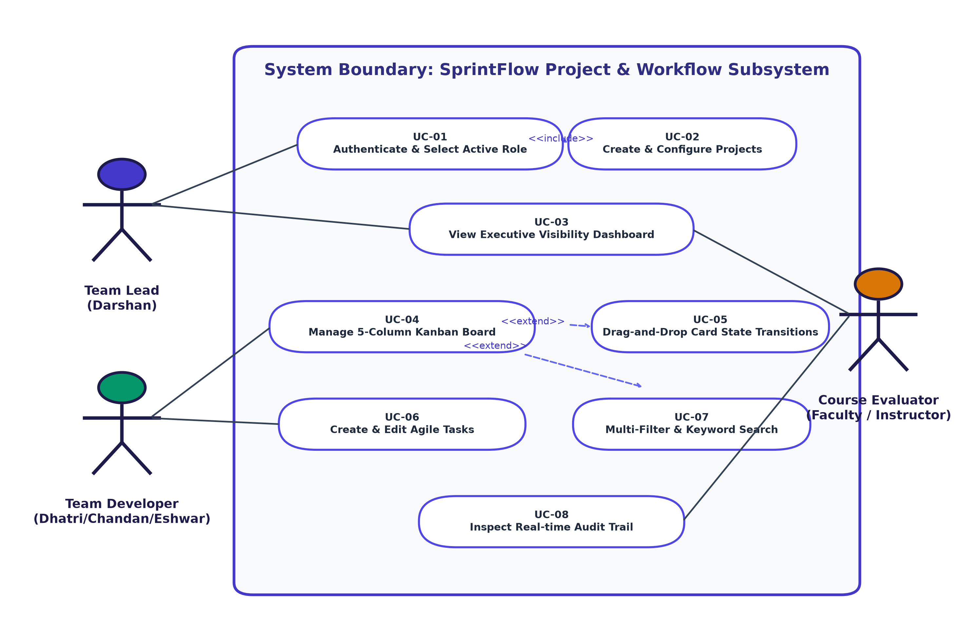
Figure 7.1: UML Use-Case Diagram — Project & Kanban Workflow Subsystem

7.2 UML Use-Case Diagram 2: Sprint Estimation, Cloud Sync & CI/CD
This diagram models Agile iteration planning, Fibonacci estimation, burndown analytics, Supabase cloud sync, and automated CI/CD gating:
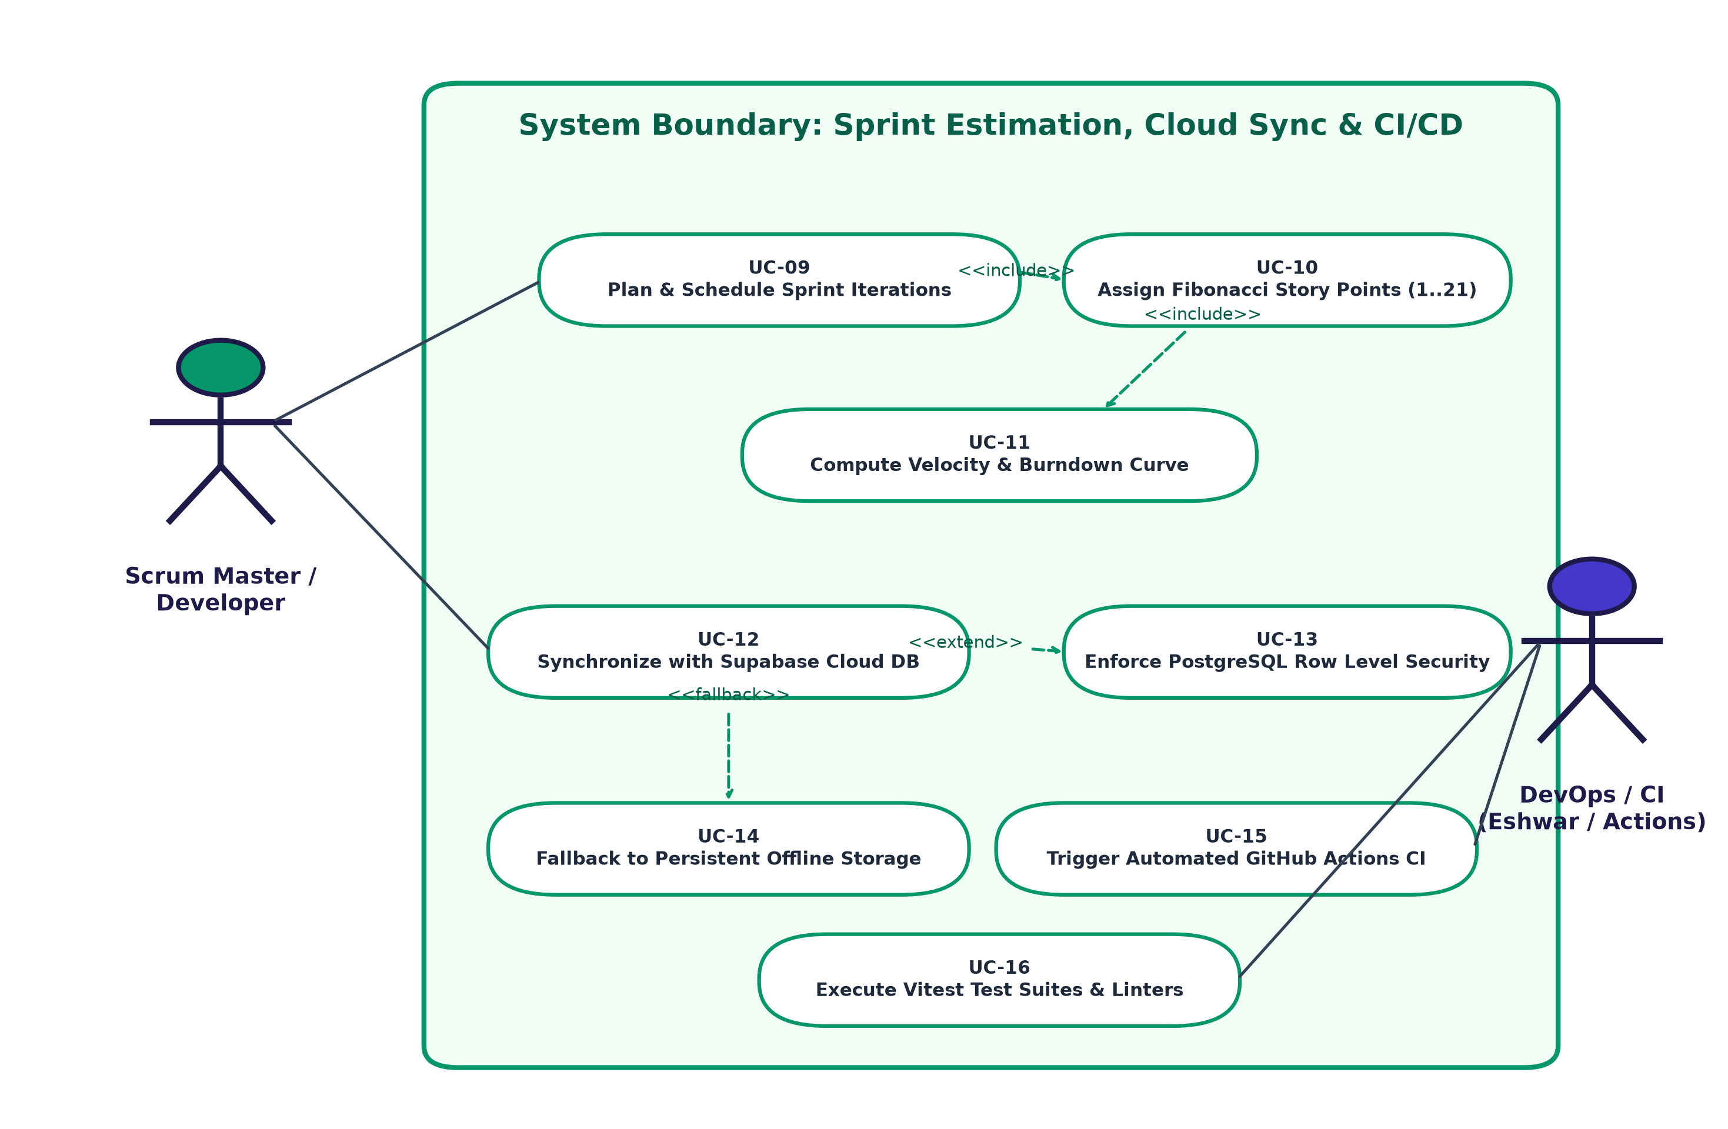
Figure 7.2: UML Use-Case Diagram — Agile Estimation, Cloud Database & CI/CD Subsystem

8. Requirements Traceability Matrix (RTM)
The Requirements Traceability Matrix guarantees complete bidirectional tracing between system requirements, test cases, feature branches, and verification outcomes:
Req ID | Requirement Description | Type | Priority | Test Case Ref | Target Branch | Outcome
PMS-F-001 | User Authentication & Profile Roles | Functional | High | TC-AUTH-01 | feature/darshan-core-auth-dashboard | PASSED
PMS-F-002 | Project Metadata Tracking | Functional | High | TC-PROJ-01 | feature/darshan-core-auth-dashboard | PASSED
PMS-F-003 | 5-Column Kanban Board | Functional | Critical | TC-KAN-01 | feature/dhatri-kanban-workflow | PASSED
PMS-F-004 | HTML5 Drag-and-Drop Card State | Functional | Critical | TC-KAN-02 | feature/dhatri-kanban-workflow | PASSED
PMS-F-005 | 1-Click Step Quick Advancement | Functional | Medium | TC-KAN-03 | feature/dhatri-kanban-workflow | PASSED
PMS-F-006 | Task Modal Creation & Edit CRUD | Functional | High | TC-TASK-01 | feature/dhatri-kanban-workflow | PASSED
PMS-F-007 | Categorization Labels & Tags | Functional | Medium | TC-TASK-02 | feature/dhatri-kanban-workflow | PASSED
PMS-F-008 | Fibonacci Story Point Estimation | Functional | Critical | TC-EST-01 | feature/eshwar-sprint-estimation-cicd | PASSED
PMS-F-009 | Sprint Velocity & Progress Math | Functional | High | TC-EST-02 | feature/eshwar-sprint-estimation-cicd | PASSED
PMS-F-010 | Sprint Lifecycle Scheduling | Functional | High | TC-SPR-01 | feature/eshwar-sprint-estimation-cicd | PASSED
PMS-F-011 | SVG Burndown Velocity Curve | Functional | High | TC-BURN-01 | feature/eshwar-sprint-estimation-cicd | PASSED
PMS-F-012 | Executive Visibility KPI Widgets | Functional | High | TC-DASH-01 | feature/darshan-core-auth-dashboard | PASSED
PMS-F-013 | Team Workload & Capacity Balancing | Functional | Medium | TC-WORK-01 | feature/darshan-core-auth-dashboard | PASSED
PMS-F-014 | Audit Trail & Activity Logging | Functional | High | TC-LOG-01 | feature/chandan-supabase-backend-api | PASSED
PMS-F-015 | Supabase Cloud PostgreSQL Sync | Functional | Critical | TC-SUPA-01 | feature/chandan-supabase-backend-api | PASSED
PMS-F-016 | Zero-Config Offline Fallback | Functional | High | TC-OFF-01 | feature/chandan-supabase-backend-api | PASSED
PMS-F-017 | Multi-Filter & Keyword Search | Functional | Medium | TC-FILT-01 | feature/dhatri-kanban-workflow | PASSED
PMS-F-018 | Automated GitHub Actions CI/CD | Functional | High | TC-CICD-01 | feature/eshwar-sprint-estimation-cicd | PASSED

9. Git Branching Strategy & Team Collaboration Record
As instructed in the Git & GitHub Beginners Guide provided by the department, Team 11 adhered to a structured feature branch workflow:
Member Name | USN | Dedicated Git Feature Branch | Individual Commits & Deliverables | PR Status
Darshan P Pawar | PES2UG24CS143 | feature/darshan-core-auth-dashboard | App shell, Auth Context, Dashboard KPIs, SRS Document | Merged to main
DHATRI SHIVAPRASAD | PES2UG24CS158 | feature/dhatri-kanban-workflow | Kanban board UI, HTML5 drag-and-drop, Task modal CRUD | Merged to main
CHANDAN KUMAR K | PES2UG24CS128 | feature/chandan-supabase-backend-api | Supabase PostgreSQL schema, RLS policies, DataService | Merged to main
GURUBELLI YEKAMBAR ESHWAR RAO | PES2UG24CS173 | feature/eshwar-sprint-estimation-cicd | Fibonacci estimation, Burndown chart, CI/CD, Vitest tests | Merged to main

