Linus

Terminal

1. First program in terminal









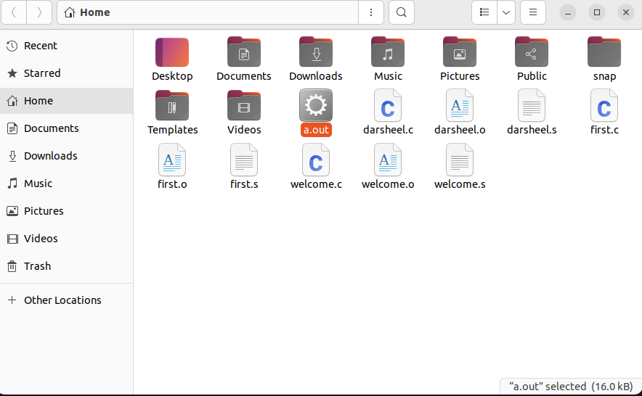

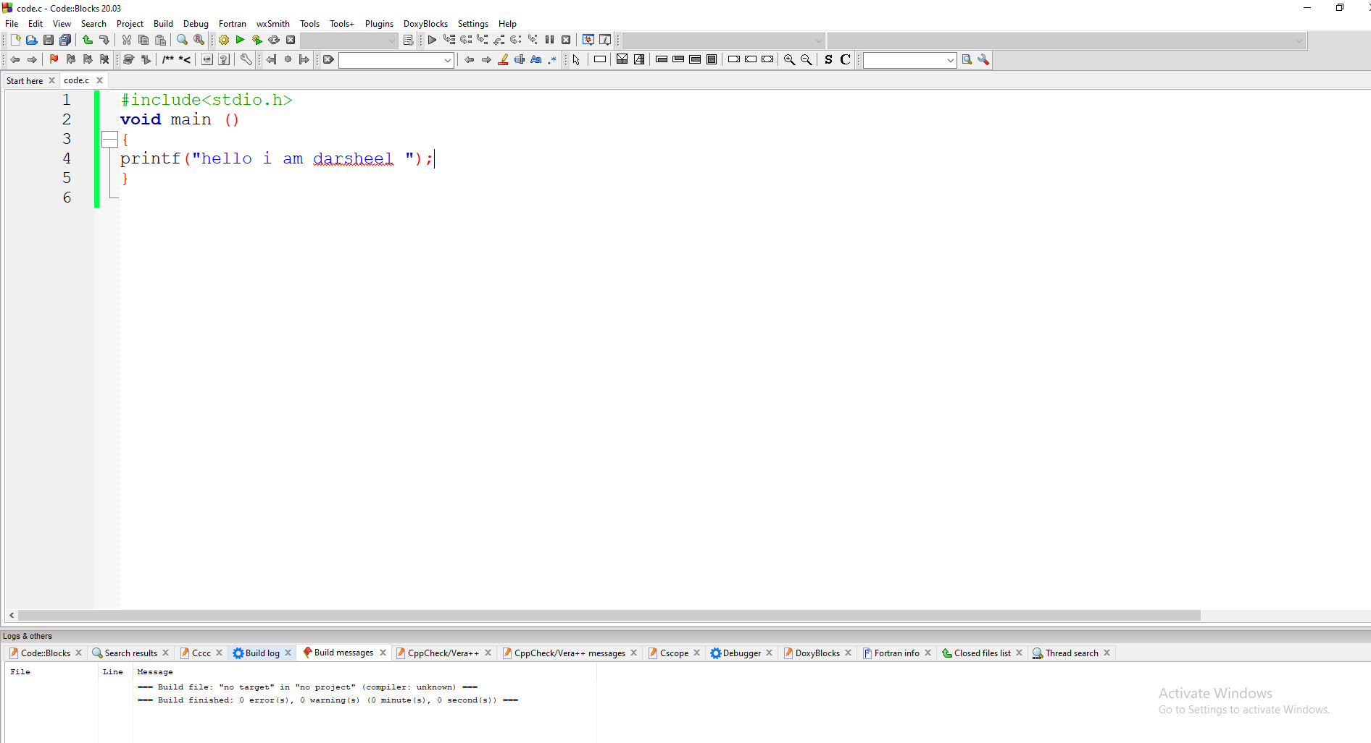

Output of above program

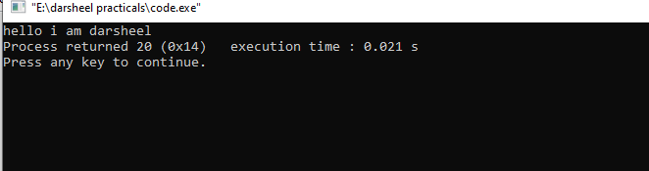

Turbo c

1 code of turbo c

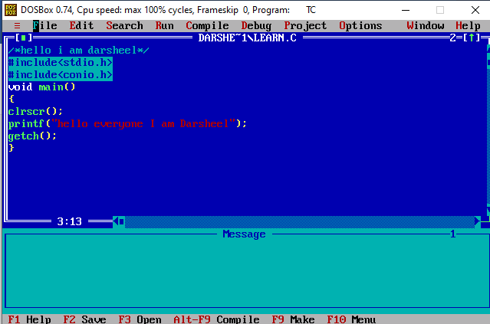

Output of turbo 1 program

