**Practical 4 code**

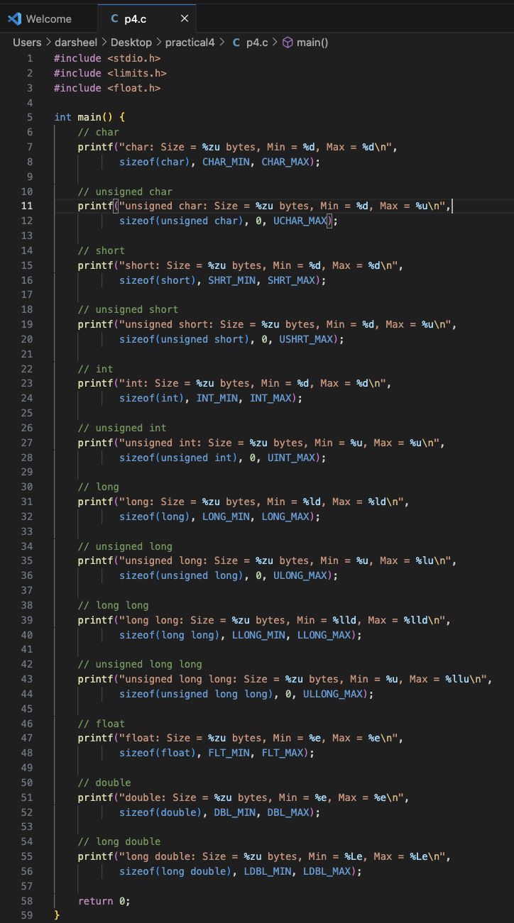

**Output of code**

