**AlexNet**

Training loss –

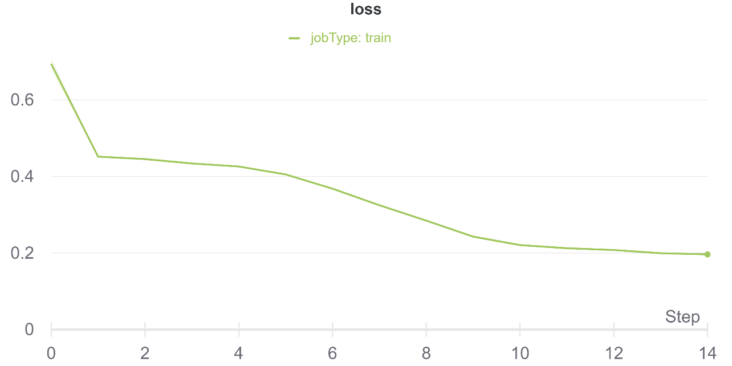

Training F1 score –

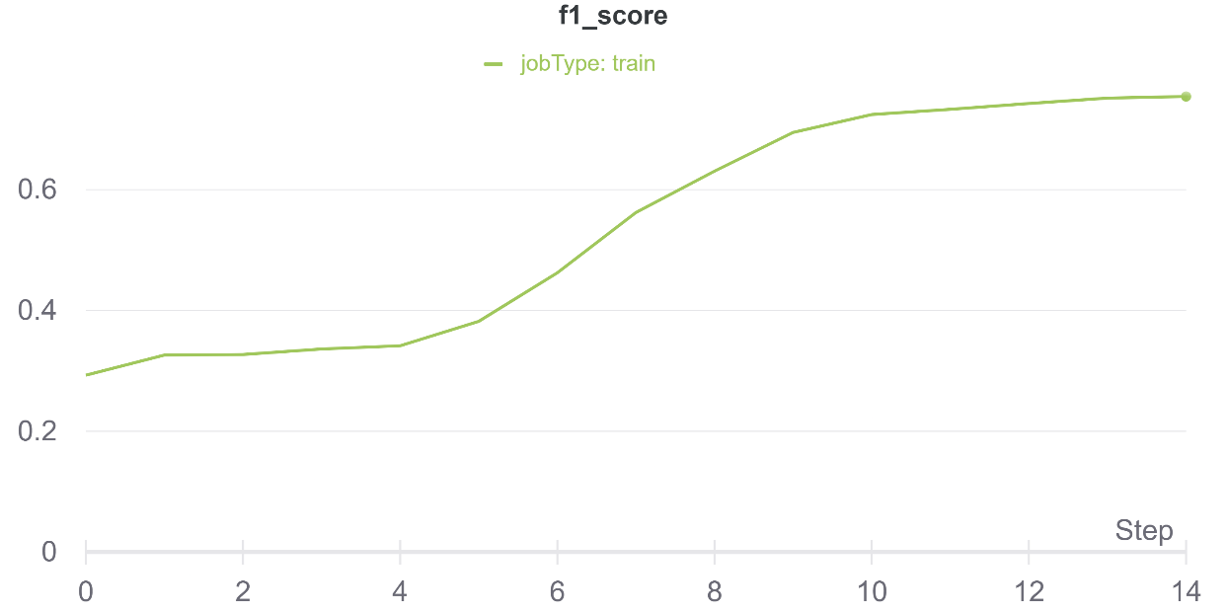

Validation loss –

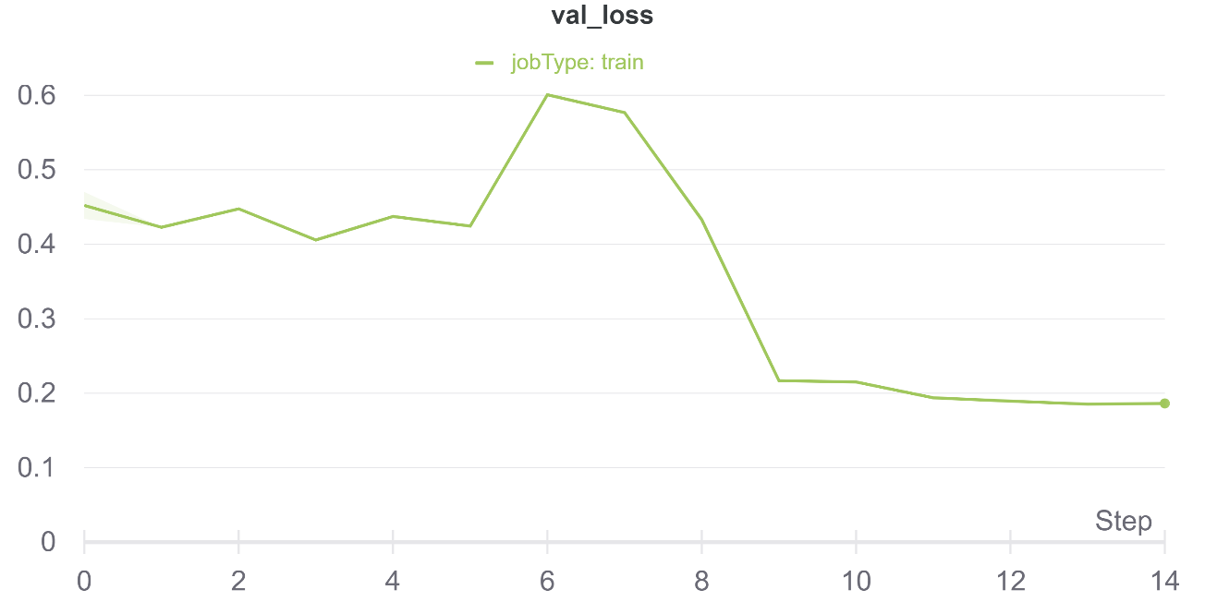

Validation F1 score –

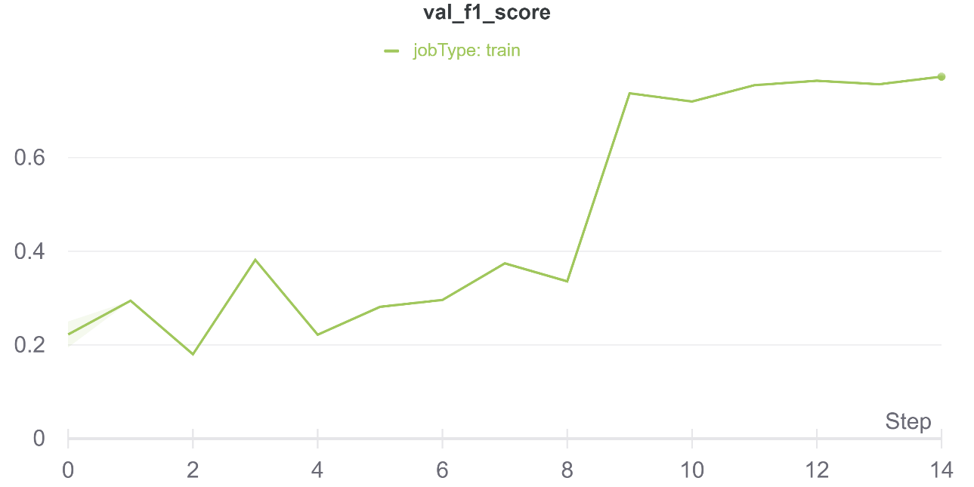

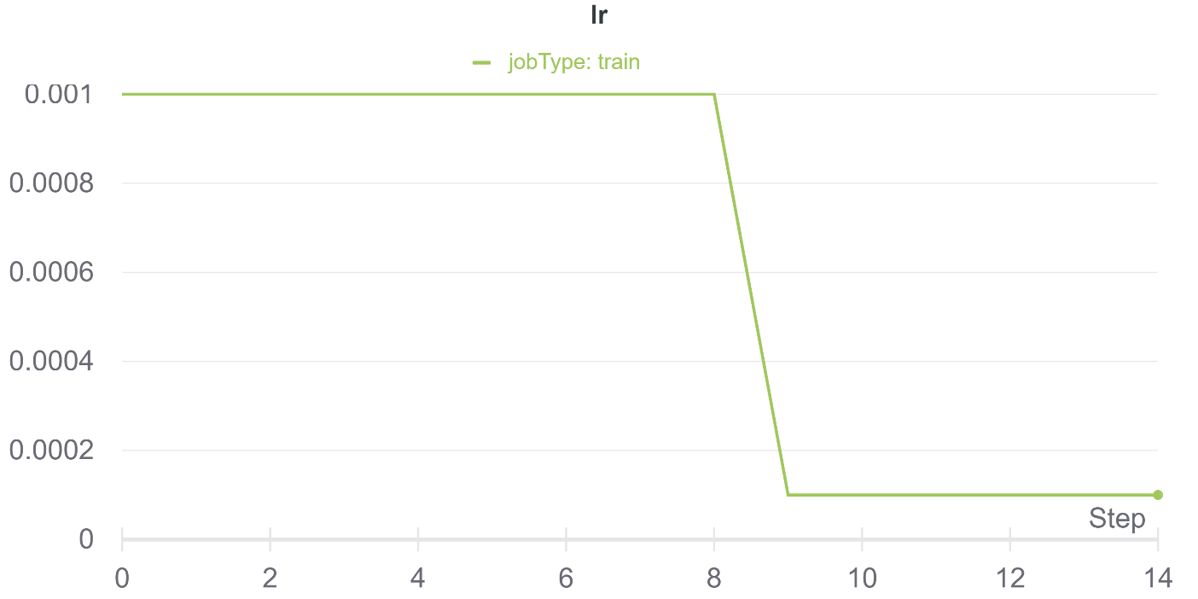Learning Rate –

**EfficientNetB7**

Training loss –

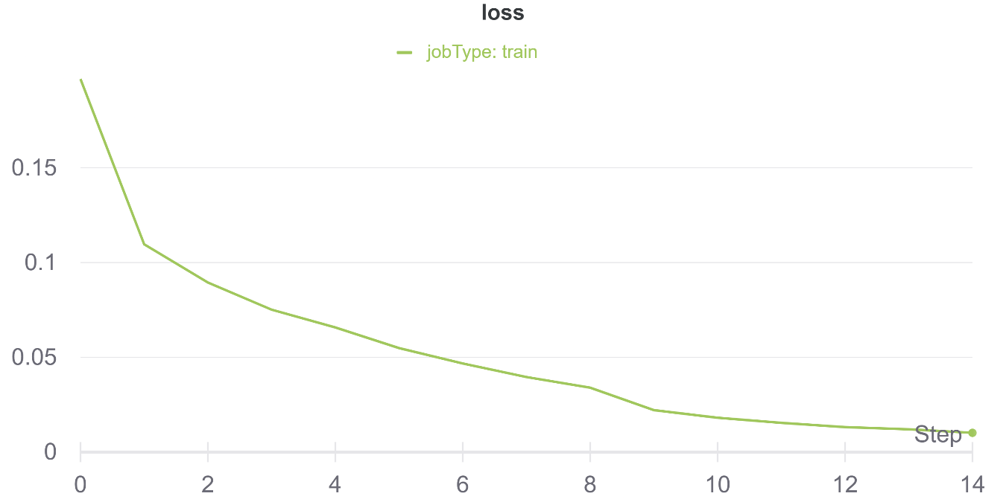

Training F1 score –

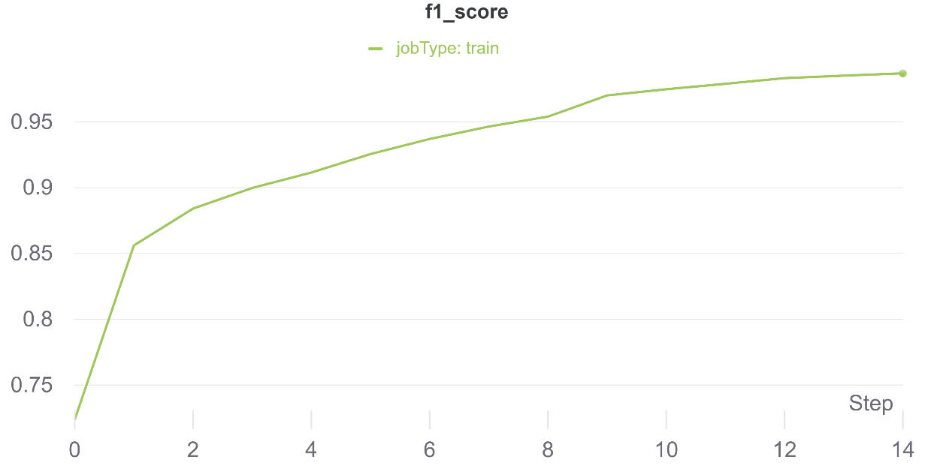

Validation loss –

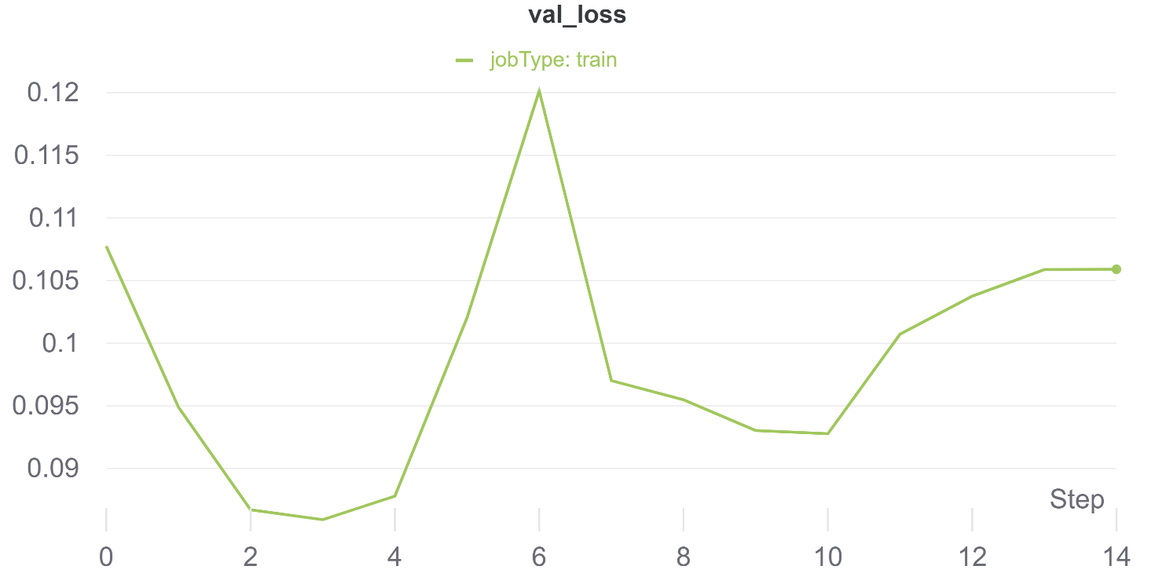

Validation F1 score –

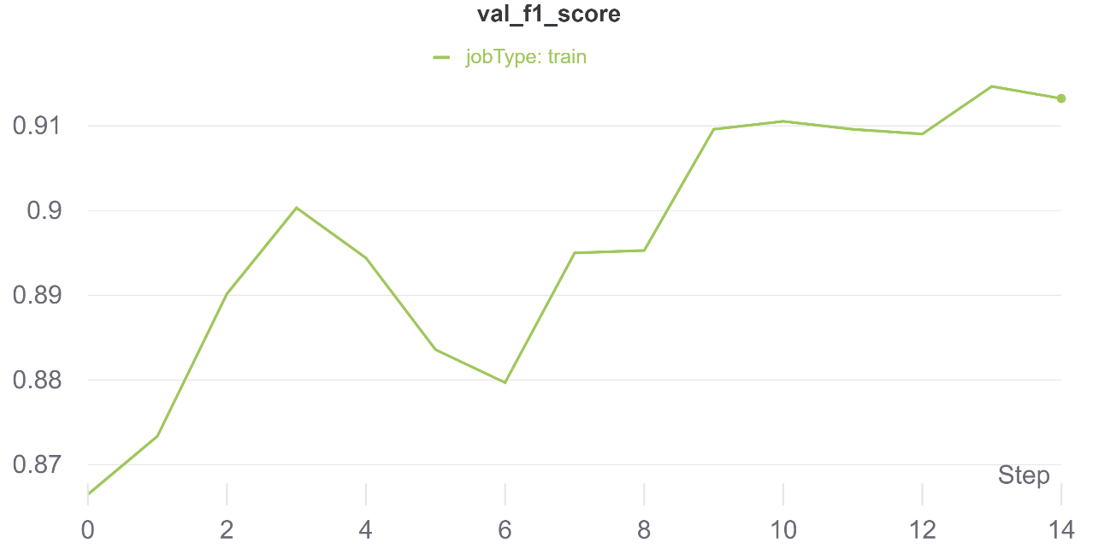

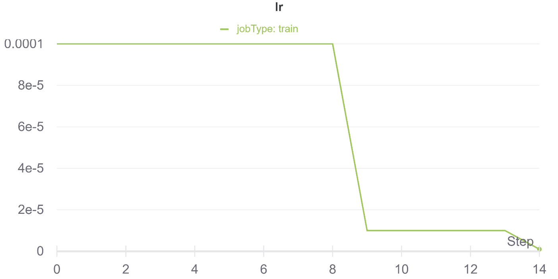Learning Rate –

**Training F1 score –**

1. AlexNet – 74.91%
2. EfficientNetB7 – 98.57%

**Validation F1 score –**

1. AlexNet – 77.32%
2. EfficientNetB7 – 91.32%