1. **Explain different type of Network Topologies.**
   1. **Bus topology**

Bus Topology is a network type in which every computer and network device is connected to a single cable. It is bi-directional. It is a multi-point connection and a non-robust topology because if the backbone fails the topology crashes.

In Bus Topology, various MAC (Media Access Control) protocols are followed by LAN Ethernet connections like TDMA, Pure Aloha, CDMA, Slotted Aloha, etc.

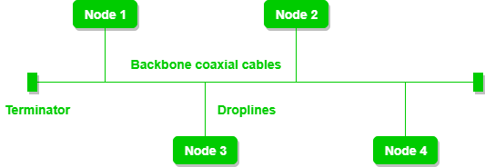

* 1. **Ring topology**

In ring topology, each host machine connects to exactly two other machines, creating a circular network structure. When one host tries to communicate or send message to a host which is not adjacent to it, the data travels through all intermediate hosts.

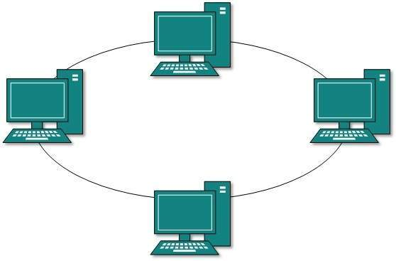

* 1. **Star topology**

In Star Topology, all the devices are connected to a single hub through a cable. This hub is the central node and all other nodes are connected to the central node.

It is Robust. If one link fails only that link will be affected and not other than that link.

Easy to fault identification and fault isolation.

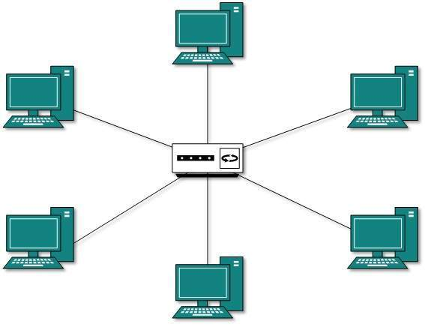

* 1. **Tree topology**

Also known as Hierarchical Topology, This topology imitates as extended Star topology and inherits properties of bus topology.

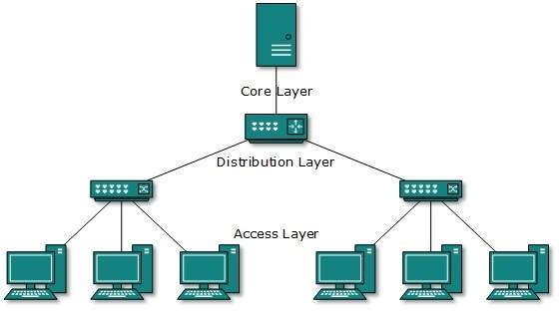

* 1. **Hybrid topology**

A network structure whose design contains more than one topology is said to be hybrid topology. Hybrid topology inherits merits and demerits of all the incorporating topologies.

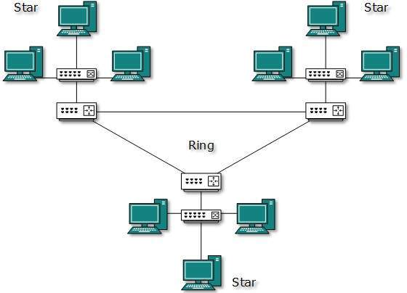

* 1. **Mesh topology**

In a mesh topology, every device is connected to another device via a particular channel. In Mesh Topology, the protocols used are AHCP (Ad Hoc Configuration Protocols), DHCP (Dynamic Host Configuration Protocol), etc.

Communication is very fast between the nodes.

The fault is diagnosed easily.

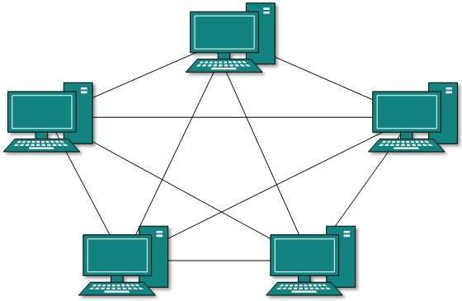

1. **Explain basic Network administrative command and protocol.**

**1. PING (Packet Internet Groper):**

**- Command**: Ping is a command used to test the reachability of a host on an Internet Protocol (IP) network. It sends ICMP (Internet Control Message Protocol) echo request packets to the target host and waits for an echo reply.

**- Purpose**: Ping is commonly used to check if a remote host is online and measure network latency. It's a simple and effective troubleshooting tool.

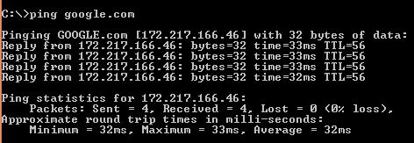

**2. IPCONFIG (IP Configuration):**

**-** **Command**: IPCONFIG (Windows) or IFCONFIG (Linux/Unix) is used to display the configuration of network interfaces on a computer. It provides information about the IP address, subnet mask, and other network-related settings.

**- Purpose**: IPCONFIG is used to diagnose network issues, configure network settings, and obtain information about a computer's network configuration.

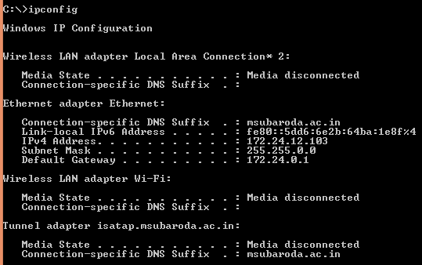

**IPCONFIG /ALL**

Provide all the detail of configuration of network interface on a computer.

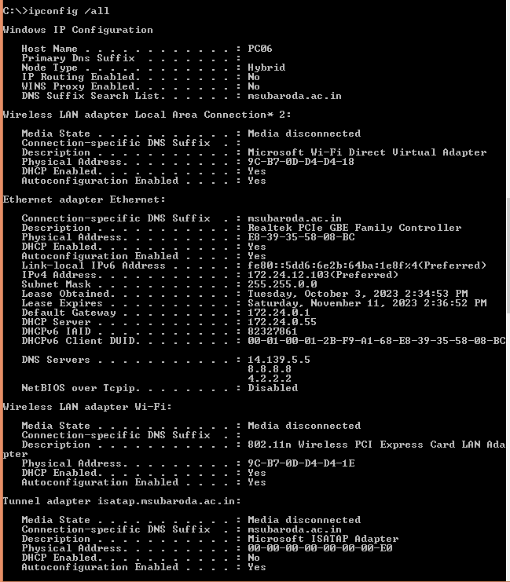

**3. TRACEROUTE/TRACERTE:**

**- Command**: Traceroute (Unix/Linux) or Tracert (Windows) is a command used to trace the route that data packets take from the source to a destination. It displays a list of all the routers (hops) that the packets traverse.

**- Purpose**: Traceroute helps diagnose network routing issues, identify bottlenecks, and troubleshoot slow network connections by showing the path and response times of data packets.

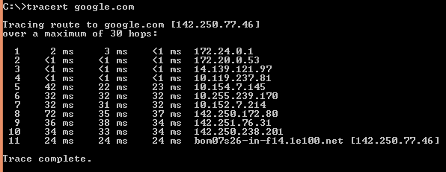

**4. NSLOOKUP (Name Server Lookup):**

**- Command**: NSLOOKUP is a command-line tool used to query Domain Name System (DNS) servers for information about domain names, IP addresses, and other DNS-related data.

**- Purpose**: NSLOOKUP is essential for troubleshooting DNS problems, verifying DNS records, and obtaining information about domain name resolutions.

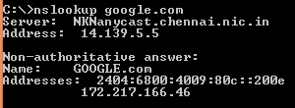

**5. TELNET:**

**- Protocol**: Telnet is a network protocol that allows remote access to and control of other computers over a network. It operates on port 23 and transmits data in plain text.

**- Purpose**: Telnet is used for remote administration and device configuration but is considered insecure for modern use due to its lack of encryption.

**6. SSH (Secure Shell):**

**- Protocol**: SSH is a secure network protocol that allows secure remote access and secure file transfers over an unsecured network. It operates on port 22 and encrypts data for secure communication.

**- Purpose**: SSH is widely used for secure remote administration, secure file transfers, and secure tunneling, making it a safer alternative to Telnet for remote access.

1. **Write a program in C to perform bit stuffing.**

#include <stdio.h>

#include <string.h>

void getStuffedBits(char bit[]){

int c=0;

int i;

int j=0;

char newBit[100];

for(i=0;bit[i]!='\0';i++){

if(bit[i]=='0'){

newBit[j]='0';

c=0;

j++;

}

else{

newBit[j]='1';

c++;

j++;

if(c==5){

newBit[j]='0';

c=0;

j++;

}

}

}

newBit[j]='\0';

strcpy(bit,newBit);

}

void getDestuffedBits(char bit[]){

int c=0,j=0;

int i;

int len=strlen(bit);

char newBit[100];

for(i=0;i<len;i++,j++){

if(bit[i]=='0'){

newBit[j]='0';

c=0;

}

else{

newBit[j]='1';

c++;

if(c==5){

i++;

c=0;

}

}

}

newBit[j]='\0';

strcpy(bit,newBit);

}

int main()

{

int i;

char bits[]="010111110101111001011111";

clrscr();

printf("Bits Before stuffing:\n");

printf("%s\n",bits);

getStuffedBits(bits);

printf("Bits after stuffing:\n");

printf("%s\n",bits);

getDestuffedBits(bits);

printf("Bits after destuffing:\n");

puts(bits);

getch();

return 0;

}