November 11, 2023

Darshil Solanki

data structure and algorithms

assignment

Certificate

This is to certify that DARSHILKUMAR MANSUKHBHAI SOLANKI of MCA SEM-1 with PRN NO: 8023057262 has successfully completed the DATA STRUCTURE AND ALGORITHMS lab work during academic year 2023-24.

Date of Completion: 04/11/2023

Signature of HOD Signature of Professor

Table of Contents

1. Introduction to array. Create an array to perform the following operation. 3

2. Introduction to string. Perform the following operation on string. 4

3. Implement a program for stack that performs following operations using arrays. 6

4. Implement a program to convert infix notation to postfix notation using stack. 9

5. Write a program to implement Queue using arrays that performs following operations. 11

6. Write a program to implement Circular Queue using arrays that performs following operations. 13

7. Write a menu driven program to implement following operations on the singly linked list. 15

8. Write a program to implement following operations on the doubly linked list. 21

9. Write a program to create a Binary search tree. 25

10. Implement recursive and non-recursive tree traversing methods in-order,pre-order and post-order traversal. 26

11. Implement AVL tree. 28

12. Implement heap sort. 32

13. Create an one dimensional array with values 22,4,67,34,12,87,89,26,56,9. Perform the following sorting operation on an array to sort the data in ascending order. 34

14. Write a program to implement Binary Search. 37

15. Write a C program to implement DFS traversal using Adjacency Matrix in a Graph. 38

1. Introduction to array. Create an array to perform the following operation.

1. Find the second largest element in the array.

#include <stdio.h>

int main() {

intarr[]={12,33,34,67,7,89,56},i,j,temp,n;

clrscr();

n=sizeof(arr)/sizeof(arr[0]);

for(i=0;i<7;i++){

for(j=1;j<=n-i-1;j++){

if(arr[j-1]>arr[j]){

temp=arr[j-1];

arr[j-1]=arr[j];

arr[j =temp;

}

}

}

printf("Second Largest is : %d",arr[n-2]);

getch()

return 0;

}

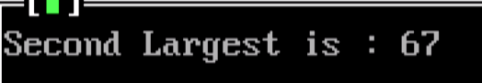

1. Reverse the array elements.

#include <stdio.h>

void arrrev(intarr[],intrevarr[],int n){

inti,j;

j=0;

for(i=n-1;i>=0;i--){

revarr[j]=arr[i];

j++;

}

}

int main() {

int arr[]={12,33,34,67,7,89,56},i,n;

clrscr();

n=sizeof(arr)/sizeof(arr[0]);

int revarr[n];

arrrev(arr,revarr,n);

for(i=0;i<n;i++){

printf("%d ",revarr[i]);

}

getch();

return 0;

}

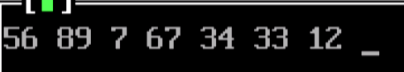

2. Introduction to string. Perform the following operation on string.

(a) Check if the string is palindrome.

#include<stdio.h>

#include<string.h>

int isPalindrome(char n[],int len){

int j=len-1,i;

int flag=1;

for(i=0;i<len/2;i++){

if(n[i]!=n[j]){

flag=0;

break;

}

j--;

}

return flag;

}

void main()

{

char name[20];

clrscr();

printf("Enter a name:");

gets(name);

printf("String Palindrome status is: %d",isPalindrome(name,strlen(name)));

getch();

}

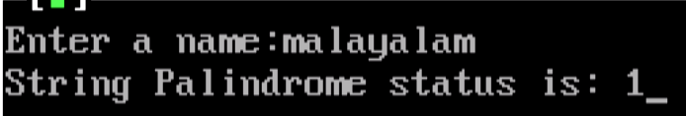

(b) Convert string into uppercase & lowercase.

#include<stdio.h>

#include<string.h>

void uppLow(char name[]){

int i,ichar;

char upper[50],lower[50];

for(i=0;i<strlen(name);i++){

ichar=(int)name[i];

if(ichar>64 &&ichar<91){

upper[i]=name[i];

lower[i]=(char)ichar+32;

}

else if(ichar>96 &&ichar<123){

lower[i]=name[i];

upper[i]=(char)ichar-32;

}

else{

lower[i]=upper[i]=name[i];

}

}

upper[i]=lower[i]='\0';

printf("Name in Uppercase: %s",upper);

printf("Name in Lowercase: %s",lower);

}

void main()

{

char name[20];

clrscr();

printf("Enter a name:");

gets(name);

uppLow(name);

getch();

}

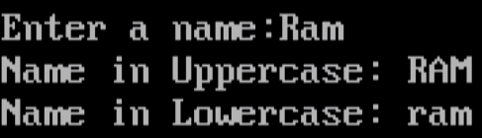

1. Copy one string to another.

#include<stdio.h>

void strcpy(char des[],char source[]){

int i=0;

while(source[i]!='\0'){

des[i]=source[i];

i++;

}

des[i]='\0';

}

void main()

{

char name[20],copyName[20];

clrscr();

printf("Enter a name:");

gets(name);

strcpy(copyName,name);

printf("Copied name: %s",copyName);

getch();

}

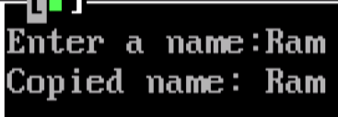

(d) Calculate the length of the string.

#include<stdio.h>

int strlen(char n[]){

int c=0;

while (n[c]!='\0'){

c++;

}

return c;

}

void main()

{

char name[20];

clrscr();

printf("Enter a name:");

gets(name);

printf("length of your name is: %d",strlen(name));

getch();

}

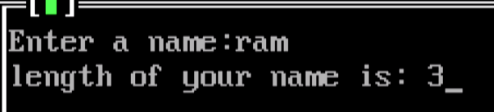

3. Implement a program for stack that performs following operations using arrays.

(a) PUSH (b) POP (c) PEEK (d) DISPLAY

#include <stdio.h>

#define MAX 15

int top=-1;

int stack[MAX];

int isEmpty(){

return top == -1;

}

int isFull(){

return top == MAX-1;

}

int peek(){

if(!isEmpty()){

printf("Peek Element is : %d.\n",stack[top]);

return stack[top];

}

else{

printf("Stack is Empty!!!\n");

return -1;

}

}

void push(){

if(!isFull()){

int data;

printf("Enter data:");

scanf("%d",&data);

stack[++top]=data;

printf("Inserted Successfully.\n");

}

else

printf("Stack is Full(overflow)!!!\n");

}

int pop(){

if(!isEmpty()){

printf("%d Deleted Successfully.\n",stack[top]);

return stack[top--];

}

else{

printf("Stack is Empty(underflow)!!!\n");

return -1;

}

}

void printStack(){

if(!isEmpty()){

int temp=top;

for(;temp>=0;temp--){

printf("%d ",stack[temp]);

}

}

else

printf("Stack is Empty!!!");

printf("\n");

}

void main(){

int data;

int choice;

while(1){

printf("Enter your choice:\n");

printf("1 : Peek Element.\n");

printf("2 : Push Operation.\n");

printf("3 : Pop Operation.\n");

printf("4 : Print Stack.\n");

printf("5 : Exit.\n");

scanf("%d",&choice);

clrscr();

switch(choice){

case 1:

peek();

break;

case 2:

push();

break;

case 3:

pop();

break;

case 4:

printStack();

break;

case 5:

exit(0);

default:

printf("Invalid Choice!!!\n");

getch();

exit(0);

}

}

}

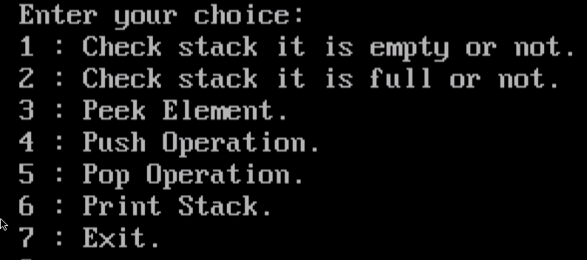

4. Implement a program to convert infix notation to postfix notation using stack.

#include <stdio.h>

#include <string.h>

#define MAX 15

int top=-1;

char stack[MAX];

int isEmpty(){

return top == -1;

}

int isFull(){

return top == MAX-1;

}

void push(char item){

if(!isFull())

stack[++top]=item;

}

char pop(){

if(!isEmpty())

return stack[top--];

}

char peek(){

return stack[top];

}

int precedence(char item){

switch(item){

case '+':

case '-':

return 1;

case '*':

case '/':

case '%':

return 2;

case '^':

return 3;

}

return -1;

}

void infixToPostfix(char exp[]){

char prefix[100];

int i=0,j=-1;

while(exp[i]!='\0'){

if((exp[i]>='A' && exp[i]<='Z') || (exp[i]>='a' && exp[i]<='z'))

prefix[++j]=exp[i];

else if('('==exp[i])

push(exp[i]);

else if(')'==exp[i]){

while(!isEmpty() && '('!=peek())

prefix[++j]=pop();

pop(); //remove left bracket

}

else{ // if an opertor

while (!isEmpty() && precedence(exp[i]) <= precedence(peek()) ){

if(precedence(peek())==precedence(exp[i])==3)

break;

prefix[++j] = pop();

}

push(exp[i]);

}

i++;

}

while(!isEmpty())

prefix[++j] = pop();

prefix[++j]='\0';

strcpy(exp,prefix);

}

void main(){

int i;

char exp[]="A^B*C/(D*E-F)";

clrscr();

printf("Infix Expression:\n");

printf("%s\n",exp);

infixToPostfix(exp);

printf("Postfix Expression:\n");

printf("%s\n",exp);

getch();

}

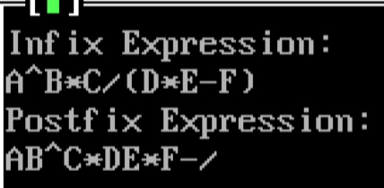

5. Write a program to implement Queue using arrays that performs following operations.

(a) INSERT (b) DELETE (c) DISPLAY

#include <stdio.h>

#define MAX 15

int front=-1;

int rear=-1;

int queue[MAX];

int isEmpty(){

return front == -1;

}

int isFull(){

return rear==(MAX-1);

}

void enqueue(){

if(!isFull()){

int data;

printf("Enter data:");

scanf("%d",&data);

if(isEmpty()){

front++;

queue[++rear]=data;

}

else{

queue[++rear]=data;

}

printf("Inserted Successfully.\n");

}

else

printf("Queue is Full!!!\n");

}

int dequeue(){

if(!isEmpty()){

printf("%d Deleted Successfully.\n",queue[front]);

if(front==rear){

int temp=front;

front=rear=-1;

return queue[temp];

}

else

return queue[front++];

}

else{

printf("Queue is Empty!!!\n");

return -1;

}

}

void printQueue(){

if(!isEmpty()){

int temp=front;

for(;temp<=rear;temp++){

printf("%d ",queue[temp]);

}

}

else

printf("Queue is Empty!!!");

printf("\n");

}

void main(){

int data;

int choice;

while(1){

printf("Enter your choice:\n");

printf("1 : Enqueue Operation.\n");

printf("2 : Dequeue Operation.\n");

printf("3 : Print Queue.\n");

printf(“4 : Exit.\n”);

scanf("%d",&choice);

clrscr();

switch(choice){

case 1:

enqueue();

break;

case 2:

dequeue();

break;

case 3:

printQueue();

break;

case 4:

exit(0);

default:

printf("Invalid Choice!!!\n");

getch();

exit(0);

}

}

}

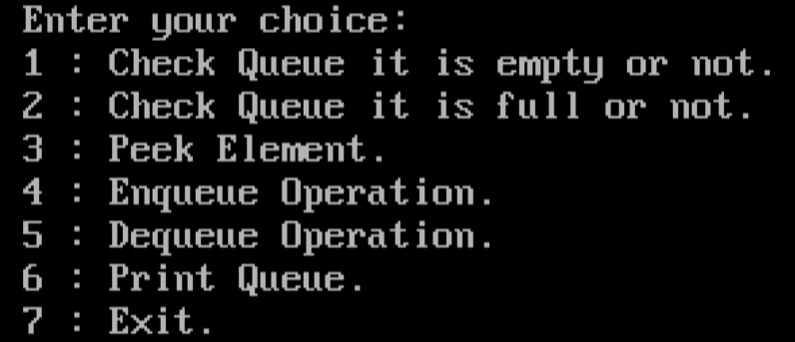

6. Write a program to implement Circular Queue using arrays thatperforms following operations.

(a) INSERT(b) DELETE(c) DISPLAY

#include <stdio.h>

#define MAX 15

int front=-1;

int rear=-1;

int queue[MAX];

int isEmpty(){

if(front==-1){

printf("Queue is Empty!!!\n");

return 1;

}

else

return 0;

}

int isFull(){

if((rear+1)%MAX==front){

printf("Queue is Full!!!\n");

return 1;

}

else

return 0;

}

void enqueue(){

if(!isFull()){

int data;

printf("Enter data:");

scanf("%d",&data);

if(isEmpty()){

front++;

queue[++rear]=data;

}

else{

rear=(rear+1)%MAX;

queue[rear]=data;

}

printf("Inserted Successfully.\n");

}

}

int dequeue(){

if(!isEmpty()){

int temp=front;

printf("%d Deleted Successfully.\n",queue[front]);

if(front==rear){

front=rear=-1;

return queue[temp];

}

else{

front=(front+1)%MAX;

return queue[temp];

}

}

else

return -1;

}

void printQueue(){

if(!isEmpty()){

int temp=front;

while(temp!=rear){

printf("%d ",queue[temp]);

temp=(temp+1)%MAX;

}

printf("%d ",queue[temp]);

}

printf("\n");

}

void main(){

int data;

int choice;

while(1){

printf("Enter your choice:\n");

printf("1 : Enqueue Operation.\n");

printf("2 : Dequeue Operation.\n");

printf("3 : Print Queue.\n");

printf("4 : Exit.\n");

scanf("%d",&choice);

clrscr();

switch(choice){

case 1:

enqueue();

break;

case 2:

dequeue();

break;

case 3:

printQueue();

break;

case 4:

exit(0);

default:

printf("Invalid Choice!!!\n");

getch();

exit(0);

}

}

}



7. Write a menu driven program to implement following operationson the singly linked list.

(a) Insert a node at the front of the linked list.

(b) Insert a node at the end of the linked list.

(c) Insert a node such that the linked list is in ascending order.

(d) Delete the First node of the linked list.

(e) Delete a node before specified position.

(f) Delete a node after specified position.

#include <stdio.h>

#include <stdlib.h>

struct list{

int data;

struct list *next;

}*head;

void insInEmpty(int data){

head = (struct list *)malloc(sizeof(struct list));

head->data=data;

head->next=NULL;

printf("Inserted successfully.\n");

}

void insAtBeg(int data){

if(isEmpty()){

insInEmpty(data);

}

else{

struct list *temp=(struct list *)malloc(sizeof(struct list));

temp->data=data;

temp->next=head;

head=temp;

printf("Inserted successfully.\n");

}

}

void insAtEnd(int data){

if(isEmpty()){

insInEmpty(data);

}

else{

struct list *temp=(struct list *)malloc(sizeof(struct list));

struct list *temp1=(struct list *)malloc(sizeof(struct list));

temp=head;

while(temp->next!=NULL)

temp=temp->next;

temp1->data=data;

temp1->next=NULL;

temp->next=temp1;

printf("Inserted successfully.\n");

}

}

void insAtPos(int pos,int data){

if(pos==1)

insAtBeg(data);

else{

int c=1;

struct list *tempData=(struct list *)malloc(sizeof(struct list));

struct list *temp=(struct list *)malloc(sizeof(struct list));

struct list *prev=(struct list *)malloc(sizeof(struct list));

tempData->data=data;

temp=head;

while(temp!=NULL){

prev=temp;

temp=temp->next;

c++;

if(c==pos)

break;

}

tempData->next=(temp!=NULL?temp:NULL);

prev->next=tempData;

printf("Inserted successfully.\n");

}

}

void delAtBeg(){

if(isEmpty())

printf("List is empty!!!\n");

else{

struct list *temp=(struct list *)malloc(sizeof(struct list));

if(head->next==NULL){

printf("%d Deleted successfully\n",head->data);

free(head);

head=NULL;

}

else{

temp=head;

head=head->next;

printf("%d Deleted successfully\n",temp->data);

free(temp);

temp=NULL;

}

}

}

void delAtEnd(){

if(isEmpty())

printf("List is empty!!!\n");

else{

struct list *temp=(struct list *)malloc(sizeof(struct list));

struct list *prev=(struct list *)malloc(sizeof(struct list));

if(head->next==NULL){

printf("%d Deleted successfully\n",head->data);

free(head);

head=NULL;

}

else{

temp=head;

while(temp->next!=NULL){

prev=temp;

temp=temp->next;

}

prev->next=NULL;

printf("%d Deleted successfully\n",temp->data);

free(temp);

temp=NULL;

}

}

}

void delAtPos(int pos){

if(pos==1)

delAtBeg();

else{

int c=1;

struct list *temp=(struct list *)malloc(sizeof(struct list));

struct list *prev=(struct list *)malloc(sizeof(struct list));

temp=head;

while(temp!=NULL && c!=pos){

prev=temp;

temp=temp->next;

c++;

}

if(c==pos){

if(temp->next==NULL)

prev->next=NULL;

else

prev->next=temp->next;

printf("%d Deleted Successfully.\n",temp->data);

free(temp);

temp=NULL;

}

}

}

int count(){

int c=1;

struct list *temp=(struct list *)malloc(sizeof(struct list));

temp=head;

while(temp->next!=NULL){

temp=temp->next;

c++;

}

return c;

}

int isEmpty(){

if(head==NULL)

return 1;

else

return 0;

}

void main(){

int choice,data,pos;

while(1){

printf("Enter your choice:\n");

printf("1 : insert at beg\n");

printf("2 : insert at end\n");

printf("3 : insert at pos\n");

printf("4 : delete at beg\n");

printf("5 : delete at end\n");

printf("6 : delete at pos\n");

printf("7 : Exit\n");

scanf("%d",&choice);

clrscr();

switch(choice){

case 1:

printf("Enter data:");

scanf("%d",&data);

insAtBeg(data);

break;

case 2:

printf("Enter data:");

scanf("%d",&data);

insAtEnd(data);

break;

case 3:

printf("Enter Position:");

scanf("%d",&pos);

if(isEmpty() && pos>1)

printf("List is Empty and Invalid Positon!!!\n");

else if(pos<1 || pos>count()+1)

printf("Invalid position!!!\n");

else{

printf("Enter data:");

scanf("%d",&data);

insAtPos(pos,data);

}

break;

case 4:

delAtBeg();

break;

case 5:

delAtEnd();

break;

case 6:

if(isEmpty())

printf("List is Empty!!!\n");

else{

printf("Enter Position:");

scanf("%d",&pos);

if(pos<1 || pos>count())

printf("Invalid position!!!\n");

else

delAtPos(pos);

}

break;

case 7:

exit(0);

break;

default:

printf("Invalid Choice!!!\n");

getch();

exit(0);

}

}

}

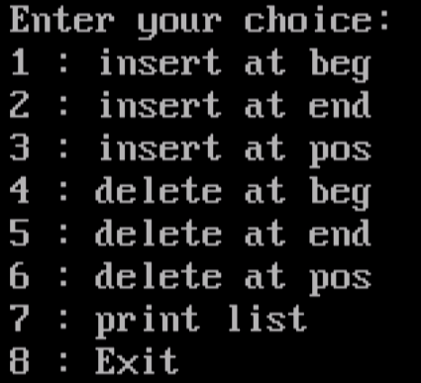

8. Write a program to implement following operations on the doublylinked list.

(a) Insert a node at the front of the linked list.

(b) Insert a node at the end of the linked list.

(c) Delete the last node of the linked list.

(d) Delete a node before specified position.

#include <stdio.h>

#include <stdlib.h>

struct list{

int data;

struct list *prev;

struct list *next;

}*head;

void insInEmpty(int data){

head = (struct list *)malloc(sizeof(struct list));

if(head==NULL)

printf("List is Full!!!(overflow)\n");

else{

head->data=data;

head->prev=NULL;

head->next=NULL;

printf("Inserted successfully.\n");

}

}

void insAtBeg(int data){

if(isEmpty()){

insInEmpty(data);

}

else{

struct list *temp=(struct list *)malloc(sizeof(struct list));

if(temp==NULL)

printf("List is Full!!!(overflow)\n");

else{

temp->data=data;

temp->prev=NULL;

temp->next=head;

head->prev=temp;

head=temp;

printf("Inserted successfully.\n");

}

}

}

void insAtEnd(int data){

if(isEmpty()){

insInEmpty(data);

}

else{

struct list *temp=(struct list *)malloc(sizeof(struct list));

struct list *tempData=(struct list *)malloc(sizeof(struct list));

if(temp==NULL || tempData==NULL)

printf("List is Full!!!(overflow)\n");

else{

temp=head;

while(temp->next!=NULL)

temp=temp->next;

tempData->data=data;

tempData->prev=temp;

tempData->next=NULL;

temp->next=tempData;

printf("Inserted successfully.\n");

}

}

}

void delAtBeg(){

if(isEmpty())

printf("List is empty!!!\n");

else{

struct list *temp=(struct list *)malloc(sizeof(struct list));

if(head->next==NULL){

printf("%d Deleted successfully\n",head->data);

free(head);

head=NULL;

}

else{

temp=head;

head=head->next;

head->prev=NULL;

printf("%d Deleted successfully\n",temp->data);

free(temp);

temp=NULL;

}

}

}

void delAtEnd(){

if(isEmpty())

printf("List is empty!!!\n");

else{

struct list *temp=(struct list *)malloc(sizeof(struct list));

struct list *prev=(struct list *)malloc(sizeof(struct list));

if(head->next==NULL){

printf("%d Deleted successfully\n",head->data);

free(head);

head=NULL;

}

else{

temp=head;

while(temp->next!=NULL){

prev=temp;

temp=temp->next;

}

prev->next=NULL;

printf("%d Deleted successfully\n",temp->data);

free(temp);

temp=NULL;

}

}

}

int isEmpty(){

if(head==NULL)

return 1;

else

return 0;

}

void main(){

int choice,data,pos;

while(1){

printf("Enter your choice:\n");

printf("1 : insert at beg\n");

printf("2 : insert at end\n");

printf("3 : delete at beg\n");

printf("4 : delete at end\n");

printf("5 : Exit\n");

scanf("%d",&choice);

clrscr();

switch(choice){

case 1:

printf("Enter data:");

scanf("%d",&data);

insAtBeg(data);

break;

case 2:

printf("Enter data:");

scanf("%d",&data);

insAtEnd(data);

break;

case 3:

delAtBeg();

break;

case 4:

delAtEnd();

break;

case 5:

exit(0);

default:

printf("Invalid Choice!!!\n");

getch();

exit(0);

}

}

}



9. Write a program to create a Binary search tree.

#include <stdio.h>

#include <stdlib.h>

// Node structure for the Binary Search Tree

struct Node {

int data;

struct Node* left;

struct Node* right;

};

// Function to create a new node

struct Node* createNode(int key) {

struct Node* newNode = (struct Node*)malloc(sizeof(struct Node));

newNode->data = key;

newNode->left = newNode->right = NULL;

return newNode;

}

// Function to insert a new key into BST

struct Node* insert(struct Node* root, int key) {

if (root == NULL)

return createNode(key);

if (key < root->data)

root->left = insert(root->left, key);

else if (key > root->data)

root->right = insert(root->right, key);

else // Duplicate keys not allowed

printf(“Duplicate not allowed!!!\n”);

return root;

}

int main() {

struct Node* root = NULL;

// Inserting keys into the BST

root = insert(root, 50);

insert(root, 30);

insert(root, 20);

insert(root, 40);

insert(root, 70);

insert(root, 60);

insert(root, 80);

return 0;

}

//NO OUTPUT

10. Implement recursive and non-recursive tree traversing methods in-order,pre-order and post-order traversal.

#include <stdio.h>

#include <stdlib.h>

// Node structure for the Binary Search Tree

struct Node {

int data;

struct Node* left;

struct Node* right;

};

// Function to create a new node

struct Node* createNode(int key) {

struct Node* newNode = (struct Node*)malloc(sizeof(struct Node));

newNode->data = key;

newNode->left = newNode->right = NULL;

return newNode;

}

// Function to insert a new key into BST

struct Node* insert(struct Node* root, int key) {

if (root == NULL)

return createNode(key);

if (key < root->data)

root->left = insert(root->left, key);

else if (key > root->data)

root->right = insert(root->right, key);

else // Duplicate keys not allowed

printf(“Duplicate not allowed!!!\n”);

return root;

}

// Function to perform in-order traversal (recursive)

void inOrderRecursive(struct Node* root) {

if (root != NULL) {

inOrderRecursive(root->left);

printf("%d ", root->data);

inOrderRecursive(root->right);

}

}

// Function to perform pre-order traversal (recursive)

void preOrderRecursive(struct Node* root) {

if (root != NULL) {

printf("%d ", root->data);

preOrderRecursive(root->left);

preOrderRecursive(root->right);

}

}

// Function to perform post-order traversal (recursive)

void postOrderRecursive(struct Node* root) {

if (root != NULL) {

postOrderRecursive(root->left);

postOrderRecursive(root->right);

printf("%d ", root->data);

}

}

int main() {

struct Node* root = NULL;

// Inserting keys into the BST

root = insert(root, 50);

insert(root, 30);

insert(root, 20);

insert(root, 40);

insert(root, 70);

insert(root, 60);

insert(root, 80);

// Recursive traversals

printf("In-order (recursive): ");

inOrderRecursive(root);

printf("\n");

printf("Pre-order (recursive): ");

preOrderRecursive(root);

printf("\n");

printf("Post-order (recursive): ");

postOrderRecursive(root);

printf("\n");

return 0;

}

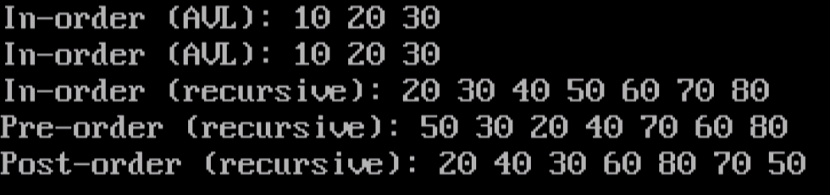

11. Implement AVL tree.

#include <stdio.h>

#include <stdlib.h>

// AVL Tree Node structure (extends Node)

struct AVLNode {

int data;

struct AVLNode* left;

struct AVLNode* right;

int height; // Height of the node

};

// Function to get the height of a node

int height(struct AVLNode* node) {

if (node == NULL)

return 0;

return node->height;

}

// Function to get the maximum of two integers

int max(int a, int b) {

return (a > b) ? a : b;

}

// Function to create a new AVL node

struct AVLNode* createAVLNode(int key) {

struct AVLNode* newNode = (struct AVLNode*)malloc(sizeof(struct AVLNode));

newNode->data = key;

newNode->left = newNode->right = NULL;

newNode->height = 1; // New node is initially at height 1

return newNode;

}

// Function to rotate the subtree rooted with y to the left

struct AVLNode* leftRotate(struct AVLNode* y) {

struct AVLNode* x = y->right;

struct AVLNode* T2 = x->left;

// Perform rotation

x->left = y;

y->right = T2;

// Update heights

y->height = max(height(y->left), height(y->right)) + 1;

x->height = max(height(x->left), height(x->right)) + 1;

return x;

}

// Function to rotate the subtree rooted with x to the right

struct AVLNode* rightRotate(struct AVLNode* x) {

struct AVLNode* y = x->left;

struct AVLNode* T2 = y->right;

// Perform rotation

y->right = x;

x->left = T2;

// Update heights

x->height = max(height(x->left), height(x->right)) + 1;

y->height = max(height(y->left), height(y->right)) + 1;

return y;

}

// Get the balance factor of a node

int getBalance(struct AVLNode* node) {

if (node == NULL)

return 0;

return height(node->left) - height(node->right);

}

// Function to insert a key into AVL tree

struct AVLNode* insertAVL(struct AVLNode* node, int key) {

// Perform normal BST insertion

if (node == NULL)

return createAVLNode(key);

if (key < node->data)

node->left = insertAVL(node->left, key);

else if (key > node->data)

node->right = insertAVL(node->right, key);

else // Duplicate keys not allowed

return node;

// Update height of current node

node->height = 1 + max(height(node->left), height(node->right));

// Get the balance factor to check if this node became unbalanced

int balance = getBalance(node);

// Left Left Case

if (balance > 1 && key < node->left->data)

return rightRotate(node);

// Right Right Case

if (balance < -1 && key > node->right->data)

return leftRotate(node);

// Left Right Case

if (balance > 1 && key > node->left->data) {

node->left = leftRotate(node->left);

return rightRotate(node);

}

// Right Left Case

if (balance < -1 && key < node->right->data) {

node->right = rightRotate(node->right);

return leftRotate(node);

}

return node;

}

// AVL tree in-order traversal (recursive)

void inOrderAVL(struct AVLNode* root) {

if (root != NULL) {

inOrderAVL(root->left);

printf("%d ", root->data);

inOrderAVL(root->right);

}

}

// Driver program for AVL tree

int main() {

struct AVLNode* root = NULL;

// Inserting keys into the AVL tree

root = insertAVL(root, 10);

root = insertAVL(root, 20);

root = insertAVL(root, 30);

// In-order traversal of AVL tree

printf("In-order (AVL): ");

inOrderAVL(root);

printf("\n");

return 0;

}



12. Implement heap sort.

#include <stdio.h>

#include <stdlib.h>

// Function to heapify a subtree rooted with node i which is an index in arr[]

void heapify(int arr[], int n, int i) {

int largest = i; // Initialize largest as root

int left = 2 * i + 1; // Left child

int right = 2 * i + 2; // Right child

// If left child is larger than root

if (left < n && arr[left] > arr[largest])

largest = left;

// If right child is larger than largest so far

if (right < n && arr[right] > arr[largest])

largest = right;

// If largest is not root

if (largest != i) {

// Swap arr[i] and arr[largest]

int temp = arr[i];

arr[i] = arr[largest];

arr[largest] = temp;

// Recursively heapify the affected sub-tree

heapify(arr, n, largest);

}

}

// Function to perform heap sort

void heapSort(int arr[], int n) {

// Build heap (rearrange array)

for (int i = n / 2 - 1; i >= 0; i--)

heapify(arr, n, i);

// One by one extract an element from the heap

for (int i = n - 1; i > 0; i--) {

// Move current root to end

int temp = arr[0];

arr[0] = arr[i];

arr[i] = temp;

// Call max heapify on the reduced heap

heapify(arr, i, 0);

}

}

// Function to print an array

void printArray(int arr[], int n) {

for (int i = 0; i < n; ++i)

printf("%d ", arr[i]);

printf("\n");

}

// Driver program for Heap Sort

int main() {

int arr[] = {12, 11, 13, 5, 6, 7};

int n = sizeof(arr) / sizeof(arr[0]);

printf("Original array: \n");

printArray(arr, n);

// Perform heap sort

heapSort(arr, n);

printf("Sorted array: \n");

printArray(arr, n);

return 0;

}

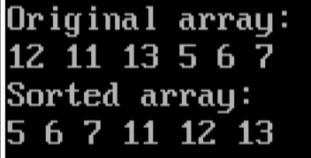

13. Create an one dimensional array with values22,4,67,34,12,87,89,26,56,9. Perform the following sortingoperation on an array to sort the data in ascending order.

(a) Bubble sort

#include <stdio.h>

void bubbleSort(int arr[]){

int i,j,temp;

for(i=0;i<10;i++){

for(j=0;j<9-i;j++){

if(arr[j]>arr[j+1]){

temp=arr[j];

arr[j]=arr[j+1];

arr[j+1]=temp;

}

}

}

}

void main(){

int i,arr[10];

clrscr();

arr={22,4,67,34,12,87,89,2656,9};

bubbleSort(arr);

printf("Sorted array is: ");

for(i=0;i<10;i++){

printf("%d ",arr[i])

}

getch();

}

(b) Insertion

#include <stdio.h>

void insertionSort(int arr[]){

int i,j,key;

for(i=1;i<9;i++){

key=arr[i];

j=i-1;

while(j>=0 &&arr[j]>key){

arr[j+1]=arr[j];

j--;

}

arr[j+1]=key;

}

}

void main(){

int i,arr[10];

clrscr();

arr={22,4,67,34,12,87,89,2656,9};

insertionSort(arr);

printf("Sorted array is: ");

for(i=0;i<10;i++){

printf("%d ",arr[i]);

}

getch();

}

(c) Quick sort

#include <stdio.h>

int partition(int arr[],int beg,int end){

int pivot = arr[beg];

int i= beg+1;

int j=end;

int temp;

do{

while(arr[i]<=pivot){

i++;

}

while(arr[j]>pivot){

j--;

}

if(i<j){

temp=arr[i];

arr[i]=arr[j];

arr[j]=temp;

}

}while(i<j);

temp=arr[beg];

arr[beg]=arr[j];

arr[j]=temp;

return j;

}

void quickSort(int arr[],int beg,int end){

if(beg<end){

int p = partition(arr,beg,end);

quickSort(arr,beg,p-1);

quickSort(arr,p+1,end);

}

}

void main(){

int i,arr[10],n;

clrscr();

arr={22,4,67,34,12,87,89,2656,9};

quickSort(arr,0,9);

printf("Sorted array is: ");

for(i=0;i<10;i++){

printf("%d ",arr[i]);

}

getch();

}

(d) Merge sort

#include <stdio.h>

void merge(int arr[],int beg,intmid,int end){

int l,r,i,temp[10];

for(l=beg,r=mid+1,i=beg; l<=mid && r<=end;i++){

if(arr[l]<=arr[r])

temp[i]=arr[l++];

else

temp[i]=arr[r++];

}

while(l<=mid)

temp[i++]=arr[l++];

while(r<=end)

temp[i++]=arr[r++];

for(i=beg;i<=end;i++)

arr[i]=temp[i];

}

void mergeSort(int arr[],int beg,int end){

int mid;

if(beg<end){

mid=(beg+end)/2;

mergeSort(arr,beg,mid);

mergeSort(arr,mid+1,end);

merge(arr,beg,mid,end);

}

}

void main(){

int i,arr[10],n;

clrscr();

arr={22,4,67,34,12,87,89,2656,9};

mergeSort(arr,0,9);

printf("Sorted array is: ");

for(i=0;i<10;i++){

printf("%d ",arr[i]);

}

getch();

}

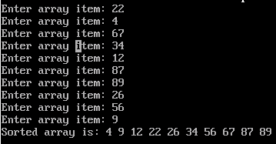

14. Write a program to implement Binary Search.

#include <stdio.h>

int i;

void binarySearch(int arr[],int low,int high){

int mid,temp;

printf("Enter item to search:\n");

scanf("%d",&temp);

while(low<=high){

mid=(low+high)/2;

if(temp==arr[mid]){

printf("found at index %d",mid);

return ;

}

else if(temp<arr[mid])

high=mid-1;

else

low=mid+1;

}

printf("Not found!!!");

}

int main(){

int arr[10];

clrscr();

printf("Enter array item only in sorted manner!!!\n");

for(i=0;i<10;i++){

printf("Enter an item:\n");

scanf("%d",&arr[i]);

}

binarySearch(arr,0,9);

getch();

return 0;

}

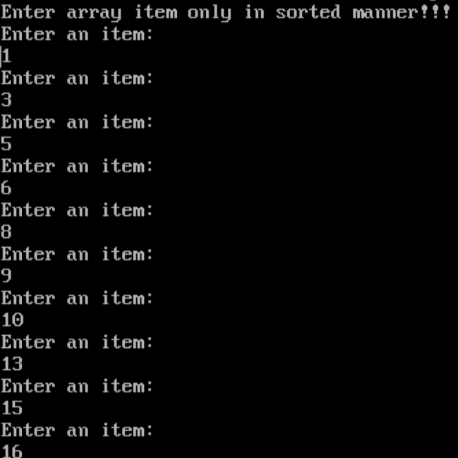 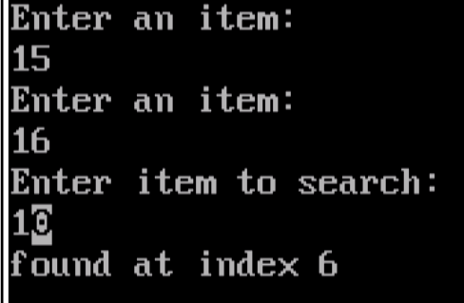

15. Write a C program to implement DFS traversal using AdjacencyMatrix in a Graph.

#include <stdio.h>

#include <stdlib.h>

#define MAX 100

// Function to perform Depth-First Search (DFS) traversal

void dfs(int matrix[MAX][MAX], int visited[MAX], int n, int current) {

int i;

printf("%d ", current);

visited[current] = 1;

for (i = 0; i < n; i++) {

if (matrix[current][i] == 1 && !visited[i]) {

dfs(matrix, visited, n, i);

}

}

}

// Function to initialize the adjacency matrix

void initializeMatrix(int matrix[MAX][MAX], int n) {

int i,j;

for (i = 0; i < n; i++) {

for (j = 0; j < n; j++) {

matrix[i][j] = 0;

}

}

}

// Driver program

int main() {

int matrix[MAX][MAX], visited[MAX], n, i, j;

printf("Enter the number of vertices: ");

scanf("%d", &n);

initializeMatrix(matrix, n);

printf("Enter the adjacency matrix:\n");

for (i = 0; i < n; i++) {

for (j = 0; j < n; j++) {

scanf("%d", &matrix[i][j]);

}

}

// Initializing visited array

for (i = 0; i < n; i++) {

visited[i] = 0;

}

printf("DFS Traversal starting from vertex 0: ");

dfs(matrix, visited, n, 0);

printf("\n");

return 0;

}

