* Q1. Steve operates a cinema chain and has given you the following information: “I have many cinemas. Each cinema can have multiple theaters. Movies are shown throughout the day starting at 11 a.m. and finishing at 1 a.m. Each movie is given a two-hour time slot. We never show a movie in more than one theater at a time, but we do shift movies among theaters because seating capacity varies. I am interested in knowing how many people, classified by adults and children, attended each showing of a movie. I vary ticket prices by movie and time slot. For instance, Lassie Get Lost at 11 a.m. is 50 cents for everyone but is 75 cents at 11 p.m.”

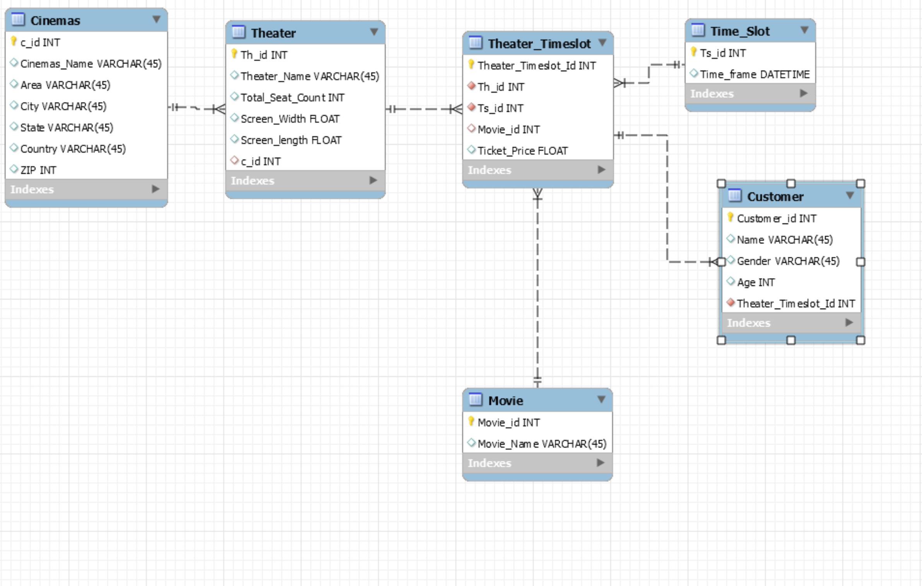

* Q2.  Global Trading (GT), Inc. is a conglomerate. It buys and sells businesses frequently and has difficulty keeping track of what strategic business units (SBUs) it owns, in what nations it operates, and what markets it serves. For example, the CEO was recently surprised to find that GT owns 25 percent of Dundee's Wild Adventures, headquartered in Zaire, that has subsidiaries operating tours of Australia, Zaire, and New York. You have been commissioned to design a database to keep track of GT's businesses. The CEO has provided you with the following information: SBUs are headquartered in one country, not necessarily the United States. Each SBU has subsidiaries or foreign agents, depending on local legal requirements, in a number of countries. Each subsidiary or foreign agent operates in only one country but can operate in more than one market. GT uses the standard industrial code (SIC) to identify a market (e.g., newspaper publishing). The SIC is a unique four-digit code. While foreign agents operate as separate legal entities, GT needs to know in what countries and markets they operate. On the other hand, subsidiaries are fully or partly-owned by GT, and it is important for GT to know who are the other owners of any subsidiary and what percentage of the subsidiary they own. It is not unusual for a corporation to have shares in several of GT's subsidiary companies and for several corporations to own a portion of a subsidiary. Multiple ownership can also occur at the SBU level.

