**Project Report on**

**E-commerce on Sports shop**

**Project Definition:**

Online Sports store is an e-commerce-based web application. where the user can view the product related to sports and can buy the product online. Admin or shop owners can add the product according to the product category or product type.

This project contains all the common features of a web application like CRUD operation ADD product, delete product, Edit, and Update Product, Dummy payment page, Cart option to view the project, or select product.

**Abstract:**

Sports has become integral part of one’s life. It is very essential for one’s growth in physical as well as mental terms. We are with website which can Add product, delete product, Editing of product, Cart, Admin panel, Pricing, delivery and many more functionalities.

**Project Purpose:**

To provide best items in terms of Quality. With minimal pricing, On-time delivery and best items. Our project is helpful in finding all the sports items, And can deliver any where around the world.

**Technology Overview:**

Python Programming language

HTML and CSS for the front-end

MySql for the Database

Virtual studio code as IDE for implementation

Django framework version 2.0

JavaScript for dynamic website

**Literature survey:**

* Sports Retailing in India: Opportunities, Constraints and Way Forward: Tanu M.Goyal
* Sports Equipment and Technology: T.J. Rosandich, Ed.D
* Exploring the factors influencing online shopping convenience in the Indian e-tailing sector: IAEME Publication

**Project Development Approach**

The project is implemented is iterative model. An iterative life cycle model does not attempt to start with a full specification of requirements by first focusing on an initial, simplified set user feature, which then progressively gains more complexity and a broader set of features until the targeted system is complete. The iterative approach begins by specifying and implementing just part of the software, which can then be reviewed and prioritized in order to identify further requirements. This iterative process is then repeated by delivering a new version of the software for each iteration. In a light-weight iterative project the code may represent the major source of documentation of the system; however, in a critical iterative project a formal software specification may also be required.

**Risk Identification:**

The possible risk can be identifying are

* Market demand
* Site traffic
* Conversion rate
* Average sales
* Order volume
* Costs of marketing
* Costs of Website maintenance
* Online insecurity
* Violating intellectual property
* Customer disputes
* Logistics
* Taxation

**Detail Description**

* **Login/Registration**
  + Admin, Shop owner, and Customer can log in and register in the application. The user has to register with some common details like contact number, email id, and password.
  + After registration user can log in in the application and can check the booking history or placed orders and can add the product in the cart.
  + The shopkeeper can log in to the application and can add the product or goods according to the categories.
  + Admin can manage the shopkeeper and the end-users and the products. Admin can add the new product also can delete update the records.
* **Product**
* The product is the key part of the application. Admin and shopkeeper can ADD/EDIT/DELETE the product.
* Users can explore the products according to the requirement also users can filter data according to the requirement.
* Users can search for the product.
* Users can filter products according to the categories or according to the type of products.
* **Payment**
* Users can buy the product online also can process the payment online. Science is an academic project so we are using a dummy payment page designed using JSP and servlet. It’s not a real-time payment gateway.
* **Cart**
* This is something like shopping beg or shopping trolly. where the user can add the product as per the interest and pay for them in a single transaction.
* Users can add or remove products in the shopping cart also users can view the added product from the cart and the user can check the discounts and price according to each product and sum of the price of all the products that are added in the bag
* **About Us and Contact Us**
* Contact us and the About Us are the static pages where users can contact admin and also users can check the about the organization ETC.

**Class Diagram:**

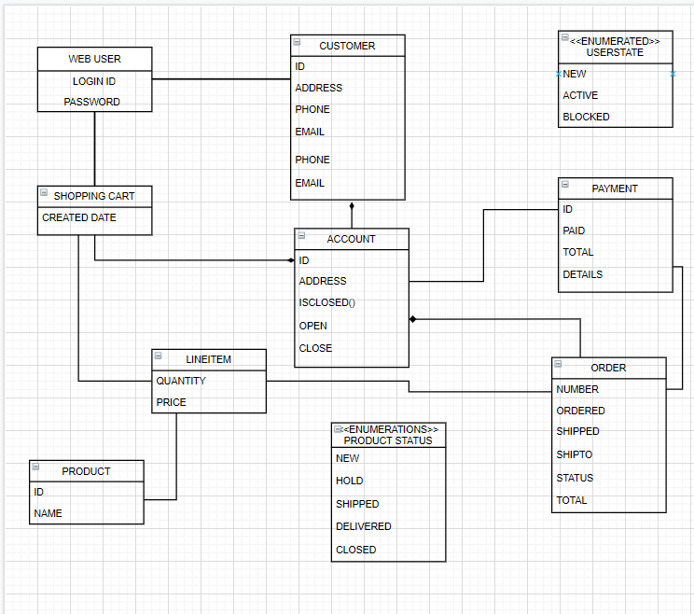

Flow Chart:

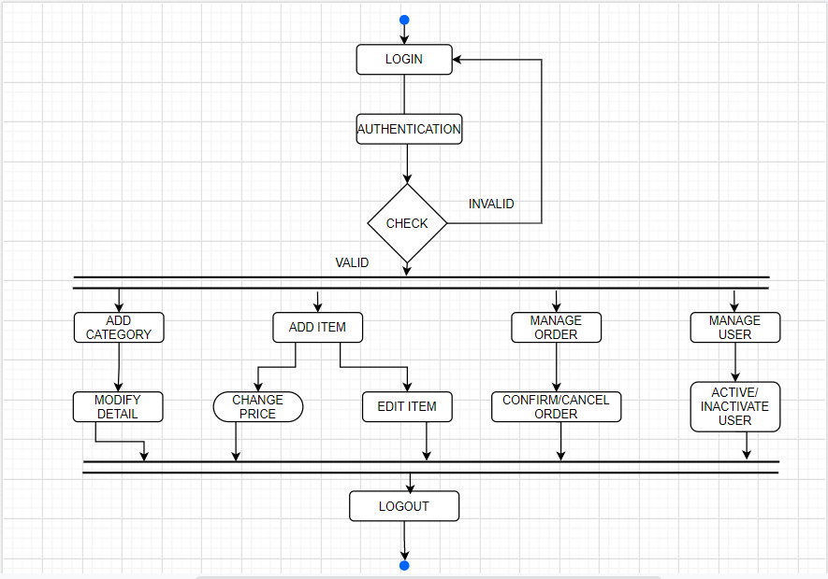

DFD LEVEL 0

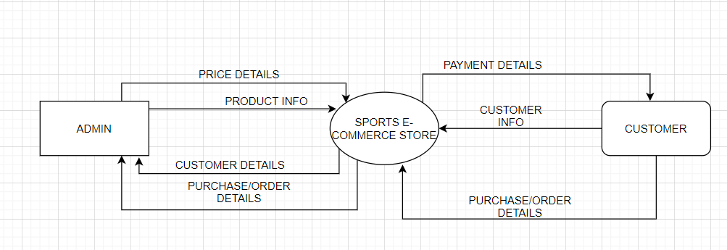

DFD LEVEL 1

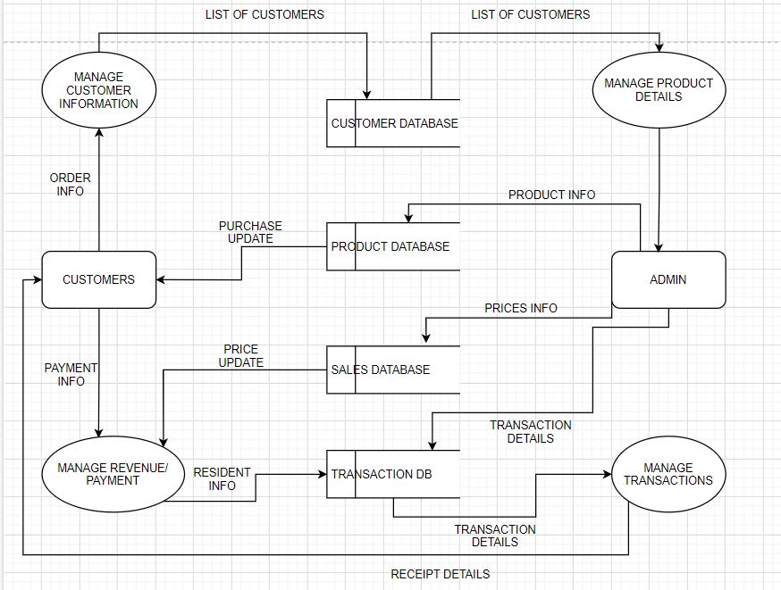

**CONCLUSION:**

This store has good efficiency as well as good functionalities. It has

Varied sports equipment’s as well as at reasonable price. One can order any sports item from anywhere around the world. And so accordingly Delivery will be done.