2>Write a program which will transform a given image (Fig.2(a)) in such way that the resultant

image histogram is equivalent to histogram of another image (Fig.2 (b)). In the process, show

the individual histograms and the intensity transformation curve.

[Hint: Use the histogram specification algorithm].

Answer:

Here we have two images and we will transfer the Fig(A) to Fig(result) in such a way that histogram matched with Fig(B). Here in program we are using **matplotlib.pyplot , skimage** and **cv2** libraries**.** We can observe image from below images with histogram format. For this matching task we are using **skimage import exposure** library function **match_histograms().** It manipulates the pixels of an input image so that its histogram matches the histogram of the reference image. If the images have multiple channels, the matching is done independently for each channel, as long as the number of channels is equal in the input image and the reference.

Fig(A):

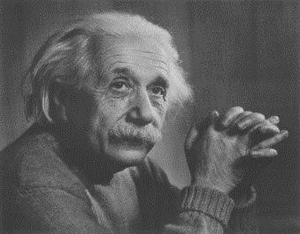 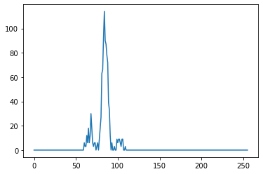

Fig(B):

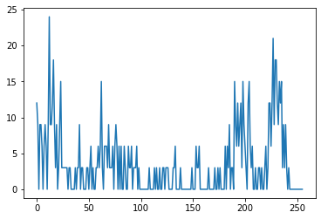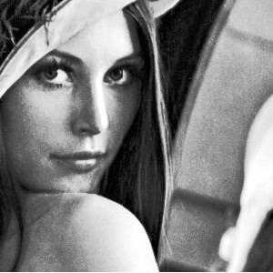

Fig(Result):

