Wide Area Networks (WAN) - Questions and Answers

Task
1. Draw a simple WAN diagram showing phone to Instagram through ISP and WAN devices.

Answer

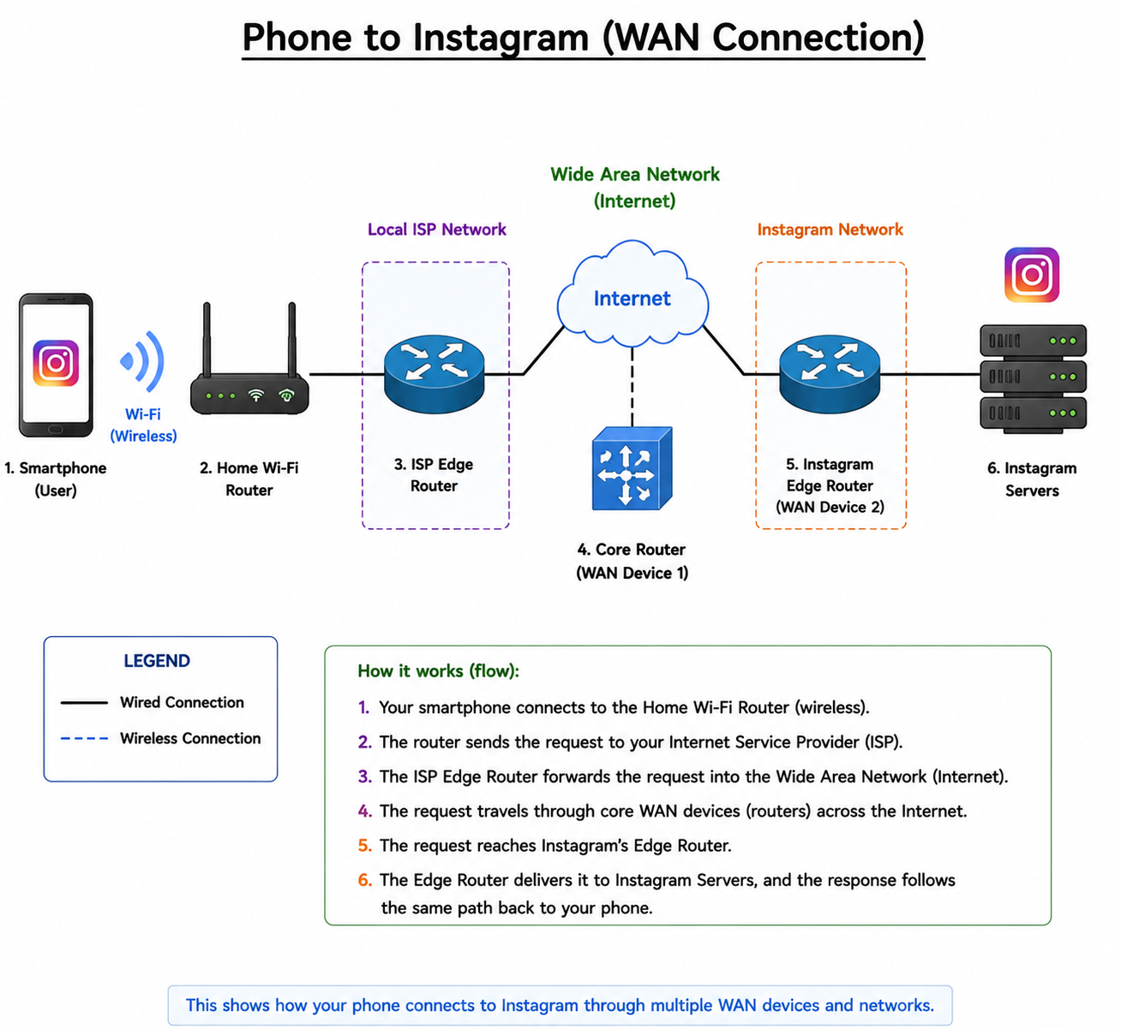

Task
2. Compare WAN technologies (MPLS, Leased Line, Broadband Internet).

Answer
Feature | MPLS (Multiprotocol Label Switching) | Leased Line | Broadband Internet
Speed | High (scalable, 10 Mbps to multi-Gbps) | Dedicated, very stable (10 Mbps–1 Gbps+) | Variable (typically 50 Mbps–1 Gbps)
Cost | High | Very high (most expensive option) | Low to medium (most affordable)
Performance | Reliable, low latency, prioritised traffic | Extremely stable and consistent | Can fluctuate depending on network congestion
Connection Type | Private managed network (ISP backbone) | Dedicated point-to-point link | Shared public internet
Security | High (private routing paths) | Very high (isolated circuit) | Moderate (needs VPN for security)
Typical Use Case | Banks, enterprise WAN, cloud connectivity | Large enterprises, data centres | Home users, small offices

Task
3. VPN and WAN explanation.

Answer
A VPN uses the WAN (internet) to create a secure encrypted tunnel between your device and a VPN server. When using public WiFi (like a café), your data is encrypted before leaving your device. The VPN server then sends your traffic to apps like YouTube or Spotify securely. This hides your IP address and protects your data from attackers on the public WAN.

Task
4. WAN technology recommendation for Flipkart warehouses.

Answer
Best WAN Technology: MPLS or Leased Line Hybrid
Reasons:
1. MPLS provides reliable and fast connectivity between multiple cities.
2. It ensures secure and stable communication between warehouses for real-time inventory updates.
Alternative: Leased lines can be used for critical data centers needing dedicated bandwidth.

