SOHO Network Setup - Questions and Answers

Task
1. Draw a network diagram for a SOHO setup with ISP, router, laptops, smart TV, printer.

Answer
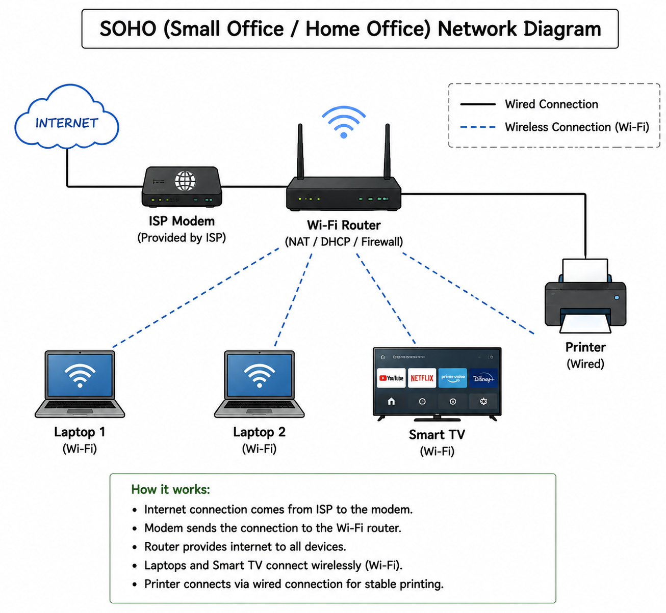

Task
2. Hardware components required for SOHO network.

Answer
Hardware List:
- Wi-Fi Router: TP-Link Archer C6 / Netgear Nighthawk
- Broadband Modem: ISP provided (Jio/Airtel/BSNL)
- Laptops: HP/Dell/Lenovo
- Smart TV: Samsung/LG Smart TV
- Printer: HP WiFi Printer
- Ethernet Cable: Cat6 RJ45
- Optional: 5-port Gigabit Switch, Wi-Fi extender

Task
3. Steps to configure Wi-Fi router.

Answer
Steps:
1. Connect modem to router WAN port.
2. Open 192.168.0.1 in browser.
3. Set SSID name (SOHO_Network).
4. Enable WPA2/WPA3 security.
5. Change admin username/password.
6. Enable DHCP for automatic IP assignment.
7. Save and reboot router.

Task
4. IP configuration table for SOHO network.

Answer
Device MAC Address IP Address
Laptop1 AA:11:22:33:44:55 DHCP
Laptop2 BB:22:33:44:55:66 DHCP
Smart TV CC:33:44:55:66:77 192.168.1.50
Printer DD:44:55:66:77:88 192.168.1.60
Subnet Mask: 255.255.255.0
Gateway: 192.168.1.1

Task
5. Troubleshooting laptop internet issue.

Answer
Possible Causes:
1. Wrong IP configuration → Renew DHCP / restart adapter
2. Weak WiFi signal → move closer or use extender
3. DNS/router issue → restart router or change DNS
Steps:
- ping router IP
- check WiFi status
- run ipconfig /renew

