Day 2: DHCP Configuration - Questions and Answers

Question
1. Configure a DHCP server in Cisco Packet Tracer with two client PCs.

Answer
Steps:
1. Add one Server, one Switch, and two PCs.
2. Connect all devices using copper straight-through cables.
3. On the Server, enable the DHCP service.
4. Create a DHCP pool (e.g., Network: 192.168.1.0/24, Gateway: 192.168.1.1, Start IP: 192.168.1.100).
5. On each PC, select Desktop → IP Configuration → DHCP.
6. Verify that PC1 and PC2 receive different IP addresses from the DHCP pool.

Question
2. Draw the DHCP process (Discover, Offer, Request, Acknowledge).

Answer

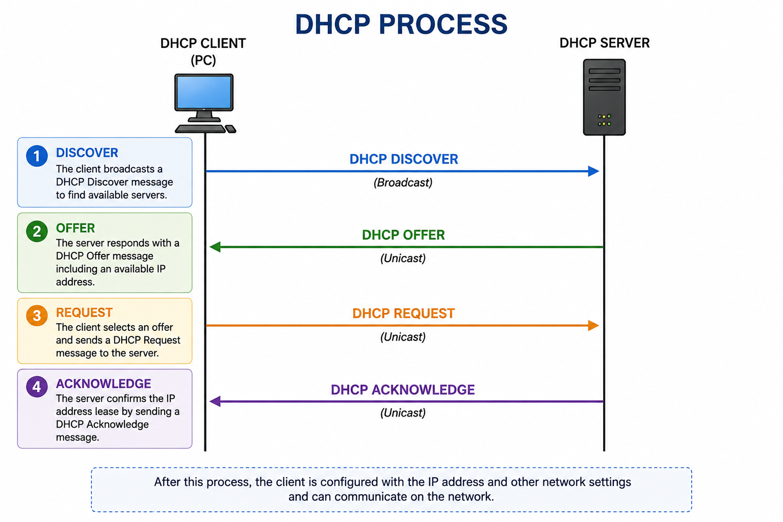Question
3. Limit the DHCP pool to one IP address and test with two PCs.

Answer
Configure the DHCP pool so only one IP address is available (for example, 192.168.1.100).
Result:
• PC1 receives the available IP address.
• PC2 does not receive an IP address and may show 0.0.0.0 or an automatic private address.
Reason:
The DHCP server has only one address available, so it cannot lease another IP until the first lease is released.

Question
4. Simulate a restaurant WiFi scenario using DHCP.

Answer
Example:
Laptop → 192.168.10.101
Smartphone (PC) → 192.168.10.102
DHCP automatically assigns different IP addresses to each device. This is useful in places like a Zomato partner restaurant because customers and staff can connect without manually configuring network settings.

