Network Cables

Question 1
Draw a labeled diagram of a Cat6 Ethernet cable showing the T568B color order and RJ-45 pins.
Answer: Draw an RJ-45 connector and label pins 1–8 using the T568B color order below.

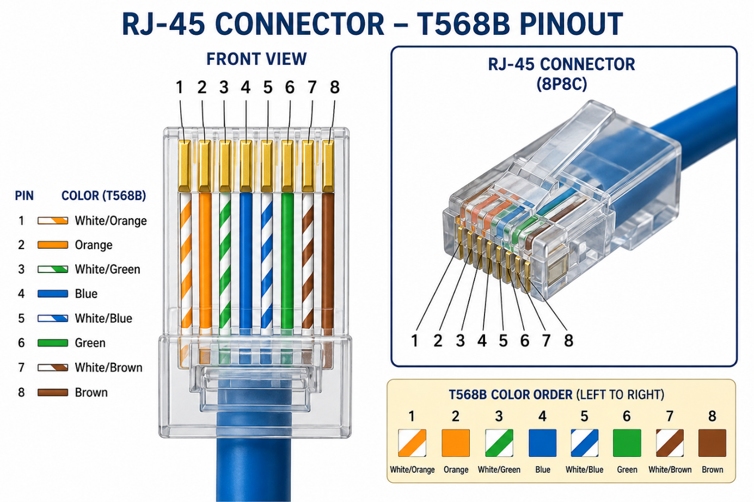

Question 2

List three types of network cables (such as Cat5e, Cat6, and fiber optic) and for each, mention one real-world app or device (like a WiFi router, Zomato POS terminal, or IPL streaming server) where it would be used, explaining why.

Answer:

Cable | Example | Reason
Cat5e | WiFi Router | Supports Gigabit Ethernet for home/office use.
Cat6 | Gaming PC / POS Terminal | Higher speed and lower interference.
Fiber Optic | IPL Streaming Server | Very high speed over long distances.

Question 3

Watch a YouTube video showing how to crimp an RJ-45 connector onto a network cable, then write down the step-by-step process in your own words and mention two common mistakes to avoid.

Answer:
- Cut the cable to the required length.
- Strip the outer jacket carefully.
- Arrange the wires in the T568B order.
- Straighten and trim the wires evenly.
- Insert them into the RJ-45 connector.
- Use a crimping tool to secure the connector.
- Test the cable using a cable tester.

Common mistakes: (1) Wrong wire order. (2) Not pushing the wires fully into the connector before crimping.

Question 4

Given the following scenario: You are setting up a gaming zone for an IPL screening event and need to connect multiple screens and consoles. Choose the appropriate cable and connector types for high-speed, reliable connections, and explain your choices.

Answer:

I would use Cat6 Ethernet cables with RJ-45 connectors because they provide high-speed and stable connections for gaming consoles and display systems. They reduce network delay and are reliable for multiple devices. If the connection between buildings is long, fiber optic cable would be the best choice.

Question 5

Find and share a photo (from your home, college, or online) of any network cable or connector in use (such as behind a WiFi router or at a café's POS counter), and describe what type it is and what devices it connects.<br><br><em><strong>Hint:</strong> Look for blue or yellow cables with clear plastic ends (RJ-45) or thin round cables for fiber optics.</em>

Answer:
Example description: Behind my home WiFi router, I found a yellow Cat6 Ethernet cable with an RJ-45 connector. It connects the router to the broadband modem, allowing all devices such as laptops, smartphones, and smart TVs to access the Internet.

