Ethernet Standards

Question: 1. Draw a simple diagram showing the pin layout of an RJ-45 connector and label the color codes for the T568A and T568B Ethernet wiring standards.

Answer:
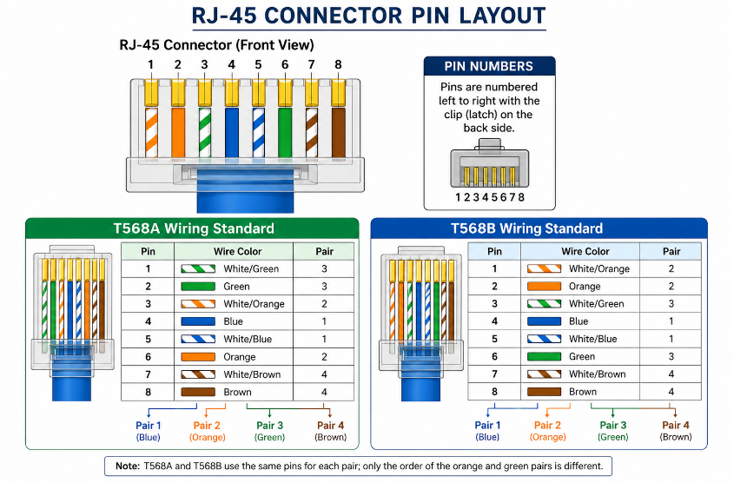

Question: 2. Create a table comparing the key specifications of Ethernet standards 10BASE-T, 100BASE-TX, and 1000BASE-T, including speed, cable type, maximum cable length, and connector type.

Answer:
Specification | 10BASE-T | 100BASE-TX | 1000BASE-T
Speed | 10 Mbps | 100 Mbps | 1000 Mbps (1 Gbps)
Cable Type | Cat 3 or higher (UTP) | Cat 5 or higher (UTP) | Cat 5e or Cat 6 (UTP)
Maximum Cable Length | 100 meters | 100 meters | 100 meters
Connector Type | RJ-45 (8P8C) | RJ-45 (8P8C) | RJ-45 (8P8C)

Summary
• 10BASE-T: Basic Ethernet with 10 Mbps speed.
• 100BASE-TX: Fast Ethernet with 100 Mbps speed.
• 1000BASE-T: Gigabit Ethernet with 1 Gbps speed, commonly used in modern networks.

Question: 3. Given a scenario where you need to connect two laptops directly using Ethernet, explain which cable
(straight-through or crossover) you would use and why.

Answer:
A crossover cable is the traditional choice because it swaps the transmit (TX) and receive (RX) wire pairs, allowing two laptops to communicate directly. Many modern laptops support Auto-MDI/MDIX, so either cable may work, but the expected answer is a crossover cable.

Question: 4. List three real-world devices in your home or college that use Ethernet connections, and for each, specify the likely Ethernet standard they support.

Answer:
- WiFi Router – Usually supports 1000BASE-T.
- Desktop Computer (College Lab) – Usually supports 1000BASE-T.
- Smart TV or Network Printer – Commonly supports 100BASE-TX or 1000BASE-T depending on the model.

