Day 2: Network Topologies

Question
1. Draw a diagram of a bus topology and write one real-world example.

Answer
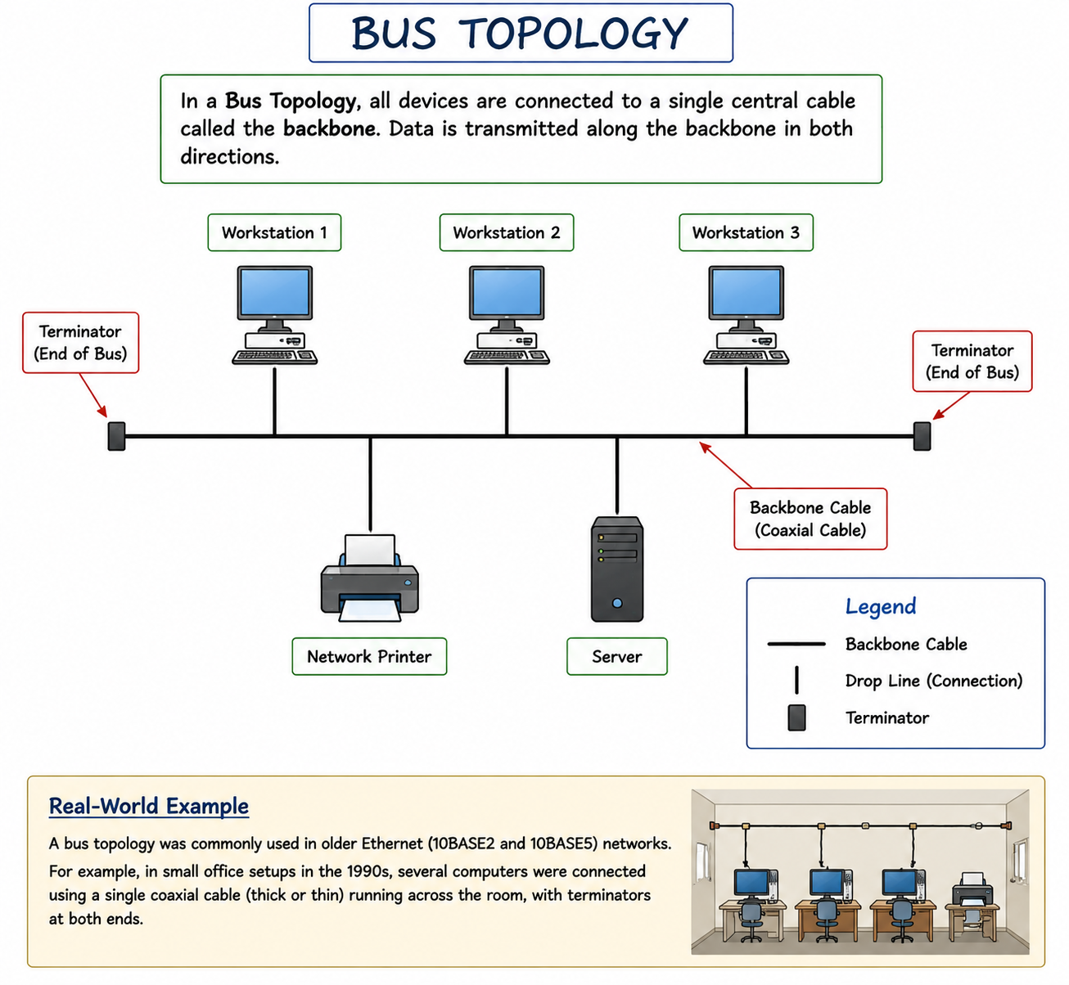

Question
2. Create a star topology in Cisco Packet Tracer and name PCs after apps.

Answer
Star Topology Setup:
PC (WhatsApp)
|
PC (Zomato) — Switch — PC (Spotify)
|
PC (Flipkart)
All PCs connect to a central switch.
Question
3. Draw ring topology and explain data flow.

Answer

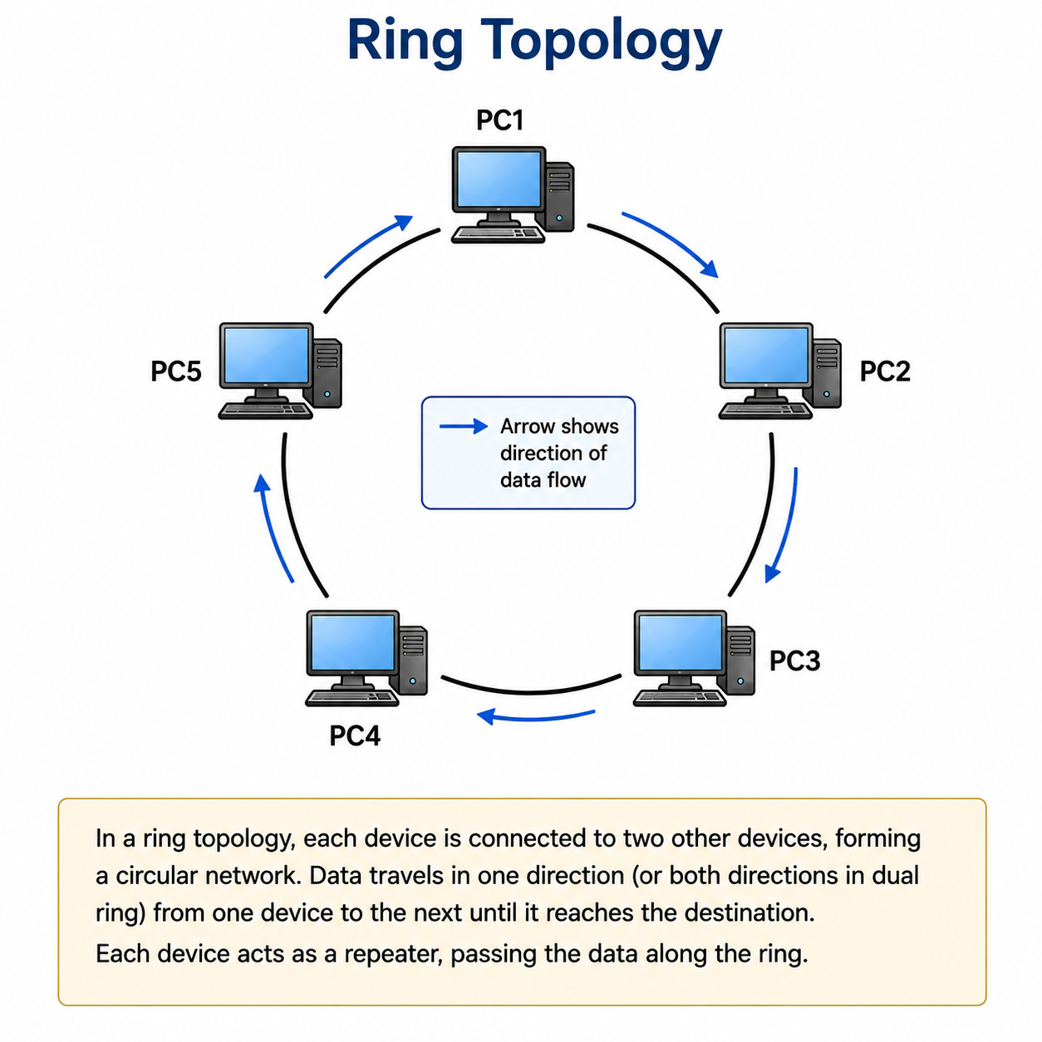

Question
4. Compare mesh and star topology.

Answer
Mesh Topology:
Advantages:
• High reliability
• No single point of failure
Disadvantages:
• Expensive
• Complex setup
Star Topology:
Advantages:
• Easy to manage
• Simple to expand
Disadvantages:
• Switch failure affects network
• More cable required than bus topology

