Network Topologies

Question 1
Draw and label diagrams of star, bus, and mesh network topologies. For each, write one real-world app/service that could use that topology and explain why.

Answer:
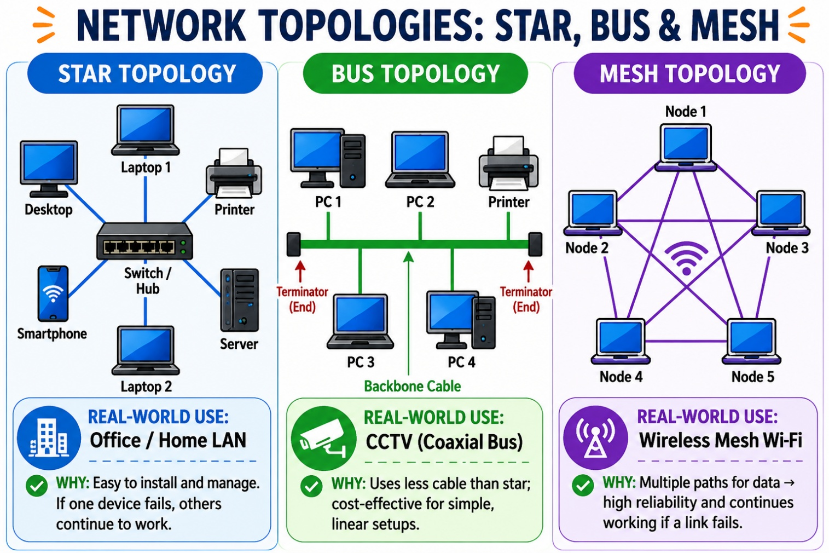

Question 2
Create a comparison table for Star, Bus, Ring, and Mesh topologies.

Topology | Pros | Cons | Best Use Case
Star | Easy to manage Fast  Easy expansion Fault isolation | Needs switch Higher cost  Switch failure affects all More cables | Instagram, Office LAN
Bus | Low cost Simple Less cable Easy setup | Cable failure stops network Slow under load  Hard troubleshooting Limited size | Small labs
Ring | Equal access Predictable traffic Less collision Good performance | One break affects ring Hard expansion Costly repair  Slower maintenance | Industrial networks
Mesh | Very reliable  No single failure High security High availability | Very expensive Complex  More cables Difficult setup | Banking, Cloud servers

Question 3
Imagine you are designing a multiplayer game like PUBG or Free Fire. Choose a topology and justify.

Answer:
Star topology is the best choice because all players connect to a central game server. It provides fast communication, easier management, and quick troubleshooting. Game servers can be upgraded as the number of players grows. Although server costs are higher, the network is reliable and delivers better gaming performance.

Question 4
A Flipkart-style warehouse wants to connect 8 computers. Recommend a topology with a sketch and explanation.

Answer:
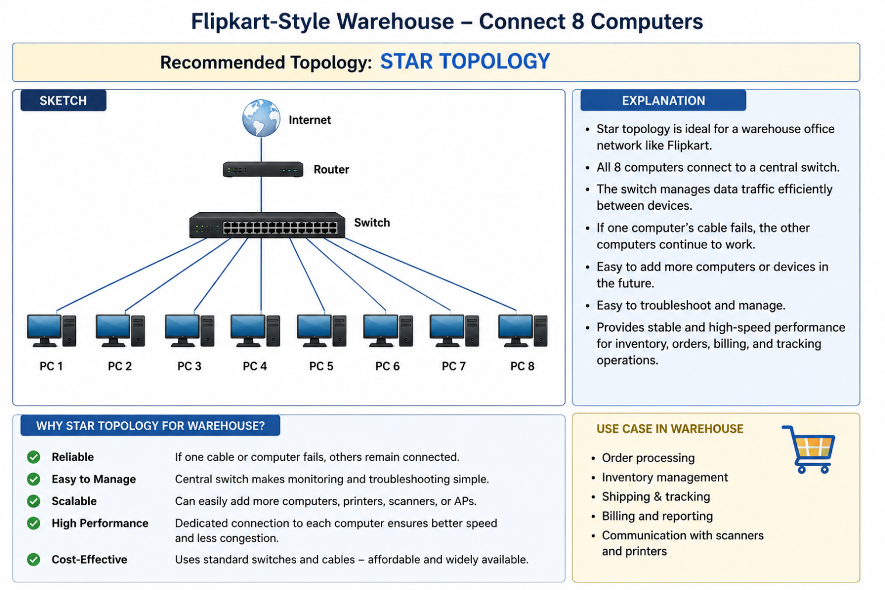

Star topology is cost-effective, easy to troubleshoot, and simple to expand by adding more computers. If one computer fails, the rest of the network continues working normally.

